Another Sissy Girl
Inspired by a Captioned image by BG Caps on Deviant Art
By Maryanne Peters

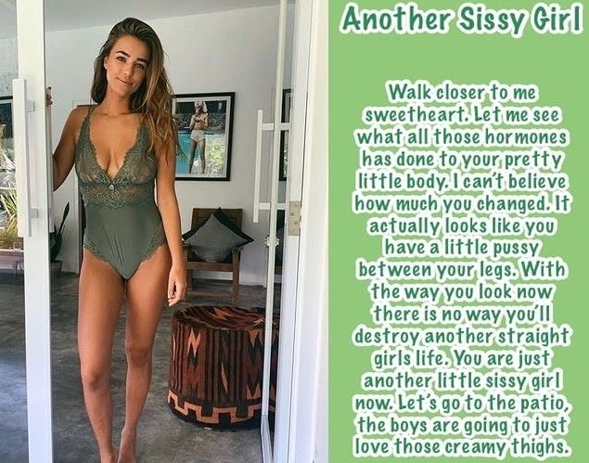

It just makes me want to burst into tears when I think of how awful I was to all those girls. In those days I did not just want to fuck them, I wanted to degrade them. I wanted virgins especially. “Straight Girls” - not as in “not gay” but as in girls who follow the straight and narrow – promising to be pure until their wedding day. I used to like to fuck them. Fuck them and fuck them up.

I suppose you have to think that one day a father or a brother might seek you out and shoot you through the head. But I used to just laugh at that thought. No reward without risk – right. And oh, what rewards! That is what I used to think. Die happy.

But death was not my fate. Yes the big brother turned up at my doorstep, but the shot was not a bullet, it was an injection. When I woke up I learned my fate. “Turnabout” he called it. I was going to be the one to get fucked from now on. He took my nuts and pumped me full of hormones. It took months for me to grow the breasts and the hair I now have, and now I can wear underwear like this.

The boys come around every week – brothers and a couple of fathers of girls I fucked when I could do that. They give it to me and they give it to me hard.

But do I look like I am crying? Do I look like I am unhappy about stepping out onto the patio for some vigorous outdoor sex with multiple men?

Well, It turns out that even without nuts I still like it plenty. I can’t dish it out any more, but man o man, I can receive!

Yes, let’s go outside today. Yes, my creamy thighs have been freshly waxed and moisturized. I have just washed my hair with floral shampoo and it will drape across the pillows on the cabana as they make my titties jiggle with every stroke. Bring it on boys! Being just another sissy girl ain’t so bad.

The End

© Maryanne Peters 2021

She Bully
From a Captioned Image by BG Caps
By Maryanne Peters

I honestly thought that she loved me. She said as much but I now know that she loved me as a possession – as a plaything.

She was always so much bigger than me. She could pick me up and carry me onto the bed. I have to say I liked it. I would have chosen her. Somehow, I have always felt that my partner should be bigger than me – is that weird? But she chose me.

“You’re coming with me”, she said. Just like that. And I just did. I went with her.

She sat on top of me and pleasured herself with me. That was how it was with her. I would get squashed, but I loved it because it seemed like love.

“You are like a little doll”, she said. “A dolly-boy. Just like the doll I never had when I grew up. Except that you have this silly little thing, and no bosom, and your hair is too short.”

I just wanted her to love me. I was prepared to do anything to please her. I was hers, and I thought that she was mine. I can say that she forced me, but really, I wanted to be forced, so long as it pleased her.

I moved in with her. People said that I was her sissy boy. I suppose I was, but I did not care. I lived with the woman I loved, and she loved me – or so I thought.

“Love takes many forms”, I might shout back at the abusers. “When you enjoy the kind of love I have then you can criticize me”.

But I was deluded. It was not love. For her it was power. She is just a bully – a she bully.

Then she tired of me. The breasts that she wanted to fill the pretty outfits she had me buy cost me the use of my ding-a-ling. When she sat on me there was not enough for her to feel. She told me that she would have to seek those pleasures elsewhere – and she did.

His name was Clyde and he was huge – like bigger than her. She had to me that he was coming around, and that they might both want to play with her dolly-boy. I have to say that I was terrified. But even though she had somebody else in her life, I still thought that it was love.

When she gave me to Clyde it was for her as if she was throwing an old toy into the trash. I could see it at last. I meant nothing to her.

And then there I was under Clyde this time. He was not interested in my ding-a-ling. In fact he said that I should get rid of it. He was interested in getting inside me, and that was going to be difficult … to start with anyway.

And now I understand. That was not love – this is.

I have always felt that my partner should be bigger than me – is that weird? But he chose me, over her in the end. So I guess that the she bully misses out after all. It seems like justice somehow.

The End

Trust Me
Inspired by a Captioned Image by BG Caps
By Maryanne Peters

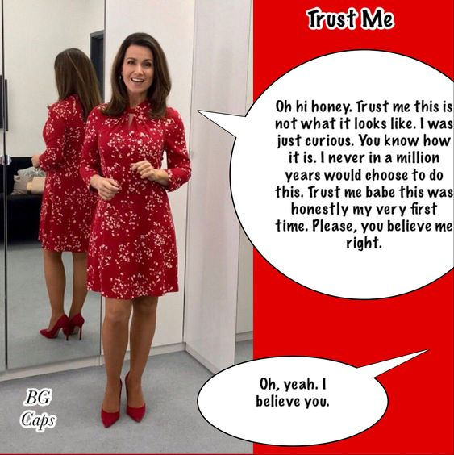

He tried to laugh it off, but I had to take the snapshot. The worst of it was that he was lying to me. I knew that it was a lie. First time?! Liar! He looked too damn good.

I mean he always had long hair, but he kept it slicked back and tied. He said that he shaved his legs for riding his bike, but why do some guys do that? And then there were all of his sales trips, where he never seemed to take any of his clothes and never had laundry in the wash when he came back.

I had just one trip away in years, and when I came back early to surprise him, this is what a found – the woman in red; the woman my husband my husband was having an affair with … in the mirror.

I suddenly seemed to make sense.

“Who are you”? I had to ask. “I mean what is your name … dressed like this”?

“Look, I don’t have a …”, he started, but he could see that all trust was gone in my face. “Margot”, he said.

“Well Margot, you’re all dressed up to go out, and I am home early and fresh enough, so let’s go out”.

“I don’t think that I am ready for that”, he said.

I was mad, I admit it. I said: “Well I think that you are ready. I think that you have been doing this for a while. I think the way that you have done your hair and you makeup you are no amateur. You look 100% female and you didn’t get to look like that with beginners luck! God knows what those business trips have entailed! God knows what guys you have picked up looking like that! God knows have far you may have gone with them! But trust me, tonight we are going to find out!

The End

© Maryanne Peters 2021

Advanced Class
From a Captioned Image by BG Caps
By Maryanne Peters

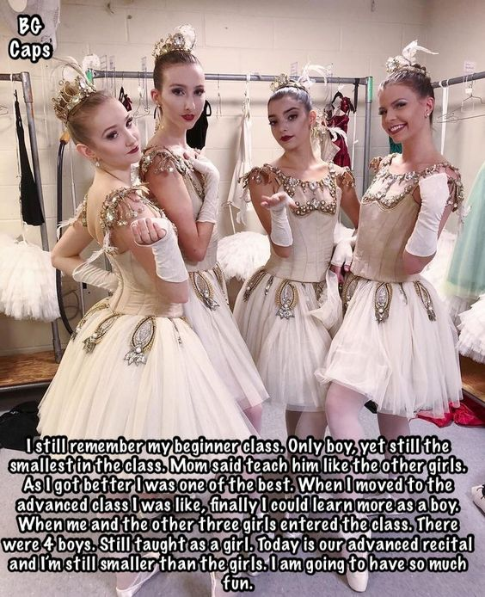

When I got interested in girls I got interested in ballet. I was the very opposite of a jock – I was smaller that all of the guys and most of the girls. But I was slim and supple and I felt that I had a good feel for dance. And while their were tall girls doing ballet, in the beginners class anyway, there were plenty my size. It was Mom’s idea. She had been a dancer.

“You should do ballet”, she said. You will meet lots of girls and you will use your physical abilities and keep fit and flexible”.

I felt a bit nervous when I discovered that I was the only boy, but Mom just told the instructor to teach me “like the other girls”. It was not as if she had much choice.

The good thing was that all the girls were really nice, and they were gorgeous too. They would come up to me in school and hug me, and I could see all the other guys looking and thinking – “How does that weedy guy pull such a great looking girl’?

But the fact is that I was one of a team. If I ever had any prospect of pairing off with any one girl, what would the others think.

The bad thing was that there was no place for me as a male dancer. I was small and lacked the strength of any roles, so I just ended up dancing the female roles. And you know what that means – I wore what the other girls did. My hair was not too long, but I kept it at a length and style that allowed me to pull it into a ballet bun to match the others, with a ball of hair added.

That was how I presented for the examination, and I used my initials K.T. which is why everybody call me Katie. I was picked with two others for the Advanced Class.

“There are going to be male dancers at the Advanced Class”, the instructor told me. It seemed as if I could lose the tutu at last. One or two male dancers would allow me to join them.

Bu things did not out that way. I mean in ballet across the country less than 15% of ballet dancers are male, so in the Advanced Class of 8 the presence of 2 boys would be highly unusual. But there were 4 … 4 boys and 1 girl from another beginner class plus the three of us.

Can you tell which one of the four is me?

“K.T. you have to stay dancing the female roles with us”, my friends all said.

4 females and 4 males. I could never pair up while we were all girls, now pairs were the way in which we all dance. I danced with all the guys, but after a while I settled on Mark, and he sort settled on me. He knows all about me now, but he says that he will support me through a full transition.

To think that I only started in ballet to hook up with a girl! He says that is why he did it too, and now he has what he wanted.

The End

© Maryanne Peters 2021

Wife Material
From a Captioned Image by BG Caps
By Maryanne Peters

Don’t think that I haven’t thought about it. He could have found some woman to do it, but he wanted it to be me.

“I need a wife and I cannot trust anybody but you”, he said. “You even have the right name”.

Was name is Kelly, but the problem with his plan is that I am a guy, or I was then.

His grandmother’s trustees were warning him that the year was almost up. If he did not get married by the first anniversary of her death, her very substantial estate would go to charities.

“It is hard to find the perfect woman, but when you are under pressure of time it is even harder”, he said to me.

“So just a do a deal with some chick”, I suggested.

“Except that when I am married to this person and I am suddenly rich they would want half, like the entitlement in this state. There is no way I am doing that. I cannot trust any stranger to simply walk away for a modest payoff. Who can I trust … other than you?”

He looked at me strangely. But it was only after he said that he had told the trustees that he had found a bride that he hit me with the news.

“I said that my fiancée’s name was Kelly”, he said. “So I guess that means that she is you.”

Of course I protested, but he was in a bind, and what are friends for?

He had the advance bequest, and he said that he would give it all to me, but some of it would have to be spent on my transformation.

A salon would not cut it. He arranged for me to go to one of those fantasy feminization places. You know the thing – turn an average guy into a woman for the day. But he told them that it would need to be for more than a day. More like the whole month he had left. He would introduce me to the trustees so that the wedding date could be set and the estate would pay for the whole thing, and once the Certificate of Marriage was signed and the estate distributed, I could toss it aside. But until then that meant a realistic body shape, facial treatments, hair extensions – the works.

“I want Kelly to impress the trustees as the perfect woman”, he said. “Real wife material”.

“Don’t worry”, the ladies said. “You have come to the right place. The look is only half the job. We need to introduce your friend to womanhood, but we have totally transformed much rougher diamonds than this one. Kelly is going to beautiful – we guarantee it”.

So that is how it happened. I married my best friend.

It sounds weird, but there is something about a wedding day that casts a spell. That is me in my bridal gown and the smile says it all. It was quite simply, the happiest day of my life – as it should be. And when I stood there making my promises to my intended husband, and he promising me back, we could see that the oaths that we made were real and unbreakable – just as they should be.

So you see, I could never toss that aside. Neither could he. We declared our love and we knew that it was not fake. It is real and it is forever. And being wealthy is not so bad either.

The End

© Maryanne Peters 2021

