New Life
A Short Story
Inspired by a Captioned Image
By Maryanne Peters

Who were they? Why him? Max never knew who, but the why was not hard to guess.

People said that he was showed no remorse, but that would be unfair. His product indemnity insurers had given him the instructions: Do not accept liability; do not apologize; deny everything. If you do not follow the rules there is no cover.

Not that it mattered, with the insured’s minimum and legal costs, within a year of the first claim the company was in bankruptcy and his personal debt to the bank was crippling.

And when those he had wronged came after him, the bank took everything. And still they were not satisfied.

Perhaps he could share the blame. He could blame Hank the Chemist. The fact was that while he said that his remedy was 100% natural and not a drug at all, it simply did not produce results. Sure Hank may have suggested that it be spiked with a drug “in development” but ultimately it was Max’s call. It was a bad one.

The drug they used would never pass FDA in any event. It worked on men but the side effects on women were serious. Sterility in 80% of women. Male secondary characteristics in 60% of women. This is what his supposedly harmless tablet for skin complaints wrought upon his customers.

If they wanted blood, they should have been happy when Hank committed suicide. The fact was that he was a fragile person. Max liked him. He was another person wronged. But for the time that they were in trouble together at least he was not alone. No, he was.

Alone, penniless and wracked with guilt that he was still unable to express. The insurer was still paying out, and the rules still applied.

When the men threw him into the back of the truck, he genuinely hoped that this would be the end. He did not have the courage or the fortitude to take his own life, but maybe they would do him that favor. Maybe he said as much. Maybe that persuaded his captors that death was doing him a favor.

So, for those women he had damaged, the sterile women with hair on their faces and deep voices, what is the punishment that a man like Max deserves? Simple. Make him the same. A hairy faced, deep voiced woman. Remove his balls and turn his cock inside out. Give him a pair of tits. Pump him full of female hormones, but he can keep the whiskers.

The man who bought the creature that they left behind seemed intent on continuing the torment. He had Max dress in pink frilly clothes. Everything was pink and frilly. He called Max “Maxine” and he now answered to that. He was a she now.

But somehow Maxine felt that she could talk to this man. She brought him his slippers and then, on her knees, she started sobbing. Maybe it was the hormones. Maybe it was the guilt. Or maybe it was just that she felt that for four years she had not had any human contact that was not abuse. It all came out.

He was the man who paid for the operation to fix her throat and lift her voice to a feminine register, as he could not bear to hear that voice from this woman. He was the man who paid for all the hair to be removed from Maxine’s face, as he could hardly kiss her mouth if it were surrounded in bristles. He was the man who paid for the hair color and soft curls, and the makeover. And he was the man who proposed marriage and won her acceptance with the love only a woman can know from a man.

So, who was he? The man who rescued her? He had nothing to do with the women who were Max’s victims. He was Hank’s father, who may well have held Max responsible for his son’s death until he heard what Maxine had to say. Deep inside he knew she was right. His son was too tender a person to survive that kind of stress. The only way out for him was death. He knew that now. Maxine was so much stronger, and, as it turns out, a much better person than Max.

The End

Perfect Candy Copy
Inspired by a Captioned image by Dawn (https://dawngs.blogspot.com/)
By Maryanne Peters

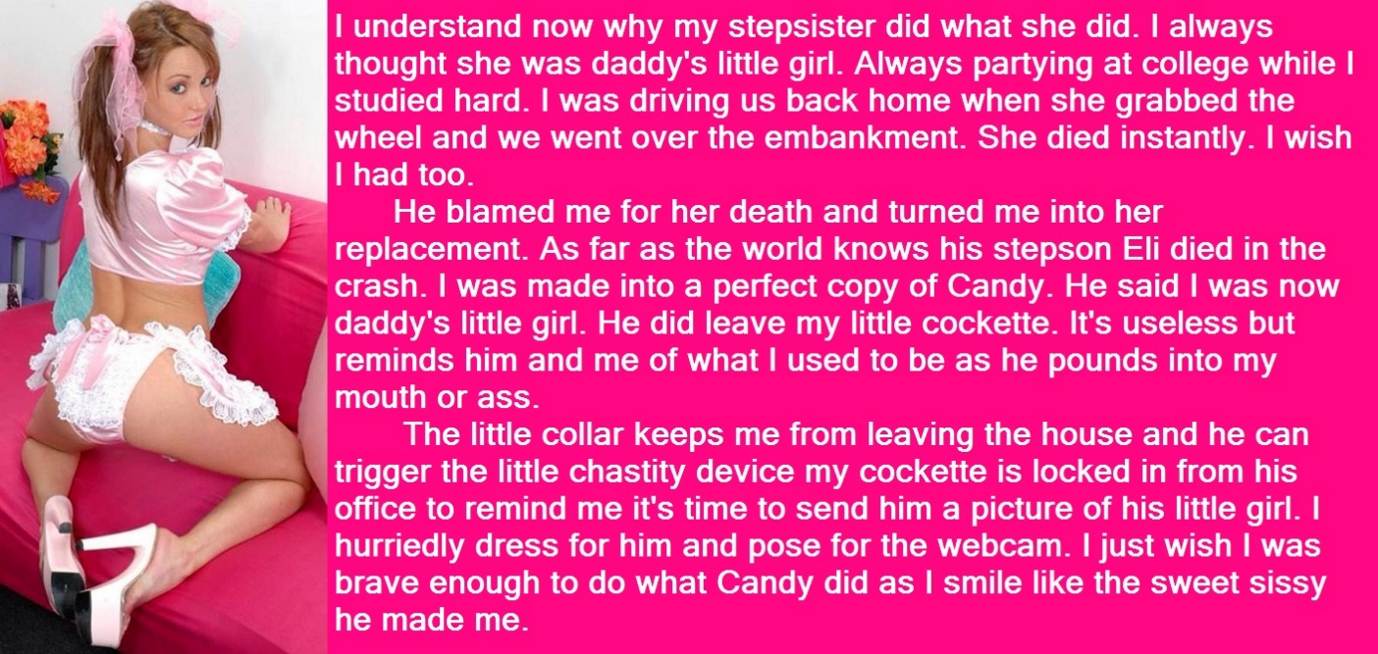

Ellen seemed to be making fun of me. All I wanted was to have my little girl back. She said that she was ready to do it. She was ready to bury Eli forever and become Ellen. She said that she could be the perfect copy of my little Candy. She told me that if that would get me out of my depression and back to work, that was what she would do.

Was it guilt? Is the story she told about Candy reaching over and taking the steering wheel a lie? Is she really to blame as I accused her time and again in my anguish? Is she trying to torment me, and this is the way to do it? To be not Candy but Ellen – just a copy? Or do I have her wrong? Is it kindness? Is she really concerned for my mental health? Or does she just want me back at work and bringing the money in? Who is she?

Or is it love? And if it is, what kind of love is it? Once the hormones had taken effect and hair had grown long, she took to wearing ridiculous clothes. Always pink and lacy. And the stupid little apron. Why? All I wanted was to check her on the webcam to see that she was keeping her side of the bargain – living as Candy would have, and attending to keeping our home neat and tidy. The devices were just designed for me to exercise discipline at a distance. It was supposed to be a control mechamism – not a sex toy.

But then the clothes she wore became increasingly suggestive. She was taunting me. The clothes said: ‘Look at me. I am a sexual being.” It seemed as if every moment of the day her blossoming tits, her growing butt and her ever longer soft brown hair, were in my face.

It got to the point that I could take it no longer. I came home and she was wearing just pink under, a cropped blouse, and apron and high heels, and she was licking her finger. I lost control. I turned her around and pulled down her panties and fucked her like the animal I had become.

She squealed: “Yes, Daddy, Yes … yes, yes, yes.” My own daughter! Or step-daughter … or step-son, that was … once. A perfect copy of my daughter, but not my daughter. I can have sex with this one.

The End

Miss Diagnosis
Inspired by a Captioned Image by Anne Oni Mouse
By Maryanne Peters

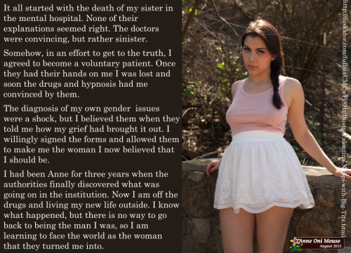

The details of the entire program were kept under wraps to protect those affected, but I am prepared to disclose what happened to you, upon your undertaking not to tell another soul.

We first became aware of the activities of the Sexuality and Gender Clinic within the Saint Joseph Mental Hospital about a year before action was taken. The Clinic was looking at behavioral modification of “sexual and gender disfunctions” in large part driven by the faith-driven direction of the hospital. Being heavily funded by religious groups the hospital was keen to see the Clinic established to look at science rather than prayer as a cure for homosexuality or transgenderism.

Unfortunately, the physicians left in charge proved to be “crusaders” with scant regard for medical protocols, with disastrous effects.

Anne’s sister was lesbian. It is still unclear whether she died at her own hand or as a direct result of over-rigorous “treatment”. Doctor’s certified her death as accidental, and her remains were cremated “due to the risk of infection”. We will probably never know.

When the victim’s brother started to press for the truth, he was persuaded to visit the clinic and somehow found himself being admitted – “voluntarily” they said.

It would appear that these physicians decided that the best way to keep this inquiring mind quiet was to use their treatments and therapies to take a normal heterosexual young man, and convert him into a transwoman sexually attracted to me. Somehow they believed that if they were able to do the opposite of what they were seeking to do, they would learn more.

Well, they were successful. Anne is the result. Quite the most beautiful and feminine of women, now surgically complete at her own request.

Quite what those villains were able to learn from their success I do not know. What I do know is that they will no longer practice medicine, except for any assistance they might be able to give in the state penitentiary.

And I do not care. All I care about is that Anne has agreed to be my wife, and I consider myself a very lucky man.

The End

Sorority Girl
Inspired by a Captioned Image by Sandra
By Maryanne Peters

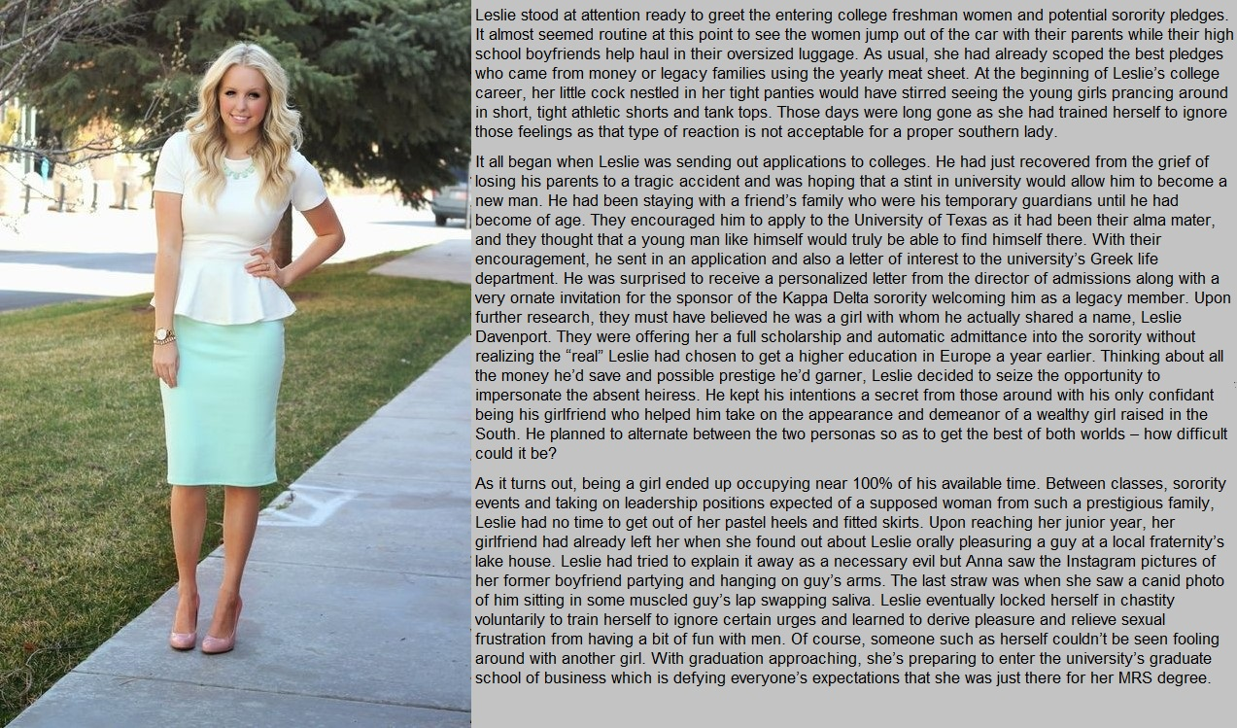

How could you get away with something like this? Well, we did. Les and I googled “Leslie Davenport” and there were plenty, but we could guess which one was supposed to get the scholarship that seemed to have fallen into his lap. It was certainly not my Leslie Davenport – my (then) boyfriend Les.

I found her and stalked her on Facebook. Yes, her. Miss Leslie Davenport of Abilene, the beefsteak heiress. Sweet little thing. So much money she didn’t need to go to a real school. She was headed to Paris, France and some Sore Bum University.

It seemed such a shame to turn down all that was being offered, but that is what she was doing. There was not even a paying place for my Les – even if he could afford it. Could it be done? Not in a million years. It was just that he was ready to try. What the Hell? And I was ready to help. Why the Hell not?

My Les already had the long hair, but that would need coloring, and the straggly beard needed to go – pulled out at the roots. In fact, all body hair – not because it might be visible but because we needed to clear the decks – get down to rebuilding him from the skin up – to be the other Leslie Davenport.

In no time he had nailed the walk and the talk. The walk had the confidence of a man, restrained by keep him in heels and tight skirts. The voice by lifting his natural voice and adding that slow arrogant drawl with educated affectations. It was perfect.

Then he needed to have his hair styled and face made up, but also learn how do maintain this look himself. It can be done – with practice. We proved it.

In fact, he became so good at it, he barely needed my help. He became so involved in campus life we barely had time to meet. He had his own room in the sorority house, and as I was not even attending college, I was off campus. And when he was not living the life of that Leslie Davenport, he was studying. I mean, he really did study. Not just MRS but proper business courses. He got interested in it and everything.

It was not even like we broke up. It was just that I never got to see him. And every time I did get to see him, it was like my Les was disappearing and the other Leslie Davenport was taking over. There was simply no time for my guy.

But I suppose that it ended when I heard about Leslie and guys. When I first heard about it from classmates of his who just knew me as an old BFF of the dazzling Leslie Davenport, I could not believe it. They said that he had been dating a guy on the track team, and that because she and her family were committed to virginity, she had blown him at a lake house party.

My Les is no virgin, but I could understand why he could not let any guy get to close, so the “saving myself for marriage” thing was a good call, and in keeping with her supposed conservative background, but sucking off another guy?! It was not possible. Then I saw the photos.

“It is not the way it looks, Anna,” he said to me. He said that he was going crazy without sex, and he was terrified that his junk would burst through the duct tape. Here was me thinking that was how he was keeping it flat – with some chastity device. I found out later that he was using tablets to suppress his male hormones and build high levels of female hormones. That was why he did not look anything like he used to. That was how she took over.
So this is what she looks like now. Little Miss Leslie Davenport, most popular girl in the sorority, about to graduate with a business degree, on full scholarship so no debt for a fresh start, three years after she started pretending to be somebody else, without anybody realizing. Nobody can deny she is not Leslie Davenport because she is. That is the name on the degree.

So why is she still dressed like this. Why is she still dating guys and not trying to get back with me. Now she seems trapped as a girl. But somehow, she doesn’t seem to mind one little bit.

The End

Staying in Shape  Inspired by a Lorna Samuels’ Cap  By Maryanne Peters  I suppose that I should have been worried when Jason … I mean Olivia, talked about staying a girl. It was just that, despite myself, I sort of felt the same way.  The Witness Protection Agency loved to talk about our new bodies as if they were not us. They talk about us “relocating into female bodies” and then “Relocating back into male bodies” as if it was changing clothes, or a fantasy body suit. But this real life. The changes that have been brought about by the hormones are real. Reversible maybe, but real.  I could joke about “tweaking my genes” but as the endocrinologist told me, if your mother had big tits, you will grow bigh tits too.  And Jason’s mother had big tits, so he is on the hormones, so my guess is that before long he will have a rack as big as mine. | 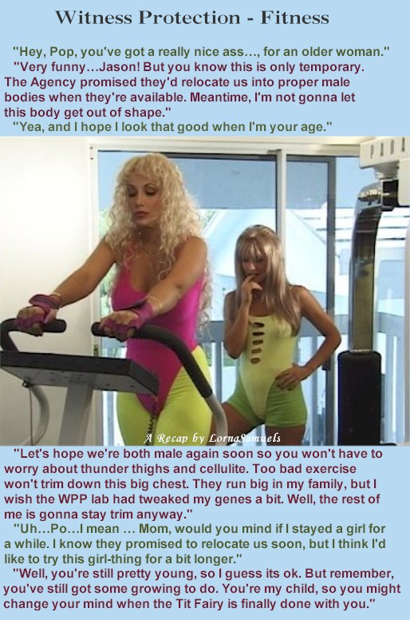

But you have to hand it to them. We are not Kevin and Jason Handley anymore. Nobody would guess that Layla and Olivia Janssen are the two most important witnesses in the trial of the Nerano syndicate.

So, how long does it take to build a case? Too damn long. Federal Marshal Jack May keeps us up to date, but seems to be taking years

And now what happens when I turn up to Court and they say: “State your name” and I brush aside my blonde curls and check the front of my blouse, and I say in the high womanly voice they have given me: “I am Kevin Handley.” Who would believe me? When I say it to myself in the mirror, I can hardly believe me. So what kind of a witness would I be?

I am just way too pretty. I don’t think I was supposed to be. It’s down to bone structure I guess. Me and Olivia both. Great bone structure and small bodies. Good bodies, but that doesn’t come without work. And that is why I am on the cross trainer, and Olivia is checking my butt to see if I have worked the wobble out of it.

Jack says he likes a bit of wobble in my butt. Why do men say things like that? A girl works hard to get her buns as hard as steel and he says he likes wobble.

I really shouln’t care what he thinks, but when you live as a woman you learn that it is nice to be admired. Nobody ever noticed me wen O was Kevin. Nobody complimented me.

Olivia feels the same way, I know. She is going to the local high school, just so that we appear like a normal mother and daughter. She is getting so popular that she is just talking about staying on until graduation. That will be next year. Could I stay on too? I guess I have to – right?

It won’t be so bad. I just can’t let up, I have to keep it up on the crosstrainer. A little bit of wobble OK. But no too much.

The truth is that Jack can’t take his hands off my butt, and I kinda like that.

The End

© Maryanne Peters 2020

