Shampoo
A Short Story
By Maryanne Peters

I was furious. As mad as I could be. And he just sat there, head down, his long lank hair hiding his face. Was he smirking under that greasy veil?

“You owe me big time, Buster,” I said, on the edge of a shout. “This is the last time I ever bail you out like this.”

“Sorry, Mom.” He sounded genuine, but these days it was so hard to tell.

Is it not strange that, as a mother you always think of your little boy just like this – on the right.  It seemed that at 6, and at 8, and at 10 years old, I would always think of him like that. And then a couple of years later, what comes down to stairs to breakfast instead of your baby boy, is a grumpy, pimply-faced, long-haired troll.  And then a few years after that, you are left wondering why you ever even had a child, or if you did (as I did) why that child had to be a boy.  Still, daughters can be difficult too, I suppose. | 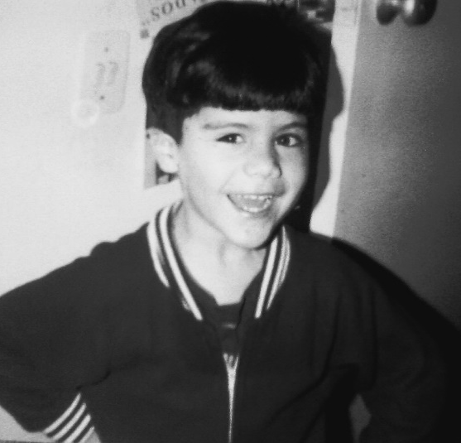

“I want every cent back from you,” I told him. “You have no job so you will have to work at the salon.”

“Mooooom,” he whined.

“And unless you have a brick of cash in your back pocket, you are going to have to shampoo a lot of heads over the next few months. And maybe while you are at it, you might actually wash your own hair as well. It is filthy.”

“I can’t work at the salon,” he complained. “The guys will give me too much shit.”

“No swearing,” I said. “We have rules of behavior in my house, and in my salon. And as for your so-called friends - they are the problem. You would be well rid of them. In the meantime, knuckle down and work to pay off your debt.”

It was not as if he had a lot of choice. The probation terms were strict, and my reports as to his good behavior were the only thing keeping him out of jail.

He always hated going to the salon. When he was smaller, he complained about the smells and all the women who fussed over him. So, when he started at the shampoo station, he was doubly horrified to see what he would have to wear.

“Mom, that’s a pinafore,” he wailed. “Only girls wear that.”

“It’s a smock,” I corrected him. “But whatever it is, it is practical. And the floral design is just in keeping with the feminine theme of this place. We are a full-service salon after all. Hair and beauty. The whole package. It is what has kept you fed and supported from the day your useless father left us, so don’t knock it. Now, you can wear your jeans and trainers underneath, and even that awful tank top if you like, but with clean hair, tied back.”  It seemed like he was always bad-tempered these days. Just like this. At least he is now washing his hair. In fact, after a few days it became apparent that he was taking some pride in his appearance, maybe because that was our business, at the salon.  He turned out to be quite good at his job. He particularly enjoyed washing long hair, which is so much more difficult than shorter hair. He learned about the different hair types and the different shampoos and conditioners that each type needed to be at its best. | 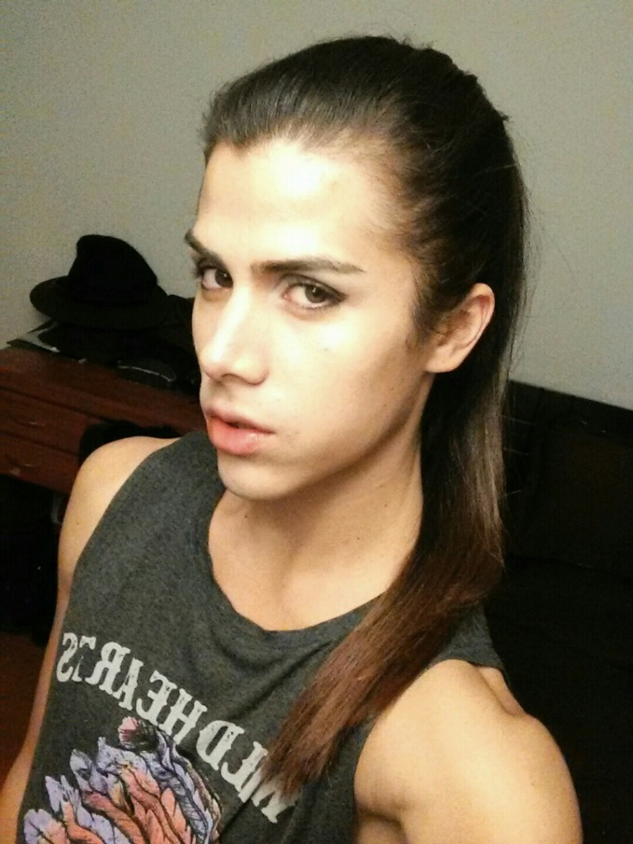

Clearly, he applied his knowledge to his own hair, which grew a little longer but seemed to acquire new body and sheen. His hair became almost an advertisement for what could be done in my salon. Women requested him by name.

I was pleased to see that he had become less interested in his old undesirable friends. He spent more time with a group of girls from school. I asked whether he was dating any one of them, but he told me that they hung together as a group “because we have stuff in common.”

His taste in clothes seemed to change. Nothing effeminate, but shirts with a bit of color. I only mention the word “effeminate” because I had overheard some of my customers using the word. Perhaps as a parent you do not perceive unwanted changes in your child. I was simply happy that he appeared to have left his criminal behavior behind and that he was concentrating on doing the work I required of him.

More than that, he was relishing it and ready to expand upon washing hair.

First I had him do some manicures and pedicures. That just requires a sense of color and a steady hand. But he was keen to move on the makeup. He has seen my expert girls at work, and only one of them had a qualification. Most of this work simply requires an interest in feminine beauty and an artistic flair. It was not long before he prproved that he could do a good job with the tweezers, the powder brush and the eyelash wand.

I suppose that I should not have been surprised that he should experiment a little on his own face.

The shock of the first time was that it was not just the makeup, there were curls in his hair, studs in his ears and he was wearing a sequin top under his jacket and sandals with his tight jeans.

I have to say that I thought that he had gone way to far, and I told him so.
“I’m just playing around Mom,” he said.

I told him that fortunately, from what I would have paid in wages, he had now almost paid me off completely. I said to him: “I have decided that from Friday you will no longer have to work here. Not only will I accept your det to me as fully paid, but I will give you a free haircut. Something a bit more suitable for a young man.

“Sure Mom,” he said. “Great. Whatever.”

But when he turned up on Friday morning for that haircut, and I suggested a flat top or some other kind of buzzcut, he was very specific about the cut he wanted.

“I want a bob,” he said, just like this.”  I almost fainted.  “I have a dated with a boy tonight, and I have a spectacular outfit to wear. A bob is just what I need. Thanks Mom.”  The End  © Maryanne Peters 2019 | Author’ Note: In November last year one of my reviewers (I treasure you all), signing off as Rachelle suggested: “Imagine a college kid with long, long hair, forced by mom to work as a shampoo girl in her beauty shop, who falls in love with the work, the customers and the clothes. Finally, he asks mom to give him a haircut. She jumps for joy and prepares to give him an "all American" flat top, only for him to ask for a pixie cut, telling her he wants to quit college, stay in dresses and go to beauty school.” Well, I don’t like pixie cuts, and while I prefer Dave Castiblanco’s hair long, doesn’t this bob look adorable on him?

