The Path to Success  Inspired by a cap by AnotherTGPage  By Maryanne Peters  For Dan it made sense. We discovered later that he was trans all along. He was toiling with us on the executive floor and trying to save enough to quit and get his surgery, but then the new diversity policy was announced and I guess he just decided: “Why not do it here and now”.  Dan was assured that it would not disadvantage his career prospects. Well, I tell you, it did more than that, it took him upstairs. While we were still toiling “Danni” was mixing with the VPs.  Sure you can say that it was using her newly acquired assets to the max. I mean, who wears a crop top to work? Let alone something that shows of that amount of tit. But she keeps a jacket on over it, buttoned up to look professional until drinks in the Boardroom are being poured.  But Danni is no bimbo – she has the smarts like all the guys on her old team. It was just that now she had the bosses ear – I mean literally … to nibble on and lick out – or whatever she did to get the old man to propose. | 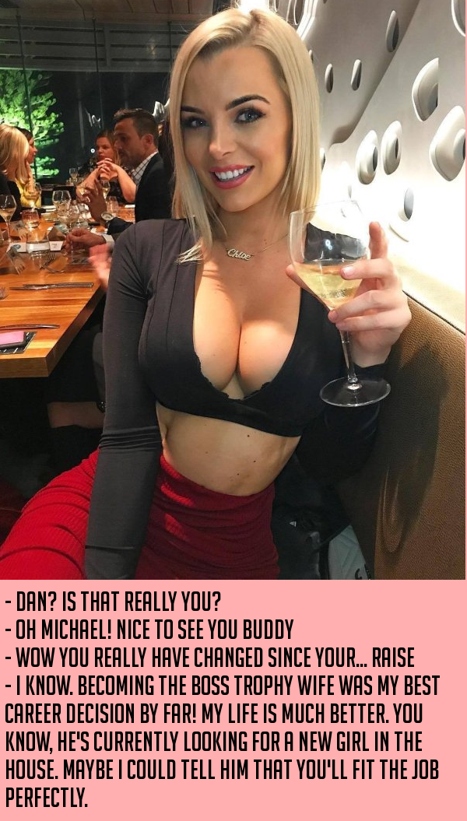

But want about me? Why would I follow that path? I am not trans, or I wasn’t then. Sure I dabbled in occasional cross-dressing, as Dan knew. He said that I was always the prettiest of the two of us when we played around with clothes and makeup. It seems hard to believe when you look at Danni now, but I will take a compliment.

With the Boss retired to spend more time with his young bride there was a new man in charge, and a man who openly admired his predecessor’s choice in a woman – somebody built for sex and without the baggage that women can bring to a relationship, and somebody smart enough to be a true trophy wife.

Danni said I could make the same career choice and see where it took me. Her path to success

“Its all reversible these days,” she said. “But obviously I am never going back.”

I looked into it. All the initial stuff can be reversed, but it is expensive too.

“I can help with that,” said Danni. “I have plenty of money these days.”

So why not? It seemed almost like an extension of what I did at home, but now dressing for the world instead of my own private thrill.

Danni’s husband made the introduction and the new boss seemed happy to take me upstairs as the new Michelle. I am loving the work and all the attention I am getting.

Who knows, maybe I will follow Danni in my personal life too, although the new boss says I would need to get rid of what does not belong under a woman’s skirt.

Sometimes success calls for drastic actions.

The End

© Maryanne Peters 2020

This Adventure
Inspired by a cap by AnotherTGPage
By Maryanne Peters

I suppose that I should have known that there was something not quite right with him from the moment that I met him. It seemed that he was always in search of something that was missing from his life. He was constantly searching for a new adventure, as if to put his life at risk and to prove his manhood. But in truth he did not want his life at all, so he could be reckless with it. And he could never prove that he was a man, because he was not one.

When he finally confronted his gender dysphoria and tried to explain it to me, I was not understanding. It seemed to me that it was just an excuse to shut me out of his life.

I told that we could fix it, and he could change. Why do women always believe that they can change their man? Maybe some can, if he really is a man.

I called it his “latest adventure”. Like the others, it meant that he would disappear for months, and then return to me, sick with worry and doubt.

“Not this time,” he said. “If I come back it will be as a woman.”

I laughed at him. I shouted and screamed. I told him that I would not miss him, but of course, I did, as always. My only hope was that he would come back as before, and I would forgive him yet again, and this adventure would be over.

The words with the message were facetious: “Thank you for helping me through this adventure”. I offered him no help or understanding. It was the very last thing that I wanted – to lose him.

The shock was to see him looking like that: His bright blue eyes now with painted lashes, his fair hair now wound up as a bun on his head, his face now so smooth and soft, and on full display, thrust into my face as the ultimate ignominy, two huge soft breasts, seeming to jiggle even in a still image.

I could only guess what the final surgery might have been, but even without that he was gone. That was clear to me even in the look and his eyes, and the smile, and the hand showing the pendant on the chain that I gave him – infinity. One adventure after another. No just no longer involving me.

The End

© Maryanne Peters 2020

Trainer Girl  Inspired by a cap by AnotherTGPage  By Maryanne Peters  I had heard that Darlene Jacobs was the kind of lesbian hardass who would never hire a guy, but then in those days I was up for a challenge. The fact is that extreme fitness and body-building are all about challenges. You set your goals and you chase them down.  I could not wait to hit back at her with the whole sex equality thing. Here was a woman who had fought for equality for women in the workplace, in particular in the fitness industry. She might not want to hire me, but the law that she fought to bring in said that she had to. I said: Back at you, Bitch!  She argued that her gym was “women’s space” which would be compromised by the presence of a man – women would feel insecure. What does that say about me? Are you calling me a rapist? Get over it! Isn’t that what you said to the guys who wouldn’t hire women?  So I was to be the only male trainer in her gym. What is wrong with that? I figured they would be seeking sessions with me. | 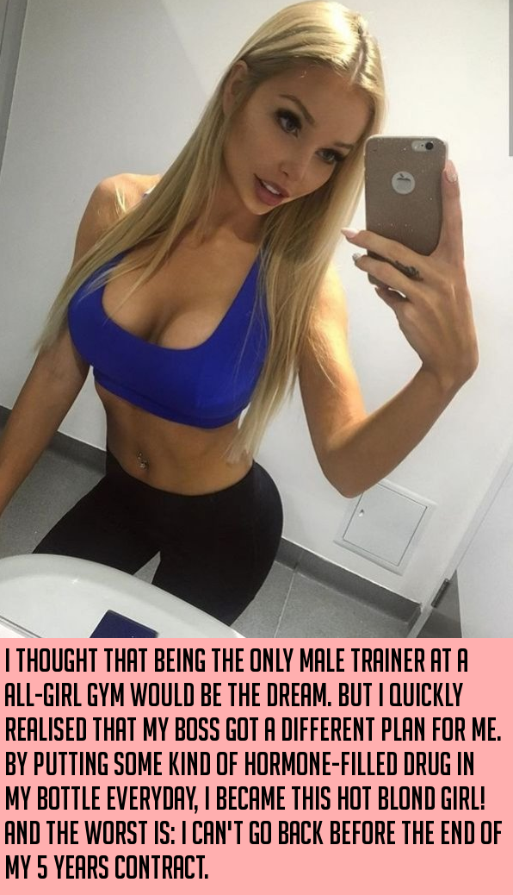

But Darlene Jacobs had other ideas. She told me later that it was about me being a threat, but about how her customers felt. She wanted them to feel at home surrounded by other women. So she figured that if I had to work there, I had to be a woman.

She signed me up for a five year contract and said that she would give me benefits not open to other staff, including a wardrobe allowance and a “Health Plan”. She had me on these shakes which were laced with female hormones.

It was not mind control or anything like that. It started with it just being about the money, then I got on board with what she was talking about. Women choose a woman-only gym so they don’t get looked up and down and propositioned by strangers. At the beginning I was just gender neutral, and then I guess I changed gear from there.

It was something about pleasing her. I mean I admired Darlene. She had achieved a lot. She had built up a business. And she was a strong personality. I guess that was my weakness. I liked to respond to strong people. Sure I liked challenges, but I preferred it when somebody set those challenges and worked alongside me.

I suppose that I am saying that I am not a loner. I need somebody in my life. It seemed impossible to believe that Darlene Jacobs might be that person, but the more I changed the more I appealed to her.

I guess that I was in love with her from the start. I wanted to prove that I existed by needling her. It seemed impossible that she would ever love me back, but over time, she did.

Now look at me! She wants me to lose the last vestige of my maleness. She says that my contract is now almost up and I need to make some decisions.

I am not so sure what she means by that (?)

The End

© Maryanne Peters 2020
Bad Advertising  Inspired by a cap by AnotherTGPage  By Maryanne Peters  Okay, so I am going to try to explain this, but I am really not sure that I understand it much myself. So, anyway, hormones – do you know what they are. They are like chemicals that run around your body and make your body like a guy of a girl. Who would believe such stuff?  Anyhow, back then I was a guy. I mean back before this happened. So, I was not much of a guy, I guess. I wanted to be more of a guy, and people said I wasn’t. I mean, I was little and weak and not hairy. Like, not a manly man.  People said this was because of hormones. I did not have enough of them. I needed hormones to attract women. I wanted to attract women like the one on the box.  The blurb said that stuff: “To increase a person’s charisma by containing hormones favoring the attractive traits of each gender”. Why do labels have to use words like that? What is charisma? What are traits? “Completely safe to use several to speed up the process”. That I can understand.  There was a picture of a woman on the box I ordered. Like, I wanted to be attractive to her, not be her. I mean, there are pictures of women on the condom box and they are not the one’s using those. You use the condoms to fuck the women – right? | 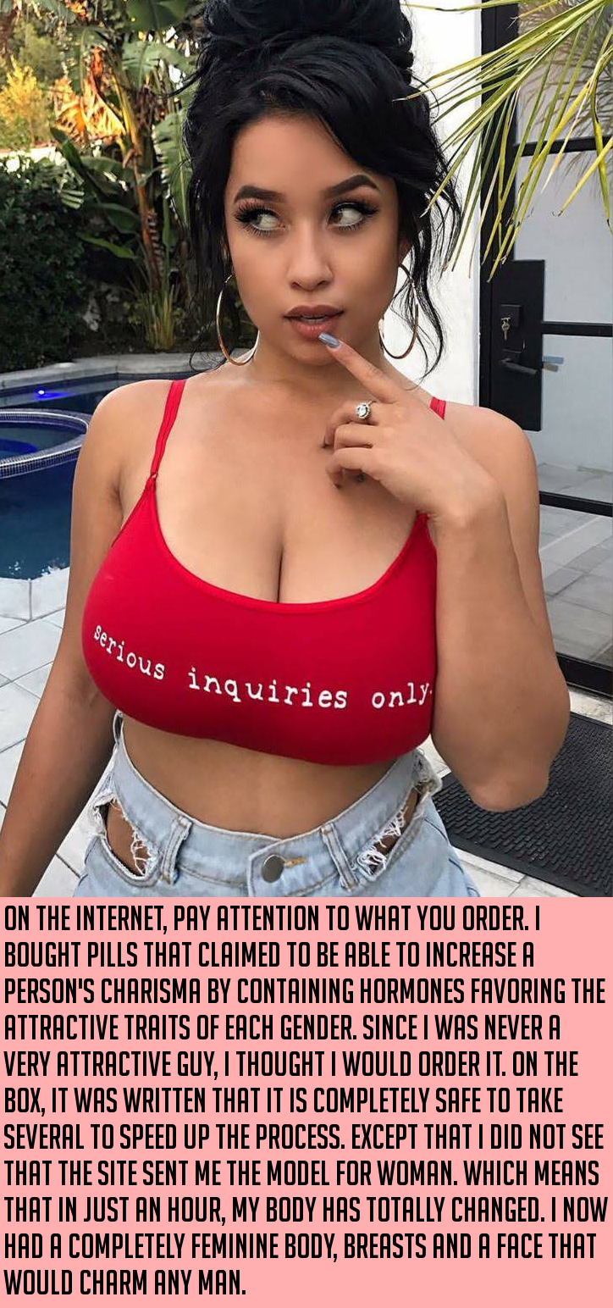

“Use several to speed up the process”. I wanted to. I went all out. I wanted to change my body and I wanted that fast. And when things started to change, I figured that it was like, you know, the first phase or something. I doubled down and double dosed my double dose.

I am not saying women are dumb, or that I was a smart guy, but it seemed to me that these hormones were affecting my brain too. I mean, things that should have made me angry just didn’t. I mean when you are trying to grow muscles and lose the flab and the opposite happens, you know something ain’t right. You should get angry – right? I was just Okay with it, and I don’t know why.

I can’t even remember how many months it was, but then there I was with these huge wobbly tits hanging off my chest and my long hair all pinned up on my head, wearing makeup. Hoop earrings, nail polish and an engagement ring. Ha it been a year, or was it just and hour? Seems like it was no time at all.

My guys says that I have the body, breasts and face to charm any man, and as for the little ting, as longs as I keep that tucked away he says we can ignore it until it is cut off.

Ain’t it nice that this is all it takes to win a guy? Because I know I am not that smart.

The End

© Maryanne Peters 2020

Matching Outfits
Inspired by a cap by AnotherTGPage
By Maryanne Peters

I wanted matching outfits, and I had just the dress that would teach Terry a lesson. It was not the dress that was expensive, but the fact that it had the plunging front. That meant high quality fake breasts and intensive work to make them merge with the skin on his chest.

And a high-quality wig too. Something to match my own beautiful dark hair. It had to be lace front too, with make up to conceal the fact that it was a wig. Other makeup over his plucked chin and upper lip, and around his brows shaped just like mine. Matching looks.

The only difference I had to concede was sleeves on the dress to mask his male shoulders, and red lipstick to draw attention away from his squarer jaw.

He had to pay for it all. He had the money. I took him to all the right places to get the work done and told him that he would have to open his wallet.

If my brother Terry was going to poke around in my closet sniffing and stroking my clothes, then he could be my sister for at least one night.

So this is the photo I took in the mirror before we went out. His breasts are hanging a little low and the hem of his dress riding so high that only half a roll of duct tape could keep him from an embarrassing reveal. But apart from the grumpy pout, he looked just so pretty and so sexy I amazed myself. Not quite as pretty and sexy as me of course, there in front taking the shot. But that is the way it should be. No fake girl should outshine the real thing.

I told my friends: “You will not believe what I have been able to achieve with Terry’s look! Make sure that you call him Theresa all night.”

And so we went out, and he continued to pout for the first hour or two, but then he relaxed into it. He had found his groove and he had found his voice too – high but not shrill or squeaky. He even started talking to strangers.

Me and my friends got our share of attention, but what it was about Terri that fascinated men I am still trying to work out. Was it that he looked like a fish out of water and that gave him the aura of innocence that men go for? My friends noticed. One of them may have been responsible for whispering that the taller of the girls in the navy outfits was not a girl at all. It was not me, I promise.

You would think that would end his evening in tears, but he just went on from that.

Just after midnight we lost him between two clubs. Girls usually follow a strict “no girl left alone” policy but I suppose we figured that it did not apply to him. When I got home I was concerned and when I checked his bedroom in the morning and found his bed not slept in, I got worried.

I called him and his phone was off. I texted him. I was on the verge of telling our parents and suggesting that we go to the police when I got a call.

“Hi Sis. Sorry but I switched my phone off.” It was the voice of Terri, not Terry.

“Where are you? I was worried sick. Where did you go?”

“Oh, we just went to a quieter place, and then back to his place. I am still there.”

I asked – “Do you want me to pick you up?”

“Nah. I can drop over later and pick up some things, but they won’t be clothes. I won’t be messing in your wardrobe anymore either. I now have a very rich boyfriend who is going to take me shopping today. He has promised that he will fill my half of our closet with only the best money can buy.

The End

© Maryanne Peters 2021

