For Daddy
A Short Story
By Maryanne Peters

He called me “Daddy” in the emails and text messages I received from him. I guess I thought that it had been so long since we had been together as father and son, that he would still think of me like that. But really, that makes no sense. My son was now over 18.

We never spoke on the phone. After my lawyer told me that he had received contact details, I tried to call the cellphone number. My calls were declined but my son always responded with a friendly message soon afterwards. He was looking forward to seeing me after so long apart.

I was surprised that I have received anything at all from Miriam, my ex-wife’s sister and the executor of her estate. My ex-wife had appointed Miriam as guardian of our son, and after a brief exchange between lawyers I agreed not to upset things. I was told that the interests of the child would favor him staying where he was. The opinion was that if I had wanted custody after my wife’s death 5 years ago, I would need to prove that I was a better parent than my sister in law. It seemed too great an effort. I just needed to wait the few years until he was 18 and then, if he wanted to be with me, nobody could stop it.

He did want to see me. It was clear from everything that he wrote. He said that the love of father was important to him, especially after he lost his mother. He said that his aunt had never been able to offer him the love that he craved, perhaps because she saw too much of me in him.

There can be no doubt that Miriam hated me. She blamed me entirely for her sister’s suicide. I think that both of them were mentally unstable, and what I blame myself for is not seeing that at the outset. My only hope was that my son had not inherited this mental fragility, something that I did worry about reading some of his letters.

He asked after Laura, my girlfriend at the time. Laura had been a moment of weakness for me, as she was not the kind of woman I was usually attracted to. She was bubbly but frankly a bit stupid. She posted lots of pictures of us together. She loved retro clothing and hairstyles and she was strictly old-fashioned in her attitude as well. She was happy to be a kept woman. She could cook and clean if required but preferred to devote herself to looking pretty and keeping me happy. At least that was how it seemed. It did not last.

Anyway, I arranged to meet my son on a visit to Miami. I wondered how he would look 9 years after I last saw him. He suggested that I meet him at my hotel and I gave him the details. When I checked in I was told that my visitor had already gone up to me allocated room, and I should go on up.

When I opened the door and walked in there was a young woman there. She looked a little like Laura. The same hair and style, but younger and much prettier. She was sitting on the chair in the corner and she was wearing very little. A black bra, white panties, and black stocking and patent leather high heels.

“You have the wrong room, I think Miss,” I said.

“Oh no, Daddy,” came the reply. “This is your room.”

I was confused and she knew it.

She said: “Oh Daddy, I have been waiting so long for you to come back to me. Auntie has told me what I needed to do to get you back, and I have followed all her instructions.”

I felt sick. What kind of perversion was this? Surely this could not be my son?

“Aren’t my legs pretty, Daddy. Auntie’s been showing me how to make myself pretty all over since you’ve been gone.” She seductively raised a leg and ran her hands up and down it. “What’s the matter? Don’t you like me being all pretty dressed up in my new undies, Daddy?”

I had to approach. I could see that the body of this girl was entirely female, with ample breasts showing atop the bra, smooth feminine limbs, and underpants with no bulge.

“Is that you, Robert?” I hoped that it could not be.

“Bobbi is better,” she said. “But as you like it.”

“What have you done to yourself?” I asked. “Or what has Miriam done to you?”

“She has told me what you love, Daddy. I have even had my hair done in the style you like, just like Laura. Isn’t it pretty. It’s the very same colour as hers now, Daddy. And I know that she always has her hair done in retro updos like this style. Don’t you adore it like this? I want to be as attractive as she is so that you will love me as much as you do her.”

It was unbelievable. Now I was more angry than sickened. I said: “This is too much. You come in here looking like that. Was your intention to give me a heart attack?”

“Auntie wanted me to surprise you by making me look exactly like Laura so that you would be sure to love me. You should love me even more now Daddy. Auntie says I should just learn to look like this instead of a plain old scruffy boy that you decided to leave behind all those years ago when you ran off with your secretary. Won’t you please say that you love me now, Daddy, please.”

I looked at the face and I realized that this was not my torturer. This boy in stockings honestly believed this. He had somehow been persuaded that this was how he should win my love.

I said: “You poor child.” She stood up and we hugged. “I am so sorry that this has happened to you.”

She smelled of exotic perfume and I could feel her breasts against me, so that It was hard to think of this as my son. But the shivering and sobbing was undoubtedly genuine. She just kept saying “Daddy. Daddy. Daddy.”
We stood for some time in that embrace, in that hotel room, in the city I used to call home, holding my child after such a long time apart.

Then she said: “Are we going out? I have clothes to go out.”

“Would you like to?” I asked.

“I will iron your shirt. She said. She had the ironing board already up and waiting, and with a colorful dress just done.

I opened my case to get a shirt and when I brought it to her she had changed bras to a more revealing white item, and she was freshening her lipstick and check the earring she had put on, using the iron as a mirror.

She looked like she had living as a woman for a long time.

“I love ironing men’s shirts,” she said. “We have no men but Auntie has had me practice anyway.

“Do you really want to go out” I asked.

“I want to hang off your arm tonight, Daddy,” she said. I want to be all that you love tonight. I want to be pretty so that you are happy to be with me and never want to leave me.”

“Maybe we should just stay in tonight,” I said. “We can go out tomorrow night.” I had arranged to nights and then I was to be off, but the child was fixated. I needed to get him help. But first I needed to understand what had happened.

“So, your Aunt suggested that for me to love you, you needed to become a copy of my girlfriend?” I said.

“I am not sure what happened,” she said. “I told them that I could not do it, Maybe Auntie and her friends have done something to me to make move and act just like a pretty girl. Do you think I’m like a pretty girl Daddy? Do you?”

“I think that you are very pretty, Bobbi.” She was. “But I think that she did this to you to punish me.”

“No Daddy, this can only be good for you. It’s me that Auntie Miriam hates. She knew that I knew about your affairs. She says that I lied and covered for you and that I must make amends. She told me that all men and boys cannot be trusted. I could only be a girl living at her place. What kindness I got from Auntie I got when I was girly. She said if I wanted love only a parent could give it. But she said that you were not interested in family. Only in pretty girls. Pretty girls like I am now.”

“That’s not true,” I exclaimed. “Surely you know that now. I love you. I always have loved you.”

“Really,” she said. There was a truly childlike expectation on her face. “Say it again Daddy.”

“I love you,” I said. She came up to me and kissed me. It was not a child’s kiss of her father, or any kind of family kiss. It was a lover’s kiss. Our lips slowly parted. But before she could pull away I pulled her back, and kissed her again. A man kissing a woman. A beautiful young woman.

Before I knew it I was on the bed. She had my belt undone and my pants and underpants down and she was licking my cock. Within seconds it was full of blood to the point of bursting.

She said: “ I have another surprise for you Daddy. I can never be Robert anymore.” And with that she straddled my raging cock and took me inside her. She had a vagina. “Made just for you,” she said.

We fucked like no two people have ever fucked.
In the morning she put her hair up again, in the same style, with some tools she had brought and plenty of hairpins. I watched her do it, and I was fascinated. This person was so unbelievably feminine. Even more than Laura was.  We went downstairs, walking past the pool, to breakfast. She wore huge white sunglasses.  “Did I please you last night, Daddy,” she asked.  “Last night was fantastic,” I said. “And you know, despite the fact that we are close family, you and I, I don’t feel weird about it. Maybe I should.” |  |  | 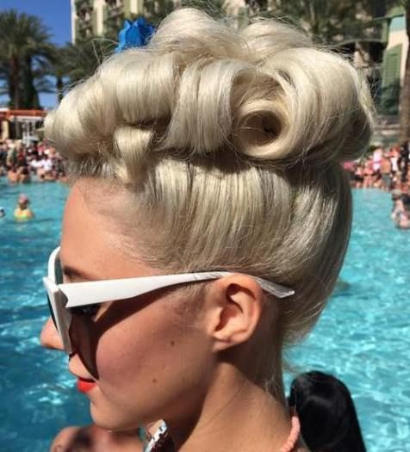
“You’re a man Daddy,” she said. “Now I’m a woman. We love each other.”

“Yes we do Bobbi, yes we do.”

The End

© Maryanne Peters 2018

Rear Window
By Maryanne Peters
Inspired by this Captioned Image

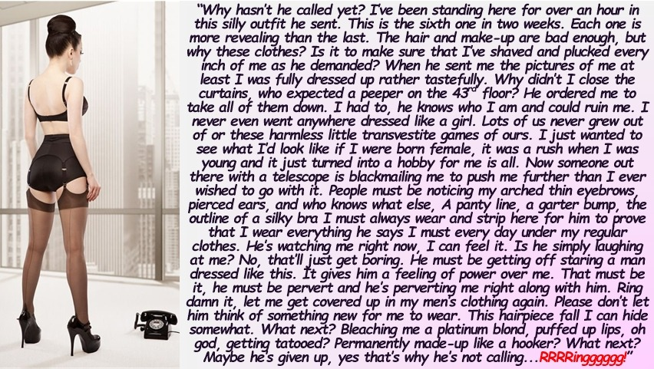

“Hello?”

“I love your hair. It looks perfect.”

“Well its just the way you wanted it, isn’t it. I just turned up at the beauty shop downstairs and they followed your instructions, hair piece and everything.”

“Well they couldn’t have done it if your hair wasn’t long enough to put up. Now turn around and let me have a look at the back. Oh yes. Wonderful. The back of your neck looks so lickable.”

“You fucking pervert.”

“Now now, Sweetie, you and me both. We both like to see you en femme, don’t we?”

“This has gone too far. After this last beauty treatment people are going to notice. The eyebrows and the skin. People are beginning to think that I’m a faggot.”

“Well aren’t you? Wouldn’t you like to feel like a real woman – beneath a real man – being made love to as a woman should be?”

“Fuck you! Are you a real man? If you were you would show yourself. I imagine you are some stunted or crippled loser, watching me from out there. If you are a real man, then come here and take me like a woman. Don’t just talk about it from your safe place.”

“I like the way you are talking. It’s turning me on.”

“Come on then, let’s have a showdown.”

“What a good idea. But first I think I will send these photos to your father. I will tell him that you want me to ravish you. That’s what you have just said isn’t it?”

“Please don’t do that. Just keep talking. What do you want me to do?”

“Turn around again, I want to look at your bootie. That’s nice. Very nice. That shiny black shaping garment is perfect. Well cinched in the waist for a real womanly figure. Not much bulge showing in the front. We just need some real breasts in those bra cups instead of those gel inserts, and your figure would be perfect.”

About the bra, why do I have to wear an empty bra under my clothes every day? I have to wear such thick shirts to hide it.”

“To get used to it Sweetie. Just like high heels around the house. You walk so easily in them now, that I could demand, perhaps, that you put that grey dress on and go downstairs and walk around the block for me …?.”

“I won’t do it. I’ll do what you ask in private. Please don’t ask me to go out dressed like this.”

“But Sweetie, you don’t look like a tranny at all with that hair and that figure. You look like a girl. Surely this is the ultimate extension of your fantasy? - Passing as female?”

“The fantasy is over. I’m just doing this for you, now.”

“Ooh. Say that again.”

“What more do you want from me?”

“I want you to take the tablets I sent around yesterday.”

I know what those are. I flushed them down the toilet.”

“No, you didn’t. You have kept them. In the cupboard above the sink. I know that’s where they are.”

“Have you in here? you creep.”

Oh, yes. Of course, I have. I have been lacing your breakfast smoothies with hormones for weeks. But I want to see you take a tablet right now. I want to watch you. Because I know that is what you want. Now that you see what a perfect woman you are, why would you want to go back?”

“You are crazy.”

But you have not flushed them down the toilet, have you? You have kept them. Maybe you have even slipped a couple down your throat? Just when you are feeling extra girly? You know that I am telling the truth. I know you, Sweetie. You are my girl.”

“I am going to hang up now.”

“That’s OK. I will call you tomorrow, same time. I have arranged another look for you. Curls I think. Now you will be off to the bathroom to check your lipstick, won’t you?”

Don’t be ridiculous.

Click.

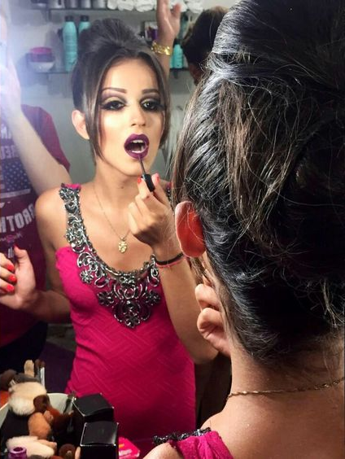

© Maryanne Peters 2018

Conditioned
A Short Story based on a Captioned Image
By Maryanne Peters

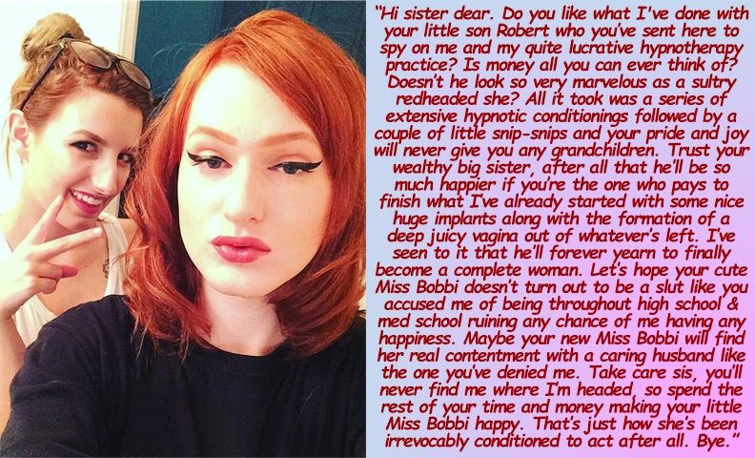

Sonia had always envied her older sister Gail, long before Robert came along. In many ways she looked up to Gail and wanted to do everything she had done. Part of the problem was that Gail was seven years older, so for Gail Sonia was always a baby or a small child, rather than a true sister. When Gail went off to college Gail was not even in middle school.

Gail had talents. She seemed to be good at everything. She was clever, she was beautiful, she was sporty, she was musical, and she was popular and she knew it. She tended to be haughty, especially towards her sister. Haughty and judgmental.

Sonia was clever enough, but she was only able to follow her sister into medical school by hard work. But it had been a hard battle, made all the harder by some spiteful actions by Gail. Gail may well deny spite, and even suggest that the things that she had said were for Sonia’s benefit, in this life and the next, but the effect on Sonia was devastating.

It is going way too far to suggest that accusing your little sister of wanton promiscuity was the cause of all of her problems. No, Sonia had real mental problems that went far beyond her lack of self-respect. It was those neuroses and even psychoses that saw Sonia unable to maintain any long-term relationship, and ultimately led to her license to practice medicine being suspended. But with every misfortune Sonia’s hatred for her older sister, and envy for the life she now led was compounded.

With such a perfect life, a wealthy husband (a fertility specialist), a beautiful home, and three perfect children, why did Gail feel the need to interfere further in her sister’s sad life? Why did she send her oldest son Robert with a fake identity to look into her sister’s current effort to pull herself out of poverty and despair? Why not live your life and leave Sonia to her fate?

Well, she now reaps the consequences.

As a physician, Gail knew well the power of suggestion. People can be cured of disease by sugar pills if they believe they are a cure. Suggestion can have biological effects – it has been documented. But Gail was skeptical, and maybe she thought that she could expose further offending by Sonia, by disproving the sweeping claims that were being made about this new hypnotherapy venture? But why put her own son at risk?

I guess that she thought Sonia would not be able to recognize her own nephew, it being so long since she had last seen the boy. But Sonia had been stalking Gail and her family. She knew them all. She had their photos on her “hate wall”. Of course, she gave Robert no clue that she recognized him, calling him by the fake name and drawing him in to tell his tale of deceit.

She quickly diagnosed the problem. Robert was feigning periodic anxiety, but Sonia told him that his problem was more deep-seated – his problem was testosterone. His body was not in balance, as she explained it. He was being poisoned by his own endocrinal function.

Robert was intelligent, as was all of his family, so he immediately saw the fallacy in this diagnosis, but he found himself becoming more open to the idea after the third session. He had to attend more than one to gather the evidence his mother was seeking, but it had not escaped his attention that he was finding Sonia to be increasingly persuasive.

When she suggested that a course of drugs would reduce the ruinous effect of his excess of testosterone n his system, he agreed to try it. He somehow justified that such a step was part of the ruse, but he was already in her web, and wrapped in her silk.

First it was the hair. Robert’s own natural curl was straightened to produce thick shoulder length hair which he happily agreed should be colored. That color was Sonia’s choice. Robert would become a redhead, but in a color that positively screamed “Look at me”. With arched eyebrows in the same color, no less.

Then the lips, pumped with filler and demanding to be colored all day and every day. Sonia made sure to ensure that Robert conditioned so as to feel positively naked without makeup, and that he should favor pale tones to show off his coloring, and stick on eye lashes and painted corners for his eyes, always.

Then came the breast implants. Robert agreed that they needed to be big. That was what he had always admired on a woman. It seemed only right and proper that this was the size he needed to have for breasts of his very own. The suggestion was that he always have them cupped in the prettiest lacy bra that he could find, so that they were always on display, and never left to drop. His pride in his new figure was obvious to anyone.

Sonia decided that Gail could complete the final task. She just made sure that Robert wanted to have it done. Just a snip to get rid of those annoying testicles, but leave the prick and empty sack so that Gail’s nominated surgeon would have plenty to work with in constructing that deep juicy vagina that Bobbi so desperately wanted. The right surgeon could make sure that Bobbi could satisfy any man and be able to enjoy sex as much as Sonia always had.

Then it was Bobbi’s choice. Would he descend into a slutty life, to fill his wanton pleasures as Sonia had found herself. Or would she be able to find a man like her mother had, a caring husband who could give her the life that Sonia had never enjoyed. How would Sonia condition her nephew? Would she give him a chance at happiness? Or did her desire for revenge destroy any sympathy for her (relatively) innocent nephew.

Only time will tell. For now Gail has received the message and has only just seen the buxom redhead tottering up the path from the front gate in her high heels, with the broadest but slightly vacuous smile on her face …

The End

© Maryanne Peters 2019

A Mother Knows
A Short Story
By Maryanne Peters

Do not judge me. A mother knows her own child.

She never should have been a boy in the first place. Of course, I was disappointed when they thrust the newborn towards me and I saw that little thing between the legs. It was a shock. Honestly, I never anticipated it. The whole 9 months I carried, I was sure that I was going have a girl. It is the kind of thing a mother ought to know. It was an unpleasant surprise.

My ex-husband insisted that we raise him as a boy. That is where he got these stupid ideas in his head. All about doing boy things with his father instead of being with me, helping me and learning to be just like me. It was an awful thing to watch.

He was just so slight and delicate I worried about him being hurt. When I saw even the smallest purple bruise on his smooth pale skin, I would be ready to burst into tears. Skin like that need to be moisturized and clothed in silk and lace.

I went to a therapist to discuss the problem. I explained that my daughter wants to be a boy, just because of that awful deformity. Is there nothing that we can do?

She told me that if my little darling presented herself as female and showed that she was ready to live as a girl for a period of time – a real life test of living not as a boy – then there were surgical options to correct the genitals that were sadly foisted upon her at birth. That is what I needed to do.

After her father left, I saw that se could do this. I suggested to her that we abandon all of this boy nonsense and that she wears some nice clothes and we go to the therapist together. She would have none of it. Some kind of denial, or perhaps the fear of the change itself.

All I could do was to administer medication to keep my beautiful girl from descending into the appalling ugliness of the puberty of teenage boys. The very thought of it ravaging the body of my darling child makes me wince. He would not take the pills so I was forced to use capsule injections after numbing his pretty bottom while he slept, and large hormone-laced-smoothies for breakfast.

I denied him haircuts and suggested styles, but he was unco-operative. Sometimes children are. Sometimes children think that they know better than their parents. A mother is there for a reason. To do what needs to be done.

That is why I decided that it was time for drastic changes. Something to put an end to this nonsense. Something to put my daughter back on track by ensuring that those hairy boys, her so-called friends, could not be mistaken as to what she was. She needed a makeover with permanent effects. And as it so happens, that is my business.

You might say that she was too young for such a beauty treatment. Normally I would agree with you. I am not one for seeing young girls pushed into adulthood too early. Every little girl should have a childhood full of fairy costumes, dolls and hair braids. But I was desperate. If my daughter looked in the mirror every morning and thought she was looking at a boy, what kind of a life would she have?

So I did what a mother had to do – I did what was best for my child. I gave her a little something to make her quiet and I took her to my salon after hours and I gave her the works. Coloring to suit blonde hair extensions, eyebrows shaped, permanent makeup on the lips and eyeliner, and an all-over waxing.

I put her in a nice dress - a black dress – and I waited for her to recover consciousness.

She was very unhappy. She shouted at me. She took off the dress and she put on some jeans and a tee shirt and she stormed out of the house. Of course, I was worried. She had experienced a surprise. She had been complaining about the growing size of her breasts for weeks, but I understand that seeing her truly feminine appearance for the first time may have been perplexing. But what can a mother do in those circumstance. Wait and worry, that is the burden carried by so many parents just like me.

Well it was about an hour later that she came back. She just walked in the front door and straight past me and up the stairs. She left the front door open and in the doorway stood the young man from down the street – I forget his name. He just stood there. He greeted me politely. He did not come in. He just stood there. And a minute or two later my daughter reappeared trotting down the stairs in the black dress and the pretty wedge sandals I left beside her bed.

I stood in her path with a frown on my face, but inside I was overjoyed. She asked my permission to go out with the young man for a few hours, and of course, I imposed appropriate conditions on both of them, as any parent should. But as the door closed behind me I was joyous. My daughter was with me at last.

The End

© Maryanne Peters 2019

Author’s Note: I noticed that this cap referred to the old Harry Benjamin “Real Life Test” which I understand is generally out of favor. But a therapist dealing with deluded mother might use it as a means of confirming a child’s willingness?

Pass Phrase
A Short Story  By Maryanne Peters  It happened just the way she said it would, although perhaps she was expecting to live a little longer.  Kevin has asked whether I was aware of what was happening when I was under hypnosis, or just oblivious. It is surprising difficult to answer, because I can remember everything, but as if it was not really happening to me. | 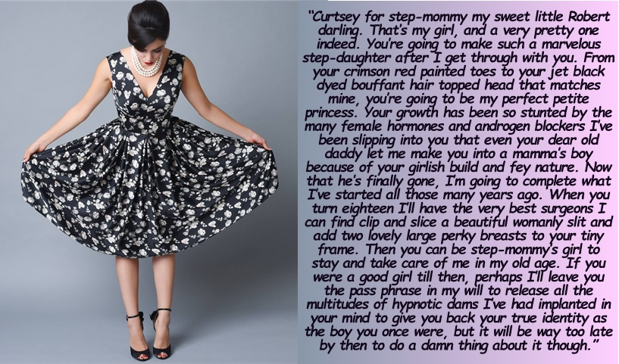

My inability to resist was not because I was unconscious, but because it simply did not seem to matter to me.

I remember the day my father left. I had been not myself for well over a year by the time he walked out. I was only aware of his hostility towards me, but I could not understand where it was coming from. I could not see that he now saw his son as a simpering sissy. I never saw myself that way.

His disgust at my behaviour was the last straw. He would not have left otherwise. But now he saw me and Mamma as a pair - vicious wife and sissy-son - equally unbearable. She convinced me that his absence was irrelevant. I was completely indifferent to his departure, something I now find heartless. I loved my father, but somehow I was able to watch him go. I cried of course, but I cried easily in those days.

It was only after he had gone that she got down to the business of turning me into a young version of herself. The crazy thing is that I felt pleased that I was now being given a purpose. It meant home schooling, so that I could focus, but that was no loss as I had always been insular at school. My increasing effeminacy had meant that whatever friends at school distanced themselves from me.

I was then free to have my hair colored and put up, and to wear clothes of a style that my step mother favored.

Now that I know what she had done to my mind, perhaps I should be more shocked about this phase than I am. But all I could feel at that time was that I was earning the love of a person whom I thought never really liked me. I felt the need to be close to somebody, and for my father, work was always his priority when he lived with us. I had nobody.

Mamma always called me “fey”. She said that I lived in a dreamworld. Although she never knew my mother – neither did I as she had died years before – she said that she assumed that I took after her. Maybe it was the loss of my mother that made me retreat into myself. I think that I needed somebody. I thought it was her, but I was wrong.

The shock really came with the surgery. She had planned it really well. There were a series of consultations where I followed the script she had formulated, first with her and then a couple alone. I can barely even remember what I said. I do remember being on my best girlish behaviour and crying a bit, saying things like: “It is so unfair that I am not a girl.”

Then we went to hospital. I was eighteen so I needed to sign the forms myself. I really did not feel as if I was eighteen. I felt like a small child, clinging to mother, but I never let anybody see that. I did my best to keep “poise”. Mamma always thought that was important.

She always talked about the “transformation” as if it was some peaceful and magical thing. I had no idea that my genitals were to be butchered and that I would face weeks of pain before I could even sit properly. Now I can sit, right on top of my new bits.

If anything should have made me snap out of it, that should have done it. But at that time she was even closer to me, and I needed her. And we got even closer a few months later when she learned that she had cancer, and she needed me.
That is what she always said: She needed somebody to look after her old age. But the truth is that she would never get old. She lost her looks, though. The chemotherapy bloated her face and she lost her wonderful hair. But she said that she would never look in the mirror so long as she could look at me. I was her reflection.

I think that the most important lesson that I learned from her was the importance of looking good. It is not just about the impression that you give to those that you meet, both male and female, and earning their desire or admiration. What it is really about is having a goal and working to achieve it, every morning when you sit at the dressing table and go through your wardrobe.

And then of course, good looking people attract success. Successful people like Kevin.

Kevin is a surgeon not an oncologist, so Mamma was never really his patient. But he was consulted in relation to possible surgery for her. When he finally came back to tell us that surgery was not an option, he did so with such compassion that he stole my heart.

I realized that after my step-mother was gone I needed someone else in my life. Somebody like this. I think Mamma knew it straight away. It was after she saw Kevin and me together that she called her attorney and gave him the pass phrase. I suppose that it was intended to destroy any chance of a relationship for me with anyone after her death. Perhaps it should have.

Kevin was beside me at the funeral – not as a doctor but as my close friend. And he was also at my side when we visited the attorney and he spoke those words to me, as his client had directed.

I remember that I looked down at the floor for a moment to try to collect my thoughts. So many of them were going through my head. Weird memories that now seemed to make sense. It seemed so long ago that I had been somebody else – I had been a boy. So much had happened since. I had learned to be beautiful – beautiful and feminine. I had learned how to dress and how to behave. I had learned how to depend on people, something few men learn how to do. Most of all I had learned how to make love as a woman. That was the only real love I knew, having Kevin’s penis inside me spilling his fertile lava into my man-made vagina.

I remember thinking that I should must as if Mamma was in the room watching me. So, I wanted to be deliberate, but the reality was that it was all me now.

I could have dropped my hands to my crotch and screamed: “What has happened to my penis!” But in fact I knew what was there and I liked it just the way it was. I just looked up at the attorney with a puzzled expression on my face.

“I am sorry, but I don’t understand what you mean,” I said.

He repeated the words and added: “She said that you might be upset to hear those words. More upset than learning that she has given all of her money to cancer research.”

“It’s a good cause, isn’t it Kevin?” I said.

“We don’t need the money,” he said. “I’ve got plenty. And besides, I’ve got you.”

The End

© Maryanne Peters

Author’s Note:
These are a collection of stories based on caps by Jeanna (https://jeannasadventures.tumblr.com/). All except the new story “A Mother Knows” have appeared elsewhere. But not included are my story “Rear Window” which was inspired by Jeanna and has formed a series on Fictionmania which needs to be completed; plus another story called “Decision Day” which has made it to my top five for a special compilation coming soon.

