The Death of Diana
A Short Story
By Maryanne Peters

1997 did not only marked the death of Diana, Princess of Wales, but also another Diana, in the actress that played Diana Trenton of the well-known television show. But the life of Janice Donnelly is indeed a remarkable story – so strange that it seems hard to believe that it is true.

Donnelly first came to fame on radio, playing the lead role in the long running radio soap Opera "The Trials of Diana Trenton". At that time, the star of that show was known as Jimmy Donnelly, a man. Jimmy was a onetime burlesque performer and occasional Irish tenor. It was said that he was born to do radio – a highly accomplished impressionist with huge vocal range. It was Diana’s sultry and sexy voice that made the show special. It was said that Diana commenting about the weather sounded almost like an indecent suggestion. The radio show had male fans who wanted to date “her” on the strength of her voice alone.

The network reveled in the gimmick, broadcasting the show in an empty studio - as opposed to the practice of the time of doing it in front of a live audience. Co-stars were sworn to secrecy. Nobody knew what "Diana" looked like, with many suggesting that she must look as good as she sounded.

In 1949 with the arrival of television, “The Trials of Diana Trenton” saw its ratings drop precipitously as its audience flocks to the new medium. The axe fell on similar shows who were not ready or able to adapt to visual media. It was decided that the show should be cancelled, and for some reason it was decided that it would end in the middle of a cliffhanger. Fans were furious.

The key sponsor of the radio show, a company that started to grow rapidly after the war years, was keen to sponsor the show on television. Their executives had no idea that the star of the show was a man. They made large offers to see the show go visual, even if only a big TV extravaganza to resolve the cliffhanger set up in the radio show.

The producers had a major problem: Who would play “Diana”?’. The search went out for an actress, but the voice was so distinct and memorable that none of the actresses they auditioned for the part could come close. They experimented with having Jimmy speak into an off-camera mike while an actress mouthed the words on camera. It was not convincing, begging the question: Where is the real Diana? And then there were calls for personal appearances. Clearly, they needed to find another solution.

Jimmy Donnelly was a performer in the tradition of vaudeville, meaning that he was a skilled dancer and mime artist as well as having the vocal range, and he had appeared in a number of acts dressed as a woman. But it was not him but a colleague who suggested that maybe Jimmy himself, could play the role.

Jimmy’s only real objection to the idea was that his appearance could never match the audience's mental image of the character of Diana. But as the new masters of makeup in the television age were to say to him: “To make beauty from not much, is a challenge, not a problem”.

1949 was also the year in which the Nazi doctor Adolf Butenandt collected his Nobel prize for the identification of the sex hormones estrogen, progesterone and androsterone which he discovered before the war and collected during it. The substance was being experimented with by a leading American biochemist Edward Doisy. Somehow the presence of a drug with feminizing effect became known to the team in charge of transforming Jimmy into Janice Donnelly, the actress behind Diana Trenton.

It is important to understand that almost nothing was known about the effects of estrogen and progesterone on a normal man at this time, although there were rumors of Nazi experiments. Certainly, Jimmy himself had no idea of what he was undertaking in submitting to a drastic transformation. But what was clear to Jimmy was that vaudeville and burlesque could not translate well to the small screen, so without offers of employment in the field he knew that he would have to adapt.

That, plus the fact that the producers would pay almost anything to ensure that the audience got their Diana. And that meant that the Jimmy would need to do more that simply appear as a female impersonator.

At that time many stage actors shaved their limbs and some (including Jimmy) even resorted to more rigorous removal of hair on the face. Stage makeup does not cope well with hair or uneven skin. But it was in the appearance and feeling of the skin that Jimmy first noticed the effects of the new drugs. Administered in almost undiluted form the hormones had immediate and substantial effect.

Jimmy was not a large man, but it soon became apparent that he was losing male form in his limbs and his torso. Jimmy was concerned, but the producers were thrilled. They brought forward the date of the big reveal. The TV show would be launched with a new cast, headed by the star of the show, now described as: “The actress who played the role on radio, Miss Janice Donnelly”.

It was a gala affair with “Janice” fully prepared with hair now long enough to be pinned up with curls on top, face prepared and an evening gown that was able to show the considerable bust that the miracle drug had created.  A hundred male hearts might well have burst open at the sight of the real-life Diana, with those blue Irish eyes sparkling in the flash of the cameras. There was not a hint that under this beauty there was a man – or what was left of a man.  Already the drug that had worked a miracle on his face and upper body, had done irreparable damage to the lower parts. The male organs had become wizened and within a year it was necessary to remove the testicles which had become septic.  I suppose that when that happened, Jimmy had to face the reality that Jimmy was no more. Janice was here to stay. But by that time the TV show was a hit and Janice had found a life. | 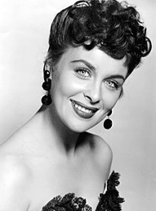

Only the producers knew the reality, and new cast members were in the dark, but some of Jimmy’s old friends, including the lady he had been involved with, knew the truth. Clearly in the early days they were concerned that Jimmy was too caught up in the success of the show and Jimmy’s success within it, and that he had gone too far. But by the time he had gone too far, there was no going back.

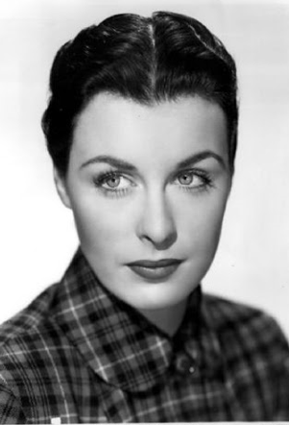 | Jimmy was never one to cry about misfortune. I think people were tougher in those days, in particular in show business, and Jimmy had suffered knocks in the past. The answer is to make do with what you have, and Janice had considerable assets at her disposal.  Time only added to her beauty, and she developed a personality that shone through in those personal appearances. While never apparent in her stage voice she retained a slight Irish accent in person, and a cheerful and mischievous disposition. That made her seem flirtatious with any man who had the good fortune to interview her  He actions and general demeanor became no longer an act, but second nature. She was totally feminine.  Demand for her to be seen in public built up and she was inundated with proposals of marriage. There is no doubt that she felt the pressure, while she remained, for obvious reasons, a private person.

One of the producers had the answer. He would marry Janice. The assumption was that there was no romantic interest on either side. How could there be? There was never any suggestion that either of them had homosexual leanings.
It had to be a society wedding, in the full glare of publicity. It was supposed to but an end to pestering from men that Janice was receiving, and it was largely successful in that  It was assumed that they would set up house together, but the idea that they might share a bedroom or a bed, had never been considered.  Such things seem commonplace these days. Just remember that the wedding took place in December 1950, two years before Christine Jorgensen made the headlines. | 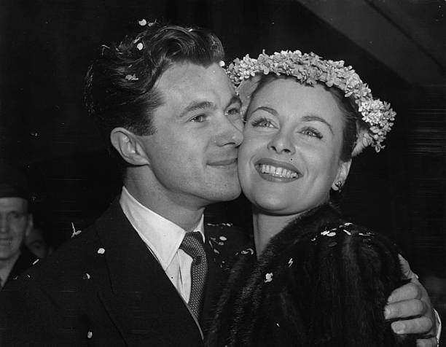

The truth is that Janice did not want that kind of publicity. The story in the The New York Daily News on December 1, 1952, under the headline "Ex-GI Becomes Blonde Beauty” made Jorgensen a household name, and she went on the become and actress, of a sort. Janice Donnelly was already an actress.

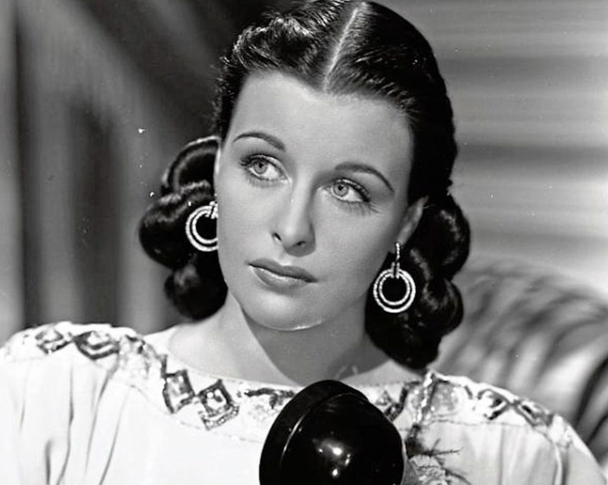 | Even after “The Trials of Diana Trenton” the TV show reached an end, she played other roles, including a supporting role in the movie “The Jacaranda Tree” where her dark hair, blue eyes and fine acting won her not only more fans but critical acclaim and an invitation to go to Hollywood.  So why did she not go? She was in love with her husband, and he with her. She would stay out East and support him at his work and at home.  They could never have children, but she would be the very best wife that a man could ask for.

It was the early days of sex change surgery too. The surgery on Christine Jorgensen did not create a functioning vagina. It was not until Georges Borou did the first penile inversion in Morocco in 1956 that it became a possibility for Janice. She had her surgery in 1957.
The secret that Janice Donnelly carried for the rest of her life was never revealed until after she died 40 years later. She survived her first husband and married again in 1971 at the age of 54, to a wealthy older man who possibly had no knowledge of her past. Few did and that was the way she wanted it  That man was my grandfather. Janice Donnely Harbison was my step grandmother. She was one of kindest and most feminine of women I have ever known, and still known to many who read her obituary as Diana Trenton. She was the other princess who died that year.  The End  © Maryanne Peters 2020 | 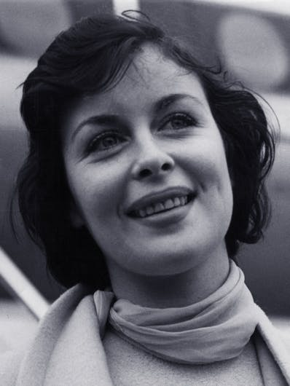

Author’s Note:
This story springs from an idea by Ragtime Rachel, or was that the suggested title?

