Yes Sir
By Maryanne Peters
Jason was really, a very stupid young man, and I’m afraid that Jenny is not much better.  “I really don’t understand girls,” he said to me when I found him, trying to sneak the car back into my garage. “She wanted me to take the car and drive around, and now she doesn’t want to know me.”  What future does a scrawny boy have is he is dumb? There is plenty of work for big dumb guys. Small clever guys are running the world. But what about little dumb guys – what do they do? Stack supermarket shelves may be? Or stack my shelves? | 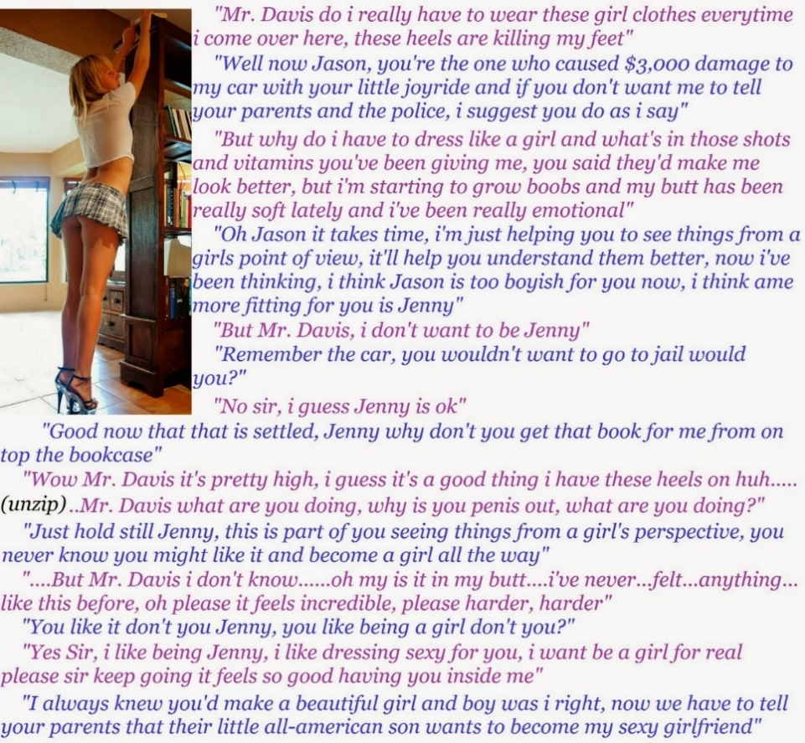

And Jason was a victim too. Easily led. Too focussed on women. He told me that he could not understand them. He never will. I don’t even try anymore. The woman I want needs to be drawn by me, starting with a blank canvas. About as blank as Jason, that will do.

Jason was terrified of his father, and worried for his mother. His father was a stupid as Jason was, but big enough to work construction. He had high hopes for Jason fulfilling the sporting career he failed in, but his son is too small. Jason’s mother wants only that her son should be happy, but what will become of him? Even Jason recognized her growing sad desperation.

Jason begged me not to lodge a complaint with the police. It was not his first time in trouble. Conviction for a second auto theft would mean jail. He had been told that. He knew just enough to know that he had to do anything to persuade me to give him a break. Anything I wanted.

I wanted to start work on my blank canvas.

“If you want to start understanding girls you need to see things from the girl’s point of view.” He understood that immediately – the foolish kid. “So, you can work off the debt to me by doing chores around the house, but as a girl. Wash your hair with the shampoo I will give you. I want you face and arms and legs to be smooth, so I will give you something. And when you get here every day, get dressed in the garage in the clothes I will lay out for you.”

Anything I wanted. He knew the rules. The shampoo had a blonde rinse. The skin cream was both a depilatory and a moisturizer. And there were shots he needed to bend over for occasionally, and vitamins to be taken every day.

I don’t know how he hid the changes from his parents. Long pants and baggy sweatshirts I guess, and a cap over that growing blond hair. All that they knew was that their son had a job, working for Mr. Davis, the rich guy in the big house at the end of the road.

All that mattered to me was that the person who appeared at my door every day was a girl, or at least was becoming one – a bit more every single day. The short skirt was Jason’s idea. Maybe it was because he wore bulky clothes the rest of the time. Around my house he liked to wear crop tops and short skirts.

Perhaps he was learning to see things from the girl’s point of view? Was he getting smarter? Was he beginning to realize that I was starting to desire his body? Could he see that?

We, now everyday it seems like we do the same little show. Sometimes the clothes are different. But the act is always the same:

“Jenny, why don’t you get that book for me?” She knows what I want.

“Wow, it’s pretty high up. Let me stretch. It’s a good thing that my legs are long in these heels.”

“Hold still, Jenny.” My hands are on her butt. Smooth and soft and wobbly.

“Oh, Mr Davis. What is that I feel inside me?”

“You like being a girl, don’t you Jenny?”

“Yes Sir. Yes. Yes. Yes.”

The End

© Maryanne Peters 2019

Energy Bars
A Story for John

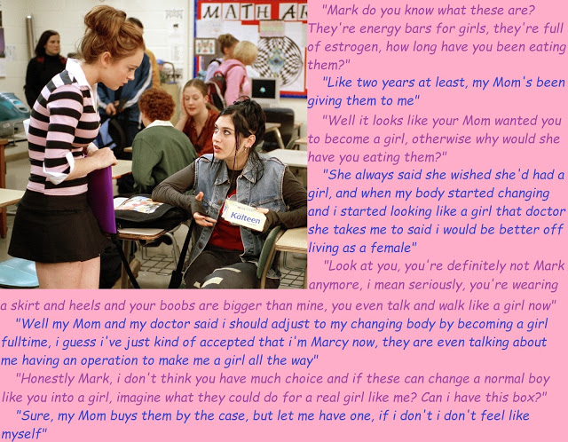

I suppose I am stupid. I don’t think that I’ve always been stupid. I just can’t remember exactly. Maybe it has only been since I started eating these energy bars. The energy bars that Ava told me have been turning me into a girl.

I think I was a regular guy before I started on them. I think I was. I think I did all the other stuff that guys do. I remember some of it. I remember that Mom was always angry about the stuff I was getting into and the people I was with. Max Dermody and his gang.

When she suggested the energy bars instead of proper meals, I just went along with it because it suited me. I didn’t have to go home to eat. We could carry on doing stuff. Some bad stuff, I guess.

I didn’t notice the changes, but the guys did. They accused me of being a faggot. I remember the first time I just walked off and then found a place to hide and cry alone. But the second time I just burst out in tears right in front of them. They just watched me with mouths open. I remember thinking: “How can you be so awful. We are supposed to be friends.”

They turned their back on me, but I was glad they did. Who needs friends like that?

I started hanging around with some of the girls at school instead. Girls are not as judgmental as guys, don’t you think? They understood because they thought my ex-friends were acting like assholes same as I did. The best lesson the girls gave me was to ignore those guys, and I did. No matter what they said about me turning gay or whatever, I just lifted my chin and ignored them.

It was the girls who suggested that I grow my hair and shave my legs. I learned afterwards that they just did it to see whether I would, but at the time I just seemed to be doing what they were doing.

And Mom said: “I am so pleased that you are mixing with the right kind of people now. So, stay away from those boys and make friends with more of the girls. Learn some proper behavior.” So that is what I did, I mean, I got closer to the girls, but I am not sure that we always behaved as Mom would like.

I did like to show off my legs. I have good legs. I think that boys who become girls often have really good legs. I like to keep them smooth and moisturized. I used to wear short pants, like cut of jeans or little lacy things, but now I wear short skirts. I just have to make sure that I wear good underwear that holds my bits in so that even if my skirt flies up (it can happen) there is nothing visible to betray me. But it seems to become easier to hide things every day. I just get smaller and smaller and smaller and I get more and more girl-like.

But the guys know. They know that I have got something extra. When I see them looking at me, sometimes I wink. They look at my breasts and then they look at my crotch. They are thinking: “What is going on down there? They know that I know they are thinking that. Max Dermody even tried to grope me in a crowd, but he would only be able to feel my panties, or maybe a bit of spring from my pubes. Very funny, Max.

Did I say breasts? Yes, I did. Big bouncy babies, that seemed to grow almost overnight. Well, months instead of years, but Mom’s doctor said that the grow was “extraordinary”. She says I must have been born to be female. How silly. If I had been born to be female, I would not have been born with a prick. Anyway, she says that a prick is a small problem for a girl these days. Ho hum.

So guys no longer call me a fag these days. I guess it is because of my legs and my breasts, and maybe my hair. It has grown and is really attractive – I think. I like it long, but I wear it up at school. If I want to tease a guy, I take out my hair brush out and let my hair down and brush it until it shines. I have seen the way guys look at me do that. Who’s a fag now – boys?

I know I have changed a lot, but I never stopped to think about why. I just went with it. But when Lola told me about the energy bars I realized that she might be right. Then when she took a box and started eating them, she changed a bit too. She doesn’t wear that filthy jean jacket anymore, she wears only designer labels.

I wonder if I should give some of my energy bars to Max. Would that be a good idea?

The End

© Maryanne Peters

Story for John
Number 8
By Maryanne Peters

Brian was not happy when I married his mother. He was only a kid, but I guess I saw him as a bit of a threat. He certainly saw me that way.

I don’t like the idea of living in a house where two guys are vying for the attention of one woman. It doesn’t matter if one is her husband (me) and one is her son (Brian). I just feel that there is just too much testosterone. Something had to give.

Luckily, I’m in the pharmaceutical business. Spiro neutralizes testosterone. I am in sales, but I know that. I have access to that stuff and synthetic estrogen as well. Truckloads if I need it.

As it turns out it did not take much to fix my problem. Just enough to mellow the boy out. Neutralize the threat, I guess. Leave me firmly in charge.

He is a hard-working kid. Kind of dorky, or even nerdy. He has the eye glasses, always reading those big text books or doing stuff on the computer. I guess because of that, nobody at school noticed that he was changing. Even when he did not cut his hair, which is straight and dark like his Mom’s. I guess he was sort of invisible, to everybody but me.

His Mom said to me: “Should we be worried about Brian?”

I said: “Maybe he’s not ready to talk to you about it yet, but it must be clear to you that his is transgendered, and he is secretly transitioning.”

“Should we help him … or should I say, her?” she says.

So, I suggest maybe buy him a dress, or a top and a skirt that he can wear to school to announce that he is ready, when he is ready. I said, maybe just leave it on his bed, just to say: “We know, and we support you.”

She did just that. I go in to his room and Brian is sitting at his desk with the outfit in front of him – a little bra and panty set, white top, blue skirt and red cardigan. He had just washed his hair and used a blow drier to dry it. It smelt of the growth enhancing shampoo I left for him – like fresh cut flowers. I came up behind him to rub his shoulders and smell that hair.

I just wanted to eliminate the competition and now I find that there is another woman in the house. A much younger woman. A prettier woman. Different competition.

I am not a monster. I know that you are not supposed to have feelings for your step-daughter. Well, that is what Brain seems to be.

“What am I supposed to do with this?” he asks.

“Wear it to school tomorrow,” I tell him. “This is who you are now. You know and I know it.”

“The guys at school will tease me.”

“I thought you said to me you didn’t care what they thought,” I said. “Well let me say, I think you might care, and there’s nothing wrong with that. But I’ll bet those boys at school will like you a lot more as Brittney than they ever did as Brian.”

And I was right.

I know that she is pretending to ignore me, but I can feel it in her shoulders, and even see in the nipples under that t-shirt bra. She is just as turned on as I am.

The End

© Maryanne Peters 2019

The School Tranny  A Story for John (Number 9)  By Maryanne Peters  I know that in these modern times such views might be seen as old fashioned, but for me there is nothing more disgusting than man on man sex. The very idea of two bearded men kissing one another turns my stomach, let alone the thought of two hairy men sodomizing one another … revolting.  Sometimes I wonder why God saw fit to curse me by having my own son reveal himself as a faggot. | 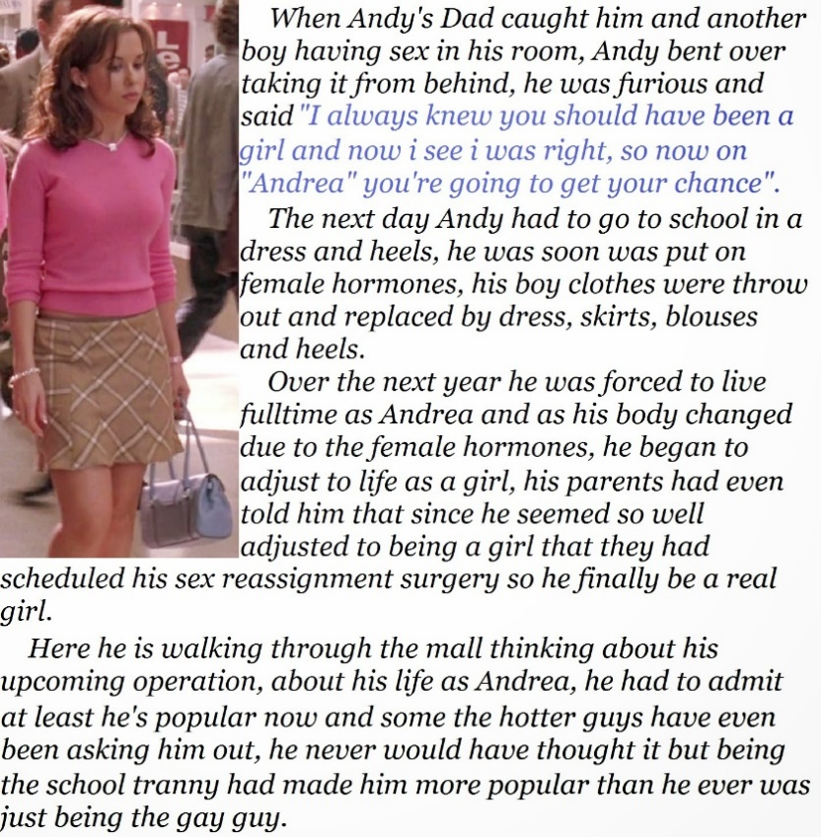

I heard the noises coming from his room. His friend Leon was supposed to be playing a video game with him. But I put my ear to the door. I knew what I was hearing. It was sickening. I smashed the door open. There was my son with his head on the pillow facing the door, his butt in the air with Leon’s cock inside him.

My wife told me that the howl I let out did not sound human. I am not surprised. What father could face such an awful thing.

I told her that he was no son of mine – I would not allow him to be. She was distraught. She said that we could not turn him out as I proposed, to take his filthy sin out of our house. She said that it would not be a sin if she was a girl.

Whether or not that is true, on a strict reading of scripture, I agreed that if he was a girl who consented to sex with a man, I could tolerate it. So, if Andy were to become Andrea “she” could stay in my house. That was her course from then on. If she wanted to stay then that was who she was.

The very next day I had “Andrea” go to school in some of my wife’s clothes. It was not a punishment. It was a new reality. I told the principal that when he called me.

“Transgender?” he asked – whatever that means.

Well, there are drugs for such people. It does not concern me what the child thinks they are. If you take a man’s cock inside you then you are female, or you should be. That means “hormone therapy” and later “corrective surgery”. But in the meantime, no a stitch of male clothing for Andrea.

Such was the perversion of his “friend” Leon, that the moment that Andrea became properly adjusted to her new sex, he was no longer interested. In fact, Andrea acquired a whole new set of friends. There were nice young women who could help him eliminate any embarrassing male behavior, and surprising nice young men who were not queer, and saw Andrea as female. That is the kind of young man I can tolerate visiting my house.

But such young men are looking for a complete female, and for Andrea that meant surgery. We are not very wealthy, but what father would not invest heavily in his child’s happiness. Consider that if you would seek to condemn me.

I think that Andrea understands all that I have done for her has been in her interests. Homosexuals are an abomination, but the doors of heaven are open to all kinds of women. And Andrea is quite the sweetest and prettiest daughter that a man could have. Not the hairy legged queer or the simpering sissy, but a true woman, just in need of a little modification to be my perfect daughter.

The End

© Maryanne Peters 2019

The School Bully
Number 10 for John
By Maryanne Peters

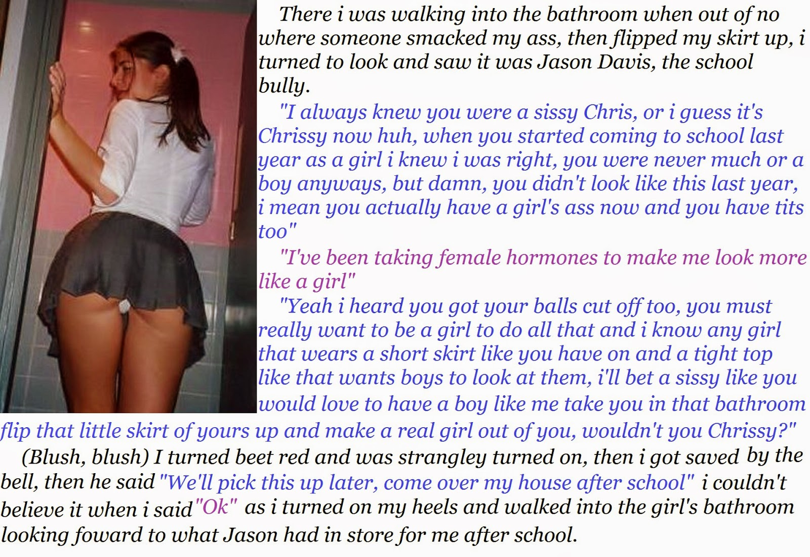
Jason’s mother answered the doorbell. Chrissy was still wearing the ridiculously short skirt, but had changed her top to something that better displayed her burgeoning breasts.

“Hello Mrs. Davis,” said Chrissy. “I am here to see Jason.”

“My God. It’s Christopher isn’t it?”

“Not for over a year now, but yes, it’s Chrissy now.”

“Come inside, Sweetie,” she said. “What a brave child you are. It must have been so difficult for you.”

“Not so much, Mrs. Davis,” chirped Chrissy with a smile. “It’s actually easier to be a girl than a sissy. As a sissy boy lots of guys gave me a hard time, but now half of the guys look at me like they look at girls, and the other half, well, I don’t care about them.”

“I hope Jason is not one of those teasing you for being a sissy.”

“Oh no. Jason is O M G amazing!

“So, what do you need from Jason.”

“Oh, I need his cum in my bum,” Chrissy chirped.

“What did you say?”

“I need his jizz in my ass. His seed inside me. He wants to do it, and I want him to.”

“I don’t think so. Jason is not gay.”

“Of course not, Mrs. Davis,” said Chrissy. “I am not a boy any more. I have had my nuts snipped off. I still have a little dangly bit, but not for long. It’s just that Jason cannot wait for my new pussy, and neither can I. We are going to go at it this afternoon.”

“Not in this house, you’re not.” Maggie Davis was suddenly very angry.

“Whatever,” said Chrissy. “Here or my place. Or maybe on your front lawn. But I should warn you, I squeal really loud when I cum.”

The raised voices had brought Jason to the bottom of the stairs. His mother glared at him.

“Get upstairs Chrissy,” he commanded. She slinked over to him and kissed him on the cheek before heading upstairs. Jason turned to his mother but said nothing to her.

“No Jason,” his mother said. “Not with that.”

Jason turned and went upstairs. Within minutes Maggie Davis learned that Chrissy had not lied. Over the bang of the legs and headboard of Jason’s bed she could hear Chrissy’s loud cries of joy.

The End

© Maryanne Peters 2019

