Special Moment
From a Captioned Image by Becky #96
By Maryanne Peters

I was just wearing my bra and panties. I had not done much to my hair and I was not wearing much makeup. I am lucky to have dark eyes and dark eyelashes and a pale skin. It turns out that the only ingredient missing was hormones. All I needed was that, and the woman in me was revealed.

That was the special moment. It was like meeting the real you suddenly and almost unexpectedly. You turn the corner and there in the mirror is a young woman looking back at you.

For my life before that special moment, I looked in the mirror in despair – first at the boy’s body I was born into and then at the face of that same male trying so hard to look like something he was not. Those recent years seemed even tougher that the early ones – the doubt that you would ever fool anybody that you were not some kind of freak.

And then suddenly – that special moment – I meet her for the first time.

I actually spoke to my reflection. I said – “Oh, hello. You must be Jennifer?” She did not reply. She just smiled to confirm that I had it right. She had arrived. He was gone … forever.

What a special moment!

The End

© Maryanne Peters 2022

Worth the Sacrifice
Inspired by a cap by Becky #97
By Maryanne Peters

When did I decide to become a woman? I still have trouble pinning down the date. Before I went to work for Mr. Foster – I still call him that – I was just Jacob, a young gay man ready to accept any office job so long as it was not too stressful.

Mr. Foster made fun of me a little, but not in an unpleasant way. He called me “a pretty boy” and I always took that as being a compliment. I was pretty. I am pretty. He suggested that I should grow my hair longer and maybe come and work in his team.

He started to research trans sites and he showed me what he had been looking at.

“Could this be you, Jacob?” he asked me. “Could you be one of these transwomen?”

Of course, I just waved a hand at him as if to tell him not to be silly, but I could see a look in his eye, a look that a boy like I was is always looking for. So I said – “Maybe I could be? How would that make you feel?”

“Hot!” he said. Just that.

And that was basically how it started. I started to wear androgynous clothing to work and Mr. Foster took to pounding my butthole whenever he could. At other times I would just blow him.

He promoted me to his secretary, and then to his mistress, paying for me to move into a nice apartment with a wardrobe full of woman’s clothes.

He arranged the hormones, and I was happy to take them. He gives me a nice life, as Jenna.

But then he told me that he had booked me in for sex change surgery. That came as a bit of a shock. I mean, my dick has been basically useless for months but to me it still marked me as a guy. Was I ready to give that up? My reluctance must have showed.

“I’ll leave my wife,” he said. “I adore you Jenna. I want you to be my wife. If you do this I will get a divorce and marry you. You can be the new Mrs. Foster.”

I mean, he is rich, and he is good looking, and when he comes inside me it is like, the best sex ever!

Hmmm? Like I said, that thing is useless, so why not turn it inside out and give my man somewhere else to stick that glorious cock of his into? It is not big sacrifice to lose that, when you think of all I have to gain.

Am I right? Or am I right?

The End

Morning Announcements
Inspired by a cap by Becky #98
By Maryanne Peters

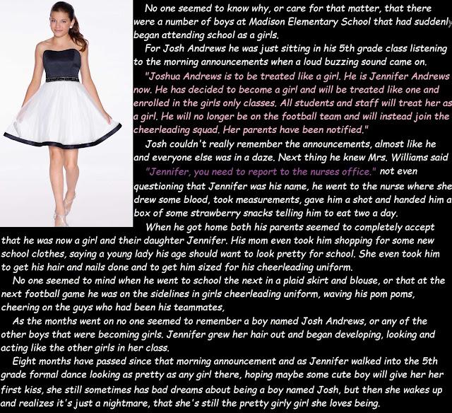

The case was typical of several incidences that we identified at Madison Elementary School which prompted the Department of Education to appoint me to investigate. Of course, the department is fully supportive of transgender students and their families, and in part I wanted to make sure that this was the case at Madison Elementary, but there was also some concern that there had been four 5th graders who had commenced transition at about the same time, and that seemed very unusual.

Certainly when I met Jennifer Andrews (as she is now known) I was a little concerned with the story that he recounted – in particular that she seemed so uncertain as to the symptoms of dysphoria prior to the announcement being made that he was transgender and transitioning from male to female. It have interviewed other transgender students and none have been so unclear as to their like before.

Even stranger yet was the fact that the other three children reported the same recollection of that single day when the four of them commenced transition fully supported by their parents and all the staff of Madison Elementary School.

The principal, Mrs. Williams, simply said that it was convenient that all four pupils should commence their transition at the same time, for mutual support more than anything, and she made sure that the nurse was on hand and equipped to assist with “clinical aspects”. I must confess that I was a little surprised that a school nurse should be involved at this level and I asked to interview this lady, but I was told that she had moved on.

I also learned that this nurse was a transwoman herself, but given that her name was Rebecca Smith I have had trouble locating her. Apparently, after dealing with the pupils in her care she visited all the families concerned on that same day.

It all seemed very odd, but having spoken with Jennifer at length, I am confident that there is nothing untoward. While it appears that going from playing football one week to being a female cheerleader the next, was sudden and certainly confusing for other boys on the football team, Jennifer seems to be a confident and assured young woman.

Jennifer is attractive and feminine and evidently has developed a relationship with a young man that she used to play football with. While she cannot remember having gender dysphoria prior to the morning announcement which changed her life, she is adamant that she wants to live her life as a women and being at the peak of female puberty at the moment, she looks for to gender reassignment surgery as soon as she is of age.

The End

Prom Girls
Inspired by a cap by Becky #99
By Maryanne Peters

I have to say that I had some misgivings when Andy (as he was then) suggested that the best form of defense is surrender.

“If they want to call us sissies then why should we not be sissies?” he said. “It is not as if we have any friends other than each other, and people on line who don’t really know us. It is not as if our parents care what we do with ourselves. I am not going to have my head pushed down another toilet bowl. What we really need to do is to claim that we are sissies and that Jim and Rick really want to be our boyfriends.”

Crazy idea, huh? Crazy, but it seemed to me with a chance that it might work.

We were nerds, I have to admit it. We spent all the time on our computers at home, or sitting together at my place or Andy’s, playing or designing computer games. We never gave a thought to how we looked or what people thought of us.

But as Andy said, we had access to all the stuff we needed to make ourselves attractive to Jim and Rick, or at least make them think again before they gave us a swirlie, and it helped that we were now using a special toilet!

All of a sudden, our eyes were open to a whole new world – the world of feminine beauty. It was a world of light and a world of color, nothing like the dark screens of Azaroth or Perdigan. I have to say it, I fell in love with this new world – the world of womanhood.

What I did not know at the time was that Andy was transgender and this was what he always wanted. As for me, is it possible to become transgender? All I know is that I love living the life that I do now, and I cannot imagine going back.

The fourth grade seems like a long time ago. We had had time to grow out our hair and order those black market hormones on line, and to become Ashley and Becky. And the whole way through Jime and Rick have been watching us and we have been flirting with them shamelessly.

The truth is that those guys are not much to look at, whereas we are a couple of girls that make people ask – “How can those two guys end up with girls as hot as Becky and Ashley?”

Well, the truth is that we have been stringing them along a little. But tonight, is prom night, and a few weeks ago me and Ashley both agreed that the boys need to get their reward. We have been preparing ourselves the way girls like us must.

And the truth is that I am looking forward to it. In fact, I am gagging for it. I want Rick inside me. I want to be a woman, and I would be happy to call him my man.

It promises to be a great night.

The End

Another New Cheerleader
Inspired by a cap by #100
By Maryanne Peters

I know that the coach was disappointed, and I did not want to let him or my team down by pulling out, but I was just not prepared to see out my time at high school without living my last year as a girl.

I had been growing my hair out for months before hand and just tying it back in a low male ponytail. And I had been taking hormones, and losing muscle because of it, but I could still catch a ball and run fast. But I was starting to bruise easily, and so I knew my time as a boy was running out.

Nothing could make me happier than that!

Like I said, I liked football. I liked the team aspect, and I loved scoring touchdowns. I was good at it, and that made it satisfying. But football is for boys, and I am not a boy. I never really have been one.

I was just counting down the days until I could remove the binding from my pretty little breasts and shake my hair free. It is not something that Coach would ever understand, and I do not expect him to.

But I was not prepared to abandon my team completely. After that last game and those last two game-winning touchdowns, I told the team that I was giving up football. They were already amazed before I told them why.

“Guys, the truth is that I am not like you – I am not really male. I am trans – I am a girl inside a boy’s body.”

It was actually much easier than I thought it was going to be. I was well liked, and not just because of the points I had racked up. The guys were disbelieving and disappointed, but not angry or disgusted.

“I will still be there for you guys next week, if the cheerleading team will have me,” I told them.

Of course, the cheer team wanted me. I was the top football player, now moved to the other side. I walked straight out of the change room down to their area and told them the whole story. Immediately I had a whole group of new supportive friends – girls like me! They helped me get ready – to get pretty and style my hair. It did not seem like much, but the effect was dramatic. I put it down to my attitude. It was like my who life to that point was a battle to be happy, and now I was free to be just that.

I think that yu can see the joy on my face. At last I am me.

The End

© Maryanne Peters 2022

