Better Life  Inspired by a Cap by Falcon21313  By Maryanne Peters  It was not so sudden. I don’t want you to think that I am not properly adjusted to my reality. I really am a girl now.  My hair was already quite long. My mother had been putting something in my cereal to make sure that I did not develop yucky whiskers or anything like that. It is so much easier to become a girl if you don’t have to undo all of that stuff.  Anyway, she had been planning it for a while. I guess that she did not want to make the final change until I was old enough to say no. I mean you can vote in some countries at the age of 16. By that time you can decide whether you want to change your life or not.  She did not actually ask: “Would you like to live your life as a woman instead of as a man?” She just told that my life was going to change when I got to the age of 16. I suppose I was ready for something to happen.  She made it clear what she wanted. In fact, it seems like all my life she was saying how much better it is to be a woman than be a man. She was always showing me pretty things and saying: “Just imagine how good you would look in something like that. I bet you can’t wait until you turn 16.”  So it was not a big surprise.  I am not saying that I was a girly boy before I turned 16. I did my best to fit in as a guy, and I think that I succeeded, but I always knew that I was not quite the same as them. | 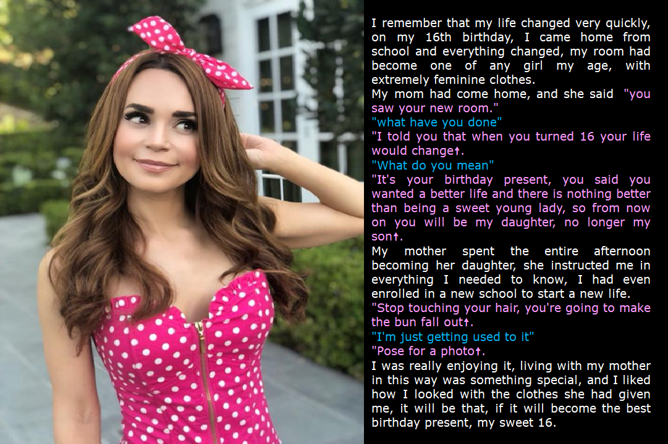

Then on my birthday I came home from school and my mother called me upstairs and into my room. It had been completely redecorated with patterned wallpaper and lacy curtains, with a new dressing table and a pink mirror, with hair brushes and a jewellery box, and a drawer for makeup. My closets had been emptied of boy clothes and were now full of dresses. My new tallboy dresser had lacy intimates including bras with fillers to tide me over until I changed shape.

My mother had me wash my hair there and then, and dried and brushed it an put it up in a bun.

The picture of me in the polka dot dress is how I look now. My hair is much longer and my breasts are real. The smile is too.

My mother was right: This is a better life!

The End

Just Like Her
Inspired by a Cap by Falcon21313
By Maryanne Peters

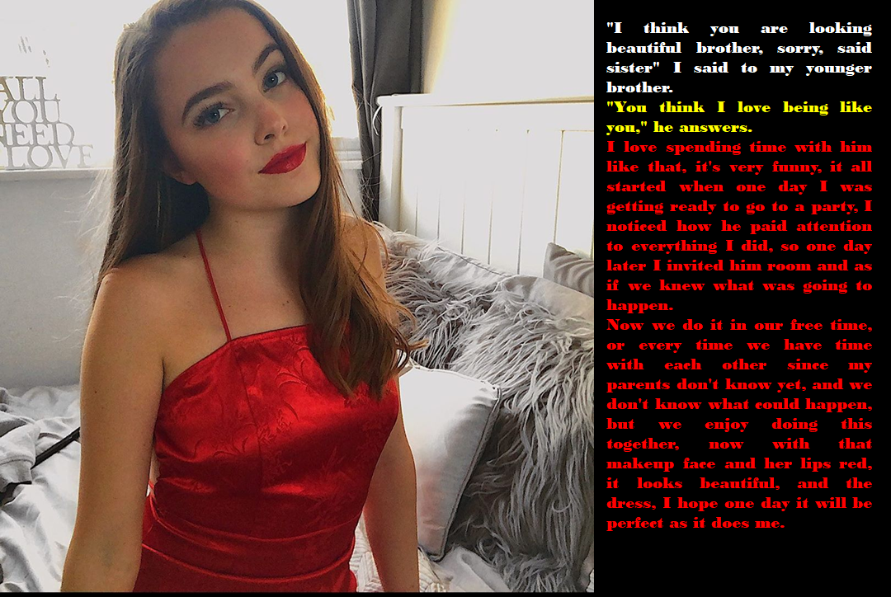

I cannot speak for other relationships between young boys and their older sisters, but my relationship with my own sister was close. She was only a couple of years older than me, but she always seemed to be the one who cared for me. Our own mother walked away from her family when we were quite young, but my sister was the rock that kept our family from drowning.

My father coped well in that he not only brought in the money, but he also did a large part of the cooking and cleaning so that we could “enjoy a childhood”. He was great like that. It was just that with all those responsibilities we had little father and son time. It was just me and my sister when it came to play.

My sister was a role model, but really a role model for girls. She loved dance and art, and being beautiful. She loved clothes and had taught herself to sew and sew well. She even made shirts for my father. She was an achiever. My father loved her – we both did.

My father remarried. She is nice our step-mom, but she knows that we are mature and independent, and she likes it that way. She wants attention from Dad, but that is OK. My sister and I have each other.

She knows that I like to watch her doing her hair and applying her makeup. I like looking at her become even more beautiful in front of me. Who wouldn’t take pleasure in that? And we talk while she is doing it. She talks about hairstyles. I know them all because of her. And the tricks about makeup.

The way she says it she just invited me in and gave me my first makeover, but she was always watching me and wanting to do it. It was she who suggested that I wear my hair long. Why would she suggest that? Honestly, whatever she suggests is what I want.

I never thought of myself as being gay or trans, but I like to like what my sister likes. I like us being together doing the things that she wants to do. Ok, so they are girly things, so I guess that makes me girly.

Of course, they noticed at school, even though I dress down – like a guy - and I tie my hair back. But I have found that the best response is to ignore any teasing or abuse. I call it “self expression”.

My stepmother doesn’t mind. She says that she never liked boys, so she is happy that I don’t act like one at home. My father loves me, and that is all you need say about him.

But lately don’t think that I have not noticed it – I am really pretty. I am not the only one. Some of the guys at school have seen me looking this way and their attitude to me has changed.

My sister says that it is because I look beautiful. She says: “Boys are attracted to you, even though they tell themselves that they are not. That is what we want from them. We draw them in, and then we push them away”.

“You think I love being like you”, I said. Well I do, but I am not so interested in pushing boys away anymore.

The End

The Event in Pink
Inspired by a Cap by Falcon21313
By Maryanne Peters

We thought that she was joking, but she was deadly serious.

“I have no daughters. Just two lazy good-for-nothing sons,” she said. “And this day is very important for me. I have three styles to put on display at the Pink Day Event and I can only wear one, so you two are going to have to become my daughters for the day.”

“Girls from school will be there and they will see us.”

“Not if I do my work properly,” she said. “After I am finished with you nobody will ever think that you are male under the outfits that I have made. They have high necklines so you can wear body stockings underneath for shape. But hose legs will need to be waxed and faces too. And I am talking hair extensions. And a day off school for a full day and half training on how to be a woman. I am determined that this is one thing you boys will get right.”

We had manicures too. Long pink nails. We went to bed the night before the event in nighties.

The crazy thing was that as we got dressed on the day my younger brother said: “I am feeling wonderful, Mom. I feel very happy”.

I mean he started flouncing around, and checking himself out in the mirror. At first I just laughed but then I started to wonder if he had gone crazy. It was like something in him snapped and suddenly he was female.

“Take your little brother as your example”, said Mom. You can fight this, or you can live this. The choice is yours, but I know which way will be easier.

Now he is saying that he likes dressing like a girl and he doesn’t want to go back to dressing like a guy. Weird huh?

But he has a nicer outfit than me – an embroidered skirt and a top with detail. I have this dress with a flounce in front that looks like I am hiding a cock under it … which I guess I am. And what is with these cups on my chest and the high collar? Mom thinks its great but I feel like a dork.

Still it was her day, so I went along with it. But I said to Mom that next week I will be wearing simple patterned or floral dresses in a style I like.

The End

Gift
Inspired by a Cap by Falcon21313
By Maryanne Peters

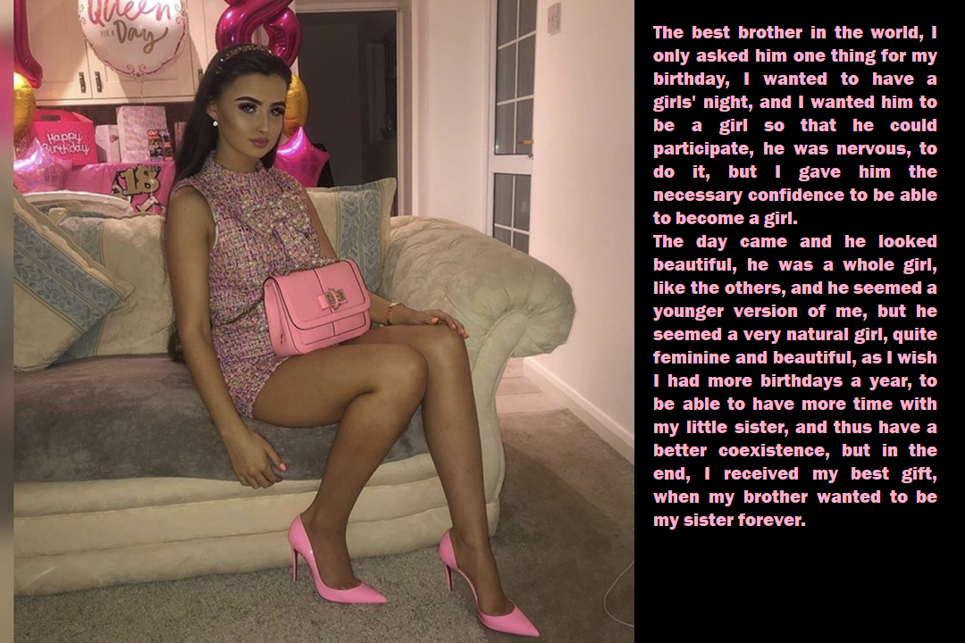

It’s a fall, down my back. It’s not my real hair. It is my hair in the front, which I normally wear hanging over my face, emo style. The hair down my back to my waist is fake. But oh, how I wish it was real!

It was my gift to my sister, that I be her sister for a day. Hair and beauty are her thing, and she had always been going on about my facial bone structure being wasted on a guy. She wanted to give me the ultimate makeover – to become like a younger version of her. I always refused.

“I am a guy and there is no way that I am a sissy,” I told it to her straight and hard. You think I am going to shave my legs and paint my nails? No way!”

It was just that she has always been a great sister to me, given that Mom is on her own and away from home so much with her job. And then last year, I had no money for any kind of gift, and there was nothing that I could do for her that I could pass off as a gift. I just felt that I needed to give her something.

“You can do it,” I told her. “I will be your sister for your birthday.”

She went to work on me, and I never complained, even as hair was ripped from my face and my body. I told myself that she deserved something from me for all that she had done, and this was a small price to pay.

And then we went out, just as she wanted. I saw the sense in being who I appeared to be. Who wants to be seen as a transvestite when you can so obviously pass as female? Besides, I had agreed to be her sister – not just a cross-dressing brother.

It was the best day of my life, at least up until that point. I never believed that it was possible to have so much fun. The fact is that we are both pretty – perhaps you can see that? Pretty girls want for nothing. Pretty girls make people happy. I loved being a pretty girl.

That was last year. I have been a pretty girl ever since. Now I have been on HRT for 11 months and I am looking forward to bottom surgery. I guess my gift to her has come back to me this year as a gift to myself.

The End

Dazzled
Inspired by a Caption by Falcon21313
By Maryanne Peters

“She’s hypnotized you. She admitted it to me. She said that she was worried that you would not agree to model her clothes … women’s clothes. So, she hypnotized you to make you agree to it.” Nate looked concerned. Kathy just looked beautiful, as she always did.

“Do you really think so, Nate? Can anybody really be forced to do what they do not want to do? Perhaps I just wanted to help her and just put on a show of reluctance? Perhaps I always wanted to be the woman I am? Or perhaps I just realized that when I was dressed like this I just felt better? What do you think, Nate?”

“I think that I am going crazy, that is what I think,” said Nate. We used to be pals and now I can’t look at you with desiring you.”

“That is what every woman want, Silly,” said Kathy. “To be desirable. To be desired.”

“The problem is that I know who you are … or who you were. I mean, the hormones have worked a miracle on you, but I know that you still have bits that don’t belong on a woman. But it is like I am a deer in the headlight, dazzled by your beauty. I am falling in love with you.

“What’s wrong with that?” said Kathy, stepping closer to the man she has known for years, and who now seemed so attractive to her.

But if this is hypnosis, then you might snap out of it, and then where would I be!” Nate was getting worked up. He was confused and a little desperate. “The problem is that I am not just falling in love with you, Kate, I am in love with you, and you know it.”

“And I am in love with you, Nate,” she said, looking into his eyes. “I am just as dazzled as you are. What hypnosis? We are both under a different kind of influence. True love is not something that we will ever snap out of.”

They kissed, and he knew it was true.

The end

© Maryanne Peters 2022

