MHA 109
All Might had not expected this battle, had not expected to cross fists with All-for-One once more.
He was not ready, but, with the remaining embers of One-for-All slowly fading, he likely never be.
In some ways, it reminded him of that fight, the last time he had seen his master, as Gran Torino had dragged him away, and he’d been powerless to do anything to help.
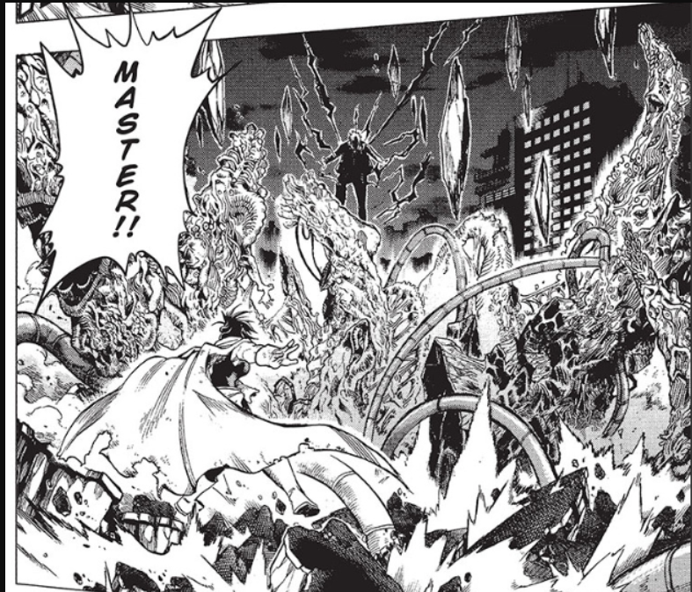
https://cdn.imgchest.com/files/84apcd3l8m4.png
Only this time… only he was the one who was supposed to fight, and Kaminari was the one that needed to get to safety.
Only… there was no one to get the boy to safety.
… Kaminari.
The boy was not the Successor Toshinori would’ve chosen, too quick to violence, too easily going lethal, as the reports from the Summer Camp Attack had stated, but, at the same time, the boy was also one who looked out for his friends without reservation, one who jumped into danger without hesitation, and someone who understood one’s duty to protect their fellow man.
Had Gran Torino known of the boy, he likely would’ve approved of him, and what All Might would give to have his old other mentor at his side, here to help, but Toshinori didn’t want to pull the veteran back into the fray, not after… everything else that had happened.
Taking a laboured breath, his old wound torn open by All-for-One’s attack, All Might cast a glance over to the now collapsed building. “You could’ve killed Kaminari!” he spat, worried for the boy, but also knowing, if he went to try and help, the Symbol of Evil would kill him, and then be free to do whatever he wanted to the young hero in training.
All-for-One, meanwhile, just shook his helmet, a single glowing red eye staring back at All Might. “Do not worry, the only one dying here is you. Well, and the people around us, but I think we can both agree they don’t really count, do they?”
“Of course they matter!” All Might spat, his form starting to falter, mindful of the news chopper in the distance, filming this fight. “Only a monster would believe otherwise!”
“That’s Demon King to you,” the Symbol of evil corrected, amused. “Much better than a mere monster. And I’m not the only one, given the trail of corpses that Young Denki left behind. Why, I’m surprised you’re not here to arrest the boy. He did, after all, break your silly little laws.”
“Defending himself from your League!” Toshinori countered. “Self-defense is not a crime!”
Holding up a waggling finger, All-for-One chided, “Not according to the society you claim to protect, but for one as stupid as you, to not realize that you are merely a tool of others. Why, you’ve done what I’ve wanted for years!”
Squaring his stance, getting ready to fight, All Might announced, “Even if I have, that ends TODAY!”
His opponent just laughed, “And you really think that will change just bec-”
CRACK!
Toshinori flinched, as a golden comet exploded out from the building where All Might’s student had been, terminating where All-for-One had been, but now, floating in the air, was… Kaminari?
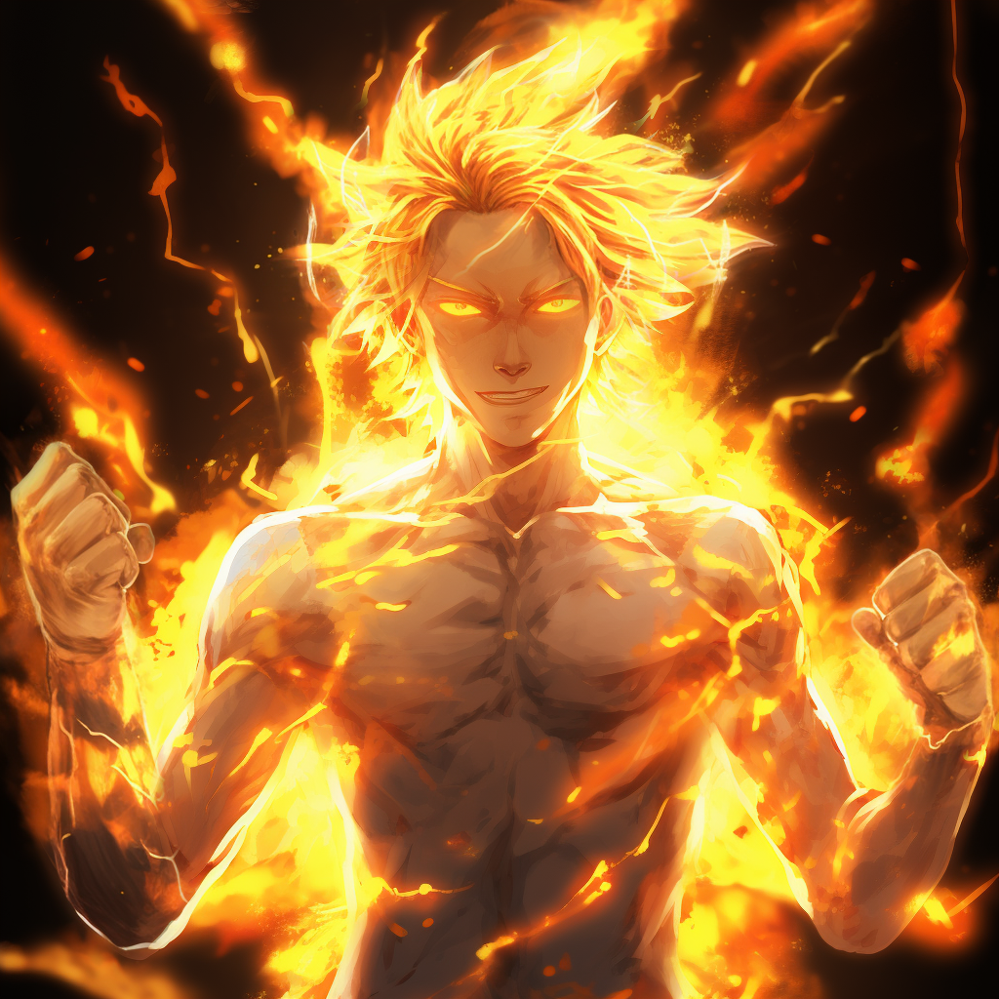
https://cdn.imgchest.com/files/345xck9m5x7.png
The boy’s body was wreathed in lightning, his form shifting and changing, all of it turning back and forth into electricity, as he turned to look at All Might with an expression that was simultaneously familiar, and utterly foreign on the teen’s face.
““““Hello, Toshinori,”””” the boy said, in a multitude of voices, stacked on top of each other, his body turning fully to lightning, and twisting back and forth, shifting between different forms, a larger man, a smaller one, a tall one, and-
“M-Master?”
Smiling, in just the way All might remembered, Kaminari’s shifting body fully snapped into an electric form, that of his old mentor, Nana Shimura.
“““Mostly no, but kinda yes!”””
The woman’s response was just… so her, as Toshinori stared, dumbfounded, as she Floated over to him, but her body lost cohesion, shifting through others, all of them familiar, though All Might couldn’t say why.
“H-How?” he questioned, confused, not having expected, expected any of this!
““Kaminari could not continue,”” a frail-looking man made of electricity stated, voice soft. ““But he allowed us to take over, to stop my brother.””
Kaminari’s form filled out, and, from his arms, long electric tendrils extended, ““Least he could do, for copyin’ it, and buttin’ in on our thing, was lettin’ us get in on this brawl!””
And then his student, who was Nana again, floating right in front of Toshinori, smiled broadly, and, leaning forward to tousle his hair, just like she used to, as she announced, ““But first…””
And then the woman glowed, not the golden light of Kaminari’s power, but with a prismatic glow, one that collected from her chest, before running down her arm, and into him.
And the fading embers of One-for-All… REKINDLED.
Toshinori knew what it felt like at full power, and this wasn’t it, but.. but it was more than he thought he’d ever have again.
His form filling out, the Symbol of Peace stared at his hand, the cuts covering it slowly healing, even as he asked… “How?”
The form of what could only be One-for-All incarnated shifted once more, to a different weilder, the larger man with whips again. “Took some of the kids mojo-”
Then a tall man, with a cracked face, “And gave it to you.”
Shorter, almost a kid, “And he’ll survive it.”
Once more, the frail one, who referred to All for One as brother, “Though it will unfortunately not be enjoyable for him.”
“Oh, so you are alright with sacrificing others, but not when I do it?” AfO questioned, emerging from the building he’d been blasted into. “Brother, after all this time, what an unexpected surprise. Truly Denki is a treasure trove of new experiences.
“He was willing,” the original holder of All for One countered. “And he wants to protect people, not dominate them.”
“Oh, but I am protecting them. From themselves,” AfO grinned, though his mouth was still covered by his now-further cracked mask, the man sending a flurry of blades towards them, trailing light, but Kaminari, no, the combined wills of the previous users of One for All in Kaminari, lifted a hand as Toshinori stiffened, getting ready to fight, and, with a flurry of electric whips, sent the projectiles careening off course, their trails, expending, twisted and warped into fractals that carved into the ground around them, leaving them unharmed
“And that’s why we’re here to kick your ass!” the larger man grinned, shooting a glance All Might’s way. “So, Eighth! Ready to put this motherfucker down?”
Letting out a deep breath, feeling a level of energy he hadn’t felt in years pounding through his veins, Toshinori stood tall, gripping a fist. “I Am!”
But AfO just shook his head. “I think you’ll find that’s a task far easier said than done.”
Which is when the battle was rejoined, the world erupted into Quirk expressions, flying swords, near-invisible cutting planes, flaming chains, flying drills, blasts of light, and more crashing towards the pair of them, yet, once more at full strength, All Might was able to dance through it all, tracking incoming attacks, using the occasional sharp slap to create the needed openings, only able to spare a single look-
And, despite his ever-changing form, Kaminari, or the expression of the previous wielders of One-for-All, was effortlessly keeping up.
He was barely touching the ground, moving with the same sort of Strength that All Might was, but there was more to it than that, the boy, or at least his body, changing directions mid-jump, a thick armor of clear fluid around him, while lasers bent and twisted around him, fired back towards AfO.
Throwing his hands outward, the suit-wearing villain tried to remake the landscape, grotesque formations of flesh springing into existence below his floating form, only for the ground it started to cover to start moving itself, forming hundreds of serpents, all of them reaching up to snap at AfO with jaws full of sharp teeth, clearly not under his control.
“What’s wrong, Ayfo? Not used to fightin’ someone with multiple Quirks?” One-for-All jeered, bulked out, electrical whips spreading out like demented tentacles from either arm. “Kids only got a few, but they’re not bad!”
All Might, meanwhile, was not idle, moving around while The Wielders of All-for-One kept AfO’s attention, coming up from the side, the mass of dirt serpents moving to twist the Symbol of Evil about, allowing the Symbol of Peace to come in, fist cocked, having to suppress his own tendency to call out, to let others know that he was there, because that was the last thing he wanted right now.
Still, striking down, his opponent realized something was off, and tried to twist about, however, it wasn’t enough, and Toshinori was able to sink a punch right into the Villain’s mask, sending him flying backwards, the metal cracking, One-for-All streaking in from the other direction, but the Symbol of Evil threw a hand out, sending a stream of disembodied heads, gaping jaws lined with rows of sharp teeth, at the lightning-covered teen.
Flipping around, OfA’s form shifted down into the small man again, landing feet first on the lead head’s top jaw, and, as the others closed on him, swung his right hand, trailing mist about, pointing it forward-
CRACKLE!
And in an instant, a glacier formed, Toshinori recognizing his student’s Quirk at work, especially as, twisting about, left hand burning with flames so hot they’d turned white, he stated in a carrying voice, “How about some steam?”
All Might pulled back as, thrusting his hand into the already sublimating ice, the entire structure cracked for a moment before it exploded, ice shards headed his way, and down, shredding the expanding mass of flesh, gouts of burning steam overtaking Toshinori in a moment, but he could take it, as he twisted about, missing one chunk, jumping off another, listening, and, there!
Rolling to the side, All Might slammed his legs down on another flying shard and shot forward, through the blanketing mists, towards the bit that sounded wrong, spinning about, somersaulting over and over, through the quickly thinning shrapnel, with a triumphant declaration of “California SMASH!”
All-for-One turned, sending blades towards the Symbol of Peace, but the shockwave from his incoming blow diverted them, sinking the strike down right onto the Villain’s shoulder, though not the already injured one, but that was enough, the suited man’s clothing tearing, before he was fired downwards, towards the ground, shadows gathering towards his point of impact, only for the area to suddenly light up like a spotlight was shining on it, a patch of daylight in the moonlit battlefield.
The Villain hit, and hit hard, the shockwave blasting away the last of the mist, and All Might spared a glance to One-for-All, a ponytailed man staring down with an expression of cold hatred. “Can’t shadowport without enough shadows, can you, old man?”
But All-for-One didn’t respond, growling with rage, as, turning over, bits of his helmet flaking off, revealing a twisted visage, only one eye visible, the other covered in scarred tissue, the Symbol of Evil slammed a fist into the ground, even as it started to twist into a variety of shapes, from closing jaws, to clawed limbs, hitting with enough force to destroy them all, only for them to start to form again.
Lifting up into the air, the Villain’s form glowed with powers, shining out light that All Might had to squint against, but could target, throwing out limbs to close on, setting himself on a trajectory, One-for-All coming down as well, and, with a tearing gesture, the light shut off, the area below him doubling in brightness and starting to melt, the Symbol of Evil reaching up instead, a forest of black and red technological tentacles reaching up, but there was an odd pattern to them, almost a beat, and working against it, All Might tore into them, his compatriot coming down as well, the clear armor covering him exploding outwards, until he was at the center of a viscous comet that look familiar.
Ms. Ashido! Toshinori realized, as of course young Kaminari would have copied his paramour’s Quirk, and now One-for-All was magnifying it a hundredfold, just as it had All Might’s and Young Midoriya’s physical abilities!
Speeding up, the glowing young man crashed into the mass of extending tendrils, moving even faster than All Might was, now in the form a scarred man with a harsh expression, the caustic fluid burning through the tendrils, fist cocked back for a punch that All-for-One, chambering his own blow, moved to meet.
Only to miss.
‘No!’ All Might realized, the return blow that the Symbol of Evil levied in the glowing teen’s direction setting off an amber-electrified shockwave that blew away most of the acid, and struck a far building, destroying it, ‘He left me an opening!’
And it was one the Symbol of Peace took, with a cry of “Detroit SMASH!” as he arrowed down, sinking his fist solidly into his opponent’s mask, which shattered, firing him back down into the ground, which formed into a forest of spikes, breaking apart, but, as he tumbled backwards, showed his back was now full of impaled spikes of rock, the dirt compressed so hard it’d turned solid.
It was only then that the Symbol of Evil spoke, demanding, “WILL YOU STOP SINGING!?!”
… what?
~’This, at ten times volume,’~ came a quiet man’s voice in Toshinori’s head, followed shortly by, ~’DANCE TO THE BEAT! WAVE YOUR HANDS TOGETHER! COME FEEL THE HEAT! FOREVER AND FOREVER! LISTEN AND LEARN! IT IS TIME FOR PRANCING! NOW WE ARE HERE WITH! CARAMELLDANSEN!’~
As quickly as it came, it stopped, and, when All-for-One launched a new barrage of attacks, crashing rivers of flaming chains, mixed with teleporting crystal skulls that, hitting a dirt-creature, exploded to shards, Toshinori could see them following the beat of the music being telepathically pumped into his head.
Landing, All Might took off in one direction, OfA in the other, Frosted hand lifting to launch a barriage of icicles, while more dirt-creatures climbed up from all around them, throwing themselves into the attacks.
“I’m afraid I cannot do that, brother,” the original holder commented, turning back into the larger man, “And what? Did ya think you had a monopoly on dirty tricks?”
Preparing for another attack, the chains and skulls still moving to the rapid beat, the Symbol of Evil waved a hand, obelisks of flesh rising up around him, studded with eyes, whose gaze slowed whatever they looked it, focusing on both Heroes, and starting to pin them down, as All Might tried to just move harder to compensate-
Only for the organs to all light up, eye-searingly bright, as the rest of the battlefield turned nearly black, and burst, exploding into showers of ichor, both fighters suddenly freed, and the Symbol of Evil, snarling with rage, gesturing, a dozen glowing guns forming behind him and firing twin barrages at both of them, the stray rounds, each as which as big around as Midoriya was tall, plowing into the buildings behind them, exploding with enough force to make him stumble, worried.
~’We’re extracting civilians with Pixie-Bob’s Quirk,’~ the original holder of One-for-All spoked in Toshinori’s mind. ~’With eight intelligences guiding our powers, we can multitask. It is unfortunate that my brother chose the path of destruction when so much good could have been done.’~
And, glancing past All-for-One, All Might could see flying shapes rising up from the far buildings and leaving, at speed.
“This is all useless, in the end!” The Symbol of Evil declared, clapping his hands together and setting off a shockwave that blew away the burning white fireballs that were streaking towards him, while balls of acid came from another direction. “You think you can defeat me? You can’t even protect the ones you love!”
Midoriya? All Might worried, the thought surprising himself, but, no, he had to trust the others were protecting-
“Tell me? How does it feel to fight side-by-side with the one that almost murdered your mentor’s grandson?” All-for-One mused, filling the space around him with glowing metallic nets that caught the spears of ice and flying dirt creations One-for-All sent his way, destroying them.
“I, what?” Toshinori asked, despite himself, looking for an opening.
“Tomura Shigaraki? My old apprentice?” the Symbol of Evil questioned. “He’s Nana Shimura’s grandson.”
And at that, the Symbol of Peace stumbled, having remembered that crazed, grey-haired young Villain, but, but if that was true, then he’d, then he’d…
~’I know,’~ the remnant of his old mentor stated sadly, in a way that only he could hear. ~’Kaminari knew, though you’d have to ask him how yourself. I tried to keep him safe, tried to hide him, but I failed, just as I failed a lot of things. I’d… I’d like it if he could be saved, but that Bastard got his claws in him since he was a child, and… and I’d understand if that’s not possible.’~
“… What?” All Might questioned, lost, confused, and conflicted. It’d felt like the world opened up to swallow him, as he’d failed, failed his master who’d done so much for him, given him her power, sacrificed her life for him, but, but hearing her words, they were a bulwark against that utter and complete feeling of loss.
Smirking, All-for-One continued, “I kept wondering what would annihilate your golden heart. And so I found Tomura. Groomed him to hate you, and watched you smile so proudly as you beat your master’s descendant.”
~’You couldn’t know, and seventh’s grandkid was an adult tryin’ to murder innocent kids,’~ another voice chimed in.
~’This is bigger than family, bigger than anything else,’~ a second noted, tone hard.
~’You’re a hero, and if you could’ve taken him down softly, you would,’~ a third stated with quite confidence.
~’It is how my brother works, and the blame rests with him.’~ the original holder stated. ~’And if blood alone could save one lost to hatred, I would’ve stopped him without the need for others.’~
“And you,” the Symbol of Evil continued, turning at the ever-shifting form of Kaminari. “Nana, you should be in there? How do you feel, knowing your successor has failed you so? That he allowed young Tomura to become what he is today?”
Transforming into the woman, her cape fluttering in the breeze, she called back, “I’m angry, but at myself. I’m the one who failed, not Toshinori. How could he protect someone he didn’t know about? But who do I really blame?” she questioned.
“That hanger on of yours, Gran Torino? Perhaps even your own child for abusing his own child so. But, given his hatred of heroes, with how you abandoned him, can you really blame him?” All-for-One mused. “Or is it as you said, the one you truly hate yourself? Then again, had the previous weilder never sought you out, perhaps you could’ve been happy, your child still alive, doting on your grand-children instead of a mere shadow of a-”
“GOD you’re lazy!” Nana spat, the edges of her body twitching, and twisting, as she maintained her electric form, glaring at the scarred man. “I used to be scared of you, ya know that? Was right up until I died. But now, with the kid’s Defenses keeping you out… how much of you is you, and how much is just your stolen Quirks, ‘All-for-One’? It’s easy to predict your opponent, when you can see the future. Easy to plan, when your Quirks give you the steps for you to follow. Easy to deliver cutting statements, when your Quirks instill despair for you.”
What!? All Might thought, having thought, but… no. He, it was right to feel like he’d failed his Master, but not to this point, not to the point that he no longer fought.
But his old Master wasn’t done.
“You’re strong, I’ll give you that, and crazy enough to go beyond the pale, but you’re weak at heart, Shigaraki!” she declared, lifting up her fist, before turning it, to point past the Villain, and towards her student, “And Toshinori will be your end, as that’s a guy whose even crazier than you are, but with the Strength to BACK IT UP!”
Within his breast, All Might felt his confidence rekindle, as he pushed away the feelings of doubt that clouded his vision, of despair which pressed down with crushing strength, as he declared, “And, if I cannot, there are others that will, for You Will Lose, All-for-One. It is only a question of if it is today, or a Not So Distant Tomorrow!”
Glancing between them, the Symbol of Evil sneered. “Then we’re doing this the hard way then?”
Looking to his master, she nodded, and, taking a ready stance, both heroes moved.
This time, All-for-One didn’t hold back, the world twisting and shattering around him, but they did not stop, chasing the Villain through the battlefield, All Might the spear, piercing through any obstacle, while, around him, flew the Previous Wielders, directing fire, ice, earth, and acid in waves, the battlefield becoming a twisted mass unlike any All Might had seen, except for his last clash with the Symbol of Evil.
Quirks, too many to count, blossomed across the quickly growing cataclysmic arena, devastation spilling out further and further, All-for-One having to constantly move back, fleeing from the pair, but not without taking damage, the amber lightning he used taken and condensed into a pillar of orange destruction that took off one of the Villain’s arms, though another started to grow in its place, full of unknown cybernetics.
Shockwaves and impossible-sharp blasts echoed out, the world turning into a riot of colors that Toshinori navigated on instinct, star-toothed horrors, invisible cutters, and shadow-limbs with black-hole talons clawing every which way, only to be met in kind with a tide of power from Kaminari, held enough for All Might to get strike after strike in, All-for-One’s armored suit torn to shreds, and the once-invincible seeming Villain bruised and battered even more.
A wide ranging blast picked both heroes up, and threw them away, All Might landing, and getting ready to rush back in, a mental voice instructing him, ~‘Wait a mo!’~
And then the ground underneath All-for-One gave way.
And then it detonated, throwing everything into harsh-edged shadows, the blast-wave forcing All Might To slam hands down on the ground to stay standing, watching as the mushroom cloud rose from their foe’s locations.
~‘Don’t worry, it’s a Fusion, not Fission. Made with Creation. The kid planned for this,~ a different voice reassured him, the shifting electric form coming to float next to him, most of the blast shoved upwards, even as All Might made a note to talk to Young Kaminari about why creating nukes was a bad thing. ~’Kid’s Almost as crazy as YOU!’~ his master’s voice added.
Though, given their foe, perhaps it was the appropriate level of force.
However, Kaminari’s golden form flinched, the edges of his shifting bodies now frayed, coming apart, and All Might realized that doing all of this was coming at a cost.
“Are you alright?” Toshinori asked, though it was clear his ally wasn’t.
“We promised the kid he’d survive, and he will,” the larger user promised, before growing taller and thinner. The man with the cracked face continued, “He has his Regeneration but this is… straining more than just his body.” Now as the shorter man, his ally added, “But if there’s anyone who could figure out a way back, it’d be him.”
Staring at the still expanding cloud of destruction, All Might nodded. “Then we shouldn’t dally!”
“That’s what we’ve been trying, but… indeed, we need to finish him. I believe my brother is ready for one final confrontation,” the original wielder noted.
And, from the column of smoke and destruction, a tidal wave of monsters, biological structures, and more poured out, over a mile away, but headed right for them.
All Might nodded, getting ready, but, but before they did this, there was something he needed to say. “Master, I’m, I’m sorry I couldn’t save you.”
Shifting to Nana, the woman just smiled at him, “You went on to be the Hero you always said you would be, so I’d day it was worth it. Besides, a bit of me lives in you, and you’ve passed that down to Denki and Midoriya, so am I really gone?”
Toshinori blinked, taken aback, “I… No. No I suppose you are not.”
“See!” she laughed. “There’s nothing to cry about!”
Her form destabilized, reforming into the shorter man. “You’ve been a worthy successor.”
“You’ve done your part,” Added the tall one with a cracked face.
“You’ve been the kind of hero I wished I could be,” stated the ponytailed man.
“And you’ve been everything that my Brother was not,” finished the originator. “Now let us end this, and protect the world from his evil. Because stepping in, getting involved, and all around meddling…” he smiled softly.
And then, shrinking down, the form beside Toshinori he turned into All Might, but the way he truly looked, without the power up, gaunt, but wearing a giant grin as he announced, “IS THE ESSENCE OF BEING A HERO!”
Extending an arm, All Might Bumped the fist of the bit of himself that now lived in Kaminari, and as death came for them both, they took matching stances, moving as one as they CHARGED!
Meeting the oncoming tide, they both struck as one, breaking the enemy advance on their fists, dual shockwaves blasting apart everything in their path, before they broke apart, All Might going to the right, The Wielders going left, both of them tearing through an apocalyptic foe, no longer acting with skill, or finesse, but overwhelming power and rage, but All Might could match All-for-One, and surpass him, focused and with a will of iron that WOULD NOT GIVE UP!
Quirks blared in every direction, monsters by the score fell under his fists, but All Might kept going, able to track his ally by the blasts of fire and ice he was laying down, reshaping the landscape, until, finally, they were on either side of the Symbol of Evil, the crazed man atop a pyramid of flesh, using everything that he could, hundreds of Quirks in concert.
But it was not Quantity, but Quality that mattered.
“WHY! WON’T! YOU! JUST! DIE!” screamed the Symbol of Evil, unleashing cataclysmic blasts in both their directions, and while the All Might of old would’ve matched them head on, he had learned since their last fight, having spent years practicing how to finish fights quickly, and try and maintain his slowly falling reserves of energy, so instead slipped by the roaring beams of nothingness, as they carved up the landscape, getting closer and closer to his foe.
The mountain of flesh he ascended exploded upwards, but All Might had already moved, leaping high, as an enormous shape descended from the storm clouds that had formed over their battlefield, a flying whale the size of a battleship made entirely of dirt, though, as The Wielder’s joined him, moving up towards it, Toshinori realized what it really was.
A Launch Platform.
Flipping upside down, to brace his feet against its bottom, All-for-One turned to face them, only for something to flash, hard to see, from below him, causing the ancient evil to scream in pain.
“Damn, never gets old,” the bulky-form chuckled, before shifting once more to Toshinori himself, and nodding to the Symbol of Peace, both men summoning all they had, and, in perfect synchronization, blasting down towards their foe, destroying the dirt creation above them, as they yelled to the heavens!
“UNITED.”
“STATES”
“OF”
“SMAAAAAAAASH!”
Descending down, they struck the Symbol of Evil DOWN, the twin shockwaves of their final strikes spinning together which created a flaming twister with a force so great it put itself out, scouring the battlefield clean, until all that was left was the two of them, and the mangled, broken, yet still living body of All-for-One, unconscious, at their feat.
They both stood, staring down, as, at the edge of the now-clear skies, dawn started to rise on the horizon.
“It’s… It’s done,” All Might sighed, scarcely able to believe it, and feeling better in a way that had nothing to do with his renewed Quirk.
The Wielders took a step forward, then doubled over, their ever-changing body twitching, almost going into seizures.
“What’s wrong?” All Might questioned, worried.
“Can’t… Hold… Together!” they replied. “Kill… AFO... Now!”
But even as they said it, as they seemed to be coming apart, All Might got the feeling they were fighting themselves.
But it was tempting. Very Tempting. He’d thought he’d killed All-for-One before, thought it’d finally been done, and that, while he’d stained his soul with willful murder, it was worth it.
And, if he were alone… he might even have done so.
But they were not, as news helicopters circled, and, while he would’ve preferred the man, the monster, who had done so much, to die here and now, he wasn’t doing this for himself.
He was doing it for them.
“I, no,” All Might pronounced. “He’ll go to prison. Killing him, is how he would do things.”
The Weilders took shape, one after another, a ponytailed man spitting out, “You’re being foolish.”
However the Originator of their quirk nodded, smiling softly, “I understand.”
The tall man with the cracked face pinned All Might with a stare, pronouncing, “You’ll regret it!”
The large man warned, “We can’t do this again. We’re killing the kid, and he don’t deserve it.”
“This won’t be the end,” the shorter man noted, sadly.
The golden fragment of Toshinori just gave himself a solid nod of agreement, as he was him.
And then Nana chuckled, “Of course you won’t. You wouldn’t be the Symbol of Peace if you did.”
The destabilization was getting worse, her form actively unravelling.
“Thank you. All of you. But, you’re…” All Might said, worried.
His mentor nodded, understanding. “This might be goodbye for a while, and we’ll get the kid to safety, but…” she floated up, so she was just a little taller than him, just like she used to, before leaning over and messing up his hair one last time. “I’ll always be with you,” she stated, tapping his chest, over his heart. “Don’t forget that.”
Trying not to cry, Toshinori manfully nodded, smiling sadly himself, “I… I don’t think I will. Not again.”
The ghost of the woman that was the closest thing he had to a mother nodded, and then, with a crack, took off into the skies, trailing gold, heading towards the rising sun… and in the direction of UA.
All Might sighed, still standing over the unconscious body of his eternal foe. Some small, dark part of himself still wanted to smash All for One’s head to paste, but… but no.
He still could feel that loaned spark of One for All, and was willing to give it back, if he could, but… he had a feeling he could not, or else The Wielders would’ve taken it back, if only to finish the job, as half of them wanted to.
Toshinori would still try, next time he saw the boy, but, as the news copter sat down behind him, the scoured ground a wide landing pad, he knew his job wasn’t done. He didn’t have One-for-All back, could feel it sputtering, and, in case he lost it completely when he returned it, Toshinori needed to lay the groundwork.
Still staring at the downed form of All-For-One, and standing in the center of a circle of devastation miles wide, Toshinori pointed at the camera, which was pointed his way, having given them enough time to set up their shot.
He’d gone over this in his head a hundred times, tried to figure out just how it should go, to not let others down, to continue inspiring them as he had for the past thirty years.
All Might had hoped this would not come for a little bit longer, that he’d be able to martial his dwindling strength that long, until the others were ready.
Though, just as he wasn’t ready for this fight, yet still succeeded, he had to trust they would rise to the occasion as well.
Because readiness was only one aspect of it.
The other was opportunity.
And there would not be another opportunity like this one.
Which meant it was finally time.
Having held his pose for a moment to capture the attention of the viewers, he began.
And the Symbol of Peace, voice strong, confident, and warm, and with a smile on his face started to talk.
As he gave his retirement speech.

