The Devil Works Hard, But S-C Productions Works Harder
By Soul-Controller

For 54-year-old divorceé Jim Taylor, it was safe to say that his day-to-day life was almost always a hectic mess. Not only did he have to deal with the constant struggles of a nagging ex-wife and ungrateful children nonstop, but he also was the head manager of one of the most popular theme parks in California. So even though he tried his best to escape the stresses of fatherhood by fully embracing the tasks of his job, the constant onslaught of customer complaints he had to deal with along with the frequent phone calls from entertainment studios asking to film on the premises really provided no levity from his already-stressful life.

Given the fact that Jim had been the head manager of the theme park for over 15 years, the lonely man was able to forge some important connections with many studio heads due to him granting access for them to film television and movies on location. Although he was more inclined to work with these studios that he had formed long-term connections with, the sudden arrival of a new studio named S-C Productions had truly shaken up Jim’s mindset. Not only were they incredibly grateful and generous towards compensating the theme park for shutting down for the day, but they were also quite friendly with Jim and treated him like a human being rather than a nuisance like some other studios did. As such, when S-C Productions proposed a sizable deal that would make it where they would be the only studio allowed to film on location at the theme park, Jim wasted no time agreeing to the terms and signing on the dotted line.

In the several years since inking that exclusivity deal, S-C Productions had used the theme park to film several important projects such as top-rated TV and films that were a success at the box office. Although Jim originally received flack from the owners of the park for shutting down daily operations for these shoots, they soon found themselves getting on board with the plan after seeing the check from the studio that more than made up for any potential losses for the day.

Just as S-C Productions began to reach the third year anniversary from signing that exclusivity contract with the park, there was a sudden rise in difficult actors throwing tantrums on set that led them to seek drastic and creative measures. Unbeknownst to the general public and the actors that worked for them, S-C Productions was a company run by a mysterious individual who possessed mystical powers that extended far beyond the reach of a human’s imagination. So as a way to both remedy this rise in actors behaving like divas while also rewarding people like Jim for his years of hard work and kindness towards working with them, S-C Productions scheduled a private meeting with the man to propose a truly life-changing deal.
Understandably, when the 54-year-old manager was first told that his present from the company came in the form of a body swap with one of their most problematic actors, Jim was unwilling to believe such an improbable concept. But as Jim watched the thin and awkward man sent to run the meeting suddenly transform before his eyes into a muscular hunk, the divorcee was quickly beginning to realize that the deal was legitimate and the concept of a body swap was actually possible.
So upon being slid over a binder full of potential actors and actresses for Jim to choose from, the man spent nearly an hour attempting to narrow down the list of potentially new bodies that he could become. Before long though, as the list began to further dwindle down, Jim found himself focusing frequently on an actor by the name of Tom Ellis. Although the man was most certainly no spring chicken given his age of 43 years old, Tom was quite attractive with a ripped body and a facial structure that was absolute perfection in Jim’s eyes.

Even though Jim was undeniably a straight man, the man couldn’t resist getting turned on as he fantasized about actually becoming the hunky star of Lucifer. With a body and life like that, Jim would be able to truly reinvent himself and never have to worry about being alone ever again. Plus, the added tidbit of Tom’s status as a British man would surely make Jim absolutely irresistible to any woman he attempted to flirt with. Even though the document about Tom listed him as a married man, Jim knew that this wouldn’t be the case for long once he took over the actor’s life.

As he attempted to conceal his boner and the pre-cum that oozed out and into his underwear, Jim finalized his selection of Tom Ellis as his new body. Even as he shook hands with the freshly jockified man, it still seemed unbelievable that he would actually find a way to swap bodies with the Lucifer actor. Despite not knowing how to act at all, Jim was still extremely excited about the possibilities as the S-C Productions agent informed him of how the swap would occur. Firstly, the studio would spend a week or two creating a script for an episode that would require the Lucifer cast to show up to film on-location at the theme park. Once the day of the shoot arrived, Jim would be required to figure out a way to get him alone with Tom. Upon doing this, the company would immediately make the swap go into effect so Jim would suddenly find himself in control of the hunky actor’s body. So after signing the contract and locking in the swap deal, Jim found himself eagerly awaiting for his much-deserved reward to come to fruition…

* * * * *

After a month of waiting, the day of Jim’s swap had finally arrived. As many S-C Productions higher-ups arrived on set to secretly congratulate Jim and witness the aftermath of the swap, they wasted no time leading Jim to the area where the cast trailers were located. A week prior to this, S-C Productions had reached out to Jim and notified him that the cast and crew of Lucifer would be visiting to film a “very special” episode that involved Lucifer and his partner Detective Decker investigating a death at a theme park. So as the higher-ups arrived outside the door of Tom’s trailer, the men all grew silent as they overheard the sound of Tom yelling at what they assumed to be an assistant. From what Jim could comprehend, he pieced together that Tom was furious at the concept of having to work out in the hot Californian sun all day rather than the usual shooting location of a nicely air-conditioned set.

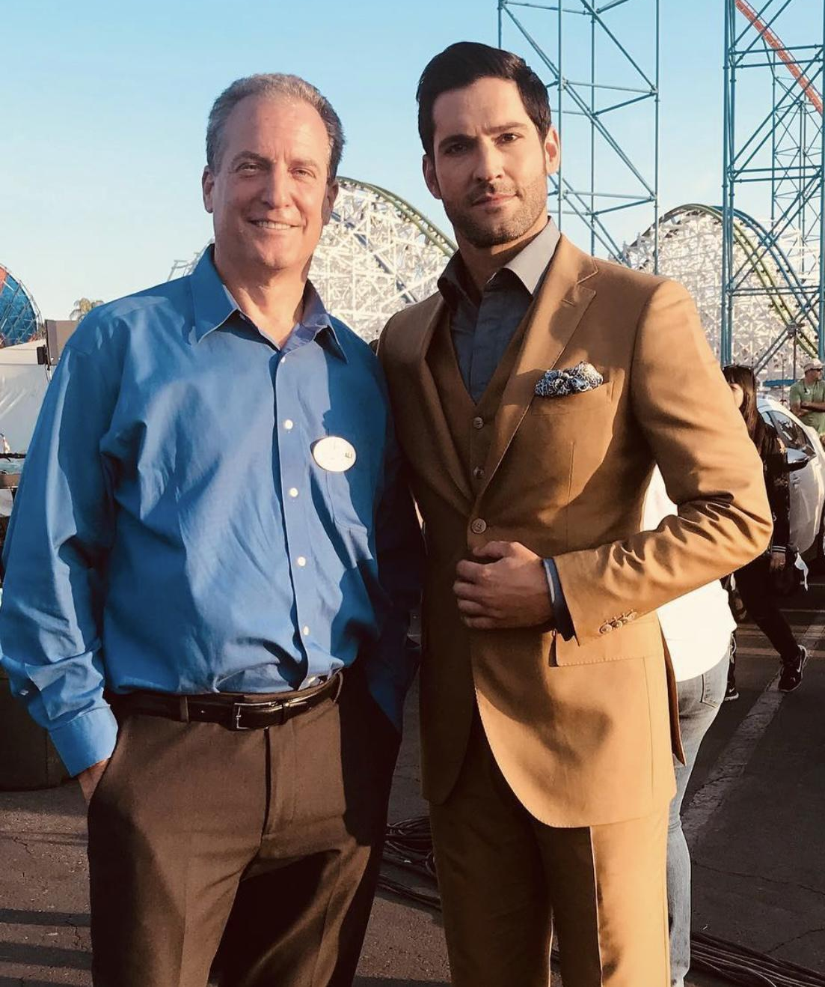
Upon hearing enough of the man’s rant, one of the higher-ups pulled open the door of the trailer and asked for Tom to finish getting ready so they could begin filming. For several minutes, the men all shared knowing glances and sly grins about what would soon occur between the average theme park worker and the lead actor of one of the company’s most successful shows.

Finally, Tom appeared and attempted to be on his best behavior once he realized that the cavalry of S-C Productions’ higher-ups were there to seemingly watch the day’s filming. So even though Tom had a clear look of disdain and disgust towards the low-level theme park manager as the higher-ups introduced him, Tom tried his best to seem in a good and kind mood as he obliged with the company’s request for him to take a photo with the manager of the park.
Soon afterwards, it became clear that the studio heads were eager to get the swap underway as they told Jim to show Tom around to one of the shooting locations of the episode - a Hall of Mirrors attraction. Despite Tom’s clear attitude as he rolled his eyes at having to spend more time with the pathetic-looking manager, Jim remained unfazed as he kept his cool and pretended to just be cheerful about showing Tom around rather than just being giddy about the fact that he would be swapping with the actor soon.

So as they made their way into the Hall of Mirrors, Jim tried his best to remain calm as Tom immediately began to make snarky comments about how “filthy” and “gross” the attraction appeared. Even from just the few minutes Jim had spent with Tom Ellis, he knew that the man was more than deserving of what was coming to him.

Allowing Tom to lead his way through the see-through maze of mirrors, Jim couldn’t resist admiring the man’s body and how it reflected onto the walls. Imagining himself wearing designer fabrics and in control of such a gorgeous body, it wasn’t shocking that Jim found his nub of a cock beginning to slowly harden at what would soon occur.

As if on cue, a sudden disorientation occurred for both men as their eyes quickly rolled back into their heads. Unbeknownst to either of them, this was due to their souls being ripped from their own bodies and deposited into their new ones. But as Jim regained his vision and looked around through the see-through mirrored walls, he soon realized what had occurred as he turned around and found himself staring face-to-face with his old body.

“Holy shit, it worked,” Jim said aloud, seemingly causing the real Tom to regain complete awareness. But as he looked at his former body, it soon became clear to Jim that Tom believed that he was just looking at his own reflection in one of the mirrored walls. As a result, Jim attempted to tease and torment the man for a moment by replicating Tom’s various moves until finally opting to stop. Upon realizing that what he assumed to be his reflection was no longer mimicking him, Tom grew quite shocked and confused. As Jim began to turn and walk away from his former body while concealing a wide smile, the real Tom broke out into a complete sprint in hopes of stopping his body from escaping the room. Before he knew it though, his head rammed against one of the see-through mirrors and sent him slumping down onto the ground completely unconscious from the impact.

Turning back as he heard the loud impact of Tom’s head against the wall, Jim couldn’t resist laughing to himself slightly as he realized that Tom had knocked himself out due to how shell-shocked he was by what had happened to him. Upon turning back, Jim grasped onto his former body’s ankles and pulled the unconscious Tom through the hall of mirrors before dropping his feet at the mouth of the exit. Seeing a full body mirror positioned near the exit door, Jim’s attention was caught and he quickly made his way over to check himself out.
Upon seeing his gorgeous new visage for the first time, Jim was understandably eager to get a full look at himself as soon as humanly possible. So as he loosened his tie and unbuttoned the dress shirt and suit jacket he now wore, the now-43-year-old had a wide smirk on his face as he set the clothes down onto the ground and stared at his ripped physique.

“Well well well Tom, you most certainly took good care of yourself huh?” Jim said with a condescending tone, allowing his eyes to momentarily dart over to his still-unconscious body. As he looked at his former body, Jim finally began to see the truth about himself and his old life. “I hate to say it, but Jim was such a great name for the old me,” he said. “It’s just so fitting to have a dull name for such a dull life and body. The name Tom though, that just lends itself to be prim, proper, and cocky as hell…” As he finished making his statement, he grew aware of his rapidly hardening dick as he recognized the new British voice he was speaking with. It would certainly be something that would take a while to get used to, but it was definitely a positive thing in Jim’s eyes.

Not wanting to waste his time on an extended monologue though, Jim pulled his attention away from his old body so he could go back to admiring his new form. Extending his hands outwards in front of him, he took a moment to wiggle his digits and admire the rugged appendages that were callused from some obvious hard work in the gym. As he pulled his hands closer until his fingers grazed against his bare torso, an intense feeling of excitement coursed through Jim’s veins.

Given his status as a hard-worker who had no real free-time, it was safe to say that Jim hadn’t had any real ability to get into a constant gym routine like Tom Ellis most certainly had. Due to this, the man took several minutes squeezing the various new areas of intense musculature he had stolen from the cocky actor. With every squeeze of a bicep or cupping of a pectoral muscle, Jim’s dick began to throb in intense pleasure at just how great he felt. The man was even forced to stifle a slight moan as his fingers ran along the well-defined grooves of Tom’s abdominal muscles!

Despite the actor’s status as a mid-40s man, Jim had never felt so energized and youthful in his life. This was most certainly caused from the shock and excitement of body swapping with another individual, but the majority of this was due to just how strong and virile Jim now was.

Thinking of such virility, the constant throbbing of a thicker and longer cock in his tan pants left Jim eager to get a closer look at his bottom half too. So as he undid the brown belt around his waist and undid the zipper of his pants, Jim let the pants tumble down towards his ankles and smirked even wider as his new cock revealed itself.
Rolling his shoulders, Jim moved more into the center of the mirror and tried his best to hold himself back from jerking off. “Oh fuck yeah, I could certainly get used to this,” he said as he turned around and shifted his head back towards the mirror. Staring at the prominent ass he now owned, Jim couldn’t resist chuckling and gripping onto each of his perky ass cheeks. While he certainly had no desire of ever using this form to engage in any “queer” activities, Jim was most certainly impressed by how well Tom had maintained his body. It was such an inspiration to see a middle-aged man continue to look this good, but there wasn’t much need to inspire Jim given the fact that he now was Tom Ellis for the rest of his life.

Just as he began to reach down and toy with the lengthy cock he now owned, a sudden stirring across the room caused Jim to immediately stop what he was doing. Although there was certainly a little bit of smugness he felt about successfully taking away the body of a “hard to work with” actor, the man wasn’t completely heartless. If Jim had his own body stolen, he surely would have gone ballistic if he came to and saw some random individual jerking off his old body. So as the real Tom continued to writhe around on the ground, Jim moved with haste as he pulled up his dress pants and zipped them up before tightening the belt around his lean torso. Grasping onto the slew of upper-torso garments that were laid down on the floor, Jim quickly pulled them on and rebuttoned them before taking a look at himself in the mirror.

As he took note of just how suave he looked in the expensive suit in the mirror, he attempted to make himself look as presentable as possible. Upon tugging down at the bottom of his suit jacket to prevent any bunching, the man took a moment to adjust his tie and dust off his shoulders before flashing one last pearly white smile and turning towards the body-swapped actor who was finally beginning to sit up.

“Wha- what happened?” Tom said, the pain from the impact his head made against the mirror making him groan and be completely oblivious to the plain and weathered American voice he now had.

“Oh old timer, you weren’t paying attention and hit your head against a mirror,” Jim said aloud, immediately causing Tom to go still as he recognized just how familiar that voice sounded. As he pulled his head up to stare up at the former theme park manager, Tom couldn’t resist letting out a loud scream at the sight of his body peering down towards him. Not surprisingly, upon taking a look down at himself and seeing the flabbier and older body he now found himself in, this screaming only grew more extreme. Throughout the entire experience, Jim sat there with a wide smirk as he watched the diva actor freak out and continue to beg for his body back. To add even more insult to injury, Jim grimaced and pushed the now-older man away from him as he tugged on his lavish suit jacket and cried against his pant legs.

Chuckling while telling the man to enjoy his new life, the new Tom Ellis sauntered his way out of the Hall Of Mirrors to go return to set. Given the fact that they only had a day of filming here at the theme park, he needed to be as best as he possibly could be. So as he returned to his trailer to rehearse his lines, the actor paid no attention to the ambulance that had arrived to take a theme park manager having a mental breakdown away to get some much needed help. For Tom Ellis, his work towards memorizing his lines was his number one priority, and as such, he believed that the devil was always in the details…

