Inspired by Tiffany/Mandy/Jennifer/Lisa
By Maryanne Peters

This is the second of my collection of extensions on the captioned images of Jennifer / Tiffany / Mandy of her various sites, including: http://suitstoskirts.blogspot.com/. Jennifer tells me that she has posted about 8,000 captioned images on various sites. She always keeps them short, under 100 words per cap, which gives me plenty of scope to build a story. Long caps are always harder for me.
Some of the caps in this collection have not been published before.

My Son’s Girlfriend  Inspired a Tiffany Manners Cap  By Maryanne Peters  Would he have done it for me? It was only because I had the long hair. I think Richie could have been pretty. But maybe not as pretty as I am.  Neither of us are handsome guys. Neither of us are that big, or outgoing, or popular. We just hang together. We like the same stuff. Its as if the stuff we like, nobody else is interested in. It’s just us.  Everybody was dating for Valentine’s Day except us. We talked about. We were both pretty sad. Then I got a Valentine card from “A secret admirer”. But it looked just like the one I sent to Richie. When we held the cards up we both started laughing.  “Thanks pal,” I said. “I just wish we could do more that lie to one another.” | 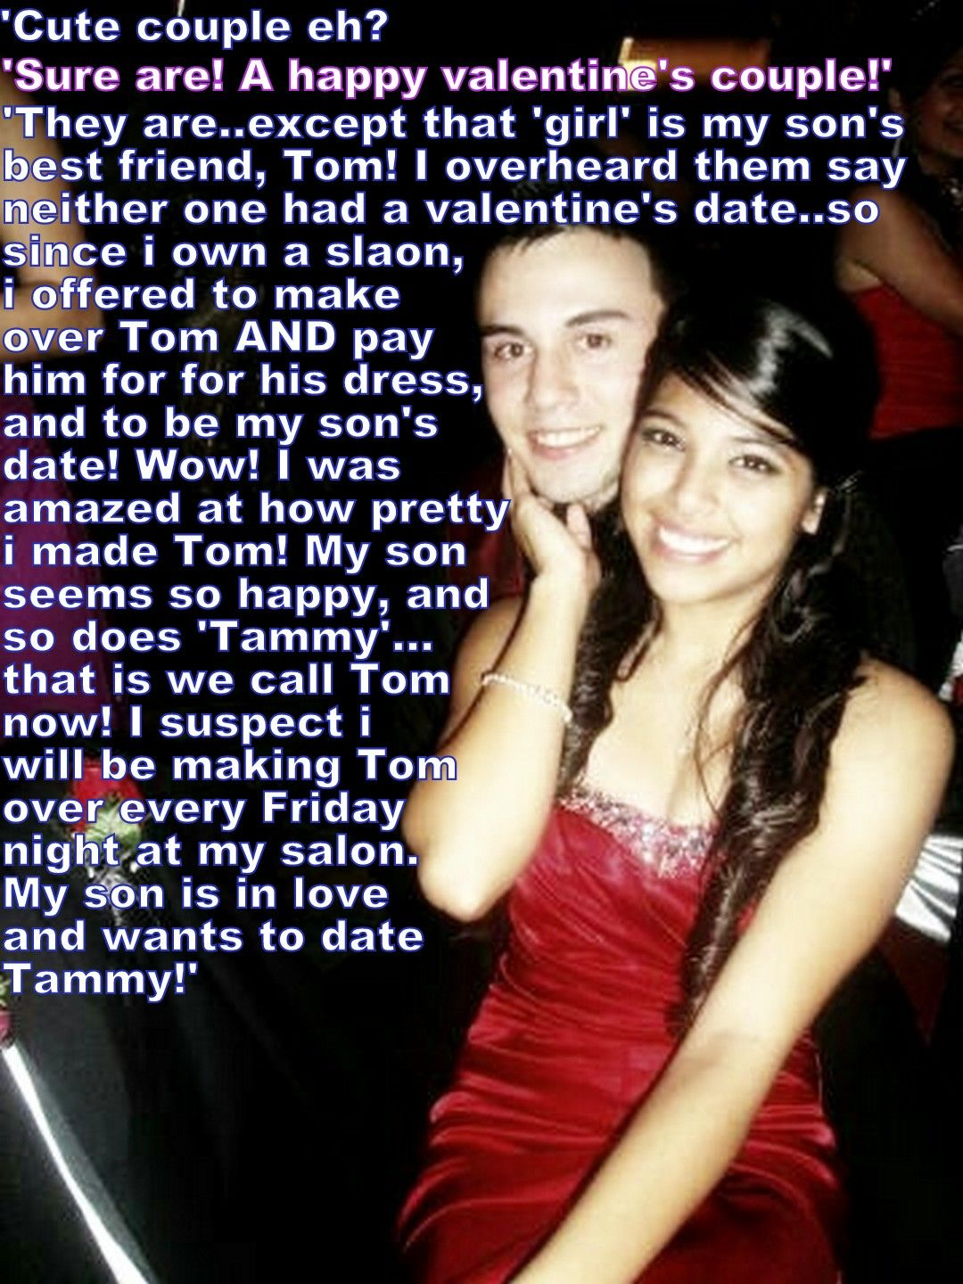

Which was when Richie came up with the idea of the one-night girlfriend. One of us would be the girlfriend for one night. And I was Ok with it being me.

Richie’s Mom has the best salon in town. I mean it is a one-stop-shop – the full facility. Body, skin, hair and makeup. This salon has a reputation for doing total transformations. I would need to take Friday off to get the makeover.

I am not sure what Richie expected. I think maybe he was worried that I might look awful, and that I would be an embarrassment to him. His Mom was not about to let that happen to him. She went all out to make me look like a girl, for real.

Not only that, she and the ladies at the salon gave me the crash course in behaving like a girl – all the gestures that girls do because they are girls, and that I had never noticed.

My hair was long, but they added ever longer extensions so that even with the curls in it hung down well past my fake breasts. With those in the right bra they were able to use some flabbiness in my chest plus a little makeup, to create a real cleavage for the red dress that Richie’s mom bought for me. She wanted Richie to be proud to take me out.

Well, he was. When he first saw me, his jaw dropped. I gave him a little smile. It was the smile that I had on my face all night.

So much for a one-night girlfriend! That date was maybe the happiest day of my life! We’re still together. I am still his girlfriend 18 months later. Of course, a lot has changed. 18 months on hormones has made a huge difference. My breasts and my hair are all my own now. And I was not about to go through another summer without being able to wear a bikini at the beach with my guy.

We’re in love. Why wouldn’t we be. We have known one another for years, and we have everything in common with one another. Except our bodies. Not much in common there anymore. But somebody has to make the changes and I am glad that it was me.

Now I work with Richie’s Mom. It allows me to focus on beauty all the time. Not just my own appearance of course, but helping people become beautiful women. All kinds of people. Richie’s Mo tells me that I have a real talent. She loves having me on her team, as her son’s (glamorous and engaging) girlfriend.

The End

© Maryanne Peters 2019

Dad Wants to Party
Inspired by a Captioned Image
By Maryanne Peters

I guess that you could say that I am exploring all gender options. People my age feel that we can do this. I am not alone. My friend Tom and some others decided that we would have a party for a bunch of us to experiment a bit.

I don’t mean one of the kitschy vice-versa parties, I mean the chance for us to genuinely present as an alternative gender.

Some might say that deciding to go to the party as a girly girl is to surrender to gender stereotypes, but I figured, if you are going to see what it is really like on the other side, go all the way over. I bought a blonde wig and heels, and two evening dresses – one in gold and one red. I hung them on the wall in my room. Then Tom and I went down to the salon to have our makeovers done.

But when I got home, I got the shock of my life. Sitting at the dressing table that I had set up in my room was my dad, in my heels, with my wig on and wearing a lime-green peignoir which was not mine and fitted him perfectly.

But the craziest thing was, that the face that was smiling at me in reflection was made up perfectly, with plucked eyebrows and mascara, and it was my Dad applying the red lipstick. I was gob smacked and could only mutter: “Dad, what the …?”

“I wondered if I might be able to go to that party of your tonight?” this person said. “Tom’s father is going to be there.” The voice was Dad but did not sound at all male.

“But Dad, this Party is only meant for our friends, not our parents.”

“Why should you kids have all the fun,” Dad said. “And besides, I have had a facial and a full body wax. And you can’t wear both of those gorgeous dresses, can you, young lady?”

I kind of liked being called “young lady”, and it had been years since Mom left, so I had somebody to help me choose my dress and my overall look.

“But that’s my wig,” I complained.

“it’s not a wig, you silly girl. Your wig is over there. They’re extensions. And I am not planning on having them taken out after the party either.”

“Is Tom’s Dad going to be dressing up too?” I asked. If I could not stop my dad from going, how bad was this going to be.

“Goodness no,” Dad said. “He’s going to be my date. So while we are at this party, you had better call me Mom.”

The End.

© Maryanne Peters 2019

My Future
Inspired by a Captioned Image
By Maryanne Peters

The crazy thing is that it didn’t really feel like a costume at all. I mean, there was no wig – it was my hair. She said that it would just need a little cut and color, and a blow dry to give it body, and there it was – a sexy little bob with a reddish tinge.

She even managed to get some cleavage out of my flabby chest. She had me wear a “fashion form” with some inserts and boob tape. The boobs on display were my flesh. And my butt and thighs too – all me.

Just a good tuck to hide the unmentionables away. Good seamed pantyhose and 4 inch heels to show off my legs. I never knew that I had good legs. But what guy ever looks at his own legs in the mirror.

I was not the only guy wearing a dress to the work costume party, but I was the only guy who didn’t look like a guy wearing a dress.

Horton Hargreaves Junior (we call him Tony) didn’t even recognize me. He tried it on with me. I had to put on a sexy little high voice to play along, but it just came out. I have to say that I had him going for quite a while until my girlfriend came over to pull me away.

“Sorry,” he said, looking a bit crestfallen. “Are you two a couple?”

“It’s Jim,” said my girlfriend (at the time) with a look of exasperation. “Sometimes a guy can’t see past a tight dress and long legs.”

I looked back to see his disappointment. I sort of felt it too. I think that he saw it in my face. Maybe it was an “Oh, what might have been” look.

Whatever it was he sent me a text message the following day. It said: “Please meet me at the fountain in the park this afternoon at 3:00pm wearing exactly what you wore last night. It will be to your great benefit. Tony”

So, what is a guy to do with a message like that? How about: “Fuck off, Creep”. But he is the boss’s son, and I like working at Hargreaves and Wilson. So instead: “OK. See you at 3:00 (smiley face).”

I mean, I looked at myself in the mirror that morning and I still saw the girl. Like I said, it was not a wig – it was my hair looking so girly. Maybe I had not washed up properly, so there was still eyeliner that made my green eyes look feminine. It was not a costume. It was me.

Truth be told, I was glad to put the dress back on. I knew I looked good in it. Everybody had said so. So, after my shower on it went. Over the top of the same girdle, and the same cleavage that I was able to replicate myself. I had washed my hair with some of my sister’s perfumed shampoo and used the blow-dryer myself. I surprised myself at how well I did it.

I even put on my own make up. I took some time. It was an afternoon meeting so I knew that I should not have the same look as last night, but I still felt the eyelashes were right – just not so much shadow and a brighter lipstick tone. There I was. The black ruched dress might have been a little inappropriate for day wear, but I looked fabulous.

I put some essentials in a little black bag and I trotted off to meet Tony, walking confidently in my heels after a night on the dance floor, but trying not to look like a drag queen.

He was standing by the fountain. I was a little late, as intended. He saw me and smiled. I smiled back.

“You look even better in the sunlight,” he said.

I should have said something smart, like “I bet you say that to all the boys.” But instead I just relished the compliment and shyly whispered: “Thanks, Tony.”

That was when he said it: “I never want to see Jim ever again. Only Jenny.”

Maybe I am just the kind of guy who likes to be told what to do? Maybe it is just the way Tony tells me. Like: ‘This is how things are going to be, so get used to it’. I should say: “Fuck off. I’m a guy”. But no, I just say: “Ok Tony” in my chirpiest little Jenny voice.

I want the job. I can be a secretary. I can type and manage diaries, and stuff like that. Best of all, I do what my boss tells me. Tony is not really my boss. His father Horton is my boss. Horton Hargreaves Senior. The guy who owns the firm. The guy who ogles me every moment of the day. He is my boss. My adoring boss.

Tony is my boyfriend. I never thought that I would say that. I have a hunky, rich boyfriend who only wants me to be pretty and attentive. That is who I am. That is my future.

The End

© Maryanne Peters 2019

Summer as Barbie  Inspired by a Captioned Image by Tiffany  By Maryanne Peters  I couldn’t believe that it was Tom. I mean he was wearing the tiniest little black dress. Like a cocktail dress, I guess. Backless. Halter top they call it. He had to wear a sort of shawl thing around himself as he walked across the mall. An dangling earrings.  “There he is,” says my sister Gemma. “That’s Tom. In the purple heels.”  He had just stepped out of the hairdresser and he was not stopping. I had to almost run to catch up with him.  But the only thought in my head as I did that, was just how sexy he looked from behind. I mean, all that leg, and the heels giving them shape. And his hair up at the back, and shiny gold in color. It was a vision. I had to shake myself out of it. | 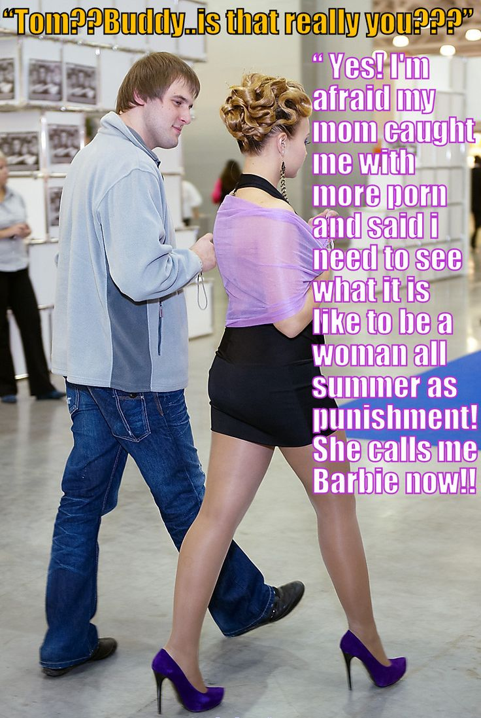
“Tom? Buddy … is that really you?”

He just kept on walking. Those heels clicking on the hard floor. Shiny stockings on those gorgeous legs. He did not want to talk.

“Wait up, Tom,” I said. “You are not going to outrun me in those shoes.”

“You are just as much to blame,” Tom said, without stopping. “You sent me all that chicks with dicks stuff. My Mom caught me looking at it with my cock out. That and all the other porn I got caught with last time. She said it was an affront to women. She said I would never understand because I wasn’t a woman. But the stuff that you sent gave her a crazy idea. It’s your fault I am in this mess.”

“What does she want from you?” I said. I could smell him. Like the smell of the salon but with fruit and flowers too.

“I am dressed to go to the “Women Against Pornography” cocktail party tonight. Look at my hair? Its all pinned up with curls and shit. And those bitches pierced my ears. And plucked my eyebrows. I mean look at me.”

“You look fantastic,” I said. He did. He did not look like Tom at all. He looked like a woman. Prettier than any of the trans porn stars I had sent him images of. Prettier and sexier, and right beside me.

“She is going to parade me in front of all the women tonight. How am I expected to cope with that?”

“Maybe just hold you head up like you doing right now. Maybe just be the best looking woman in the room. I think you might be. I don’t know who’ll be there, but I don’t know anyone who looks as good in a cocktail dress as you do right now.”

“You’re not helping,” he said. “and it gets worse. Mom says that I need to see what it is like to be a woman. She wants me to spend all summer dressed as a girl as punishment for the porn thing. She calls me Barbie now.”

“Can guys come tonight?” I asked.

“No,” she said in disbelief. “Its “Women Against Pornography” you idiot. Even if you were invited lock at yourself. You look like a slob. There is no way I would be seen with a guy looking like you do. You need to lose that awful jacket and those baggy jeans, and you need a shave and a haircut.

“I could do that,” I said. “I’m in the mall.”

“Well, men are not invited,” Tom confirmed. “It just for female guests. But including me.”

“What time will it finish?” I said.

“It’s just cocktails, you dummy. Before dinner time.”

“Ok let’s meet for dinner. I will spruce myself up. Message me when you get clear and I will take you out to dinner.”

“What? You’ll pay”

“Of course. Is it a date, Barbie?”

The End

© Maryanne Peters 2019

Author’s Note: This must be my shortest cap expansion, but it begged for more than it gave us – don’t you think?

Mocked  Inspired by a Caption Image by Tiffany  By Maryanne Peters  Tim was a small guy but a smart ass. When he lined up Nicole Jones to take to the prom he just could not let go of the fact that I still had no date. I did, but Olive Gumm, the girl I had lined up ditched me only a week out. It turns out that she was a lesbian and was going to go with another lesbian.  Why would I care about that. It would be a bummer anyway. No chance of action after the prom with a lezzie, and no summer beach-dates either. It was just as well I found out when I did.  What’s more, Olive ditched her dress at my Mom’s beauty salon where she was going to prep for the prom. It turned out that she was going to the prom in a tux, with her partner yet to be announced. | 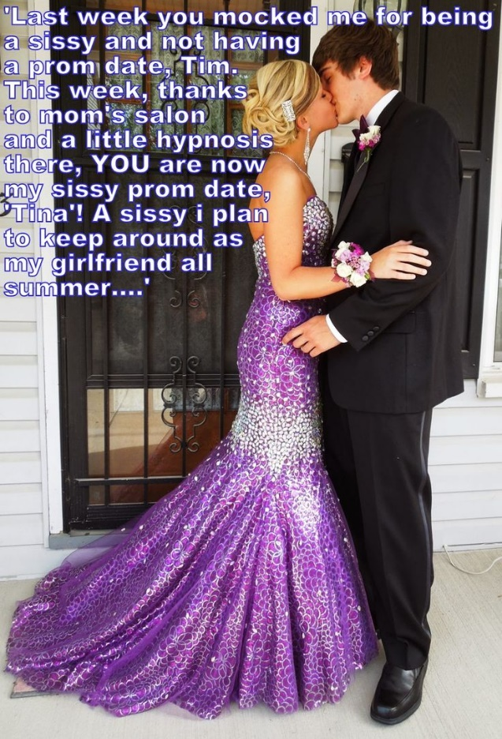

Tim called me a sissy. He said that everybody now knew that Olive was into girls, so if she said yes to me that must make me a girly-boy. I always figured that Olive must be fighting her feelings, so she picked me because I was the opposite of a sissy. That’s my story anyway.

Anyway, I was stewing about the whole thing and my Mom was talking about whether she could call Olive and use the power of suggestion to bring her back. My Mom is into hypnosis and says she uses it at her salon to help people remember their beauty routines. I told her that hypnosis can’t make a gay girl go straight.

Then the boom came down on Tim. I suppose that I should have been happy, given all the shit I had put up with, but it was a bigger bummer for him. The girls Olive Gumm would be taking to prom was Nicole Jones! Tim had been dumped the day before prom.

Everything Tim had said about sissies would fly back into his face. How good is that? And yet, I was ready to give him a way out. I had an idea that give me a date, give him a date, make a point to Olive and Nicole, and maybe even allow Tim to lay low so that nobody could give him a hard time.

That idea would need my Mom’s help and would put Olive’s dress to good use.

Basically, Tim was hiding out when I called him.

“Just a minute,” he said. “You want me to deflect being called a sissy by becoming one?”

“You don’t understand what my Mom can do, Tim,” I said. “We have just over twenty-four hours to get you ready. My guess is that nobody will know that my date Tina is really you. Nobody except Olive whose dress you’ll be wearing, and maybe Nicole. But hey, they forced us together by getting together without telling us, right?”

He could not deny the logic or the justice of it.

So, Tim came around to my place the night before prom and slept over, and that night my mom began the transformation that changed lives.

The hypnosis was just to pick up and retain certain girly moves and traits. Mom knew all about those. But most of the work that began that night was physical. By that I mean stripping all the hair from Tim’s body and sorting out the fitted underwear which would give him a feminine shape. Part of that involved tucking his nuts away, and part of that involved an injection in his butt to keep his pecker sleepy.

Once he was hairless and moisturized Mom had him sleeping in the extra bed in my room but wearing a girl’s nightie. Tim seemed more puzzled than objecting. I guess that was the hypnosis. As I went to sleep, I could hear Tim practising a whole bunch of little phrases given by Mom. I think that continued even while he (or she) was asleep. Maybe that was the hypnosis too.

Then on prom day, Mom came up to wake us – me and Tina. That is what she called her. She laid out a dress for her to wear and she put it on without a word of resistance. We sat down to breakfast and all those little phrases came out in a girly voice – things like: “Thank you sooo much”, and “Oh, this is truly wonderful”, or my particular favorite: “I’m just so happy at the moment”.

I thought that it was just Tim practising. Was it the hypnosis thing?

Mom took Tina to the salon and she stayed there all day. She had to have her dress fitted and have her hair and makeup done – no more than 2 hours I would guess. But Tina was there the whole day, helping out, and just being a girl I guess. Apparently, lots of girls from school came and went and nobody spotted Tim. Probably because he was not really there – Tina was.

So I really met Tina when she came home. I was upstairs getting ready and Mom and Tina got back just before we were to go. Mom called out for me to come down and see my date.

And there she was. In the purple dress with the sparkles on it. Her hair had been extended and colored and was swept up in a special style with a jewel in it to match her dangly earrings. Her make up was perfect and she looked simply beautiful.

“Here is a corsage,” said my Mom handing me a package. “Give it to Tina.”

Maybe I was a little slow to react. I fumbled a bit. As I said, she was beautiful. She made Olive look like … an olive ‘ a dried one.

She took it from me. She squeaked: “Thank you sooo much. “Oh, this is truly wonderful”. “I’m just so happy at the moment”. And then in my ear she whispered: “I am so looking forward to being your date”. But those words did not seemed to be in Tina’s voice. Was Tim talking to me?

Mom took the photo as I kissed my date. It should have been our only kiss, but I think that we both knew that it wouldn’t be.

I was so proud when I walked in. Everybody stared at the girl on my arm. We were right, only Olive knew something was amiss when she saw the dress, and then she realized. I am sure Nicole did not know, but I think Olive probably told her to stop her ogling Tina. Lesbians can ogle, I discovered.

They didn’t tell anyone. I am not sure anybody would have believed it. Tina was so clearly all woman.

We danced close. We kissed. It seemed so natural. She was Tina.

At the end of the night she came back to my place. It had been arranged. She came back to my bedroom. I guess that was arranged to. And into my bed, whether arranged or not.

She was smooth and soft and she smelt of spices. Sure, my girlfriend has a little sissy dicklet, and no real tits to speak of, but who knows what the future holds. We plan to stay together and she does want to wear a bikini over summer, so some further changes may be needed.

The End

© Maryanne Peters 2019

