Cheer Coach
A Short Story
By Maryanne Peters

To me, it was a natural extension from gymnastics. At college I was a gymnast, but injury put an end to my career.

People do not understand that when you devote your life to something, and one day it is just gone, it leaves a huge hole in your life. People said that I was fixated on gymnastics, but to be successful in anything that competitive, you need to be. Every waking moment, and many sleeping ones too, I lived what I loved. And then it was gone. In a freak accident both calf muscles were ripped. I was left without a future in gymnastics. The chronic pain was of less concern. I would happily have carried twice as much as that to able to continue as a gymnast.

Without the discipline and the exercise regimen of gymnastics, my body became soft and weak. I became depressed. I let myself go a bit I suppose. I didn’t cut my hair or shave my face. I looked like some kind of flabby troll.

Somebody suggested coaching. But to my dismay I discovered that I could not coach gymnastics. I cared about it too much. I would get so frustrated that I would get emotional, which is not something that a man should do.

Then my little sister suggested that I coach her cheerleading team. It was a team that supported our college football team, the Cobras. I used to watch the football, not the cheering, but when she put the idea in my head, I started to watch, and to see potential.

I had skills in all the apparatus, but the floor routine was my speciality. The key to a good floor routine is to have all the tumbles and compulsory moves down pat, but string it all together with constant movement. I suppose that some people would call it “interpretive dance”. It needs to be graceful and show the potential of the human body. Then you release the coiled spring with speed and height. It should be beautiful.

Some of my friends called my moves feminine. I would call them graceful. I suppose it can be an issue for male gymnasts doing a floor routine, but you need to maintain movement, or the routine looks disjointed. The Cobra Cheerleaders had some skills, but their routine looked disjointed.

Their coach was having a baby and it was getting close. She had to stand down at a crucial point in the season. Could I take over just temporarily? Of course, I made a show of being reluctant, but I wanted to do this. I was excited for the first time in ages.

Their heavily pregnant coach introduced me to the squad at training, and I set my terms.

“I think that you are good, but you can be so much better,” I said. “If you work with me then we could be state champions, but I expect commitment.”

I knew that there was a contest, but I knew nothing about it. I just believed in competition and a target to aim for. Not everybody was interested in that, but a core of the girls was. Those girls promised commitment, and I promised the same in return.

To seal the deal, they presented me with a cheerleader’s outfit with my name across the back, matching theirs. It was a joke, and I knew it was. I am not sure that they expected it, but by way of a humorous response I turned up to my first training as coach, in that outfit with my hair tied up in a hair ponytail like most of them wore.

Everybody clapped, and I did a classic curtsey. It set the scene for a good first session, with plenty of humor and friendly exchanges of ideas. It was just what I wanted.

“Pull off those whiskers and you could be one of us,” one said.

“If you can pull off all of the moves that I am planning this weekend, I will let you,” I said.

I had set a list of things that I wanted but I did not expect. They were not difficult moves, but they involved timing and fluid movement, which is not something that you expect to achieve in just two sessions, but on the weekend, they pulled it off. The moves, that is. The beard followed later.

Monday was declared “beard-plucking-day” and I had to endure it in good humor. I had expected a shave would do the job, but they were holding me to it. It turns out that they had done two other sessions on their own to get our moves right, just to put me through a bit of suffering. It was not nasty behavior on their part, it was about testing my commitment them, and I approve of that.

It was just that my beard did not grow back. Not then, and for entirely different reasons, not ever.

I do not regret one minute of the pain that I went through because from that moment I was part of the team that I was coaching. Gymnastics is fundamentally and individual pursuit. Cheerleading like football and soccer, and baseball, is a team sport. You are only as good as your worst player, so everybody needs to work to lift the performance of everybody else. And to do that, you have to know that everybody is prepared to go through the same pain. Even the coach.

I have to say that the cheerleader dress they gave me on the day that I started had a special place in my heart. I wore it with pride. It was not a fetish thing - it was a team thing. Just like the hair – when I wore the high ponytail it was in solidarity with my team. The makeup came later. It was just that if you wear and dress and put up your hair, then …, well nobody wants to look stupid. Nobody wants to let the side down.

It was an all-woman team. I was part of it. We all had the same problems. We all fought the battle of keeping our limbs smooth, and our hair shiny, and our faces bright and smiling, no matter what we were going through. No matter how hard it was, and how much the pain, we had to endure to be the best. Everybody, including me.

I suppose that there was a day when I stepped off the field after co-ordinating our performance from the sideline and I looked in the mirror and I saw somebody who was not me standing there. She was wearing her Cobras outfit, with bleached hair up in a high bow, plucked eyebrows and false eyelashes, lipstick and fake tits. And it was me.
I supposed the biggest surprise was that the person looking back at me was not bad looking. And I wasn’t the only person who thought so.  Cheerleaders have their own hangers-on, and there were always boys. Most of them were younger than me, but not Ted. His youngest sister was on the squad and he would collect her from practice some days. He also attended games that we cheered at, and he would come down to the sideline to talk to me.  Somehow, he got the idea that I was a girl. Now where would he have got that idea? I mean, look at me.  Of course, the right thing to do would be to point out his mistake and tell him to run along, but, weird as it may seem, I sort of liked the attention.  So, one thing led to another and he asked me out. Now was the time to tell him that he had gone far enough, but somehow I just couldn’t. I told myself that I didn’t want to disappoint him, but the truth is that I didn’t want to disappoint myself. I had suddenly realized that in all the years I had spent at the gym perfecting my skills, I was missing something – intimacy and relationship. | 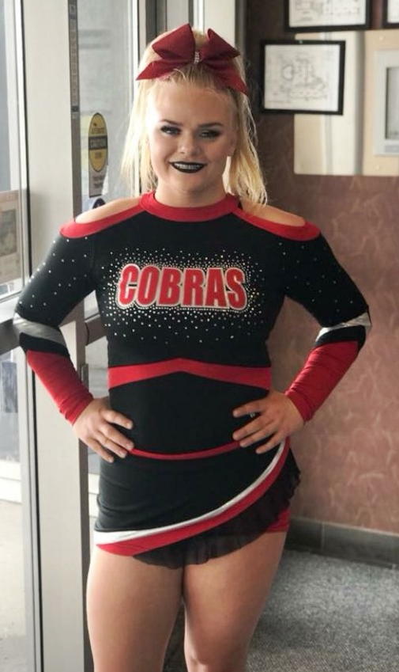

Of course, it could not be Ted. Ted was a guy and so was I, or I thought I was, when I wasn’t with him.

But when I was with him, I was somebody else. Somebody happy. I mean, coaching the cheerleading team had given me purpose and lifted my spirits, but fundamentally the man in me was still depressed and lacking self-esteem. There was another version of me who had no such problems but that version wore a dress.

I bought it on a whim. It was just that Ted was talking to me and I had a sucking on a bottle of Powerade – not in a suggestive way … much. He said that the blue brought out the color in my eyes. What a pick-up line! An energy drink!. But I fell for it. I must have done. I saw the blue dress in the store window. They had it in 12 so I bought it. I wore it that night.

I was trapped but I didn’t feel that way. I felt great. As long as I was her I felt great. When I was back to being him, I didn’t feel so good. I almost hated him for being so sad and helpless. He was a failed gymnast. She was a successful cheer coach.

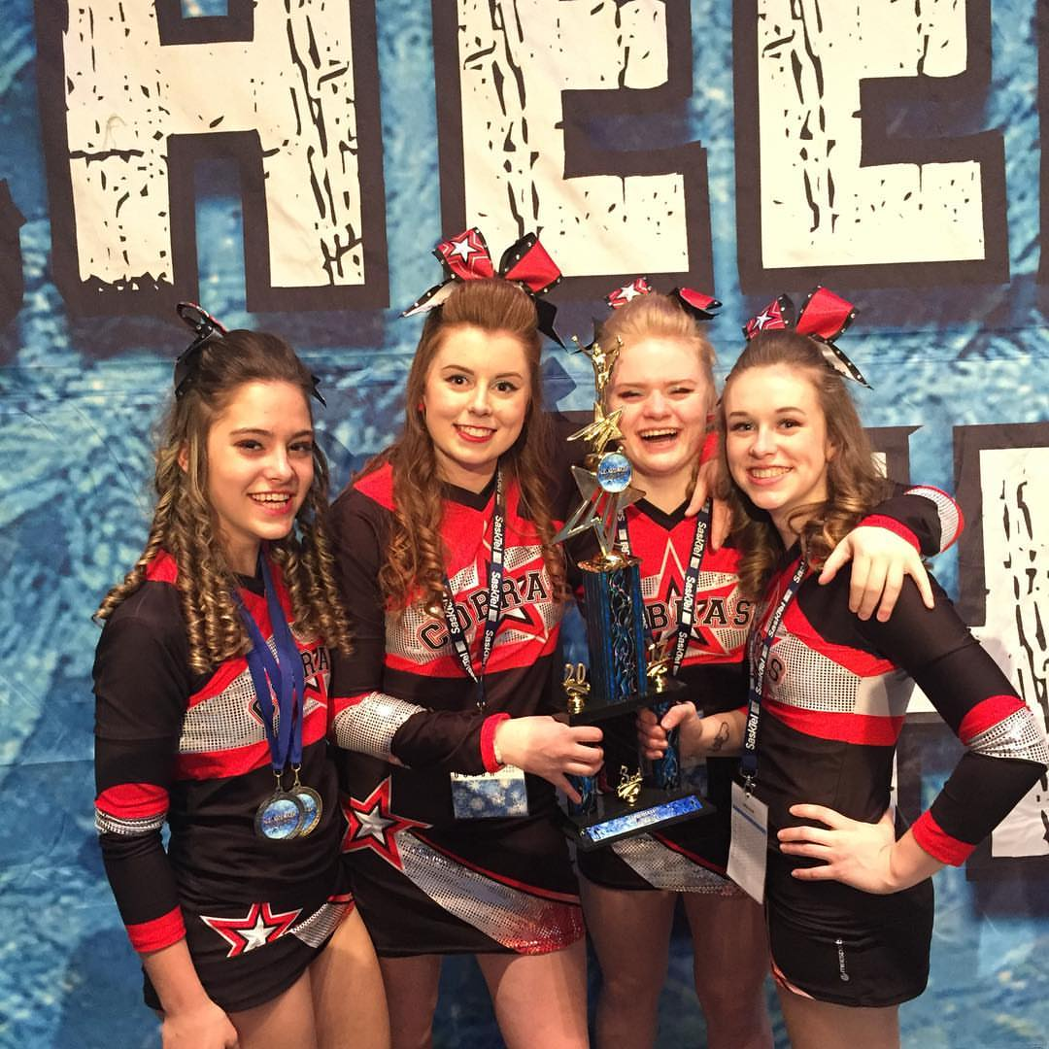  Section Leaders with the Trophy! | And I was successful. My team entered the state cheerleading competition and we picked up first prize. I received a special commendation for my choreography. It was a big deal.  I bought another dress for the afterparty. It was silver and low cut in the front so I had to use some tricks and some gel inserts to fashion my flabby chest into a sexy cleavage. Ted went as my escort. We danced together all night, slow and close a good part of the time. And he kissed me. Long, lingering, sexy kisses. Kisses that made me want to be the woman he thought that I was. But that could never be. Like Cinderella I ran away from the ball in tears, leaving Ted very confused.

But I decided that this was not something that I could walk away from. My team needed me, and (in a way) I needed them too. And, whether or not Ted would want me when he found out, I wanted him, as long as I could have him.

So, I went to the doctor and I went on hormones. It’s only been a few weeks but I think I can see the difference already. I know I can feel it. There is a chance Ted may want me. It’s a chance I need to chase. It is like I said, but to be successful in anything, you need to be a little fixated. You need to live for what you loe

The End

© Maryanne Peters 2019

Author’s Note: I owe the inspiration for this story to my patron and the chair of the Maryanne Peters fan club, Brittini Blaire. Thanks Britt!
Maryanne

