No Going Back
A Story for John Number 41
By Maryanne Peters

I remember the moment. You might think that it was the first time that he held my wrists as I tried to scratch his face, and when I realized that the hormones had robbed me of all my strength. Just look at my arms – thin and fragile. My whole body seems so small and week now that girly fluid has melted me away to something that he can pick up and throw on the bed like a rag doll. But it was not then.

You might think that it was when those titties had grown so large that I need for them to be cupped in a bra or a bodice, so that I could just do simple things, let alone be able to run, with them bouncing around. Is there anything more unmanly than having a pair of breasts dangling off your chest, with two huge pink nipples staring at you as you stand naked in front of the mirror.

I remember the moment. That was not it.

What the castration. He wanted me to watch it. He had me paralyzed and numbed but conscious while the surgeon (or whatever he was cut my sack open and pulled the blood spatter grey orbs into the silver kidney bowl, and with an easy flourish cut the tiny cords with his surgical scissors, one by one.

What could be more final than that? There is no reversing that. So, was that the point of no return? Not for me it seemed.

The End

False Memory Syndrome
Story for John Number 42
By Maryanne Peters

You have to understand why I did it. I had suffered more than anybody I know. Even if I had not been convicted, the shame of it would have been enough to ruin my life. It did ruin my life. I was accused of raping my own daughter.

It was all based on “recovered memory”. Have you heard of that? She lies beside a shrink on a couch and he puts her in some kind of trance, and then he has her spout forth the most disgusting lies. Lies about me. About me and her.

I read all about it in prison. I joined the “False Memory Syndrome Foundation” (FMSF). They say: “Some of our memories are true, some are a mixture of fact and fantasy, and some are false -- whether those memories seem to be continuous or seem to be recalled after a time of being forgotten or not thought about”. They talk about “memory illusions”. Crazy ideas that can be inserted into the minds of troubled people. That is what happened with my daughter, but nobody was prepared to believe me, not even my wife. She divorced me the day I went to prison.

I still had my son Allen. He visited me and did his best to support me. How could I ever consider doing him any harm? It was just that I needed to prove that false memories can be created from nothing, and he was willing to help me with that.

We needed to come up with memories that were so far from reality that we could prove how powerful they could be – we could prove that they could dominate logic. Maybe it was Allen who came up with the idea? Anyway, it was the fabrication of a memory of being transgender from a young age. It seemed a serious but a harmless thing. FMSF had somebody who could show how it was done.

To anybody who knew Allen, the idea that he would suddenly remember that he was not really the handsome virile young freshman that he appeared to be, would be ridiculous. If these memories could be successfully fabricated and inserted, then we might be able to use this to get me a retrial with the recovered memory evidence excluded.

He had to go out of state to meet the guy, so I knew that it would be some time before he could come in to see me, but we stayed in touch through monitored emails.

When he emailed me that he was coming to visit me with some startling news, I was excited. I hurried down to the gallery, but even though he had been to see me only a few weeks before, at first, I did not recognize the person on the other side of the glass.

It was the face of my son, but with painted eyes and lips and with his fair hair all styled as a woman would. The face was smiling at me. I was not.

“Daddy, I can see you are upset, but you need to understand that this is the real me.”

Daddy? Allen would never call me Daddy. Who was this person speaking with that effected squeaky voice?

“Allen, no,” I said. “This is not you. This is an idea planted in your head. You are not transgendered.”

“I know what you think, Daddy, but all those memories were real,” he said to me with an imploring look. “When he talked about it I realized that it was true. I really had spent my childhood dreaming of being a girl.”

“It is not true, Allen,” I said, becoming increasingly exasperated. “Just as everything your sister said about me is not true. These are ideas put into your head. God knows I am grateful for you offering to help, but the idea was just to show how easily it could be done. How easy it was to create false memories. But they are false. You need to go back to the guy who did this and get him to undo it.”

“I have been back, Daddy,” Allen said. “He insisted that I do. He is on your side. But you can’t take away memories if they are real. My memories are. Dreaming of being a princess and walking down the isle in a wedding dress. That is how my childhood was. I was a girl in the body of a boy. I understand that now. Now I can do something about it. Now I am on hormones. I will see a specialist therapist next week to arrange for my orchidectomy. I am so excited. At last I am going to be the woman I dreamed that I would be, all those years ago.”

“We need to get you help,” I said. I was getting desperate. I knew what an orchidectomy was. After that it would be too late. Suddenly the walls of that prison became all the more real. It happens when you understand that there is nothing you can do except watch the world crash and burn.

The End

© Maryanne Peter 2020
Author’s Note: The False Memory Syndrome Foundation is a real thing! The quote is straight out of their stuff! I think that I will take this idea and pull it into a longer story!
Neighbor
A Story for John Number 43
By Maryanne Peters

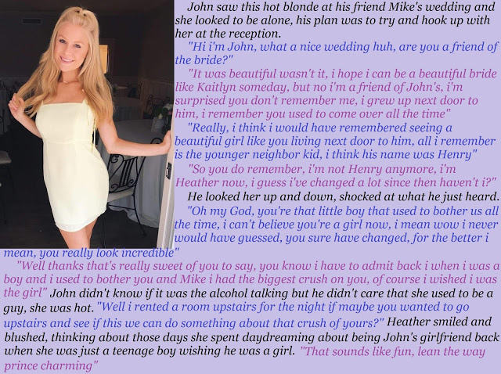

I remembered him – little Henry. The boy who stared at me. It was the same look, but now with a smile, as “Heather” played with her hair and struck a pose in that little white dress. Any man can read the signals. So, I made the offer. I got in early and had a room at the venue. Too easy. And she was keen.

She. There seemed no doubt, with that long blonde hair and those cute tits. But she needed to say something when we got to the room.

“I hope you don’t mind, but I still have my boy bits.” It was said in a shy little lisp, with her hips swining. She made it sound as if she had a heart-shaped mole below her navel.

I have to say it, I gulped. This was it. My first guy. But somehow that was not the way it seemed.

“You don’t have to look if you don’t want to,” she said, seeming to read my mind – to measure my uncertainty. “I can bend over if you want to do it doggy style.”

It was clear that she was no virgin, but the look on that face continued to deny that: Young innocence with the sweetest smile.

“I would like to do it face to face,” I said, cupping her cheeks and kissing that pert little mouth.

“Great,” she said. “I want that too.”

Strangely, it did not seem so out of place. It was so small, and a delicate shade of pink. I was pleased that it was not engorged and purple as mine was. Maybe I could not have done it if it was, but that seemed unlikely. I was as hard as iron.

There was not a hair on her body, even above and around her “boy bits”. I decided that I should treat it as an enlarged clitoris and touch it – just stroke the tip. It moved just a little but stayed small and dangling. She giggled.

“I have lubrication,” she simpered. “But you look sooo big. Please be gentle with me.”

She lay down on my bed. A phallic shaped dispenser had appeared from nowhere and she was squeezing some goo from it.

“Let me,” I said. I was on the edge of losing control. My cock was straining with a mind and will all of its own – seeking a hole to bury itself into. Still I had time to apply some of the jelly to her tight little butt hole, and poke some inside. She gasped. Time was running out. I needed to be inside her.

She let out the cutest little noise as I pushed in full length. I done anal only once before (with a real girl of course) but this was different. This was all she had. This was her sex organ, not that thing that just wobbled uselessly as I rammed into her again and again, shaking those beautiful titties.

I came with intensity I barely knew that I had, spewing forth inside her, in a seemingly never ending stream. She wailed with pleasure.

Then, out of the hole at the end of her silly little clitoris, a few drops of clear sticky fluid shot forth. I looked down as I was still donkey deep inside her.

She smiled and said: “Girls like me can’t fake it.”

The End

© Maryanne Peters 2020

In Denial
Number 44
By Maryanne Peters

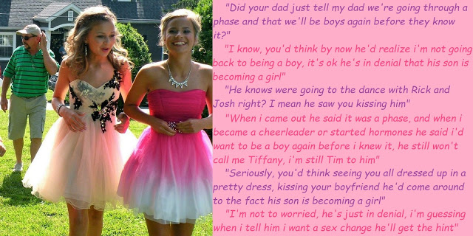

I told myself that he might just be gay. No father wants to think that about their boy. Hell, it seems only yesterday that he was catching ball in the back yard. It seemed to me that he could have been a natural. He had the potential to grow up strong and fast on his feet. Now look at him.

I thought that it might be down to his friend Vic. He was the one who seemed to have started it. But then Vic’s father called me and accused Tim of being the bad influence. He was even more worried about his son than I was about Tim.

I told that it was just a phase. This is the world we live in these days. “Gender fluidity” they call it. Girls dressing up as boys and boys dressing up as girls. Tim and Vic growing their hair was one thing, but dresses? That looks to me like perversion.

I just hope that Tim will snap out of it. Parents need to give their kids space.

I am not so sure about Vicky. I think that has gone too far. She must be taking those drugs, because they are definitely little tits on her chest. She will never grow up to be an athlete the way I expect Tim to develop when this phase is all over. No, she has a soft body. So soft. She sure is pretty, that Vicky.

But I shouldn’t have thoughts like that about somebody the same age as my son. That really is a perversion. I can put such thoughts out of my mind, no problem at all …

The End

© Maryanne Peters 2020

Crossing - My Stepmother
A Story for John Number 45
By Maryanne Peters

You have to believe me Dad, I never wanted to be a girl, not until Chloe came to live with us.

I told you that I didn’t like her, but it was not really true. It’s complicated. She is amazing. I understand how you fell for her. But I guess she was a threat when she arrived. Like I did not want her to come between us.

When I learned from you that she had not always been a woman, of course I was surprised, even shocked. But something else too. Maybe fascinated? But something else … curious maybe? No, another feeling, like … I dunno … she seemed to have it all.

I reacted badly, I guess. I wanted to hurt her. I found out that her name used to be Chris. She went off her head. I understand why. She wants to put that all behind her.

She had a shitty life before she became a woman. I guess it is like a caterpillar just crawling through life until they can be reborn as a butterfly and take flight.

I really do understand, Dad.

I guess I was fascinated. I mean she always dresses so well, even wearing heels around the house. I think she is the kind of woman every woman aspires to be – anybody who wants to be truly feminine.

It’s like I say Dad, I understand why you fell for her. She is the complete package. 100% female.

I just wanted to try to understand how she did it. She had some old stuff at the top of her cupboard. Stuff that she doesn’t need anymore. I just wanted to see whether my body could look as good as hers with that stuff on and with the jiggly breasts and bits and pieces tucked away.

Sure, it should have stopped there. She caught me and when I lashed out she told me that she would tell you. I didn’t want that Dad. I know what you expect of me.

It was just that I was disappointed with my look, I guess. I knew that I was not going to be as pretty as Chloe but I had hoped that I might look a little better than I did.

Ok, so that is why I took the pills. Some of them she doesn’t even need since the surgery, and the other ones – well, she has plenty. Maybe I just thought that if I took them it might improve the shape of my legs, and my face. Sure, it was stupid. It took it way too far. Now look at me.

Really? I thought that you had high expectations for me to follow in your footsteps?

I Chloe’s footsteps? I should be so lucky. She is married to the perfect man. A man who loves her.

I know you love me, Dad. I’m sorry about the tears. It’s the pills you know.

Thank you for the hug, Daddy. Your support means everything to me. I promise I will never cross Chloe again. I will cross like her instead.

The End

© Maryanne Peters 2020

