My Daughter’s Friend
Inspired by a Captioned Image by Tiffany
By Maryanne Peters

Solo fathers are entitled to be a little protective of their daughters, even if at 15 she was hardly a child. At that age I felt she was entitled to veto my choice of a nanny for the five weeks away in Europe.

“Tina can stay with me,” she said. She is a friend and she is almost 21.”

I agreed to meet her. She was tall and I remember that she had great legs. She had dark blonde hair, shortish but pretty, a strong jaw and bright blue eyes. She was attractive without being beautiful. She seemed a little nervous and spoke in a husky whisper. But she seemed mature and responsible, and that was what I was looking for.

It seemed sensible. My daughter could share our house with a friend but somebody who was old enough to deal with any issue, and who agreed to stay in touch with me on a daily basis. Tina agreed to call me every morning (European time) which would late at night at home.

We talked. I asked her to send me images of her and my daughter doing her homework and her chores, and she complied. I had no idea that they were deceiving me. I called her every day and we chatted - what would have been for her, well after midnight, long after my daughter was asleep.

I have to say that I had been attracted to her when I met her, but it was that constant contact that brought me closer to her. Work was frustrating and difficult in Europe, and I could not share my worries with my daughter. So, I shared them with Tina, and she listened and comforted me. It seemed that there was a special bond developing, even though neither of us wanted it.

It seemed to me also, that in the daily images she was becoming even more attractive that I remembered her in person. It seemed that her smiles were just for me. It seemed that her clothes were more suggestive - perhaps just more feminine.

By the time I got home I was infatuated with her. But how do you share such a thing with your own daughter’s friend?

I took Tina and my daughter out to dinner, to thank her. Tina wore that short skirt and stockings, and just enough heel to remind that those legs I had been dreaming about in those lonely hotel rooms, and wondering if they might ever be wrapped around my hips as I penetrated her. I was almost beyond control, but I keep it in check until after we were home and little girl was in bed.

Then I was all over her, and instead of pushing me away, she was welcoming of me. It was a dream come true that I could have somebody so young interested in me. But something was not right. I was not ready for what happened next.

“I want you, but you have to know the truth,” she said. “We have been lying to you. Your daughter has lied to you. I have deceived you. The truth is that I pretended to be somebody else so that we could share a bed while you were away.”

Of course I was shocked, but also surprised. I said: “My daughter is not a lesbian. She has that boy she was going out with … Tim.”

“I am not a lesbian either,” she said, sniffing back a tear. “I am Tim”.

I choked. I felt as if I was about to have a heart attack. The worst of it was not that my hand had been creeping up her thigh and I had come so perilously close to fondling a cock, but that my hopes of a lasting relationship with a sexy young woman had been so totally destroyed. Tina was not a woman at all. And yet, I almost refused to believe it.

“We hardly engaged in anything you would disapprove of,” she said, detecting my revulsion, maybe even sensing my pain. “Because I discovered something about myself from the moment that we first meet, when you interviewed me. It is you I want. Not her. And I will do anything to be the woman you want me to be. Anything. I have already started.”

I did not understand what she meant back then. But all I saw was the look in her eyes and the need for me written all over her pretty face.

I kissed her long and hard and I have never looked back ever since.

The End

© Maryanne Peters 2020

Missing Papers
Inspired by a Captioned Image by Tiffany
By Maryanne Peters

She was away on a business trip for the whole week. Not due back until Friday night. So, I took Wednesday and Thursday off. I had been planning it for weeks.

Crossdressing was my vice, but she could never accept that it was just a release. When she discovered, she forbade it. She told me that if I was not strong enough to stop myself, I was not man enough to be her husband.

Sometimes women can be so cruel. I am a man for her, but when I am not, I need to be Nora. It is not something I can give up. God knows I have tried.

Maybe if Nora was not so goddam pretty. With my wig and makeup on, my body shaved and my fake tits stuck on, wearing something skimpy that can show off my slim body and long legs – I can’t help that either

But it almost as if when I am Nora I turn into the very woman she looks like – an airhead only interested in appearances. Pretend to be my secretary?! How dumb was that idea? Was I dressed like a secretary? Did I really believe that I could confront her wearing that dress and keeping my head down and long locks across my face in the hope that she might no see that it was me.

“I’m sorry Mrs. Herbert. Brent gave me the keys and told me to come and collect some papers …”. I was doing my best Nora voice, but it was not well practiced. Back then I seldom went out as Nora.

“Those papers seem to be missing. Don’t be stupid Brent. I can see that it’s you. You promised me. Now look at yourself - something of your own to wear. My God, it looks like underwear. How slutty.”

I looked up and she was taking photos of me on her phone. “What are you doing?” No Nora’s voice.

“I think everybody needs to know,” she said, keying away on the touch screen.

“Give me that!” I have never been violent with my wife, but I was about to be.

“Too late. It’s on Instagram. I have added a caption - “my husband wants a sex change”. This will be the first day of your transition”.

Well, whether or not she believed that, it turns out that she was right.

The End
Getting Home
Inspired by a Captioned Image by Tiffany
By Maryanne Peters

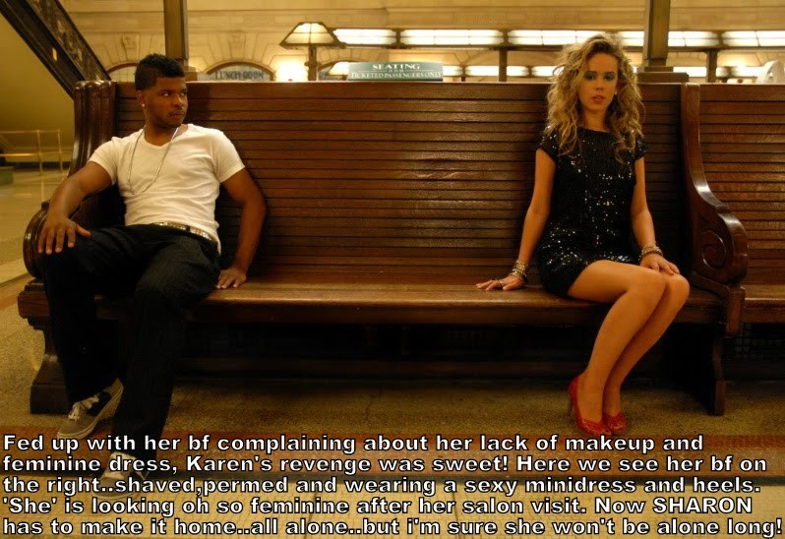

“Please stop staring at me.”

“Whoa! I thought I was just looking at a woman too gorgeous to be sitting alone, but from the sound of your voice, maybe I’m mistaken. Don’t tell me you’re a dude?”

“Ok. I’m not used to this. I can’t hide it. I just want to get home.”

“Hell. You are a dude. But I got to say Man, you make one hell of a hot chick! Not every tranny can pull it off, but you … all I have to is Wow!”

“I am not a tranny. I am just a regular guy. I have a girlfriend. She did this to me.”

“I think she did you a favor. I don’t know what you look like as a guy, but that would be a waste. The world needs more beautiful woman and less … well, people who are only ordinary.”

“Look, I don’t wear this stuff usually. She was just out to make a point. She doesn’t like me telling her what to wear, so she drugs me and does this to me. Then she dumps me across town without even a handbag or any money.”

“That’s a problem.”

“At least she left me at the station. I figure that I can jump on the train and do my best from there.”

“Looking as good as you do I am sure that you will be able to talk yourself into a ride. You really have great legs. You need to wear dresses like that. Maybe that is why your girlfriend doesn’t like dresses. Does she look as good as you? What do you want her to wear that she won’t?”

“I think a woman should wear something feminine, don’t you? I mean dresses and nice shoes. Not pants all the time, and shapeless tops.”

“I’m with you on that. Like the clothes you are wearing now?”

“I bought this outfit for her. She was like: You like it you wear it.”

“It’s a great outfit. I would love a woman on my arm wearing that … looking as good as you do.”

“That’s my feeling.”

“Listen, I was just waiting here for someone, but they clearly missed the last train, so if you are local, I maybe could give you a lift somewhere?”

“That’s kind of you. I don’t want to impose. It would be almost an hour’s drive to my place from here. But travelling in private would be my preference.”

“I’m not doing much. But I would need to grab a bite on the way. You have no money so I can pay.”

“Thank you so much. But the shoes. I’m a little unsteady.”

“Why don’t you take my arm, just to steady yourself.”

“Ok, … Whoops, sorry.”

“No problem. I’m here to catch you. And your hair smells great too.”

“Extensions, but they do look good, don’t they. I just need to … there.”

“Nice. Anyway, “The Whistlestop” does a great burger and they have cheap drinks too. I think there may even be live music tonight. We may never want to leave.

The End

© Maryanne Peters 2020

The Wrong Girl
Inspired by a Captioned Image by Tiffany
By Maryanne Peters

James was not a patient of mine. I could never offer a patient a job, let alone take a patient out to dinner, or make advances. That would cost me my licence. No, James was a friend. Well, maybe not a true friend, but we have known one another a long time. I have always known that he is a prick, and he has always known that I can be taken advantage of.

He was always the stick man. He was constantly on the hunt for one-night-stands. Charm them, bed them, dump them. He never took any notice of the damage he caused. As a doctor I deal with the consequences of casual sex in my young women patients all the time. Men laugh and women cry. I see it. I am there.

When another sad woman turned up at my surgery, I was there to take her in.

“It’s me Doc. It’s me, James.”

I could not believe it. Here was a young woman standing in front of me but speaking with a voice I recognized, and yes, the nose and the little sneering mouth, and behind the makeup, they were his eyes. But then there was a pretty face, and beautiful long blond hair.

“Jesus, James. What happened?”

“I went out with this girl … was it last night? What day is it? It seems like last night. She works for a plastic surgeon or something. She was a good lay. I went to leave. There was some shouting. I got to the door, and then she was behind me and … and I woke up in a room in the motel two doors down … looking like this. Like is top and skirt, and with this hair and these tits. What is going on?”

There was something about the anxiety in that voice that made me think what a perfect punishment this was. The tables had been well and truly turned. But my shock was genuine. What was under that skirt?

“You had better take your clothes off.”

One thing was clear – this had not been last night. Yes these were breast implants, but the stitches had been removed and the scars below those breasts showed at least a week of healing. It also appeared that his whole body had been stripped of hair and the skin inflammation that would have caused had long subsided. In examining the eyes, I could see that the upper and lower lids had been tattooed as permanent eyeliner, and the lips had been ringed with tattooed color as well. This was intended to be permanent.

But his genitals had been spared. The pubic hair had been shaved leaving just a small bush over a penis that now looked totally out of place. Good news for him I guess

So I laid on the bad news a bit thick. All breast implants can be removed. All hair can be cut. I just disn’t want that to happen.

I could have said that this was about me seeing justice done, and seeing that a wrong put right should not be tampered with, but it was not that. No, there was something very attractive in that plaintive look. There was a helplessness that made this creature desirable in a way I had never encountered before. And then there was this penis sitting there, as if waiting to be removed.

I never liked James, but this person could be just what I was looking for, and I just happened to have a vacancy.

“The healing looks good,” I said. “But just in case I will give you a shot.”

He nodded, then winced slightly as the needle went into his arm. It was the largest possible dose of slow release estrogen that I could administer, but it seemed to me that if Janet was going to be mine she would need it.

The End

© Maryanne Peters 2020
Maybe  Inspired by a Captioned Image by Tiffany  By Maryanne Peters  “Maybe,” said Jim. I asked him to be my date at the cross-dressed prom dance and he seemed a bit uneasy. I just thought that he would look better as a girl that me, and I didn’t have a girlfriend who could dress like a guy. This way I could go and check out all the guys dressed as girls.  Maybe it is a sickness, but I like looking at those special kinds of girls. I check them out on the internet. I like the pretty ones best. And the ones with little floppy dicks rather that big stiff ones that wave about as they get pounded.  Maybe somehow the thought that the idea of seeing some of the guys from school looking like cute girls would be a big thrill. | 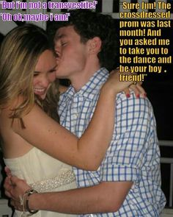

I wasn’t necessarily thinking of Jim, or maybe … maybe I was. After all, he and I had been friends since elementary school. It would be weird to think of your friend in a sexual way. But I have to say that after I looked at all the other guys in their dresses wigs and makeup, I had to admit that the one on my arm was the best looking.

“But I am not a transvestite,” Jim said.

Maybe not. So, if Jim was not a transvestite, well Jessica certainly is not. Because when we woke up the morning after the cross-dressed prom, it was Jessica lying beside me. And now a month later it still thrills me when I wake and she is there.

“I know you like my little dingle,” she said. “But how would you like me to have a little sleeve instead. Something custom made with you in mind. Maybe with you name tattooed on the side before it is inverted.”

“Maybe,” I said.

The End

© Maryanne Peters 2020

Author’s Call for Help
I love Tiffany’s caps because she finds suggestive images and her captions are less than 100 words but carry enough detail to start a story for me to tease out. And she has been prolific, and has released caps under various names. Recently, after she briefly ran an archive site of some old material she shut down. She wrote me: “I deleted all my Tiffany caps as I want to start fresh. I also won't be posting much as i am concentrating on a real relationship and learning makeup and femininity for my boyfriend. I will also be writing more and happy to send you ideas etc.” Which sounds great for her, so good luck.
Some of the images of her caps that survive out there are very poor quality – this one is not great, but it is readable. If anybody out there has good copies of her stuff that you could send me, that would help me to keep her great work available to those who love it.
Maryanne

