The Dark Lady
A Short Story
Based on a literary mystery
By Maryanne Peters

That is what Mr Shakespeare called me – “the Dark Lady”. The name is right enough. My mother was mulatto. She was attractive enough to earn the affection of the man what owned her. I was born by that joinder. To my good fortune my blood father had good conscience enough to provide a little for my mother, and by her graces when I enjoyed them, myself.

My other piece of good fortune is that I was born with good looks. I had my fathers sharp nose and wavy hair, and my mother’s big dark eyes and inviting lips. My body was from my youngest days, strong and supple, and with time acquired the shape that is the stuff of men’s dreams. With those assets, and little else, what is a girl to do with her life?

My given name was Lucy. I was denied my father’s name so both my mother and me took the family name Black, but I was sometimes Lucy Negro. Mr Shakespeare would call me Lucy Nero, being as he knew the Italian tongue by his travels there. Lucy Nero it was.

He was a hard fellow to understand, that Mr Shakespeare. Some would say he loved me. There is no doubting that he wanted me. But it was as if his desire for me was a curse that he needed to fight against. I know not why. It is of no concern of mine whether he love me or not, so long as I am paid to love him back, when I am on my back.

But that story, the story of my being Mr. Shakespeare’s dark lady, is not this story. No, here the Dark Lady speaks, and what I tell here is the story is of the young man that he brought to my establishment in the year 1595. The young man name of John Hughes, and he was fairest young man I have ever seen.

Now, this is not “the fair youth” that Mr Shakespeare did write of much. I know that man as well. Mr Hampton he was. The Earl of Southampton – surname of Rotsley or some such. The vainest man in all England. I am told that another poet - name of John Clapham or some such - dedicated to him (Mr Hampton, that is) a poem called Narcissus, about some Greek fellow who fell in love with himself. That would be Mr. Hampton. So long as Mr. Shakespeare wrote of him in his poetry (comparing him to “a summer’s day” no less), Mr Hampton would meet all of Mr. Shakespeare’s bills.

But I suppose that Mr. Hampton had much to be vain about. He had the most beautiful hair. He was mightily proud of it as well. Every portrait of him has his hair arranged like a girl. My girls all thought he was the finest man they had ever seen. And well hung on top of that.

So Messrs. Shakespeare and Hampton call upon me one evening after the show at the playhouse on the South bank, and they have with them a pretty young girl, or so I thought. My thought was that these gentlemen had found some lost young woman to surrender to my protection. But to my surprise they reveal that this is no woman, but a young man. This is Mr. Hughes, at the time only about 15 years old, so that would be younger than Mr. Hampton by 5 years and by Mr. Shakespeare more than 30.

We all know well that the law of our land was then, as it is now, that no women are to perform on the stage, it being immoral. By this law all actors in Mr. Shakespeare’s company are men, and all the female roles are played by men, usually the youngest of the company. Mr. Shakespeare well loved to make fun of this deceit, with some of his plays toying with the heroine of the tale dressing as a man. That would be a man pretending a woman pretending a man. But the law is the law, and the rule allowed no women. Mr. Shakespeare was always looking for a young man who play those female roles that be so important to him, such as “the fair Juliet” of the Italian play.

Now, I know well that Mr Shakespeare is no sodomite. I should know, as he has entered me many a time. But there are some as may confuse any man. Mr Hampton maybe, that some says pops up in Mr Shakespeare’s poems. But it was clear for all to see, that Mr. Hughes, being as pretty as he was, did affect Mr. Shakespeare somehow. He was no pretty man. He was a girl in all but one respect.

It was him what caused Mr Shakespeare to write the sonnet poem of his numbered 20 – the one that starts with the words: “A woman’s face with Nature’s own hand painted hast thou, the master-mistress of my passion”. That is because young Mr. Hughes did indeed, bear a woman’s face. Useful that was, being that his profession was to be the fair Juliet and Rosalind, and others in Mr. Shakespeare’s plays.

Now Mr. Shakespeare, he says in that poem that he is cursed by fate, as young Mr. Hughes was born to be a woman “till nature, as she wrought thee, fell a doting, and by adding one thing to my purpose nothing …”. Being as God in His wisdom, or nature in hers, or by the very Devil’s mischief perhaps, to add to this perfect girl, a prick. This odd feature, as Mr. Shakespeare did say “for women’s pleasure” but certainly not for his. He had no want of that. By this addition Mr. Shakespeare’s desires were defeated.

But Mr. Hughes was to remain Mr. Shakespeare’s “master-mistress”, for some time after his first visit to my house, and the frustration was there for us all to see. In particular when Mr. Hughes was want to go whoring at our establishment, with Mr. Shakespeare having to stand by while his favorite girl use his (or her) cock to very good effect.

My landlord was Philip Henslowe, the same Philp Henslowe who built Rose Theatre, and the same man who also owned property leased to Mr. Gilbert East, well known in this city, and who put his house to the same use as I did mine. And Mr Henslowe did much like to visit both our establishments. He was the one who found the boy, then at study at a school for young boys of promise.

But Mr Henslowe did greatly enjoy the business of performances and he knew what the spectators did want to see. Best for an act like that there be a pretty girl up front and Mr Hughes was the prettiest girl that I ever did see, that was not one, that is. It was Mr Henslowe what introduced the boy to Mr Shakespeare for the first play he was in, being “The Comedy of Errors” [1594]. The fellow was barely 14 years old but mature in many ways.

He was a great success in the female lead. I am told that many in the audience were confused by his presence, thinking that this must be a woman upon the stage, in breach of the local ordinances. I am also told that the guardians of morality did ask to examine the boy, to confirm that no law had been broken.

Being that he was now an asset to the company of actors, both Mr Shakespeare and Mr Henslowe were happy to see the youngster kept happy with my ladies and those of Mr East. And the truth is that the boy was hungry for the cunny. In those days of his youth.

Now, Mr Shakespeare had a notion that I have heard called “romantick” He would say, as he did in his 20th sonnet poem, that he loved Mr Hughes, but that he could not love his body, being as he was no sodomite. “Tis you I want, not your body.” He wanted Mr Hughes to love him back - "mine be thy love and thy love's use their treasure". “Their” meaning my girls could have his body so long as Mr. Shakespeare kept the attention of young Mr. Hughes.

Now Mr Hughes liked the care of my ladies plenty, but he also appreciated the kindnesses of Mr. Shakespeare. To give to Mr. Shakespeare some pleasure, and perhaps to fuel his torment, Mr Hughes would sometimes dress as a woman in public, and walk upon the arm of Mr Shakespeare. I do not believe that many men could do this in the crowded streets of London, but in his time upon the stage, playing only roles of women, nobody could believe that Mr Hughes was not one in reality. His manner of speaking, and his walk, and the way of hands, the tilt of his head, all spoke that he was of the weaker sex. Only those that knew otherwise knew what dangled under those skirts.

When in this guise, as the mistress of Mr. Shakespeare, there was nothing what Mr. Shakespeare would not do for, or give for the pleasure of “his lady”. And “she” was not above showing her joy at being his paramour. The person could giggle and faun and may be give him a little kiss.

But Mr Hughes could be cruel to his patron. I was one what thought that he would lead Mr Shakespeare in nasty fashion. Mr Shakespeare was of frustrated mind (so I am told) when he wrote his 52nd sonnet poem, bout lying with the boy, and the hope of taking him in the manner of a sodomite, until the view of his prick did ruin the night.

I still do not believe that Mr. Shakespeare ever took the boy as a man takes a woman. As I say, his inclination was “romantick”. The same cannot be said for Mr. Hampton. He was witness to the charms that Mr. Hughes used against our Mr. Shakespeare. Now Mr. Hampton may have looked a girlish man, but in truth he was a fighter - brawler and a fucker, he was. He was married and I have no reason to believe that he did not love that good lady, but he needed more. For that reason he would call to my house, and the house of Mr. East as well. And even then, he was not satisfied. He lusted after Mr. Hughes, but only in his feminine personage. He was not alone, I think. Many people in the audience of one of Mr. Shakespeare’s play did fall hard for the lady portrayed by Mr. Hughes. And when Mr. Hughes did walk upon the street dressed as a lady, there was no hiding Mr. Hampton’s desire.

I could say that Mr. Hampton was no sodomite either, but it is more fair to say that Mr. Hampton could fuck anyone, in any manner. I have said he was vain, and pretty he was too, but he was manly as well. He had no need of stuffing his codpiece. He was a soldier too, by determination more than anything. And he was determined to have Mr. Hughes skewered upon his pride. Sometimes I did think that Mr. Hampton had decided that if he could not be frocked up and as pretty as Mr Hughes, he must have him.

Now Mr. Hampton was rich. Under the reign of our good Queen Bess he had suffered a little misfortune, but he had talents that could not be hid. Under the reign of King James, he rebuilt his reputation by his soldiering, and added to his wealth by putting his money to good use. In that regard it was the money that he applied to the Virginia Company of London, building a new nation across the ocean in Virginia (named after our virgin queen). The success of that saw his wealth increase by many times. He sponsored the building of the town that bears his name, and other places besides, in America.

On the subject of our late queen, I should say that there are some what believe that the esteemed lady herself, was not a lady at all. That story goes that while the young princess was sheltering from the plague in the town of Bisley, in Gloucestershire, she died suddenly. Her attendants were too afraid to tell the king, who was shortly to visit his daughter, so they decided to find a substitute. They found a child who had the same features, but the child was a boy. It was true that the king had rarely seen his daughter around that time, and the deceit (so it is said) was a success. So, we are told by these storytellers, that the masquerade continued and that we were ruled for forty-five years by “The Bisley Boy”.

You could never believe it possible that a boy could pass as a woman that easily, had you not seen Mr. Hughes in his female clothes. Who would ever know if our “Virgin Queen” could only ever be that.

Mr. Hughes was an actor, and actors earn little, and actors that have known poverty know the value of money. Even a virginal fundament has a price. Mr. Hampton could pay it, if Mr Hughes was ready to receive from Mr. Hampton, in both manners.

But sadly, the deflowering of young Mr. Hughes was more than Mr. Shakespeare could bear. He left London and went back to his native Warwickshire in the year of our Lord 1610. He left behind the playhouse, but with new plays enough to keep the company busy.

With Mr. Hughes a little old for the female parts, he seemed to drift away from acting, now that he had the patronage of Mr. Hampton to depend on. The only change was that I never saw Mr Hughes dressed as a man after Mr Shakespeare had left. Even when he called upon me and mine, he would appear in a dress, his body now so well shaped by corsetry that you would think him female even if naked. But he could then lift his skirts and deal to any young girl as he liked. His own special cunny of the behind, was reserved for his patron alone.

I heard that Mr. Shakespeare died in 1616 at the age of 52. Mr. Hughes was sadder on that day than the day, 8 years after that, when Mr. Hampton died at the age of 51. Or so I am told. More than 50 years is a fair lifetime for a man in these times of ours. But Mr. Shakespeare died in his bed, while Mr. Hampton died as the king in the play, atop a horse as general of His Majesty’s troops in a battle in the Low Countries. With the passing of Mr. Hampton ended what support Mr. Hughes needed when no longer fit for the stage.

But by then it was of little concern. I heard tell that Mr. Hughes had travelled a great distance across the seas, and was now living in the town bearing his patrons name, in the distant colonies of the Americas. I am told, by some that know, that Mr. Hughes now goes by the name of Joanna, and runs an establishment such as mine, on those far shores. What I am told is that the men in those parts, as they do far outnumber womankind in those colonies, or perhaps because of the airs on that side of the Ocean, are very happy to dip their ends into that different kind of woman, especially if they be as pretty and as perfect a lady, as Miss Joanna Hughes.

The End

© Maryanne Peters 2018
 | 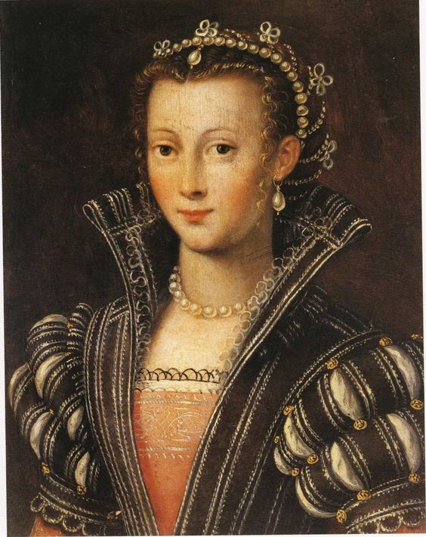
Henry Wriothesley aged 26 in 1599 | Unknown Lady, possibly Joanna Hughes, 1602

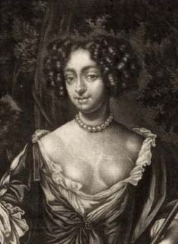 | 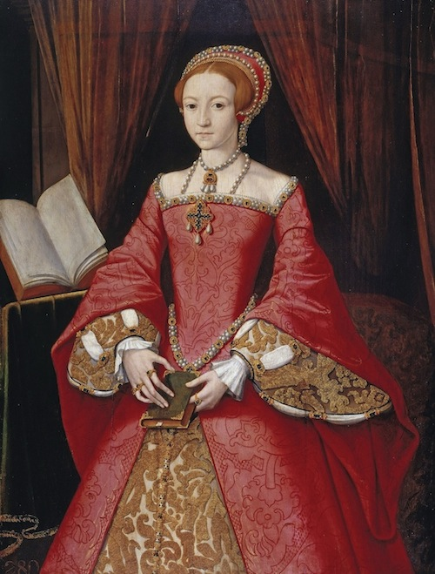
Dark and Buxom 17th Century Lady | Princess Elizabeth (or the Bisley Boy?) 1546

