Isolation
A Short Story
By Maryanne Peters

Franck and Claude had only been on the island a week, when a storm deposited the container on the beach only a short distance from the research station. It must have been a massive wave, as the container lay the right way up but on uneven ground, well above the high water. It was impossible t say how long it has been in the sea, but it did not appear overly rusty, or holed in any way. From the way it sat, Franck guessed that it was not so heavy – maybe less than 10 metric tonnes.

“Do you think that we should report it?” asked Claude.

“If it has no scientific value then I don’t think that they will be interested,” said Franck. “We know the tides around these islands. We know the shipping lanes. It is no big surprise. We should look inside.”

“Should we do that? It does not belong to us.” Franck had met Claude before the posting and had spent a pleasant “isolation test week” with him, but the more that he talked like this the more that he wondered whether he could manage spending another six months wintering over at the station with only him for company.

“We have salvage rights,” said Franck. “It’s the law of the sea. We can’t sell it without accounting to the owner. You are not going to sell anything we find, are you?”

“Of course not,” said Claude. They would have no contact with anyone else for many months. “I just don’t want to get into trouble.”

“So, I will open it and you watch,” said Franck. He had already brought the bolt cutters down from the workshop building.

He needed to shift some of the sand – more like fine gravel, in order to open the door. It pulled open with a tearing sound, as if the door was completely sealed somehow. Inside it was surprisingly dry.

“It smells like a lady’s bedroom,” said Franck. There were pallets with boxes, wrapped in clear film. Despite spending time being buffeted by the waves, everything seemed very orderly. There was room to squeeze between the pallets. Franck had also bought a torch.

“What can you see?” said Claude. “Anything useful?”

“I’ll call out if you want to make a note,” said Franck. “We’ll make a rough inventory. Now let me see. We have garments. Women’s clothing is my guess. And women’s underwear. Bed linen, Pharmaceuticals. Cosmetics. That will be the perfume. It’s overpowering in here. Some drugs, but nothing I recognise from the names on the boxes. A shipment of fashion shoes and bags. Some electrical appliances.”

“So, nothing useful?” said Claude.

Franck emerged carrying some boxes. He said: “I am curious about these,” he said.

“I think you should put it back,” said Claude, as Franck closed the container. “They are pharma items.”

They walked back to the research centre without speaking. Franck went straight to his desk to access the satellite connection thru to the web, while Claude brewed some coffee.

After a while Franck came back with some notes. He dropped them on the table and poured himself a mug of coffee.

“Well, if we want a woman during our long stay, we are well equipped to make one,” Franck announced. “This is a sleeping pill, and this one, a pain killer. And this is an antibiotic. But this is an anti-androgen used to neutralize male hormones, and these are female hormones. This compound a compound for stripping hair from the body. Everything you would need to switch over. And there are more boxes of all of this stuff in the container.”

“So, nothing of use then?” Claude observed. “You finish your coffee and I will go up the valley to check seismograph 6.”

“As you like,” said Franck. As Claude left, he wondered if he could bear spending another 24 weeks with this guy. They were both scientists for sure, but Claude was earth sciences and he was life sciences. Could that explain the differences between them? Sometimes Claude seemed to be like a chunk of earth – brown and dull, unmoving, uninteresting. Checking for tectonic and volcanic movement, and filing weather data.

Franck was about life. He was researching mainly the plant life on the island. He was interested in vegetation including mosses and lichens. That was his field. But on this trip he was also to report on birdlife and any threats from pests that may have arrived on the islands.

Franck saw himself as interested in life. He was strong and fit, and would admit to himself that he had a tendency to be a little overbearing.

It was that which annoyed Claude. As he made his way up the valley he had the same thought. How could he handle the next 24 weeks without going crazy?

***

The answer for both of them appeared to be work. They rose at different times and went about their tasks outside, while the weather remained good. They only met for dinner. They took turns to prepare the meal, and ate together, but often in silence with a book or some papers on the table beside their plates.

It was better that way. Franck had a tendency towards a bad temper. It occurred to Claude that he was sexually frustrated – too much testosterone. But, that was not his field.

For his part, Franck was annoyed that Claude failed to notice the effort that he was making to add some local plants to the largely prepared meals they ate. He had found some interesting items that were very palatable.

The only thing that they agreed on was how much they both enjoyed Calolpac tea. They had discovered that their stock of coffee would need to be rationed to last. Franck had discovered a lichen similar to caloplaca lucens, and with after drying he had used it to make an infusion which tasted very nice. It seemed that there was always Caloplac tea being brewed.

The genus caloplaca was well known to Franck. He knew the composite compounds. It never occurred to him that consuming this plant (although strictly speaking lichen is not a plant, but a symbiosis between different organisms - a fungus and an alga or cyanobacterium) might have any effect on them. As it turns out, part of that effect is that they were not really aware of it, and there was nobody else there to tell them.

The islands lay well South of the 45° latitude, so by the middle of May the weather was getting cold, and the storms brought forth by the prevailing “Roaring Forties” winds limited outside activity. But it was warm inside. Their quarters were well heated with the fuel oil stocked, so warm in fact that Franck and Claude were sitting in short pants and singlets when Franck noticed something odd about his chest.

It was suddenly so obvious that he could hardly believe that he had not noticed it before. He pulled his singlet right off. It was unmistakable. He had breast tissue – small incipient breasts with enlarged pink aureoles. How could this have happened?

He looked across at Claude who was reading some dry textbook on geomagnetic anomalies. He was suspicious. He said: “Claude, what have you done to me? Look at this. Look at these nipples, this swelling.”

“Yes,” said Claude. “What is it? I have the same.” He pulled off his tee-shirt. The same. He was the same.

“You have been feeding me those hormones, those female hormones,” Franck accused.

“And you have been doing the same to me,” said Claude with the look of realization now obvious. “You shit, Franck. You have been doing the same thing to me.”

“So you have been doing it,” Franck said. “Why? I mean, I admit that I was slipping something in your food, just to make life a bit more interesting. There was no malice in it. Just harmless fun. But why give me this stuff?”

“Well, because of your constant domineering attitude. I guess I thought that putting a bit of girl into you might mellow you out a bit. OK, it was wrong. I was not expecting these … the tits. The drugs must be stronger than I thought. What exactly have you been giving me?”

“just two of the yellow ones and four of the pink ones every day, in your tea,” said Franck.

“Shit. That’s exactly the same as I have been giving you.” Claude got up and walked over to compare his breasts with Franck’s. “Are you having the problem with the sensitive nipples?”

“Yes,” said Franck. “And there must be another side effect. Because I should be hitting you in the face for doing this to me, but somehow I just don’t feel that violence is called for.”

“I think that we need to go down to the container and find something to cup these breasts,” said Claude. “Now that I can see how big they are, I think that we need something practical.”

***

“Ohmigod, it’s so cold out there,” said Fifi. She had left her boots and heavy jacket in the anteroom but still had to brush snow from her suspender-pants. She pulled them down quickly in the warm room, saying: “Now I have to go for a pee. I’m busting. I can tell you, I almost went for a pee the old way.”

“You naughty girl,” said Coco. “I have some hot tea ready for you, my darling.”

Fifi rushed to the restroom and sat, pulling aside the gaff to pee straight down. She checked herself in the mirror. Her hair was down and across her forehead under the hood of her jacket, but now she would be able to put it back into the bun she favored, when she found a brush and some hairpins.

Under the sweater she was wearing a long sleeve top with a floral pattern and a lacy front. Even when checking traps wearing pants against the cold, she insisted on being properly dressed underneath. She unbuttoned it to reveal her breasts, now unbelievably a C cup, with some assistance from gel fillets underneath, nestled in her lacy black bra.

“Good to see you again ladies,” Fifi said to them, cupping them and giving them a squeeze.

Coco giggled. She was reclined on the sofa that they had constructed, wearing a long figure-hugging knit dress with a split up the side to reveal a beautifully polished leg. Her hair, this week colored chestnut brown, was in rollers, lovingly applied, with increasing skill, by Fifi before she went out.

“I have downloaded another romcom,” said Coco. “Let’s watch it.”

Fifi put on a wrap skirt and slipped her feet into fluffy slippers. She poured herself some tea and went to the couch, playfully bumping Coco aside with her growing bottom.

Coco took a brush to style Fifi’s hair. She gave her a little kiss on the cheek. She said: “I am so happy that we have found one another.”

Fifi turned and kissed her on the lips with passion. When their lips parted Fifi said: “We each needed to find a girl to spend our nights with, and we did.”

“Then maybe we should go straight to bed?” asked Coco.

Their bed was now in the living area. Two beds joined together. Decorated in some of the pretty pink bed linen that that they had found in the container. They looked at it and then looked at one another lasciviously. With a laugh they bounded across the room together and onto the bed.

“I can wear the Pilot tonight, if you like,” said Coco.

Fifi was very proud that she had made the Pilot, fashioned from the baculum of a pilot whale that Franck had found washed up, only days before Fifi had taken over. Not so much taken over that there was still not the skill to stitch the webbing together and fasten the bone to it. Now it was polished by constant use. Now it served as their common penis, having basically lost the use of their own.

Neither of them really wanted to be the man anymore, but they took turns. Both preferred to be underneath, taking its hardness with a bit of lubrication and blubbering in delight.

“Maybe later,” said Fifi. “But let’s just cuddle for now.” They both liked to do that. They lay together.

“Is that a whisker on your chin?” said Coco. “Let me get my tweezers. I can tidy up your eyebrows as well.”

Fiji winced a little as the offending hair was drawn. “I hate whiskers,” said Fifi. I never want to have any again.”

“Me neither,” said Coco dreamily. “I just want to be pretty. Is that so weird?”

“It’s admirable,” said Fifi. She kissed her friend. Their soft lips mingled lipstick as their tongues mingled saliva.

“Pull up the covers. It’s still so cold. Snow in October. It should be spring by now down here.”

“Just some late cold storm,” said Coco. “But if they have a storm like this next week, they won’t be able to bring a boat in.”

“If the sea’s too rough to come into the beach they can lift us out by helicopter,” said Fifi.

And as they lay there it suddenly seemed to occur to both of them, that there might be a problem. The summer relief team will not be expecting Fifi and Coco, but Franck and Claude.

“Omigod! Darling, are you thinking what I am thinking?”

***

Lieutenant Andre Martin looked puzzled. “What do you mean you are the research team?” he said.

“That’s us,” said Fifi, because she and Coco had decided that it was. It would be stupid to deny it now. It was over. This was the real world. Who would re-enter it? They would. The girls.

“I’m sorry, ladies,” said Andre. “I am not sure who you are, but we are here to collect the two scientists left here in April. Now let me see, I have their names…”.

“Franck and Claude. That’s us. Or it used to be. That is Franck and I am Claude. We have just changed a bit, I suppose.”

Andre was looking at the profiles on clipboard – photographs of two serious young men. One fair, the other a little darker. There was something about the eyes. Could it be?

“Well, I suppose you are ready to leave?” he asked, still disbelieving, or at least uncertain .

“Our bags are packed,” said Fifi. “And I have some boxes of botanical samples. And you have some rocks, don’t you Coco? And the journals. Everything else is posted online. Sorry if we have lacked detail over the last few months, but the weather has been awful. We have been stuck inside, with so many other things to do, haven’t we Coco?”

“Horrible, horrible weather,” Coco agreed. “Stuck inside. Yes. Just ourselves for company. Just doing our own little things.” She was toying with her curls and she looked to Andre to be a little distant.

“Well I am only here to get you off the island and to introduce the new team,” said Andre. “We have landed the helicopter down on the beach. That is our only option. You have a quadbike and trailer? Right?”

“It’s in the workshop, with all that oily stuff,” said Fifi. “Sorry we did not come down to the beach. We’ve been packing.”

Andre directed his co-pilot to take the vehicle down to the beach to collect the replacement team. Four men had arrived for the summer months.

“You may want to brief the team on any issues,” said Andre. He saw Franck in Fifi’s face now, but he still could not believe it. What had happened here? Both of them were so changed, and so … attractive. This would be a difficult report to file.

He followed them inside.

“We have added our own touch to the place,” said Coco. “It’s probably a bit too feminine, but we felt that it needed a lift. These new guys may want to change it, but before we re-decorated, we found it depressing.”

“Way too masculine,” said Fifi. “There is something about pink that just shouts out optimism and happiness. Don’t you think?”

“It’s very nice,” said Andre. But he was appalled. “What about these clothes. You have not packed these.”

“Oh, the original outfits? The new guys can have those if they are a fit,” said Coco. “Even in summer down here it gets cold sometimes. We have other clothes. We should explain the we have claimed salvage over some things washed up on the beach. We have all we need from there. We won’t be needing those ugly things. Winter garments are so shapeless. I would like to avoid any winter in the future.”

“We should move to the tropics,” Fifi giggled. “we could just live in bikinis.”

Andre found himself wondering if he should restrain them for the flight. It seemed clear to him that these two had gone completely crazy during their stay on this island. But they seemed so pleasant.

“Would you like tea or coffee?” asked Coco. “And I have baked some madeleines. I have really got quite good at baking, if I say so myself.” Her smile made Andre’s heart miss a beat. Unexpected. Totally weird. But not unpleasant either.

“I love madeleines,” he said.

***

The cabin onboard the Research Vessel “Moana” was cramped, with over and under bunks. Fifi and Coco were less than impressed. There would be little chance to unpack things. But then again it would take less than a week to sail to Port St. Denis on reunion Island. They would have to endure.

But then suddenly a look of shock came over Coco’s face. “Where’s the Pilot?” she asked Fifi.

“He’s gone to his quarters,” said Andre, lifting the last bag into the cabin.

Both of the “ladies” looked at one another in horror, but then they turned to look at him. In that instant Andre felt as if he was naked in front of them.

The arrival of Captain Carre broke the silence. He could see Andre standing in the passageway, and he bustled his huge frame towards his senior officer.

“Let’s have a look at these fellows you say you have picked up,” he said. Andre’s report did not seem credible.

He reached the doorway and looked into the cabin. Coco and Fifi had both shed their heavy coats. Coco was in patterned leggings and an apricot camisole top, with her curiously large breasts on full display. Her chestnut brown hair tumbled around her shoulders. Her face was made up as appropriate for a lady stepping out, even in the depths of the Southern Indian Ocean. Fifi had only just pulled down the overalls. She still had a tight sweater on which showed all the curves underneath, but below that she just had on her powder blue panties with no visible bulge, and he long, smooth alabaster legs. Her blonde hair was piled on her head but with long wisps dangling in her disarray. He painted eyes and lips were wide with the shock of the moment. A man was looking at her in a state of undress. A large and very attractive older man.

Captain Carre was speechless. He took a moment to collect himself before he stammered: “I am terribly sorry ladies. Please excuse me for butting in on you like this. I had no idea. I … Forgive me.” And then to Andre he snapped: “Help these ladies settle in and then report to me on the bridge, Lieutenant Martin.”

“You made another impression,” Andre said to them once the Captain was gone.

“It’s Andre, isn’t it,” purred Coco. “We seem to have left an important bit of equipment behind, so I was wondering I you might be able to help us.”

“Yes, would you,” asked Fifi looking up at him suggestively.

“I’ll do what I can,” said Andre. As it turned out, the Captain was willing to help too.

***

They had been waiting for almost half an hour in the comfortable consulting rooms of Dr. Devereux. They had been sitting on the couch arm and arm, but now Fifi was up and pacing around her high heels making a noise on the hardwood floor near the window not cover by the huge Persian rug. She checked her stockings, she found a mirror and checked her hair, done in a French roll. She drummed her long painted nails on the window ledge. She looked out onto a cool Parisian autumnal afternoon.

“First one winter and now another coming,” she muttered.

“Come and sit down, Darling,” said Coco. Her hair was now colored red, piled on top of her head in a mass of bouncing curls. Her makeup was laid on a bit thick, but the look was perfect. It had drawn whistles on the walk over. Fall or not, Coco liked Paris.

Dr. Devereux entered the room with the other psychiatrist. He forced a smile for both of them as he hurried across the room to his desk, his colleague pulling over a chair to sit beside him.

“Ladies,” said Dr. Devereux. He had chosen the word with some care, but now that it was spoken it seemed totally appropriate. “We have interviewed you separately and now we would like to speak with you briefly together.”

“We prefer it that way,” said Fifi. She was standing by the window leaning against a curtain. Her long black stockinged legs crossed below the knee, her green dress showing all the curves that she had miraculously developed.

“Now we have the results of the medical tests, and they are virtually identical,” said Dr. Devereux. “We have two people, XY chromosomes, I don’t need to explain to you as scientists, abnormally high female hormones in the blood. Very high in fact. No male hormones detected. Very unusual. Where drugs are used to neutralize the effect of male hormones we would still expect them to be present. Small genitalia and testicles atrophied to the point of … quiescence.”

“We have examined ourselves and one another,” said Coco. Then looking at Fifi: “Quite closely in fact.”

Fifi smiled at her.

“Well, at the moment I am more concerned about the motivation for the change, and less about the very odd way in which it has been effected. That is a mystery for somebody else. I need to understand how two men, who by all accounts were normal heterosexual men before this trip, should return to us … well, as you … present yourselves today.”

“Boredom. The need for intimacy, but not with a man, opportunity with a gift from the sea of just the most gorgeous clothes, in our size. You choose.” After saying it, Fifi pulled a compact from her handbag and checked her lipstick. She could see Dr. Devereux staring at her. She knew that he was attracted to her, despite all her knew about her, despite his own professional code. She gave him a look. Just a look. Perhaps she had been practising a little in the mirror. A woman of style should have a quiver full of such looks.

“Well, now that you are back to civilisation as it were, you have the option to undo things … to reverse this transformation … if, if that is what you want?” Dr. Devereux was clearly affected by something. Was it her?

“Why would we do that?” asked Coco. “Look at me. Look at Fifi. Look outside. Omigod, we are in Paris, Girl.”

“Girls love Paris best,” said Fifi.

The End

© Maryanne Peters 2019
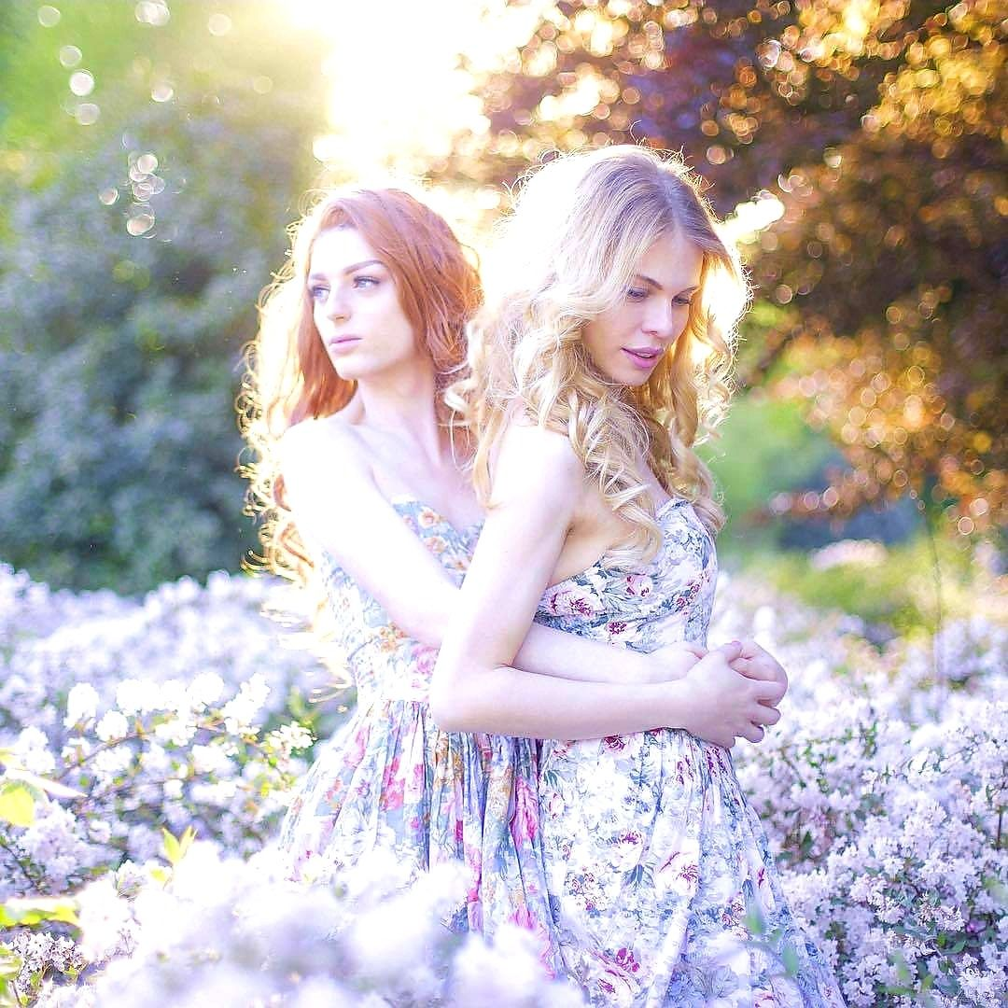
Coco and Fifi

