My Better Mom
Inspired by a Cap Image by SpottyCat44
By Maryanne Peters

When Mom got together with Tyrone, I have to say I was shocked. It is not that I am racist or anything like that, it was just that he was so different from Dad. He was not a big guy, but he was athletic. I was only 11 at the time, but even a 11 year old understands what sex is, and how some women need a man for that. I guessed that was what this was all about.

Certainly he was never going to be a provider. Whatever job he had he quit when they got married. Mom said that Tyrone could stay home to look after me. She said that he would do whatever I wanted – that we should do everything together.

Those preteen and early teen years are so important for a girl. They really are the years when you truly become a woman, and Tyrone shared that with me too.

We became a pair, and my mother almost dropped out of the picture. The truth is we were never close. Her career was what matter to her.

It all started when he told me that he liked dancing too. Or rather he said that he had always felt an urge to dance but was too embarrassed to express himself. He said that I should not be nervous and that I should just let go, and he would show me how.

When I told him that when we practised together, he would need a leotard like mine, he said yes. And when I suggested a tutu like mine, he agreed to that too. He had nice hair too. It was not too crinkly, and he wore it quite long and slicked back. He kept on growing it so that it could be pulled back into a bun, like I wore when dancing. He liked doing my hair and told me that he would love to have hair like mine, but of course he was Africa American.

For I first big performance he said that he would be right there with me. Some of the other girls did synchronized pairs with their sisters or mothers, so I asked him if he would do that with me. That meant matching costumes, and matching hair, and makeup. And he said yes.

So that was us. See how beautiful he looked. He still had those masculine shoulders then, but his legs looked really good in tights. So good that somebody from the audience approached him afterwards to talk to him, thinking he was really a girl.

He said his name was Jamal and he was huge, and black, and kind of scary. I did not want my stepdad to tell him that he was really a guy, so I said: “Tyra, can we go now?”

“Tyra” took the hint and started acting really strange, and Jamal said that she looked a lot like Tyra Banks, and she just giggled. It turned out that Jamal was divorced and caring for his daughter was also a dancer, but not a very good one.

Anyway, everything was different after that. It is like I said, we shared our girlhood. While Mom was at work, my best friend and the kind of Mom every girl dreams of, was Tyra. Except that we were even closer because we were finding out all about womanhood together.

For a while, when Mom came home Tyra had to become Tyrone, and perform what she called “Husbandly duties”, but Tyra explained that this was becoming more difficult ever since she decided that she was going to share puberty with me too.

Anyway, Mom was going to find out and she did. She went apeshit. I just held onto Tyra and told Mom to leave her alone. I think I also might have said that I hated her, but that is not true. I just no longer cared about her. Not the way I cared about Tyra. She is my better Mom.

Anyway, she said Tyra had to go so we both did. Now we live with Jamal and his daughter, and we are a very happy family.

The End

© Maryanne Peters 2020

Ringlets
Inspired by a Cap Image by SpottyCat44
By Maryanne Peters

I was proud of my long hair. I had been growing it for years to be as much like my anime hero Kotaro Katsura. I have to admit that I was obsessed with anime, and Kotaro in particular. I locked myself away in the my loft room and watched my screen, growing my hair and sometimes posing in front of the mirror with my samurai sword. I played sword fighting games all the time.

My sister thought I was sick. She was always trying to persuade me to go out. She said that she knew some young girls that I might like. I just said no.

Then suddenly I started picking up messages from a girl on one of the games I was playing. She was hopeless at the game and said that she just liked watching me fight in mass battles. I guess she stroked my ego.

I told her that I had long hair, just like my hero Kotaro. She said that she thought long hair was really sexy. I guess I was cyber-smitten.

You assume that people on the net are on the other side of the world, or at least the country, so imagine my surprise when she told me she lived in my town.

I made the mistake of telling my sister, or so I thought. I found out later that my admirer was her all along. She must have been planning it for ages. She had been on the gaming sites I played on, stalking me online. She knew all about anime.

She played it all so well. I mean she played me like a fiddle, as they say. She told me that I should go on a date with this girl – the first date I had ever been on. She said that she would guide me through it. She had been dating for years. She knew what girls expected.

It turns out that the eyeliner was her idea. It was all her idea – everything. That included “doing something with my hair. And this is the result.

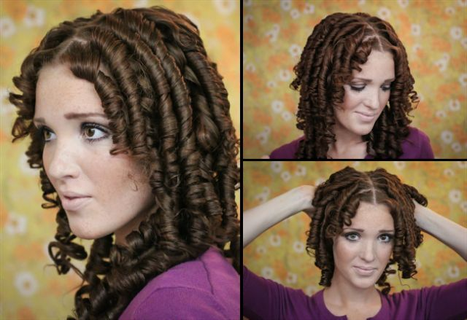

She said that she would post the photos if I did not agree to go out with Ricky. Nobody on line knew what I looked like, and this is what they would see. Me in ringlets

“Who the hell is Ricky?”

“He is the best friend of my new boyfriend Kyle,” she said. “He is a bit shy like you, and really into gaming and anime just like you are. And he is a nut for ringlets, so … well look at yourself. Scrunch them with your fingers a bit.”

I have to admit they did feel good. And the way they bounced around my head and into my face when I turned my head. They did look pretty good but most of all they looked like fun. That’s it – fun. It made me feel like smiling.

“This guy Kyle likes ringlets, huh?”

No. A nut for ringlets was what she said. And a nut about anime just like she said. He is just crazy about my ringlets, and crazy about me too.

The End

The Femme Suit
Inspired by a SpottyCat44 Cap
By Maryanne Peters

“Pretty cool, huh. You can’t even see the seams right. Like, it’s two pieces. The stocking tops hide the end of the legs and the panties are attached to the latex making no seams near the crotch. The top piece which includes the bra goes down to the navel and the straps are the arm holes. So I needed to shave my arm pits – see? You can just glimpse the v-neck seam going down to the cleavage, which I have done my best to hide with concealer. And the seam between the two pieces is covered by the suspender belt.”

“Wow,” said Tad.

“The tits jiggle too. Watch this. Just like the real thing.”

“You did this for me?” he said

“I know what you want, Tad. I am not stupid. I know you are not gay. I am, I guess. Because ever since I have been staying at your place I have been trying to wrestle with my feelings. I did not know what it was, but I know now. I think it’s love Tad. Not the brotherly kind. The romantic kind. The sexual kind. And you know, I don’t care if they say it is wrong, I hope it is love. It makes me feel like I have been living under a rock all my life before now.”

“I’m your brother,” he said.

“Step brother,” I corrected him. Even if I was a girl it was still a forbidden attraction, but why?

“I was just helping you out”, he said.

“You know I could have moved out months ago. You like having me around. You like me cooking your meals, cleaning house and ironing your shirts. I have seen you watching me brushing my long hair. I know what you are thinking when I do. I know you are wishing that I was a girl so that you could fuck my brains out. Now look at me. Am I girl enough for you now? Maybe you should come home and find out.”

“I just needed to get out,” he said. “It is not natural.”

“Tad, please. I know you are fighting this. But why? You want me as much as I want you. Now look what I have done for you. Have another look. Come and feel me. Come and fell my smooth legs. Let me get close to you so you can feel my breasts against you. Don’t you want to explore my female groin through these lacy panties. Come home. Come home and kiss me.”

“I am going to hand up,” he said. I could hear it in his voice. He was aroused. I could imagine his cock standing at attention.

“If you don’t come home, I am going out. I have a dress in my room and a pair of fuck-me ankle boots. I’ll find a bar somewhere. I find some poor guy and tell him that I want him to pretend that he is my brother if he wants to bed me. Because I am I love with my brother.”

“That would be dangerous,” said Tad, with genuine concern that I could feel. “He will find out. You could get hurt.”

“I don’t care.” I was starting to cry, and I let him see it. But it was true. Would I have to throw myself into violence to prove it to him. “If I can’t have you, I don’t care. I you won’t let me suck your cock, maybe any cock will do.”

“You suck cock?” he asked.

“Yours, definitely.”

Tad said: I’m coming home.”

The End

© Maryanne Peters 2020

Dressing her Hair
Inspired by a Cap Image by SpottyCat44
By Maryanne Peters

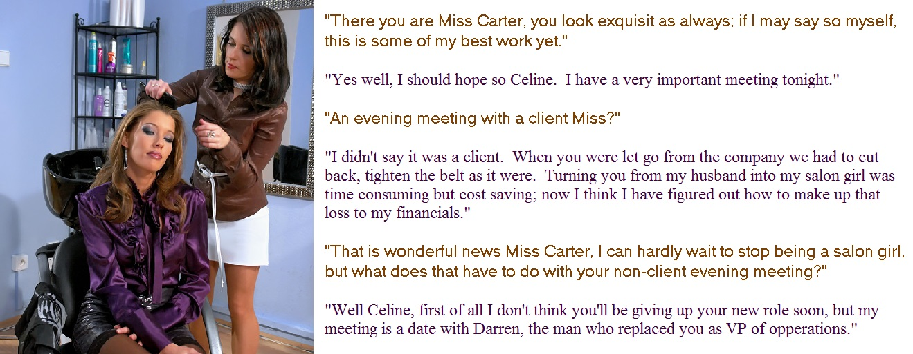

When I married Madeleine Carter, I thought that I was the luckiest man alive. It was not so much love as worship. She seemed like a goddess to me. She was beautiful, rich, and successful – a powerful woman in every way. It never mattered to ne that she had been born a man.

She was bigger than me, sure, and with heavier features, I guess. From the moment we married she was always saying to me that I would make a prettier woman than she did. I never thought so. To me she was just stunning, and most of all she had that beautiful hair.

I have to say that I have always had a thing for hair. I don’t think that is such a weird thing for a guy. I loved to brush her hair. If we showered or bathed together, I loved to wash it for her.

“I like my hair long, but it is high maintenance,” she said. “Maybe you should be my live-in hairdresser in addition to your other chores?”

I had become the house husband not by choice. I was laid off when the small bank I worked went bust and I ended up doing everything around the house including taking extra pride in making her restaurant quality meals.

“Why not,” I said. “I love playing with your hair”.

So she set a little salon in one of our many spare rooms. It had a styling chair, mirror, wash station, shelves for products and all of the equipment we would need.

I loved getting her ready for work every morning and then doing her hair at night for when we went out.

I never thought about growing my own hair before, but now without a job and with our own home salon I could not help but try to do something with my own hair.

I am not sure when Madeleine lost interest in me as her sexual partner – the person she described as being “VP of Operations”. I think it came before I started taking her hormones, but it was certainly confirmed when they affected my erections. Whatever! Estrogen is just so good for the quality of your hair.
She said the if I could not share her bed then I could only serve her as salon girl. I was happy so long as I served her, and so long as I could do her hair.

But I new things were changing when she started calling me Celine and insisting that I address her as “Miss Carter”. It was only a short time after that when she brought Darren home to share her bed and I was slept in another room.

I continued to do her hair, and I felt privileged to be able to do it, but I felt depressed that I had lost a deeper relationship with Madeleine. I suppose that I am just one of those people who needs a strong person in their life, telling me what to do and rewarding me for doing it well.

But Madeleine has so little time. Work comes first. She is always busy.

I would be lonely, but Darren and I have struck up a friendship which makes time alone at home bearable.

Darren says Madeleine was right, I do make a prettier woman than she is.

The End

© Maryanne Peters 2020

Undercover Cheerleader
Inspired by a Cap Image by SpottyCat44
By Maryanne Peters

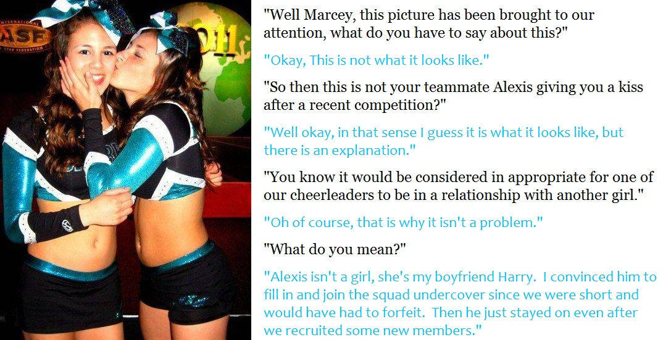

“Are you saying that Alexis is a guy?! She is one of our best. We need her for the lifts.”

“That was our problem remember? We could not find any girl with the strength for those lifting moves we needed to win the championship. With his background in dance I knew that Harry had the strength and could do all the other moves. He was willing to do anything to please me back then. So I asked him if he would become Alexis, and he did.”

“How could we be fooled like that?”

“Harry had to go deep undercover. He could not just pretend to be Alexis – he had to become Alexis. That is exactly what happened. The hair extensions and the Brazilian wax were just the start. Alexis has been living as Alexis ever since she agreed to do this. That meant moving to live with her aunt as her parents hassled her.”

“But she doesn’t act like a guy … not at all.”

“Her aunt helped with that. And I did my part, and so did the two other girls on the team that knew she was not a real girl.”

“Even most of the team don’t know?”

“Just enough of us to shield her in the changing room while we get her fully taped up.”

“How can she hide that even with the high kicks and the like?”

“Well to be honest, what the hormones and everything “that” has not been so big lately.”

“Hormones?”

“To be honest that is turning out to be a bit of a problem. Alexis is losing strength which is what she is on the team for. In fact she is pushing to have a guy or two brought into our routine. Her boyfriend Kevin has said he was interested. Apparently he lifts Alexis all the time. I don’t know the moves, but there is one she calls “the standing butterfly” which she says needs a man’s strength … but I don’t know what that is.”

“So Alexis is still your … your boyfriend?”

“Well, I guess we are just plain friends now. That kiss is just a kiss between close friends. I can’t understand why it is such a big deal.”

The End

© Maryanne Peters 2020

