Brians New Mother  A Story for John Number 31  By Maryanne Peters  No mother wants to upset her son, least of all a mother who is new in the job like me. I just want Brian to understand who I am and why I need to be the way I am.  I was a good father to him. I was there through those formative years, so that he had a strong father figure. I put off my transition longer than I thought I could. I stayed with Brian’s mother longer than I should have. I went on the hormones and that put an end to that sex life, when she deserved better from a husband. And I did that for Brian.  I could have been selfish and just left. I could have told them both that I was going crazy living a lie, and just walked out. Instead it was she who walked out. And from that moment the gate was open, and I was free.  I told Brian why she left. It was not her; it was me.  “Your mother is not a lesbian, you see, and I am a woman.”  I did not look like a woman then, but I was determined that I should do, as soon as possible. I doubled the hormones and grew my hair, and while Brian was away at summer camp, I had everything done the way I wanted.  I got the breasts I wanted, the hairline I wanted, the face that I wanted, the vagina that I wanted. All the things that I had wanted for as long as I can remember. All the things that I had saved for, and I had put off again and again, in the interests of my family.  And from that moment, the moment that I became Karen, I was complete. | 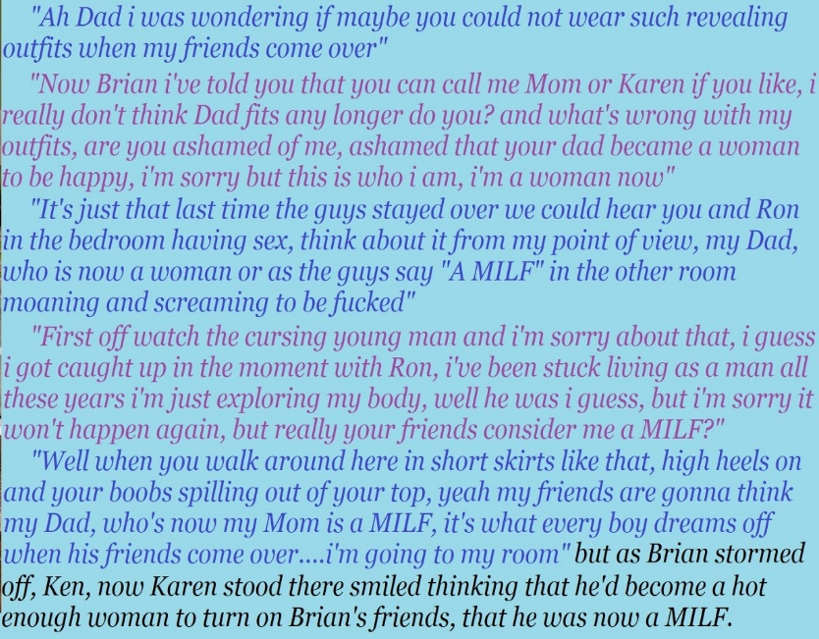
Ron was a surprise, I suppose. It took me months to heal down there, but when I was ready I suppose that I went on the prowl. But I was up front with every man I met. I suppose I went with the code of what I would expect if I were the man. That is fair, having been a man most of my life. Ron was the only one who said: “That doesn’t matter to me. I am only interested in the woman you are now.” That is a line that I guess every transwoman wants to hear. Of course I invited him into my bed.

I was married for years to a woman, so I know what good sex is, or at least I thought I knew. But when a man is inside you and you are just lying back and letting wave after wave of orgasm roll over the top of you, that is when you know what you have been missing. So I moan a bit, and encourage him. I want his hips banging against my thighs. I want his tip to reach the end of my passage. I want his semen so deep inside me that it comes out my ears.

Get over it, Brian.

As for the tops, well, have you noticed I have boobs. The best money can buy. The very thing I have dreamed of having. Big heavy bouncing boobs. Boobs Ron like to put his head between and give me a raspberry and make me giggle like a teenager. Do you think that I am going to hide these? No way.

The short skirts and heels? Look at my legs. Many born girls would kill for legs as good as these. I never want to wear pants again. The heels make them look long. I am happy to wear heels around the house. So does a short skirt. Preferably tight across my butt to show off the shape I have developed there. And the best thing about a skirt is that if I am not wearing panties, my sweet smelling pussy is exposed to the air. If Ron comes over, I can fall over backwards onto the sofa: Whoops! Oh Ron! I’m not wearing any panties!

Don’t think that I haven’t thought about Brad and Nathan, and Mike and the other one, all of Brian’s friends. Don’t think that I have no thought about their swinging cocks, and what they might do to Brian’s sexy mother; the woman who used to be his father.

Get over it, Brian.

I am not a bad person. I might be a little drunk from all these new pleasures, that’s all.

The End

Big Cousin
A Story for John Number 32
By Maryanne Peters

I have to admit it, I was always a bit scared of my big cousin Matt. At family gatherings he used to bully me unmercifully. I was just lucky that we lived at a distance, so I did not have to be alone with him too often.

If you had said that a member of my family was transgender and wanted to go from being a boy to being a girl, Matt would have been the last person I would have guessed that would be. But my mother suggested that maybe this was just a part of his self-deception. He had been fighting back against accepting that he was not a true male.

He was not effeminate when he was Matt. He had long hair which he wore in a greasy braid down his back. He was not so much a big guy, but he had big shoulders and a look that could scare the be-Jesus out of me.

When I heard that he was now dressing as a girl and calling himself Mandy, I was amazed. I was dying to see what Mandy looked like, and I would not have long to wait. His mother, my Aunt Sara was getting married again and the whole wider family had been invited to her wedding.

And then, there she was. I have to say “she” because there was no doubt that is what she was. The only sign that this had once been Matt were those eyes. Even under those eyelashes they were slightly threatening.

Her hair looked gorgeous flowing in curls around the still strong shoulders, clearly shown by the dress in silver blue embroidered silk.

“Well look who it is.” I could not help but point out the irony that it was clear that I was the sissy or the faggot – she was.

But she just ignored the words and pretended to be pleased to see me. She came up and kissed me on the cheek just as a girl cousin should but whispered her threat in my ear.

I was not sure that she could take me physically, but I was not going to put it to the test. How can a guy fight off a girl anyway? And she was a girl.

She made me her escort for the whole wedding, clinging to my arm, and whispering things in my ear about how pretty the bride was, and how the groom was “a hunk”. It seems that Mandy was just the female version of Matt – the cousin determined to make my life a misery.

We drank at the reception, although I probably should not have. I think that she drank less than me. But she dragged me on to the dancefloor after the official dances were done, and I guess I started to relax a little.

In a side room at the reception was an area prepared for the photographer which included and mock bridal bed. Mandy dragged me in there.

“I want to show you what I got for my birthday,” she said.

She lifted the skirt of her dress and pulled down her panties. I was amazed to see that she was completely female below the waist. I had never seen Matt’s junk, but I had expected that it would still be there, even under that dress. But it was gone.

“My pussy is still quite tender and fresh,” she said. “But I work it over every day, and I did that just before the wedding. It is filled with warm lubricating jelly. What I need is a little noodle-dick to poke in there and push it around. I am sure you are small enough to not hurt me. Would you like to? Would you like to take your sweet cousin’s virginity? Tell me that you would.”

I mumbled. I wanted to, but she was putting the pressure on. I was not sure if I could.

“Unzip me,” she instructed. “Take a look at the whole package.”

I wish I had a photo of that to show you – her body. It was perfect with full breasts and a narrow waist, and not a hair anyway except those long thick tresses hanging down below her nipples. Any doubt about being able to perform was gone in an instant as my cock rose to worship her, as hard as an iron bar.

“Ooh,” she said. “Maybe I was wrong about you. That’s no noodle. I am still keen to take you but you must promise to be careful. Please be careful.”

She sounded so girly and fragile that it just made me even harder. But to make the point she grabbed me by my cock and pulled me in to embrace her.

She whispered in the manner that could well have been Matt, as she squeezed it: “Fuck me gently or I will have this in a jar alongside mine.”

That should have terrified my erection into collapsing, but all it did was make me want her more. I kissed her, but in an instant she was tongue fucking my face.

We were on the bed and I was pounding her like a porn star. She was groaning and I exploded, probably way too soon. But she seemed happy. She pushed me away and leaned forward so that she could watch my juices draining out of her pussy.

“Now that is what I am talking about,” she said.

“Thank you.” It was all that I could think to say. It sounds pathetic.

“I am sorry if I was a bit pushy,” she said. “I just needed you to do it to me. I thought you might get a kick out it. You know, like really fucking the person who fucked you over a few times. If you got a kick out of it then maybe you can accept it as some part of an apology for being a bit mean to you.”

“Are you kidding?” I said. “It was great. The best sex I have ever had.”

She smiled. Maybe she knew that I was telling the truth. I hope so. Maybe she knew that I had never had sex before that time – excluding jacking off, of course. I hope not.

The End

Radical New Therapy
A Story for John Number 33
By Maryanne Peters

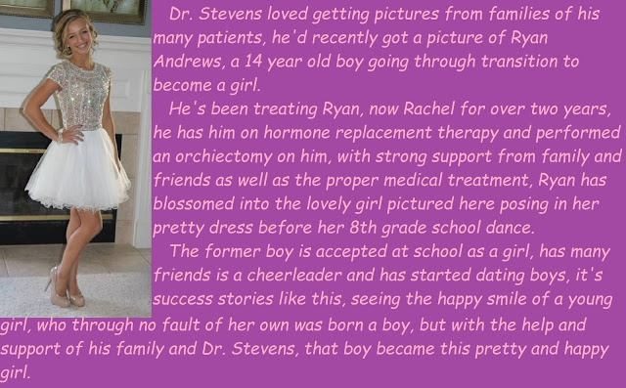

Adolescent depression is recognized as a clinical issue. There are any number of causes, but primarily the cause is chemical. Partly it is the natural maturing of the brain as an organ, and the number of new neuro-transmitting brain chemicals coming into effect, but the primary impact is hormones. Changes in the body can be drastic. I women the major changes are in connection with the uterus, with the onset of menses, but also breasts and body shape. With boys the changes can be even more extreme, and not always welcome.

Added to this physiology, modern childhood faces learned patterns of negative thinking, fostered by violent games, depressing movies and television, and means of belittling present in social media. All of this presents a threat to any young pre-teen, but for somebody with a predilection towards poor mental health in these formative years, it seems close to a death warrant.

In the case of young Ryan Andrews there was a family history of depression. It is established medical science that depression is more common in people whose blood relatives also have the condition. In Ryan’s case, it appears that the problem only affects the men in his family. His father committed suicide in his twenties, but an uncle killed himself during puberty.

Suicide is not the only risk. In these important years, depression can lead not only to the usual problems but to learning disabilities, eating disorders, chronic physical illness, alcohol or drug abuse, conflict and crime.

Ryan’s mother and his maternal aunt consulted me on how we might address the problem before it arose. Was there anything that could be done before puberty to prevent this from happening to their precious son and nephew?

There pleas were so fervent and heart-felt that I felt that I should discuss with them any option, including prophylactic anti-depressant medication, but I advised strongly against that.

“You don’t want this boy to be a doped-up zombie,” I said, although I may not have used quite that language. “He would have a better chance of living a happy and full life as a girl rather than just living for the sake of it.”

“What do you mean?” asked his mother. I waved it away as just an aside, but she wanted to know more.

“It appears to me from the family medical history that puberty is the problem. But male puberty could be avoided. Cancelled in fact. Without a uterus female puberty would not be severe – it would just be changes to the body that would probably necessitate the child being reassigned to the female gender.” I am not sure that they understood the full consequences of what I was saying. Nor did I, really.

His mother posed the question directly: “Dr. Stevens. Do you mean to say that if we raised Ryan as a girl from now on, he would not be depressed?”

“To be honest I don’t know,” I told her. “But it would seem highly probable. And, we could observe and reverse it that were not the case. As lest over the first few years.” It appeared that I was now seriously considering this as a treatment. “But if it were permanent, he, or she, could have no natural children.”

“But we have just been talking about this,” said his aunt. “His children could carry the same weakness in their genes. We would not want that.”

“This would be a radical new therapy,” I said. “I am not advising it, but if you direct it, I can arrange it. We could try it. As I say, it is reversible up to a point.”

And that was how it happened.

A few days later I had young Ryan in my surgery looking very confused.

“What do you mean, re-assigned gender?” he asked.

“Your sex is male, but your gender can be anything you want,” I explained. “There is reason to believe that if you try the female gender for a while, it may prove beneficial to your mental wellbeing. You are entering a dangerous phase. We are concerned that you will never find happiness as a man. Nobody in your family has. But maybe if you try being a girl, it could be different.”

“Please try it, Sweetheart,” said his mother. “We want you to live.”

“The final decision will always be yours,” I added.

I gave the family time to consider, but a week later Ryan was back to accept the shots and patches and commence with the transition to womanhood.

For ethical reasons I entered the diagnosis of “Gender Identity Dysphoria”, and that is the certificate that I filed with his school. But I was aware that Ryan told his friends that he was transitioning “for medical reasons”. It made no difference in the end, because within a year Rachel and her mother came to me to request an orchidectomy, which was her way of saying that there would be no going back to being a boy.

It certainly helped that Rachel had grown to be a very attractive girl, and to be totally accepted as such by her peers, of both sexes.

It was just unfortunate that the child had been born a boy and face a life of unhappiness. It is now clear just what a happy life Rachel will lead. I am totally satisfied that I gave sound advice and good treatment. As a physician, nothing can be more satisfying.

The End

Extreme Stage Mom
A Story for John Number 34
By Maryanne Peters
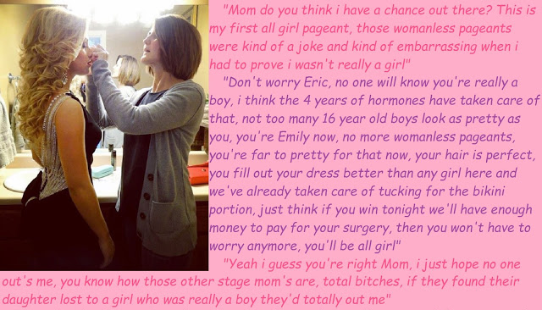

Mom said that she had been a pageant contestant before, but I am not so sure that it true. I mean, it is not that she is not pretty, or could have been when she was younger, it is just that she has never show me any photos or anything. She takes photos of me all the time.

She says that knew from an early age that I was too pretty to be a boy. She entered me in my first girl’s pageant when I was 10. She said it had started as a joke, but I was so good that I put some of the girls to shame. At the time it just seemed like a fun thing to me, and at that age even the girls were just learning to be girls.

It did not come up again until the first junior school womanless pageant, and then it started all over again. I won easily. And then there was an open pageant coming up in a town nearby and she wanted me to compete. That was when the diet and the “vitamins” started, and I was never to cut my hair again. Imagine going through school looking the way I did. It was tough.

There were more womanless pageants, and then Mom decided that I should compete in all girl pageants as a girl. This is not just being a girl for a few fleeting moments. This required me to be female throughout all the preparation, and after the prizes.

Mom said that the only way to do that successfully was to live as a girl full time for a period leading up to the pageant. That does not simply looking like some kind of long-haired effeminate weirdo, it means dressing as a girl all the time.

Mom told the school that I was transgendered so that I could go to school in a dress. The school was good about it because they believed her. I just nodded on cue. I don’t think schools have much choice when faced with this kind of thing.

But the big surprise was all the students. Some seemed to say: “Oh well, that explains it”. The girls were accepting, and maybe even excited. There were a few snide comments, but everybody was under instruction that I I got trouble, they would get it double.

Is it true that if people treat you like something, you become that thing? It sure seems that way.

There were times that I wanted to rebel, but we are talking about my mother. You do what you can to make your mother happy. If she needs to live through you and your achievements, you let her. She is the one who gave you life, after all.

When you attend as many pageants as I have now, you meet your fair share of stage Moms, but my mother is the extreme.

The End

© Maryanne Peters 2019

Author’s Note
Forgive me, I cropped the text on this one which referred to Emily always being transgendered. Here I think that idea that her mother was the ultimate stage mom bitch makes this a much better tale.

Little Brother
A Story for John Number 35
By Maryanne Peters

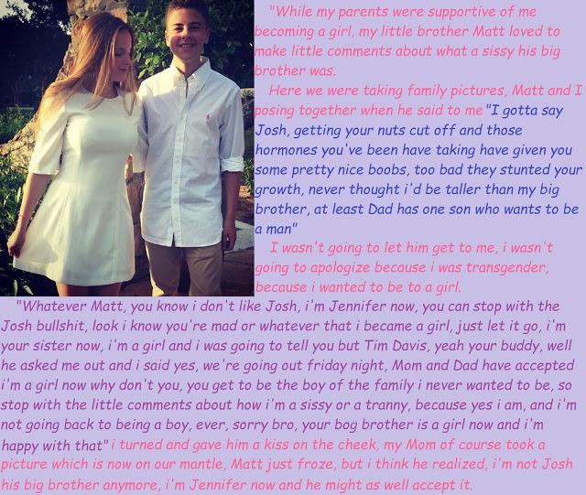

In all this transgender shit, nobody talks about people like me. Nobody talks about the little brother.

Imagine that you have an older brother that you always looked up to, a sportsman and a musician and a popular guy at school, somebody a little brother would want to be, and then he tells you he wants to be a girl. That is what Josh did. I could not believe it. None of us could. Our parents were in shock too.

Josh might be a sissy, but he was a determined one. There was nothing my parents could do, especially after they had him assessed and the specialist told them it was true. The specialist prescribed hormones, and because Jason had attempted to do it himself, he suggested castration might be appropriate too. So Mom bursts into tears and say how they will back him through all of it, and from now on Jason will be Jennifer.

Mom and Dad and “Jennifer” are all hugging and talking about love and family. But what about me? I am in the corner thinking: What the fuck!

If that wasn’t bad enough, Jennifer turns up at school, admittedly wearing “gender neutral” but definitely gay clothes, and people in his class including the captain of my ball team, Tim Davis, get told that Jason is now Jennifer. Everybody starts looking at me, the brother of the fag. Nothing that day, but in the days that followed I get the shit. Everybody feels for Jennifer, but not for me.

The teachers say that nobody can tease Jennifer. She is special. Like the school’s first transgender student. “We will all be judged by the way we treat people who are different, so show her respect.” Stuff like that. It applies to Jennifer, but m not to me.

Then every day Jennifer gets revealed a little more, as her hair grows and her body changes.

“I never want to wear pants again,” says Jennifer after she comes home from her “little procedure”. “I only want to wear dresses.” And everybody says that Jennifer, the ex-athlete softened by all those hormones, has great legs -long and toned. Whatever.

I loved my brother, I guess. Brothers can fight but they do love one another – right? But who the fuck is Jennifer. I don’t know this girl. She appears in my house strutting around in her skimpy clothes, with those legs and those freshly sprouted titties. How the fuck am I supposed to react? Call me a heel, but sure, I called her a sissy and a tranny. Sometimes she needs to be reminded that she is not really a girl at all. Sometimes it helps for me to remind myself.

Guys at school started to talk about Jennifer, but not in those terms. They started to talk about how pretty she was, and that she was “fuckable regardless of what she might have in her panties.” They even asked me: “Hey, Matt, does your sister have a pussy yet?”

The very thought was disgusting, but all I could say was: “She is nutless, but she would still have a bigger dick than you.” It was not true. In panties there was hardly a bulge at all.

Tim was not one of those to talk that way. He was in the same class as Jennifer but he only made it to the second ball team, because he is more the academic type, with me on the reserves being “the little brother of a star player”. He would ask me about Jennifer at practice, but only to ask if she was into boys. “I hear some transwomen are not,” he said.

How the fuck would I know? But She certainly seemed to dress to turn the guys on – dresses high in the leg or low in the front, or both. It was like she was deliberately trying to embarrass me – Here am I, Matt’s Trans sister. Fuck Jennifer.

But that was the problem. It is wrong to think about your sister that way. But I figured the reason why I did was because I was not brought up with her. She was not really my sister. If she always had been I would not be having wet dreams that featured her.

Then Jennifer is telling me all about being the man of the family. She how I am no taller than her because of the female hormones and me flooded with the male type, and how I am the brother now, and like, the family name depends on me because she will never have kids. And she tells me that Tim Davis has asked her out.

“Tim knows is happy with me the way I am,” she said. But the thought of Tim fucking my sister is … well, somehow it just drives me crazy.

The End

© Maryanne Peters 2019

