Like a Real Girl  Inspired by a Captioned Image by Jennifer  By Maryanne Peters  I have always loved pretty girls, but I never thought I would become one. Not that I am – not a real girl. But I am getting close.  I always liked long hair on a girl. It seems to me to be the very essence of femininity. So, if I was a boy, why would I grow my own hair as long as I did?  Humans are strange, and I am human.  I used to think that I did it so that I had long hair to play with and get off on. If I sort of pulled it over my face and brushed it in front of the mirror it was like there was a girl in my bedroom brushing her hair.  The problem with that is not having long hair – other guys did. It was that my hair was so clean and well looked after that it looked like girl’s hair. It was, I guess. | 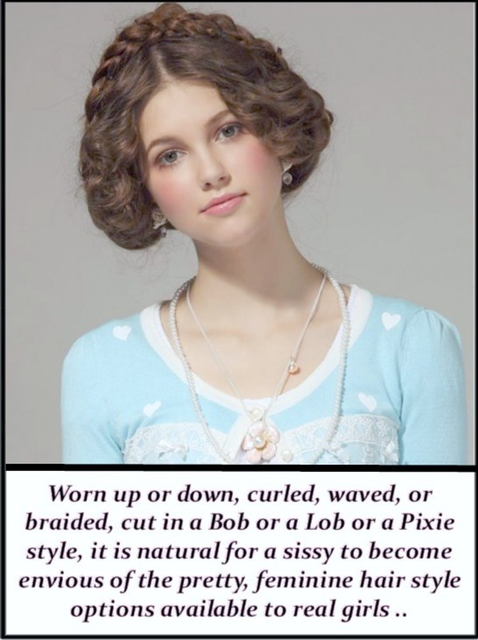

They started calling me a sissy. I suppose that the options are pretty clear when that happens: Cut off my hair and be a boy, or be a sissy and damn them all! I told my father that I made the courageous choice. He was not happy, but he could not deny that I had pluck.

Having made such a choice you can close your ears to the taunts and go all in. I started to experiment with my hair, with styles becoming more an more feminine. I still wore boy’s clothes at that time, but I never had a very boyish face, so people meeting me for the first time would usually assume that I was a girl. A boy would not dream of wearing his hair curled or braided – would he?

It would make me laugh when I said: “I’m not a girl, I’m a boy!” Sometimes the look on their faces was priceless.

If they said: “Like a sissy boy?” I would say: “What the hell is wrong with that. Welcome to the 21st century, asshole!”

But there comes a time when you just cannot be bothered with all of that. I don’t have to make every day a battle. I found that it was easy just to not stand out and invite the taunts. It just took a change of top, some tighter jeans, colorful shoes. And then maybe something around my neck, pierced ears and something nice in them, then just a touch of lipstick, a little mascara … just like a girl.

Then you can really make your hair look special. Look at the do I am rocking today – lifted up at the back with a braid at the crown and soft waved loops framing my face. It is the kind of look that makes me look like a real girl and feel like a real girl.

I never thought I would become one but I am getting close.

The End

© Maryanne Peters 2020

Breaking Point  Inspired by a Captioned Image by Jennifer  By Maryanne Peters  Everybody has their breaking point, and this was mine. It probably shows, but I did it myself. It’s a bit messy, but I know I am only going to get better from here.  She was always tugging away at my hair with brushes and scrunchies and stuff. And I was always complaining – all the time. | 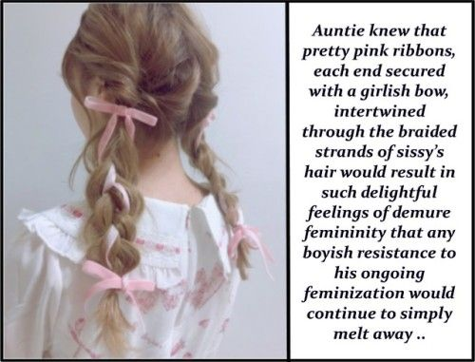

“Why do I have to wear my hair so long Mommy? Why are you always fussing over me?”

“You do it your self then,” she said. “Here is the picture of what I am trying to do, but you just won’t keep your head still. Use the ribbons and wear the little dress with pink through it. And if you do I might let you go outside to climb that tree at the bottom of the garden like you are always saying you want to.”

“Really?” I had to ask. It seemed as if I would never be allowed to behave like a real boy ever again.

“It is a promise,” she said. “Do it as well as you can. Have a proper wash and put on the slip and panties and the pink dress. Show me that you can be a pretty little girl and I will let you be a horrible little boy for the rest of the afternoon.

She had always forced me into those silly clothes before, but now it was just me in my bedroom. It was the bedroom that was now all decked out in pink and had been ever since Daddy left and made Mommy a little crazy. It was just me and the dressing table mirror and the hand mirror to check the back.

Now I was brushing my hair myself. I checked the tips that were really blonde and not split like long hair sometimes gets. I had shampooed it that morning and it smelt good. I thought how wonderfully soft my hair was. Mommy said it was because of the vitamins I was taking, that and regular brushing.

I brushed it over my shoulder. I decided that my hair really was pretty. Perhaps I would not get it cut. I can climb trees with braids, or even a bun on top. You just can’t let it get caught in branches. That would not be nice.

When my hair was shorter I got some tree sap in it once and that was a nightmare to get out.

I know how to do braids. I brushed it out and then put my head forward and ran a comb to the front to get a nice parting and I used some sectioning clips to split my hair into two bunches. I have 4 of those clips with my other hair stuff. Next is to get the first bunch in the right place behind the ear so they can be even. Then start the braiding before putting in the ribbon.

I like a nice clean braid, but Mommy was right: The ribbon adds a feature and matches the colors in the dress. That is what dressing like a girl is all about – “coordinating” they call it – “coordinating my look”. Boys don’t do that kind of stuff. Boys don’t use colors like girls. Maybe blue, but otherwise black and grey. No pinks. No yellows and greens. Now pastel colors or lime green.

Next the other bunch. You need to get it starting from the same height on your head or it looks lopsided. Nobody wants to step outside with a lopsided hair do.

I used to this that having to do your hair was a pain – like the worse thing about being a girl. But it is about having pride in yourself.

Somehow when Mommy was doing my hair, I felt like I was just a victim. I was always grouchy when she did it – always whining. Now that I was doing it myself and checking with the mirror, I could see how it could be nice. I realized that it was about have that pride.

Even girls who aren’t pretty do their best. I know some girls at school who look like gophers but have nice hair. But I am pretty. I mean, I think I am prettier than most girls.

Okay, so I didn’t do the best job, but Mommy was pleased.

“I could probably tidy them up a bit for you, but if you are going tree climbing then I won’t bother until you get back,” she said.

“No, I don’t want to go tree climbing Mommy,” I said to her. “This dress is really nice, and my hair looks great, although my braiding is not the best. Please re do my hair. Then maybe we should go shopping down at the Mall?”

I guess that was my breaking point.

The End

© Maryanne Peters 2020
My Dominant
Inspired by a Captioned Image by Jennifer
By Maryanne Peters

I really didn’t understand what he was talking about when he told me: “I don’t want to be just your friend, I want to be your dominant”.

I thought that he was the coolest guy in school. All I wanted was to be with him. It was not a gay thing … or maybe it was.

I was too young for sex at the time, but he said that was not what it was about. He said that he needed to dominate, but with domination there must be respect. Love was not mentioned. Not then anyway.

I was never a particularly strong person – not strong like him anyway. We could be friends, and I would meet the terms he set for that friendship. Why is that wrong?

He never said anything about feminizing me. I might ask myself that if he had right at the start, would I have said no? Probably not. He reached out to me and offered to make me his closest friend. How could I refuse him?

Having not said no, that was his first requirement of me: That I should never say no to him, always say yes. He said that it was about trust. He would never put me in a position that saying yes would not be in my best interests. I believed him – I still do.

He told me not to cut my hair, but to keep the rest of my body clean of all hair. I did not ask why, because he told me never to question him, and I said yes to that.

He gave me special pills. They were not pills that you swallow, but pills that you put in your butthole. Every day he would moisten them in his mouth and then pull down my pants and shove one in my butthole between my smooth cheeks. I never question what it was about.

Of course, I am not stupid and the effects of this treatment because fairly evident over a few weeks. But he was my dominant, so I did what he told me to do.

He said that I should look down at the floor unless instructed. Sometimes he would not tell me to look up at him, but he would come over and take my soft little chin in one hand and lift it up and look into my eyes. He would say: “Do you trust me? Do you respect me?”

I would say: “Yes. Yes I do”. But it was much, much more than that.

It sounds sexual, but it was not back then. Only the insertion of the pill, and his finger coming into contact with that most tender orifice … that might be sexual. Otherwise this was a relationship on a much higher level. It was a relationship where one person places themself completely under the control of another, and that dominant takes full responsibility for the life of his submissive. What human bond could be more noble and meaningful?

My parents did not understand. They liked him when he first came to my house, but then when they understood what I was prepared to give up to be his, they became hostile. I said that I was not strong like him, but I was strong enough to tell them that I could make my own decisions. And I only had one decision to make, and that was to leave all other decisions to him.

He told me what to wear, and even bought me the clothes that I should wear.

My mother asked: “Why would you choose to wear women’s clothes!”

The answer was that it was not my choice, but to say that would only make matters worse.

My father baled him up when he came round to my place, but my father was so much smaller than my dominant who just listened quietly before coolly saying: “You will never understand what it is that we have going, and I am not going to bother to explain it to you.” I felt so proud of him. I stared at him smiling, but quickly dropped my gaze when he turned to me.

He took me by the hand, and led me out of the house, and I never went back.

I left everything behind to move up to the next stage.

It is more sexual now. But when I say yes, I mean yes. And I never say no. He is my dominant, you see.

The End

© Maryanne Peters 2020

Curler Dreams  Inspired by a Captioned Image by Jennifer  By Maryanne Peters  There is something about that salon that sends a person off to another place. I think that it the warmth of dryers, the smell of the chemicals mixed with the perfume of shampoo, and perhaps the pull of tight curlers on the scalp, as if pulling from you head the last vestiges of whatever was once male in you. | 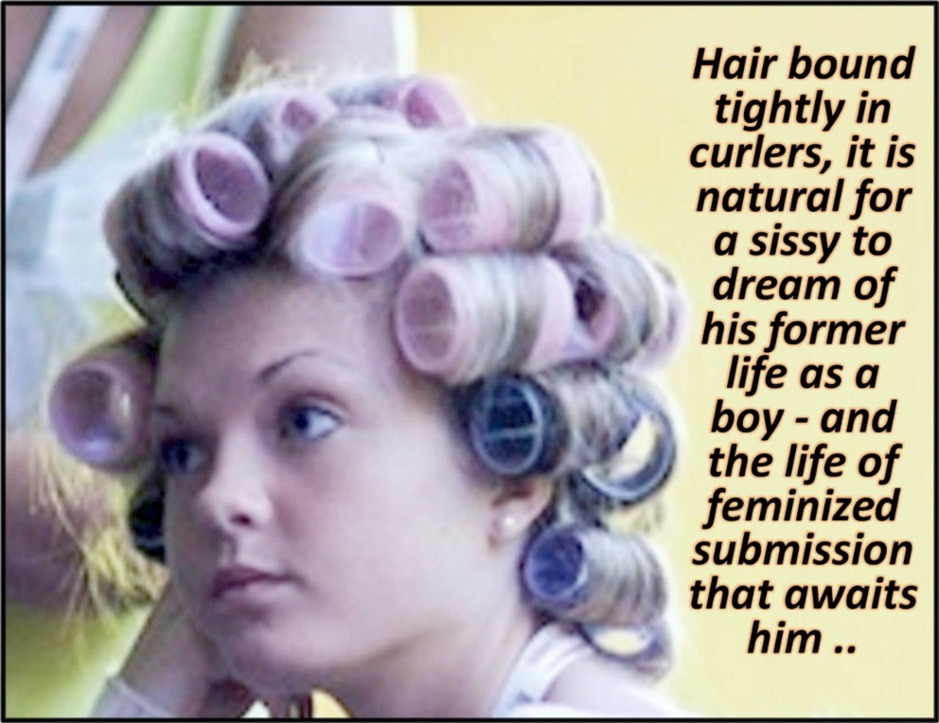

The point is the transformation was so complete. They took away my chin and my heavy brow and gave me just the cutest little nose. I was always blonde – can’t you tell? It just need to grow enough to take a do, and then the laser treat on my face to ensure that I would never have a whisker and barely a blemish, and then the eyebrows plucked thin. Bushy brows look boyish, and that is all in the past.

I won’t deny that there have been dreams of regret, and even anger, but that is in the past too. Everybody’s life changes. We learn to put aside childish things … boyish things. We learn to be who we are … who we look like.

I am pretty, don’t you think? Why would I not use that?

Life as a feminized submissive sissy? I think not. I don’t mind learning the life skills, but when that is done I intend to use my assets to get what I want. There are men out there who would fall at my feet with me looking this good. I am not dreaming of the past – I am dreaming of the future.

But I have to say it – there is something about the warmth of dryer and the smells and the tight curlers that makes you just dream … about nothing in particular really.

The End

© Maryanne Peters 2021

Author’s Note: I have completely lost the address to this website (Jennifer) – can anybody help me with a link?

New Humanity
Inspired by a Captioned Image
by Jennifer
By Maryanne Peters

Let’s talk about the way people should be. So many people talk about the way we are, as if there is nothing we can do about it. But it is the way we are that has made the world the hell-hole in which we are all expected to live and be happy.

Ok, Jennifer may have got the order wrong. That is not exactly what I was talking about, but just think about the opposite.

Rough, rude, proud, aggressive, angry, masculine – that is what is wrong with the world. We need to change things. We need to change things drastically. We need more girls. I mean we need women too, as they become mothers and that is how the human race can survive. But we need more girls. We need people who are only concerned to see that humanity is refocused toward beauty and grace.

I have taken the first steps. Look at me in my pretty dress and those adorable heels!

Why don’t you come and join me? Once you have become addicted to be totally effeminate and girlish you will never want to go back, and in the process, we will make the world a better place. Take a leap and save the world! Leave manhood behind. Become a girl like me!

The End

