Fairy Tale  A Vignette  By Maryanne Peters  We both got jobs at “Storyland” the big amusement park themed around classic fairy tales, but I always ended up in some of those bulky hot outfits that were like hell, especially in the summer months.  It was her idea that I try out for Snow White. They needed a larger girl because the dwarves needed to look smaller. She said that with a bit of work I could pass for a girl.  I refused to believe her, of course. I mean, we had been together for a few months, and although I was not that great in bed, I always thought of myself as male as the next guy. But I needed the better pay, and she loved her job so much. | 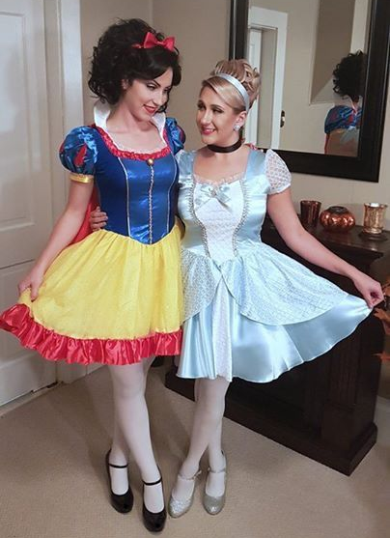

“Being a princes is a dream,” she said. “You just have to dance around a little and smile at everybody. There stuffy costumes, clearing bins, carrying plates or dealing with complaints. You are just being there. You pose for photos. You barely need to talk, but for just a few words – classic lines from the fairy tale – I can coach your voice.”

“But how would I be expected to look like a girl, let alone a princess?” I insisted.

“Honey, I hate to disappoint you by saying this, but you don’t have a particularly masculine face. You hardly even have any whiskers to speak of. I could pluck every one of them out in under an hour, and tidy up those brows as well. We could even use you hair – just dye it black - and just add a fall at the back for volume.

By the time she had finished and put me in costume I was amazed. I looked at myself and saw a girl. So did the boss at the park. I got the job and I went to work as a princess alongside my girlfriend – well, not always together because she was Cinderealla with her handsome prince, and I was Snow White with a bunch of little guys.

Actually, I found those seven idiots quite annoying. I used to spend a lot of time just lying down is the “bed of flowers” pretending to sleep .. and sometimes not pretending.

Of course the inevitable happened and just like the fairy tale, Cinderella fell in love with her prince. She fell for that guy and dropped me like a hot brick.

I told her that life is not like that. Theis guy was not a prince. He was a good-looking dumb-ass. He was a fantasy and I was real.

“He fucks way better than you do,” she said. “That makes him real.” She sure knew how to hurt me. It seemed to me that I was even less of a man than I was when she was together. At least at work Cinderella and Snow White did not have to cross paths unless we wanted to … which we didn’t.

She moved out leaving me to pay the whole rent on our place. The car was hers so I had to ride the bus and that meant going home in female clothes. Because the manager of the park thought that I was female, even after I finished work I used to get changed into something gender neutral to go as far as the car, but now it seemed that I spent even more time off work looking female as I picked up groceries and met workmates for a drink every now and again.

I even found myself sitting at home alone in a robe watching TV with a skin cleansing face mask painting my nails. I guess that the maleness in me was slowly being sapped away by my job.

But she was right - being a princes was great. It is not just easy, but the look on the faces of children when they hold the hand of a princess or accept an air kiss from one, made me feel really happy. It was like job satisfaction double plus. I even didn’t mind the men, older boys or randy fathers, who tried to put a hand on my butt or whisper something indecent in my ear. I could smile and laugh and keep my composure better than most, probably because the joke was on them – I was a guy in drag and they would never know it.

But let’s face it, there is no career path. A princess will never be pretty forever, and there is nothing beyond that unless a prince comes along. I used to have thoughts like that but then a little girl would see me and come running up to me and asking oif I was really Snow White and I would pose for a that photo and be happy again. “Being a princes is a dream,” she had said. Just a dream – a fairy tale, and fairy tales never come true.

But then one day, the same thing happened, just a little differently. I was waiting at the bus stop and a car pulled over. There were two children in the back and the little girl had recognized me and asked her father to pull over. The passenger seat was empty and he offered me a ride.

Men had offered me rides before but I had always refused. Things could get complicated, and what with the hormones I had been taking to help keep good skin and hair, I would never be capable of fighting a man off. But this was a man with children in the back, so it seemed safe, and he said that my place was on the way.

“You know that I am not really Snow White?” I said once I was belted in. “I am pretending. I am sure you pretend to be a princess sometimes? Well, I do it for a job.”

Her name was Gail, and her brother was Felix and their father was Kevin. I had to ask where the mother was, but I soon regretted that.

“She died of cancer 3 months ago,” said Kevin. “We just felt that a trip to “Storyland” would cheer us all up, and it has. And now we get to drive a princess home. It actually feels good to have somebody sitting in that seat, but I have never had a princess sitting there before.”

“Well, ride on, my prince,” I said playfully. “Take me to your castle.”

We all laughed. He told me later that it was the first time they had all laughed together since his wife had died. It had some special significance for him because of that. I only remember that he turned to me and smiled, and there was a look in his eyes that seemed to strike me like Cupid’s arrow.

Fairy tales can come true. I am proof of it. True love can do anything. It can awaken the poisoned or cut away the unwanted manhood. Nothing can stand in the way of love like that. Notrhing did.

The End
1170

© Maryanne Peters 2024

