Sauna Swap (Part II)
By Soul-Controller

As his eyes looked down at his torso, Paul watched as the magic of the spell he had uttered went to work. Stifling his gasp with a hand clasped over his mouth, the businessman witnessed his gut beginning to disappear. Within an instant, the hefty ball gut had essentially melted away and left Paul with a flat and toned torso. Although it was certainly a relief to actually look down and see his cock once more after years of having it obstructed, the man was even more excited to watch as his torso underwent further changes. Before his very eyes, the man witnessed the emergence of muscle that invaded his stomach and quickly created a well-defined six pack.

While Paul was amused and running his fingers along his washboard abs, across the gym sauna Alek remained completely oblivious to the spell that was in the process of exchanging their bodies. Instead, his head remained tilted back with his eyes closed as he relaxed and envisioned his dream of having his own gym someday. As such, he couldn’t see nor feel the flab that was invading his torso. Even as his abs withered away and his gut began to extend out into a slightly pudgy belly that made him feel slightly lethargic, Alek remained totally unconcerned about this new sensation. Instead, his mind quickly tried to reason an excuse for the sensation and just simply assumed that it was a side effect of having to workout twice today due to his own workout earlier in the morning along with his late-night demonstrations for Paul.

Fortunately for Alek though, this unawareness was soon broken by the intense grumbling from his stomach that echoed throughout the entire sauna. Now with his attention pulled away from his daydream, Alek allowed his eyes to slowly part as he moved a hand up to his stomach to softly rub it. But as he did so and instead felt soft and doughy flesh rather than his firm six-pack, the trainer’s eyes began to widen in horror.

Upon forcing himself to look down to figure out what was going on, Alek gave a loud scream as he looked down and saw the now-basketball-ball sized gut that he now possessed. “What the fuck?!” Alek screamed, instantly jumping up in shock. As he did though, the rapid force of his movement caused the man to cringe as he felt his gut violently jiggle and bounce. This movement seemed to be a catalyst for more changes as Alek witnessed his body become further riddled with flab. In an instant, his gut had extended out to the size of a beach ball and his chest had suddenly accumulated a solid amount of flab that made the area resemble a beginning set of female breasts rather than the firm and angular pectorals he should have possessed.

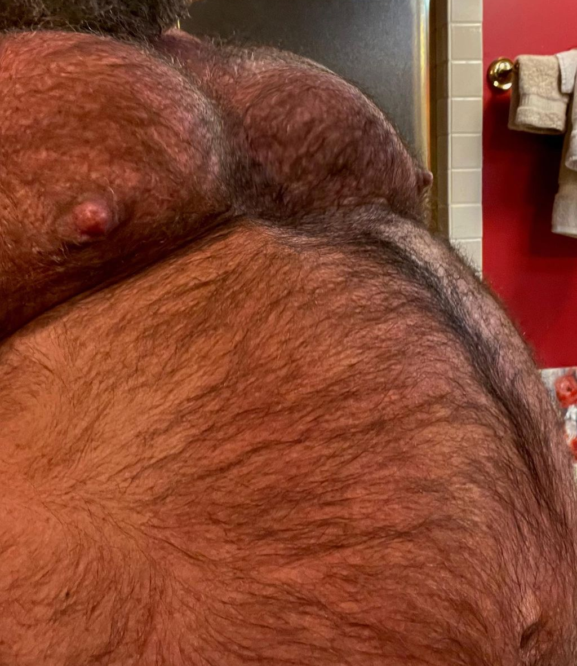
Although he had no idea why this was occurring to him, Alek knew one thing for sure - he needed to get the hell out of the sauna to fully see what was happening to him. The haze of steam left him struggling to see what had occurred to himself beyond the outline of his huge gut and incredibly prominent moobs. Desperate to exit the sauna, the trainer thus began to rush towards the sauna door to leave. But as he did so, the man nearly toppled over as he struggled to adapt to just how top-heavy he now was. After adjusting as best he could, he continued to rush towards the door to escape.

While he did so though, further changes began to quickly attack his body and completely conceal his muscles. The first area of change that became clear to Alek was his legs as he could feel his steps growing increasingly louder against the floor of the sauna and thus causing his body to continue jiggling. As he attempted to look down through the haze to see his legs, the man was quickly able to piece together that he had gained thunder thighs based on how they were now rubbing together and smashing against his manhood. As he attempted to adjust his stance by widening his legs to prevent further pain, his calves were quickly gaining flab that robbed the area of their firm and sharp angular shape and left him with thick calves that showed no indication of any definition.

Despite the short distance from his seat to the door, the various changes that attacked Alek’s body caused him to take over a minute to reach the door. As soon as he thought he would reach salvation by gripping onto the handle of the sauna door, the magic of Paul’s spell immediately caused his prominent biceps to suddenly deflate like popped balloons. As he began to tug on the door though, that vacant space left by his missing muscles was soon filled by plump flesh that soon began to make his arms larger than they originally were. But based on the way his entire body from his arms down to his legs were shaking from the frantic attempts to pull open the door, it was clear that this wasn’t an upgrade in terms of his physique but rather an extreme downgrade. The concept of becoming simply overweight was horrific to Alek, so the realization that was certifiably obese now left the man feeling like he was undergoing the worst possible nightmare. Upon taking a moment to stop and pinch himself though, the soft and vast flesh that he felt along with a feeling of sharp pain informed him that this was all real and he was somehow being punished by the universe once again!

After this moment to verify that he wasn’t dreaming was complete, another attempt at tugging on the door finally obeyed Alek’s request as it was pulled open and allowed the man to exit into the locker room. While he did so and exited the dark and hazy room though, the man found himself somewhat loathing the bright fluorescent lighting as it caused him to look down and discover his newly flabby and bizarrely wrinkled flesh. Rushing as fast as he could, the man made his way towards the full-length mirror that he had earlier admired his physique in.

Halfway through the journey though, Alek loudly cried out in pain as intense sensations began to course through his back and legs. It felt like the worst possible pain he had ever experienced, so much so that he found himself instantly trying to hold back tears as the combination of the pain and the horrors occurring to his body made him teetering on the edge of a breakdown.

Upon finally arriving at the mirror after slowing down his pace to try and not flare up his back pain, the body reflected back to Alek was far different from the one that he had earlier seen. Not only was he no longer muscular but rather incredibly obese to the point where his entire body couldn’t fit in the entire reflection due to how wide he was, Alek also picked up on the fact that he now looked even shorter in the mirror. Although he had no way of knowing this now, his assumption was correct as he was now 5’7” rather than the 6’1” height he once was.

As he leaned in closer and turned around a few times to observe his reflection, Alek quickly picked up on more new changes to his body. Not only was his vast back tattoo completely gone, but his body hair was incredibly different. Although it was similarly dense and populated as it had once been, Alek’s fear and rage about the changes to his body hair was attributed to the fact that the hair was now a weird mix of grey and white. Although he wasn’t the smartest kid back in college, the body hair along with the wrinkles that ran throughout his new form along with the intense pain that manifested around his back and legs left him able to quickly figure out what had happened to him - he had become an obese and old man.

Perfectly timed with this revelation, Alek could feel more changes occur that further made his new age and life abundantly clear. As he turned and watched as his perky ass began to widen and become dotted with cellulite, the man instinctively cringed at just how unattractive it looked. Eager to forget about the sight of his wider and lumpy ass, the trainer turned back to face the mirror frontways. By doing this though, his eyes soon picked up on the fact that his dick was changing. Given the fact that he was rocking a cock that was over 7 inches soft, it was quite obvious that something was occurring as he watched it begin to dramatically shrink. Within a second, only a nub of his cock remained nestled amongst his thick bush. To his horror as well, Alek found that he could only really see or mess with it by having one hand tugging up on his low-hanging gut.

Before he even had time to comprehend the horror that had befallen his manhood, his reflection began to change once more - this time exclusively to his head. Dropping his jaw in shock, he watched as his firm jawline was quickly obliterated with a thick ring of fat that suddenly manifested around his neck and made it seem like his neck and head had become a singular unit. Now forever cursed with a permanent double chin, the personal trainer watched as his cheeks grew pudgier and lost his prominent cheekbones as a result. While this occurred, the man’s beard instantly became a stark white similar to his body hair as his nose cracked and contorted to become the pudgy and unattractive centerpiece on his new visage.

While wrinkles began to quickly emerge along his visage to tie it in with the rest of his body, Alek’s hair underwent a dramatic change as the follicles were rapidly popping off of his scalp and forced to fall off down to the floor. Within a minute, the man’s thick and luscious hair was completely gone and scattered on the floor around him until only a grey horseshoe of hair was left on his head.
As he watched the final pieces of his visage finish changing, Alek’s face contorted from a look of shock to one of pure panic. The face staring back at him along with the body all looked familiar, he looked just like…

Before he could finish that thought though, the sound of a deep chuckle suddenly filled the locker room. With wide eyes and a slack jaw, Alek turned away from his reflection and made his way closer to the source of the sound. After a few seconds of waiting in front of the open sauna door, Alek gave a scream of pure horror as the steam dissipated and revealed what had become of Paul. Instead of the portly old man who Alek had caught making lustful stares at him, Alek found himself looking at a complete duplicate of himself.
At first, Alek had assumed that Paul had nothing to do with the changes that had befallen them given the look of pure shock that was on Paul’s face as he exited the sauna. But as the man began to run his fingers through his thick yet damp beard hair before looking deep into Alek’s eyes and flashing a cocky smirk, the trainer quickly realized that he had been right to be off-put by his client. The goddamn asshole had somehow stolen his body!

Despite just how badly he wanted to curse out Paul and demand him to give his body back, Alek found that he was too stunned to speak up. Instead, his wide eyes were forced to simply watch as the man wrapped his towel around his newly thin waist and began to saunter down the aisle of the locker room. As Paul passed by him, Alek watched as the body stealer couldn’t resist giving a devious wink in his direction before finally approaching the full-body mirror.

As soon as he made his way into the mirror, the brand new Alek couldn’t resist moving his arms and watching as his pecs bounced and widened from the motion. Although he felt giddy like a kid in a candy store, Paul attempted to remain as stoic as possible as he lifted his arms up and flexed his brand new muscles. It was such a far cry from his weak and obese body, which only made the situation of the body theft all the more hotter in his eyes. Upon turning to the side to examine the way his perky ass and pecs both jutted out from his body like shelves, the man audibly oohed as he reached a hand towards his back to admire his new full back tattoo.

After a few minutes of admiring himself in the mirror, the hunk finally turned and faced the still in-awe former trainer. Upon flashing a cocky smile in his direction, Paul finally spoke up to taunt his trainer. “Fuck, that workout was incredible,” he began, chuckling as he heard his brand new voice for the first time. “You’re right Alek, I truly do feel like a brand new man now!”

