Home Improvement
By Soul-Controller

As Timothy made his way into his bathroom to take a shower, there was an obvious sense of annoyance spread across his face in the form of a deep frown. Although he had just graduated early from college and returned home six months prior, his nosy and rather controlling parents were eager for him to either move back out or get a high-paying job so they could charge him for rent and utilities. Due to his parents’ persistence, the man wasn’t allowed the opportunity of having a break and just relaxing for a few months after four years of intense engineering courses. Instead, he was forced to immediately begin looking for a job.

* * * * *

This job search began just a week after Timothy had finally packed up his belongings and moved back home to his rural Midwestern town. During one of the days where he was forced to help run some errands with his father, Timothy found himself in a local hardware and general shop that had a help wanted sign taped to the front window. Of course, as soon as Timothy’s father got his desired items and reached the cash register, he couldn’t resist inquiring about the help wanted sign. As the bulky corn-fed cashier gruffly told them about their need for a new cashier, Timothy immediately tensed up as he knew what was going to happen next. Just as he had expected, his father immediately pushed the meek blonde-haired man closer to the counter while talking about how his son was in need of a job after graduating.

Upon hearing this, the cashier called up a manager to talk with Timothy as he finished ringing up the items that his father was purchasing. Before he knew it, Timothy had been taken to a backroom, finished an interview with the manager, secured the position, and even been given a start date that was in just 3 days.

As he walked out to his dad’s car to share the news, Timothy tried to mentally prepare himself for the impending disagreement with his highly argumentative father. Given the fact that he had no “manly” pastimes like manual labor, he would literally be a fish out of water if he was forced to work at the hardware store. But no matter how hard he tried to explain this fact, Timothy found his father unwilling to budge on the prospect of a new job. In fact, his father even gave him an ultimatum - take the job and work there or move out and live elsewhere. Knowing that his closest living relatives were his redneck grandparents that lived down in Kentucky, this left the openly gay man with little to no options. In fact, as Timothy slowly nodded his head and agreed to take the job, his father stated the same thing to him while taking the opportunity to make a few jabs at his son’s sexuality.

“No offense kid, but it would be nice for you to become a bit more manly from this job. I mean, it’s no wonder you can’t ever find yourself a boyfriend when you’d rather play video games and mess around with Legos,” his father said with a hearty chuckle, finally putting the car into drive and allowing Timothy to escape his brand new personal hell (at least for those next 3 days).

However, by June, Timothy hadn’t learned to become more of a man’s man from working at the hardware store. Inversely, it had only reaffirmed his raging homosexuality as he found himself constantly thirsting over the hunky clientele that ranged from hot burly dads to hunky construction workers that stopped in to replenish their materials on occasion. As he stood at the register and watched as the men lifted their heavy items up from their carts and onto the counter, Timothy was constantly enamored by how their biceps and pectorals bulged against their too-tight shirts along with the slight reveal of their hairy stomachs as they lifted the items up high enough to reach the counter.

Due to the constant flexing sessions that he was always witnessing, the pale man was constantly thankful for the counter that helped conceal his near-constant boners. Given the fact that he was in an extremely conservative town in the Midwest, it seemed likely that this would be the closest he’d get to any real and personal intimacy with a man (at least without the high risk of being hate-crimed) until he saved up enough money to move out and jump into the next phase of schooling for his electrical engineering career.

Although it wasn’t surprising that being back in this rural town was impactful to the man’s confidence in terms of his sexuality, Timothy was quite certainly shocked by how detrimental returning home was to his mental health. In fact, it had gotten to the point where he was so depressed that he found himself wishing at night that he could no longer have to fear showing love and affection towards men.

* * * * *

Watching as steam finally began to rise up above the shower curtain, Timothy finally stopped himself from traveling down memory lane. He only had 45 minutes to finish getting ready and eat some food before his shift started, so he definitely needed to get in and out of the shower as quickly as possible. As such, the man quickly pulled off his shirt, shorts, and underwear until he was completely nude. Taking a moment though, he opted to take one look at himself in the bathroom mirror and observe his features.
Much like every other day though, as soon as his eyes stared into his reflection, he was quite unimpressed by what he saw. Not only was his body lacking in any form of muscle definition, but his pale complexion made him look even more frail and weak. Despite having a gorgeous set of light blue eyes, they were not appealing enough to compensate for the man’s patchy facial hair, bulbous nose, and crooked teeth. Continuing down his body, he immediately cringed as he stared at his definition-less chest and saw the thick patch of brown chest hair that stuck out like a sore thumb on his body. Although it was incredibly unattractive, Timothy couldn’t bring himself to shave it off as he believed that he would look practically invisible without that hair to bring in a much needed pop of color.

Even though he was disappointed with the vast majority of his body though, there was one part that he wasn’t ashamed of - his cock. Looking down, he stared at his 5” flaccid cock and couldn’t resist allowing a slight smile to form on his face. While this was certainly an impressive feat for the blonde twink to have, it was even more hot to him when thinking about how long and girthy it got once he was hard. This was yet another reason why he was thankful for the cubby hole that was underneath the counter at work, as it was able to easily conceal the 9” cock that would proudly jut out of his pants no matter how hard he tried to conceal it.

Although this was certainly an impressive thing in Timothy’s eyes and something that he was actually happy about, the concept of having a long cock was quite the double-edged sword. Given the impressive size, he was quite a hit on Grindr while he was in college, but by the time Timothy would send the desired selfie to the person interested in hooking up, the conversation would immediately die and he’d end up spending yet another night alone. As he took a moment to observe it for one more moment, he silently wished for the opportunity to finally lose his virginity before entering the shower and preparing for the inevitably boring shift he was going to have.

After finally finishing up, putting his uniform on, and getting a quick bite to eat, Timothy finally made his way out of the house and drove to his workplace. Luckily enough, he had a few minutes to spare and thus opted to try and hype himself up by blasting some loud pop music in his car to try and keep his energy up. The store was a black hole of Timothy’s positivity, especially due to the gross fluorescent lighting and the near constant country music that played through the store’s speaker system. But as he checked his watch and saw that he only had two minutes to spare, the man finally turned off his car and made the agonizing yet short trek into his personal hell for the next 6 hours.

For the next two hours, Timothy’s pop song pick-me-up did little to save him from becoming miserable almost immediately. The clientele for the majority of the shift so far had been older elderly couples that had purchased a few items and then loved to complain to Timothy about “his lazy generation”, so it was safe to say that he was understandably ready to go home already. But luckily, Timothy was able to get some much needed eye candy shortly after passing the two hour mark as a shaggy haired blonde jock came into the store. Immediately upon hearing the man’s dopey and dim-witted voice ask for directions towards the clothing section, the cashier’s cock rose to attention as Timothy smiled and pointed him in the proper direction.

Upon hearing the jock thank him and refer to him as “bro”, it wasn’t a surprise that Timothy’s cock almost immediately began to dribble out pre-cum for the next 20 minutes while he continued to observe him in between customers. This also wasn’t helped by the fact that the jock decided that he wasn’t interested in using the store’s dressing room and instead peeled off his shirt to show off his ripped torso while trying out a series of tank tops. Although he could have watched the man change for hours, the sudden clearing of a throat near him caused Timothy to finally turn back towards the checkout lane.

Immediately, he found himself staring face-to-face with a striking woman. Although he had no interest in her due to the fact that she wasn’t a man, Timothy could easily notice how gorgeous the woman was due to her long and wavy brunette hair, impressive makeup that allowed her eyes to look incredibly doe-eyed, and a curvy figure that was struggling to stay within the confines of a tight flower-patterned sundress.

“Oh hello there,” Timothy said, attempting to hide his blushing towards the stripping jock with a wide smile. Looking down, he watched as the woman placed her basket of items onto the countertop and flashed back a bright white smile towards the cashier.

“Hi there. I was wondering if you’d be able to help me make sure I’m getting the right stuff,” she said, her voice in an incredibly cheerful tone that immediately caused Timothy to not feel so dour.

“Uh, I’m not really the best person to ask about this stuff, but I can try my best to help you out I guess,” Timothy said, that wide smile shrinking into a smaller one as he leaned down towards the basket and pulled the items out. In doing so, he found himself staring at a bucket of screws, a few common tools, and a large handheld drill.

“Oh that’s ok, my husband sent me a list of things to get. I just want a second opinion to make sure I’m not misreading anything,” the woman responded, pulling her phone out of her purse and beginning to unlock it.

In hopes of trying to make some small talk and allow the time to pass a bit faster, Timothy found himself trying to engage in more conversation as she scrolled through her text messages. “So, what are you doing with all of this stuff,” he inquired, looking up from the counter and towards the woman.

“Well, my husband’s been wanting to create a back patio and deck for our house for a few years now. So now that he’s got a huge increase in customers at his business, he finally decided that he was going to make it over the summer. His goal is to finish it by the 4th of July, but I honestly don’t know if he’ll finish it in time,” she said, finishing her sentence with a light chuckle that only made her seem more bubbly in Timothy’s eyes.

“Ah nice, that’s cool. My parents have a back patio at their house and it’s really nice,” he responded, his tone growing increasingly chipper with each exchange they had between each other. “You said your husband got a huge increase in customers at his business right? If you don’t mind me asking, what does he do,” he further inquired, his still-horny mind from the shirtless jock dude making him eager to paint a mental portrait of this mysterious handyman husband.

“Oh no, it’s totally fine. He’s a personal trainer, he runs a business out of the local gym here and also through Instagram and stuff. I guess you could say he’s a bit of an influencer, but not really since he’s terrible with technology,” she continued, flashing a wide smile that once again made Timothy’s workplace not feel so drab and boring for the moment.

Upon hearing the concept of her husband being a personal trainer, Timothy was back to being rock hard from underneath the counter. Letting his mind run wild, he envisioned the most attractive and muscular man possible, thinking about how great it must be to be with someone like that. In many ways, Timothy was jealous of the woman, but he was also happy for her due to her seeming like a nice down-to-earth lady.

“Ah here it is,” the woman cheerfully said, breaking the horny gay man out of his inner thirsting as she handed the phone over to Timothy to show him the text. Taking his time, the man slowly checked and verified that each item that the woman had grabbed was correct. But as he did so, he also took the opportunity to scan through the messages that he had sent both prior and after the list text. From doing this, he was able to find out the hunky man’s name: Liam.

Just as Timothy was able to finally gather that information about the man’s name, the woman’s phone suddenly buzzed as a text message came through. At that instant, the phone automatically pulled Timothy down to the most recent message, which was a brand new text from Liam that he couldn’t resist reading.

Liam: Hey babe, just got done at the gym. Gonna wash up and head home. I’ve been thinking about you during my entire pump… 🍆
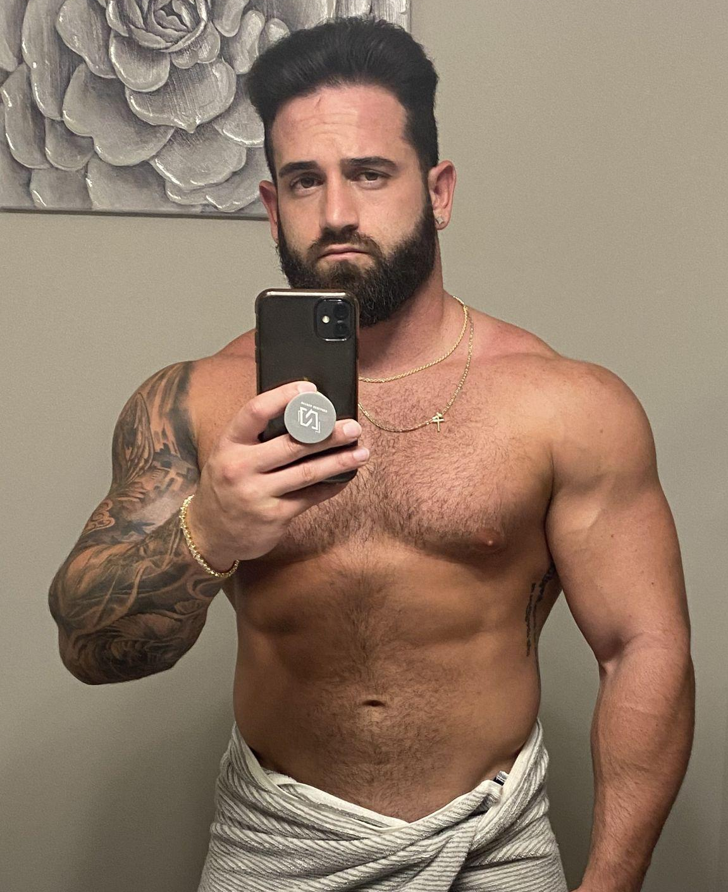
Right after he finished reading that message, the phone once again vibrated as a brand new image suddenly appeared and allowed Timothy to see what the woman’s husband looked like. Given the reveal, Timothy felt his dick throb from underneath the counter as his dirty mind envisioned the hunky tattooed man fucking the giddy and cheerful woman in an extremely dominant fashion. Apparently, this vision was able to elicit a shift in Timothy's expression as the woman curiously asked what was wrong.

Breaking himself out of that horny mindset, the man was understandably flustered about how to respond. “I- um, your uh, husband sent you a message,” Timothy stammered out, handing the phone back to the woman and allowing her to gasp and blush before closing the phone and tucking it back into her purse. “But uh, those are all of the correct items he asked for. So yeah, we can go ahead and get you charged for these items,” he continued, attempting to change the subject while trying to get his cheeks to no longer look flush.

Upon finishing ringing up the items, Timothy quickly announced the total and proceeded to the payment phase as the woman, equally bashful, inserted her card and entered her PIN code. While this was going on, the pale gay man’s mind was going wild with continued visions of Liam completely nude. But instead of envisioning him with the brunette woman, Timothy had instead inserted himself into the visions, allowing the hunk to easily seduce and fuck his tiny ass while making Timothy worship his muscles.

As the payment went through and the receipt finally began to print, there was one lingering thought that was running through the cashier’s head. I would literally do anything to have a life with a guy like that. They seem so genuinely happy and in love with each other, why can’t I ever have something like that for myself? But as he saw another customer finally begin to join the line, Timothy forced himself to push aside that thought. Quickly grabbing onto the receipt, the man extended it outwards for the woman to grab as he told her to have a great day. But as soon as she gripped onto the receipt, Timothy’s vision went completely dark and he seemed to be enveloped into nothingness.

Out of nowhere though, an all-too familiar voice suddenly was picked up on and made Timothy feel confused. “Excuse me ma’am, you dropped your receipt,” he heard, which caused himself to finally return to consciousness and open his eyes. Upon doing so, the man audibly gasped as he found himself standing at the other side of the counter and staring at his own body.

“Wha, what’s going on?” he said, his voice wavering as he began to hyperventilate in complete shock. Why does my voice feel weird and sound incredibly soft? As he felt a slight weight tugging against his left elbow, Timothy darted his eyes downward, which caused him to suddenly see a light pink purse hanging from it. Beginning to piece things together, the man quickly looked around further, taking note of the thin and flowy sundress he was now wearing, the perky and sizable breasts that were threatening to spill out of that aforementioned sundress, and the long wavy hair that kept falling into his face every time he leaned downwards. He had somehow swapped bodies with the female customer!

Although he was understandably confused by what was going on, that confusion was further elevated as he found that the woman who had swapped bodies with him seemed unaware of anything that had happened to him. In fact, Timothy’s usual pessimistic and dour mood was on full display as if she was the real version!

“Uh nothing is going on lady. You bought your items and then dropped your receipt before spazzing out for no reason. I’ve got a bit of a line forming, so I’m gonna have to ask you to move aside so I can start helping others,” the woman-turned-cashier coldly said, immediately telling the next customer to move forward so “he” could begin scanning them.

In complete shock, Timothy gripped onto the three bags that the woman had purchased and sort of slowly moved away from the register. Throughout the few strides he made towards an empty section near the front of the store, Timothy found himself immediately stumbling due his new footwear: a pair of white platform wedge sandals. While it seemed as though the woman had naturally adapted to believing like she was a man and acting like the real Timothy, the brand new married woman hadn’t been afforded the same luxury.

Due to this, Timothy found himself curious and somewhat eager to get more acquainted with his new form and thus decided to head towards the bathrooms inside the store. Although he almost nearly ran into the men’s restroom, he was able to successfully stop himself before trouble ensued and head towards the women’s restroom. Upon making sure that no one else was in the restroom, he locked the door behind him and set down the bags of items against one of the walls. Upon doing so, the man gingerly made his way towards the mirror and watched in awe as the woman’s curvy figure and gorgeous face were reflected back at him. No matter how hard he tried to pinch himself (and his new dainty and hairless arms) in hopes of discovering this to be some strange dream, the desired result didn’t occur for the incredibly confused man.

So for several minutes, Timothy playfully tested out his new body in a multitude of ways. He expressed countless emotions to see how they manifested onto the cute face of a woman and took note of how annoying long hair could be despite enjoying running his fingers through the wavy brunette locks. Due to his more curvy figure as well, he couldn’t resist running his hands up his dress and squeezing his large breasts and pillowy ass cheeks to adapt to his new hourglass figure. Upon doing this, the man grew curious further and decided to experiment by breaking into a jog in place to feel the sensations he would now be forced to get used to. Although it was certainly not great to feel such strange areas of heft in comparison to his skinny and frail body, Timothy believed that he could most certainly get used to it in time as he spent more and more time as a member of the opposite sex.

Before he could dive further into exploring his new form though, a sudden vibration emerged in Timothy’s new purse. Unzipping it, he pulled the purse lips open and reached in with his well-manicured pink nails. As they finally grazed against the woman’s cell phone, he gripped onto it and pulled it out. Clicking on the power button, he watched as the home screen informed him of a brand new text from Liam. Although he had no idea what the woman’s passcode was, FaceID came to the rescue as he was granted access to his new phone and quickly opened up the new text message.

Liam: Hey babe, is everything ok? You read the message but never responded.

Although he knew that he was talking about his wife, Timothy’s heart couldn’t resist fluttering upon realizing that Liam was now talking about him. As such, he was quick to fire off a message to try and explain the delay

Timothy: Yeah, sorry about that. I was dealing with some issues at the hardware store.

Liam: Oh ok, do I need to come down there?

Upon envisioning the concept of the hunky personal trainer coming to his rescue, Timothy would have surely been rocking a thick and throbbing boner. But now that he was a woman, this sensation was now a deep tingling from the inner depths of his crotch. Giddy at the attention from his new husband, instant flirtation immediately came to his mind that quickly translated into text.

Timothy: No, but I certainly wouldn’t be mad at seeing you sooner rather than later.. 👀

Although he wasn’t intending on beginning a sexting exchange with his new husband, Timothy’s words seemingly spurred Liam into action as Timothy soon found his phone bombarded by a text and video.

Liam: Ask and you shall receive babe! 😜 I’m always down to please you Cassie, and as you can see, I clearly miss you too…

While Timothy was most certainly excited to check out the video that Liam had sent, his attention was immediately caught by the fact that he now knew his new name. Cassie, you definitely seem like a Cassie, he thought to himself as he turned into the mirror and admired the girly visage and body. Now secure in his new identity, the brand new woman took the opportunity to click on the video and allow it to play.

Immediately, the former man became incredibly horny as he saw the camera panning down and showing off every inch of the man’s dewy skin. He moaned in pleasure as he saw the man’s tattooed arm that worked incredibly well with his biceps, but none of that compared to the point when the camera panned down to the man’s crotch that was being playfully concealed with a small washcloth. Biting his glossy lip in lust, Timothy mentally begged for the man to drop the towel but was annoyed to find that the video stopped just before that occurred.

Cassie: Wow you’re such a fucking tease, why did you have to end it right before the
best part? 😩

Liam: I mean, how else am I gonna encourage you to come home ASAP? I’m needy and want you so badly…

Feeling that wave of pleasure coursing through his body once more, Timothy was eager to continue on with the teasing.

Cassie: I want you so badly too babe. I’ve been thinking about you a lot too…

Liam: Prove it.

Being egged on by the sense of a challenge, Timothy decided to become even more of a tease to the horny man. Pulling open the camera, he began to record himself slowly pulling down his sundress before suddenly wagging a finger at the camera and abruptly ending the recording. Upon sending the video off, Timothy couldn’t resist chuckling as Liam rapidly typed out a response.

Liam: C’mon babe, gimme some more. I’ve sent you several compromising photos and videos so far. You’re in a public restroom, lock the door and give me a little bit of a show!

Feeling incredibly eager to both please his new husband while also being encouraged by how much he lusted over his wife, Timothy once again verified that the door to the bathroom was locked before finally deciding to further explore his body. Gingerly, he slipped off the sundress and allowed it to land in a clump on top of his platform sandals and partially slump onto the tiled floor. Although he felt an inner desire to pull off his bra and take a look at his tits, the concept of struggling to pull back on the bra left him quick to abort the idea. So at first, he quickly snapped a few photos in just his bra and panties before sending them off.

Since he knew that Liam would surely be begging for more though, Timothy furthered the fun and decided to pull down his panties and take the opportunity to record himself exploring his new genitalia. As such, as soon as he pressed record and began to run his fingers along the lips of his new pussy, Timothy couldn’t resist moaning and uttering Liam’s name as he envisioned the hunky personal trainer putting every inch of his clearly sizable manhood into his femine folds.

Upon finishing recording the video, Timothy quickly sent it off and admired his figure some more while awaiting his husband’s new response. Not surprisingly, it only took a minute after the message was delivered for Liam to send another text response with an accompanying photo.

Liam: Oh fuck yeah babe, you better feel up that tight little cunt and think of me. I’m tired of waiting, get dressed and come home immediately. The sooner you get here, the sooner I can eat you out before we get onto the main event…

Reading the message in conjunction with the open mouthed photo that his husband had sent, Timothy was just as over the texting as Liam was. Although he had no idea what was going to happen when it came to having sex with a pussy, his desires and lust for the man was too much to resist any longer. So as he pulled back on his panties and the sundress, Timothy took one last look into the mirror before zhuzhing up his hair.

As soon as he would exit this bathroom, he would forever leave behind his old life as a pale and frail gay virgin. Although there was a slight twinge of loss towards his years of hard work when it came to college, none of that would matter if he had no one to hold him at night and treat him with the love and respect that he deserved. So although he wasn’t entirely the biggest fan of losing out on his impressive cock and becoming a woman, he ultimately viewed it as a necessary loss to get everything that he’s wanted in life. After leaning down and grabbing onto the bags of items that her husband had wanted, the brand new Cassie eagerly unlocked the door and stepped into her new life.

Making her way out of the hardware store, the woman’s hips naturally swayed and allowed her juicy ass to draw all of the attention of the other shoppers (as best as it could from her gorgeous and prominent rack). As she approached the front door of the store, Cassie slowly turned around and gave a light wave to the bored-looking cashier. Not surprisingly, his wave back was not enthusiastic in the slightest as Timothy quickly did that and went back to taking care of the blonde-haired jock who had a basket full of tank tops resting on the counter.

Turning back on her heels, the woman finally made her leave and slowly pressed the fob of her car keys until her car revealed itself to her. Finally approaching it, she quickly opened the backseat door and deposited the three bags before finally entering the driver’s seat and turning on the engine. Quickly pulling open her phone, she pressed the
“Home” location on her phone’s GPS and allowed the directions to begin. As she sat there for a moment, a wide smile formed on her face as she realized just how great this life was going to be for her.

As if on cue, a loud ding echoed through the car’s speakers as another text message from her husband filled Cassie’s car. Opening it up, she couldn’t help but gasp at what she both read and saw.

Liam: I love you so much babe, I can’t wait to fuck your pussy so good tonight. Just think of all of the fun we’ll have this summer once I finish building that patio deck for you…
Not surprisingly, Cassie’s mind began to play the video on an endless loop. With each instance of watching her husband bite his lip in an incredibly erotic way and shake his sizable bulge for the camera, she found herself quite desperate to get her hands, mouth, and pussy all over his glorious manhood. As such, the woman instantly pulled her car into reverse before speeding off to have some quality time with the absolute love of her life.

