ROMANCE SIDE STORY (ROXXI)

- Go to the bar in the undercity main level during the evening, and you will have a chance (it’s a randomized encounter which resets every day) to see Roxxi sitting near the entrance of the bar.
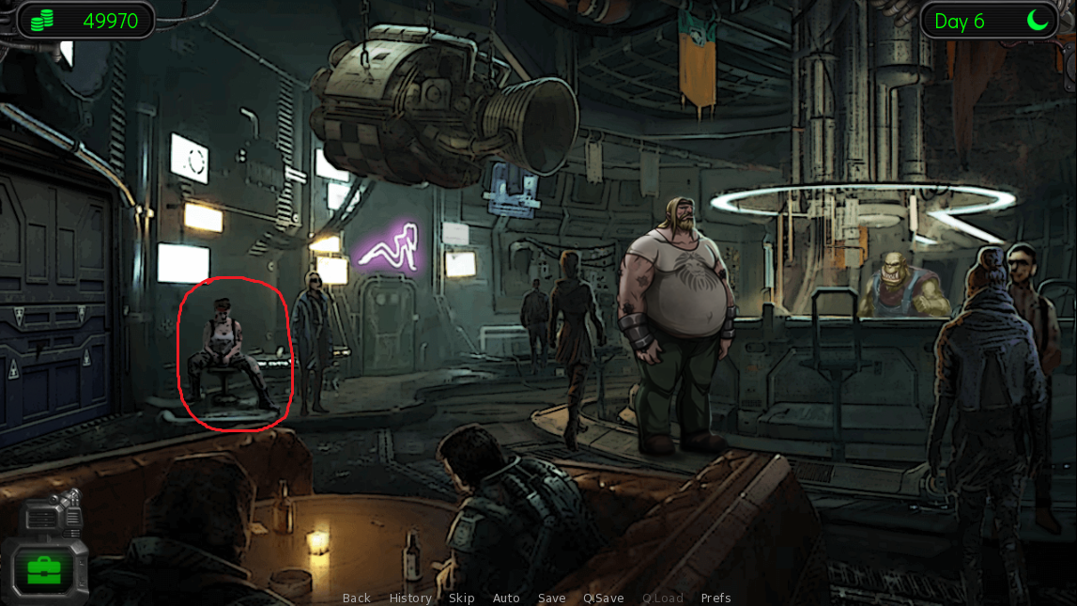
- Offer to buy her a drink and she will open a conversation with you (you will need at least 3 perversion level points in order to do this)
- At the end of the conversation, you get her vox communicator ID number so you can contact her from your apartment.
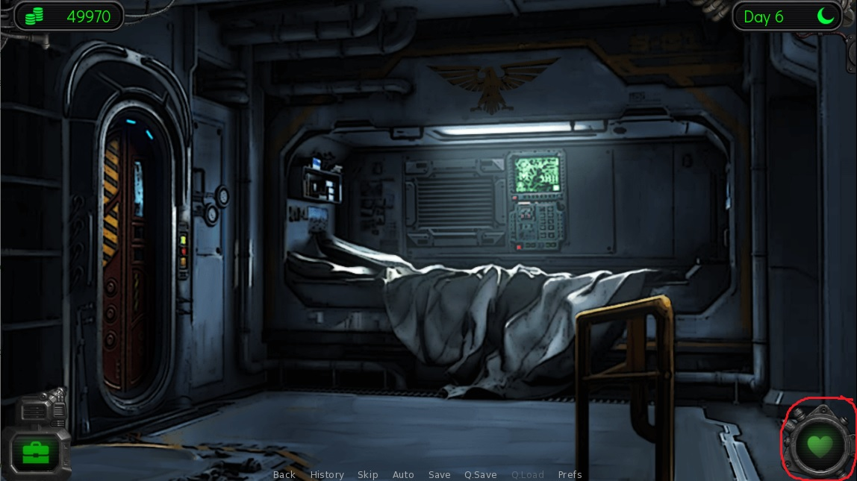
- By clicking the “Call Friend” interface, you will be able to talk to people who gave you their vox comm id number, and in this case, you have Roxxi.
- Initially, you will only be able to talk, and check your relationship level with the person.
- The talk option will have two sub-options which are: ask advice and talk about personal questions. Asking advice (feature still under development) will start a conversation between Roxxi and Heidi where they talk about the mainstory related events, this will change according to the mainstory progression level and you may do this as much as you like during each day. Talk about personal question will start a conversation where Heidi asks Roxxi about herself and her homeworld (at the end of each these talks, the relationship level will slightly increase) and you may only do this once every day and you need to sleep before you can do this again the next day.
- You may also talk with Roxxi again in the bar during the night. Here there will be two dialogue options. The first option is to chat with Roxxi. This option will start exactly the same conversation as the “Ask Advice” dialogue option from the vox comm in your room. The second option is to give Roxxi some gifts in order to increase the relationship level.
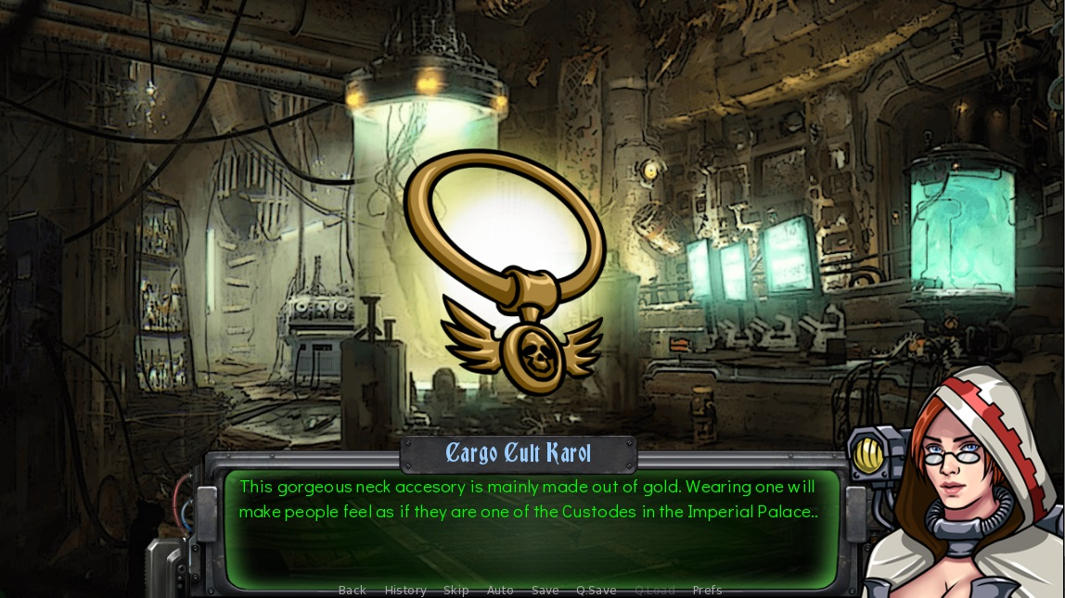
- Gifts items can be purchased from Karol and Vugnog. They may not be equipped, or used for the main quest. These items can only be given to your romantic partners. Each item will have different effects for different partners. Some will prefer Weapons than Food etc.
- When your relationship level is high enough (The person adores you), you will be able to ask them to go out on a date from the vox comm in your room.
- With Roxxi you will begin to ask her out on a date to the Bar. There, a sex scene will occur in the restroom of the bar, but before that you will need to decide if you want to shave her armpits and/or pubic hair. Note that this option will have permanent effect (Roxxi will keep her body hair throughout the game if you decide not to shave her and vice versa so choose carefully).
- After the sex scene in the bar, you will have two additional Dialogue options for asking her out. When you’ve done two more dates, there will be an option to invite your partner to the apartment to have sex and sleep over (the feature is still under development).

