The Man of Steal (Part One)
By Soul-Controller
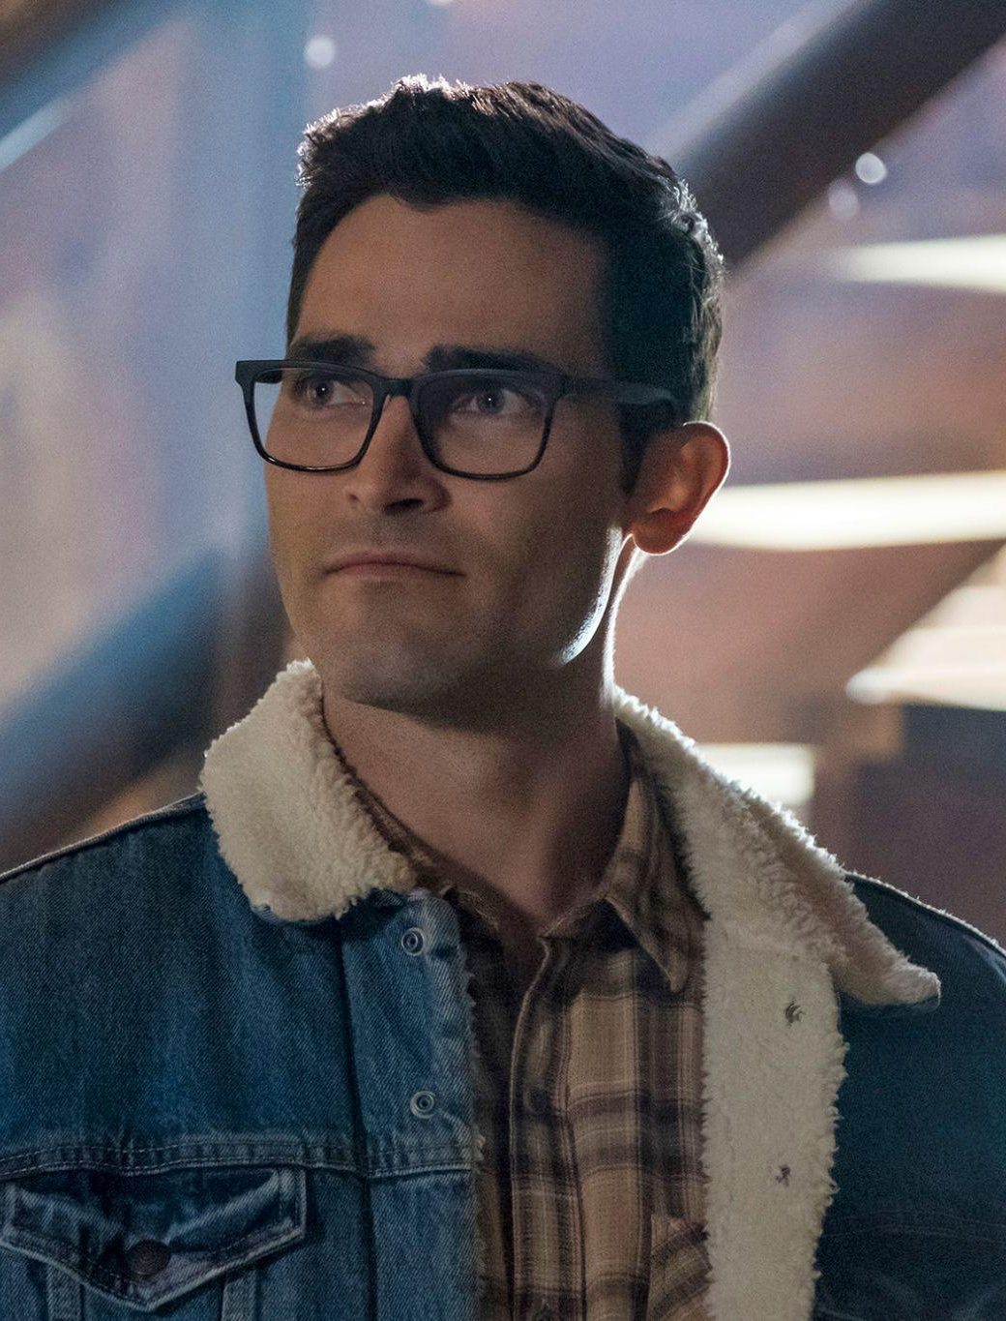
For Superman, it seemed like his desire to enjoy his normal civilian life as Clark Kent was an impossibility. Any time he planned to have any sort of family event with his wife Lois and two sons (be it dinner or a simple trip to the movies), there always seemed to be some sort of interruption from the news that begged for the assistance of the crime-fighting vigilante.

This was proven to be true once again as the Kent family began to assemble for their family dinner. Just as Clark started to help himself to Lois’ home-cooked meal, the television in the living room suddenly went off as a breaking news bulletin appeared. With his innate desire to protect others and save them from danger, the superhero couldn’t stop himself from leaning past the dining room table and taking a closer look at the screen. For several minutes, the man intently listened to what the news reporter had to say. According to that anchor, it appeared as though a museum a few towns over from Smallville had been broken into by a criminal.

When the reporter first brought up the fact that it was one individual stuck in a stand-off with nearby police surrounding the museum, Clark had originally decided to just allow the cops to do their job so he can spend time with his family. But as the news anchor began to include more details about the museum, Clark’s attention was immediately piqued when she stated that the museum had just recently opened an exhibit devoted towards educating everyday individuals about Superman and his home planet Krypton.

As soon as the reporter began to discuss the fact that the museum had a priceless amount of Kryptonian relics on display, Clark gave an apologetic look towards his wife and kids before quietly sitting up and rushing into his bedroom to pull his suit on. The threat of having some criminal get their hands on some Kryptonian equipment rightfully caused Clark to be alarmed. While he dedicated his life towards using these powers for good, Clark was fully aware of how detrimental Kryptonian items could be with others. In fact, it was for these exact reasons that he recalled how he didn’t even offer his blessing towards the museum’s exhibit when they first proposed it to him. Of course, his prediction came true and now he was going to have to fix it before countless people could get hurt! So as he pulled on his suit and took one good look at himself in the mirror, the man wasted no time rushing out of his house before pushing off of the ground and rapidly flying off into the night.

Within a minute, the hero was able to rapidly traverse across several miles of farmland and make his way to the museum. As he quickly made a hero landing onto the concrete road outside of the museum, Superman made his way up to a group of officers to get an up-to-date report about what had occurred so far. According to the head officer in charge, the unknown criminal had accidentally tripped a security laser upon breaking into the museum. With the assistance of drones that could look through the glass atrium in the middle of the museum, the police were able to determine that the man was working alone yet heavily armed with an armored suit and a high-grade weapon. As such, a stand-off was afoot with the police attempting to convince the man to surrender and prevent anyone from getting hurt. Unfortunately though, these talks had quickly stalled and the criminal refused to surrender, instead deciding to further barricade himself deeper into the museum.

Given the tough situation that the police were in, Superman was quick to offer his services due to his skill set and innate bulletproof skin. Although there were a few officers there who gave him sneers and angrily told him off for “invading their turf”, the Smallville resident tried his best to remain positive and cheerful in order to help bring another criminal to justice. Luckily, the chief in charge of the operation got his men in line and gave the superhero the go-ahead to help remedy the situation. After giving a slight nod in the chief’s direction, Superman levitated himself back into the air before flying up to the top of the several stories high museum.

Upon setting himself back onto stable ground, Superman quickly traversed across the museum’s metal roof until he approached the glass dome in the middle of the museum atrium. As he peered around, it didn’t take long before he saw the criminal walking around in the bulky armored suit. Not wanting to inform the man of his arrival though, Clark opted to quickly use his laser vision to cut out a portion of the window so he could slyly sneak through the hole to surprise the villain. Upon doing so and quietly setting the portion aside, the hero carefully squeezed his bulky and muscular physique through the cut-out section of the glass. Once he was through, the hero slowly levitated his way down to the ground floor and hid for a moment to conjure up a game plan.

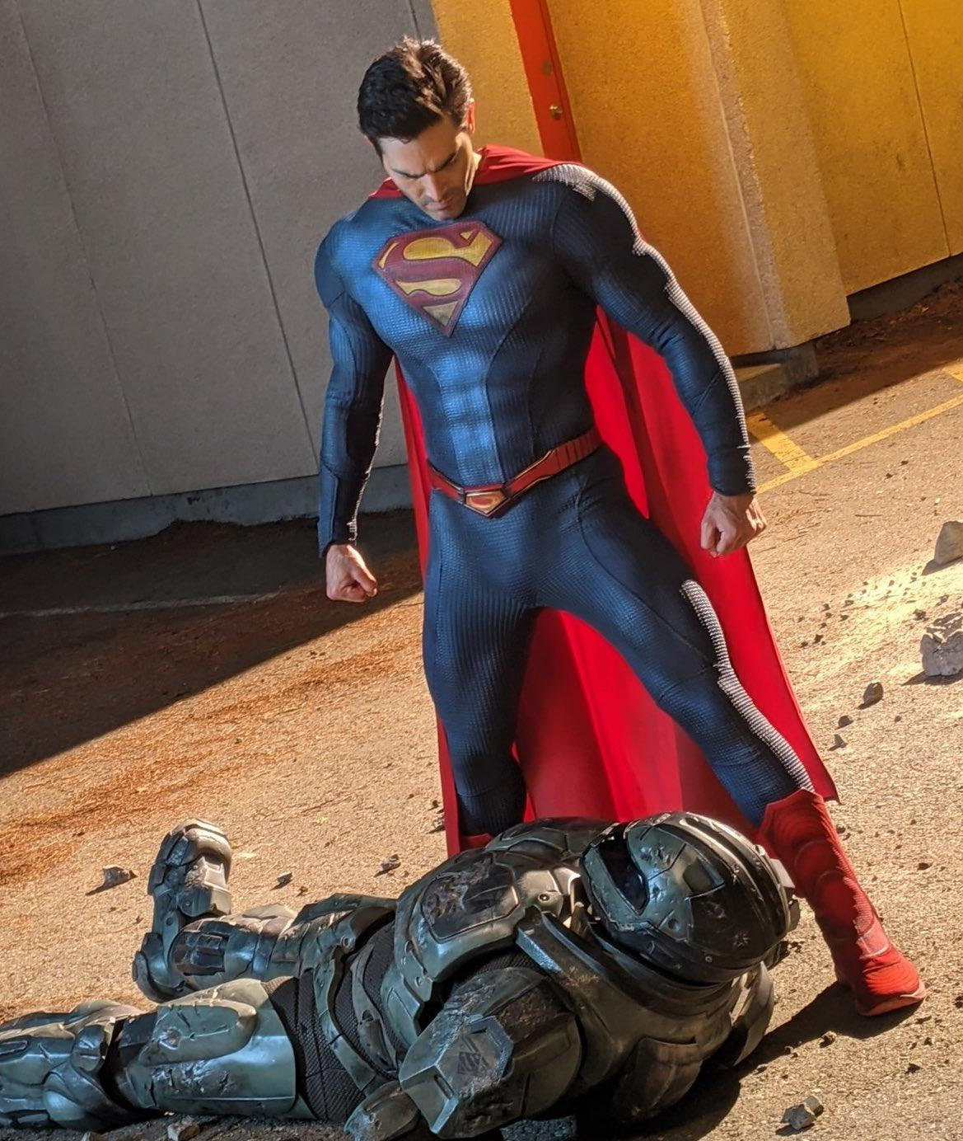
As he quickly looked around, Clark decided to sneak attack the man with a high-speed collision to hopefully disarm him and destroy his suit so he could be easily apprehended and delivered to the police. Narrowing his eyes and taking a moment to prepare himself, the man then wasted no time as he flew at top speed and his body crashed through the long aisles of museum displays. Before the criminal could even turn to look at the source of the noise, the hero’s extended arms immediately collided with the metal suit and easily pushed him against the wall. But given Superman’s extreme strength, that wasn’t all as the force of his movement caused the duo to crash through the concrete wall before Clark gripped onto the collar of the suit and threw the man to the ground.

While the confused criminal grimaced and groaned from the impact, Clark wasted no time tugging off the suit piece by piece until the villain was left in nothing but his normal clothing. Upon peering down to examine the culprit behind the robbery though, Clark found himself shocked to see that the man’s appearance was quite unusual. Most of the villains he faced were these imposing figures who had bodies that were packed to the brim with a musculature that could rival Superman’s own physique. But looking down, Clark instead found a man who had no sort of muscle definition or impressive physical features.

Taking a look at the man’s overall physique, Clark was baffled to find that the criminal was stuck with fragile-looking arms and legs that seemed to indicate that he would be tired from even a simple jog down a street block. The man seemed young, yet with his high hairline and partial balding, Clark presumed that the man was in his mid to late 30s. To make matters worse for the man, the criminal’s pale white face and body was also ravaged with a vast array of scarring and tattoos that caused Clark to surmise that he was some sort of low-level gang member. Despite the gang affiliation though, it seemed like the poor man had been unable to pack on any muscle and was instead treated like a punching bag and guinea pig by the higher-level members based on the intense scarring that resembled knife cuts.

As the man began to stir back into consciousness, Clark opted to try and take a more gentle approach with the criminal. Clearly the man posed no physical threat to him, so he tried to be as delicate as possible upon extending a hand towards the man and quickly pulling him up to his feet. With the man looking around in pure horror as he saw his unsuited self and Superman’s imposing body, Clark tried his best to calm the man’s nerves and indicate that he had no desire to hurt him further.

“Hey, don’t worry, no more fighting needs to happen tonight. Given the threat level of that suit you were wearing, I just had to disarm you as fast as I could and figure out who was operating it,” he calmly said, looking down at the frail individual and trying his best to give a reassuring smile. “So, what’s your name?” Clark inquired, trying his best to form a connection to the criminal. In many ways, the frail and anxious man reminded Clark of his own son Jordan. Clark’s relationship with Jordan was currently strained at the moment, so the superhero father felt a strange desire to view the criminal as a stand-in for his son and thus try and be a positive influence to help the man change his life and be the best version of himself he could possibly be. If he was able to successfully do this for the criminal, Clark was hopeful that he could replicate the same thing with Jordan and fully reconnect so they could be as close as they once were.

Although the criminal remained tense and quite uncomfortable being in the hero’s presence, he eventually decided to answer Superman’s inquiry. “It’s Darren,” he said, a thick midwestern accent coming from his throat.

“Gotcha, well it’s nice to meet you then Darren. I wish it wasn’t under these circumstances, but alas here we are,” Clark said, finishing his sentence with a heavy sigh. “Your plan though, it’s over now Darren. I don’t know what you were trying to do here tonight, but let’s just end this now so no one has to get hurt in the process. Alright?”

After silently nodding his head in agreement, Darren shifted his head down in apparent shame as he slowly began to make his way back into the main atrium of the museum. As he passed through the large hole into the concrete wall though, the criminal opted to continue speaking once more. “I was just trying to get some quick cash to help pay for my mom’s hospital bills. She’s not doing good and I don’t have the money to keep paying for her tests,” he solemnly said, causing Clark behind him to frown in sadness.

Despite his innate desire to bring criminals to justice, Clark couldn’t help but feel severe empathy for the man. It seemed as though all avenues of Darren’s life led to disappointment and struggle, so it was no wonder why the man had no other option to resort to a life of crime! As such, Clark’s warm heart left him eager to try and help fix one aspect of Darren’s hard life.

“You know, I actually know some people who work at Metropolis General Hospital,” he began, tilting his head and looking down towards the captured criminal with a light smile. “If you wanted, I could definitely pull some strings and help get some of your mother’s tests covered for fr-” he continued, the words unexpectedly being interrupted as a sudden impact into Clark’s gut caused him to stop speaking. As he watched Darren pull his elbow back up away from his stomach, Clark’s eyes widened. The man had truly just said anything so he could get Clark’s defenses down and try to make an escape!

Watching as the man quickly fled on foot through the museum, Clark’s eyes began to rapidly redden due to the intense rage he felt about being tricked. Although he felt no pain from the impact due to his general invincibility, he couldn’t help but feel a bit embarrassed about being so easily fooled. But rather than allowing his laser vision to come out in full force and quickly stop Darren in his tracks, Clark mentally pulled back due to the fear of accidentally killing the man. Instead, he stood back up onto his feet, dusted off his dusty shoulders, and pushed off the ground to begin flying towards the still-sprinting criminal.

Given his rapid speed, it didn’t take long before Superman was catching up to Darren. To be fair though, the task was fairly easy for Superman as Darren’s frantic clumsiness had caused him to stumble over the tipped over display cases and trip over the various artifacts that those cases had once held. As he extended his arms out in hopes of quickly capturing the man now lying on the ground, Clark was eager to get the standoff over with so he could return back to his family before they finished dinner. While he thought about what he was going to do once he was back home on his farm, the man was unaware of Darren’s quick motion towards grabbing a hefty rock that had been held in one of the cases. In fact, he only ever picked up on this face as Darren turned towards to face Clark and immediately slammed the superhero in the side of the head with the artifact.

As a momentary pain rushed through Clark’s head, he quickly moved back to an upright position and stood back onto the ground so he was directly above the criminal who was still lying on the ground. However, as he waited for the pain to fade away, the hero was quickly overcome by a severe tingling sensation throughout his entire body. With this sensation rushing through his body, the man’s many years of crime-fighting and battles with intergalactic foes came back to the forefront of his mind. Bizarrely, the feeling felt both familiar yet incredibly foreign at the same time.

So as Clark directed his attention back to the criminal, his eyes quickly began to widen as he saw what had become of the artifact that had hit him. Instead of the blunt and gray rock that he had felt smashed against his face, it appeared as though his angular jawline had actually caused parts of the rock to crumble! By doing so, it appeared that a special Kryptonian artifact had revealed itself to be hidden within the rock - a small piece of red kryptonite!

Immediately, the tingling sensation that he felt began to make sense. Although he hadn’t ever experienced the effects of red kryptonite for himself, his extensive research about his home planet caused him to immediately recall some basic information about the rock type. The rock itself had a wide array of effects on Kryptonians according to his own research, but all of the examples Clark had read made it abundantly clear that this was a terrible type to encounter. As such, the man tried his best to reason with the criminal and get him to set the rock down.

“Hey, you got a good lick in there huh,” Clark inquired with a chuckle, rubbing his temple where the rock had made an impact as he returned back to standing on the ground. “Now let’s not do anything stupid here Darren. That rock isn’t safe for me, and by default, that means it’s not safe for you as well. So just toss it aside and I’ll forget all about this little outburst of yours!”

However, the criminal refused to agree to those terms, instead rushing directly towards Superman with a deranged and enraged expression on his face. Preparing to just stand tall and immediately disarm the man, Clark angrily scowled while putting his hands on his hips. Watching as the man gripped the rock in his right hand, Clark waited for the man to be in close enough proximity for him to hit him and cause him to drop the rock. With him now only a foot away, Clark immediately jumped into action as he lifted up his arm and immediately brought it down on Darren’s outstretched right arm. As expected, Clark breathed a sigh of relief as the rock quickly slipped out of his grasp and began to fall towards the floor. Unfortunately though, Darren apparently had quick reflexes, as he was able to reach out his left hand and quickly capture the kryptonite once more. Before Clark could fully comprehend the swapping between hands, the superhero suddenly felt the pressure of the rock make an impact against his broad chest.

Understandably, Superman feared the wild card nature of the rock’s power and thus instinctively pushed out his arms in order to make contact with Darren’s torso and send him flying away from him. However, as the motion was completed, both men were suddenly overcome with a dizzying sensation that rendered them momentarily with a full-body numbness and an inability to see. As both of these things made their return to Clark though, the man was suddenly shocked as an intense full-body pain coursed through his body as his back suddenly made impact against a concrete wall.

Grimacing as he slid down the museum’s wall, Clark let out a deep groan after his crumpled body made an impact onto the glass-covered floor. As he gingerly tried to sit himself back up, the sudden sounds of a deep bellowing gasp and chuckle caused Clark to grow alarmed. Peeling open his eyelids to finally take a look around the destroyed museum once more, Clark directed his attention towards the source of the noise. Upon doing so though, the superhero was immediately shocked to find himself somehow staring at his own smiling body!
Looking down in an extreme mix of confusion and fear, Clark gasped in shock as he looked down and now found himself looking at Darren’s own frail, pale, and scarred body. “Wha- how did this happen,” he cried out, notably triggered by the thick and surprisingly deep Midwestern accent coming out of his mouth. “That damn kryptonite, it must have swapped our bodies Darren!” Upon turning towards the imposter inside his body though, Clark immediately shivered in fear as that alarmingly wide smile remained stuck on his former face. Watching as the imposter cockily swaggered towards him, the superhero was shocked as the real Darren began to speak once more.

“I don’t know what you’re talking about buddy, I’m Superman!”

