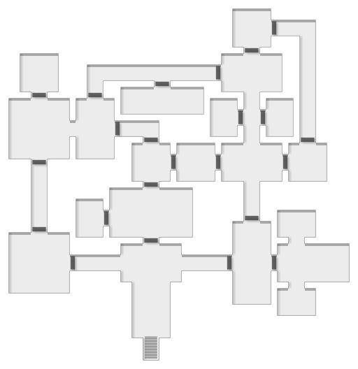

Two bubbling cauldrons smoke in the center of the room. The first gives you skin like hardened ceramic, while the second makes people forget you as soon as they aren’t looking at you. Four alchemists are working in the room. If threatened, they will all drink skin-hardening potions and attack with knives. The shelves are stocked with unusual potion ingredients.

The walls of the room are lined floor to ceiling with skulls set into square niches, some covered in dried blood. If you pour someone’s blood onto a skull it will speak to you in that person’s voice and answer any questions that they knew when the blood was drawn. Lasts until the blood dries.

An array of formal vestments for various duties. All are extremely ornate and show masterwork-levels of craftsmanship. Most have deep hoods.

A dozen golden thuribles hang from hooks on the walls. A brazier full of hot coals smokes faintly in the center of the room. Surrounding it are three incense boats on tables. Each produces a different effect when burned in a thurible. A.) The thurible bursts into black flame and can be swung as a weapon. B.) Makes invisible creatures visible. C.) Summons an incense elemental.

Eight clerics sit cross-legged on the floor in a circle. When the party enters, each PC will receive a cleric as their personal escort. They will follow the PC wherever they go, without speaking. As soon as the PC does anything inappropriate, the escort will attempt to garrote them. The west door is locked.

Statues made of lapis walk about a fungal garden. Huge white mushrooms push their way up towards the ceiling. Spores slowly drift through the air. Eating a mushroom increases the potency of spells, but non-clerics are not permitted in this room. The statues will resist intruders with force if necessary. They will ignore intruders that have dyed themselves entirely blue in the stained glass room.

The doors to this room are locked. It holds a Seraph: a celestial being apparently made of hundreds of wings and eyes. When it stares at an evil character, its all-consuming love for them is so excruciating that they burst into flame. All clerics in this dungeon are evil.

Hundreds of candles hang in the air. The floor is a pool of hot, bubbling wax two feet deep. When a cleric walks across the pool, it hardens into a path beneath their feet.

A labyrinth has been drawn on the floor in black paint. If a player wants to walk it, print out a maze from the internet and have them try to solve it 30 seconds. If they do, their character gains a profound insight into the nature of the universe, and some XP. If they fail, they lose some XP.

A wizened prelate in ornate robes sits on a throne atop a raised dais. He is surrounded by six elite robed guards with spiked flails. He demands tribute to the Hollow Prince or the guards will attack. He will only accept artifacts with historical value; offering gold will enrage him. He holds the key to all locked doors.

the

Hollow prince

a one page dungeon by ben Milton

patreon.com/questingbeast

**Prelate demands tribute**

**Skulls**

**Garden**

**Escorts**

A grate in the locked door reveals a skeleton sitting on a bench. It can’t talk, but will be very grateful to be rescued.

**Skeleton**

A grate in the locked door reveals a bound prisoner wearing a grotesque silver mask that prevents them from talking. If released it will remove the mask, revealing a face that always looks like the last person the viewer killed. It will aid any rescuer.

An empty throne, carved from heavy black stone. A crown made of candles lit with blue flames hangs in the air where a head would be. Clerics in this room will talk to the throne in a subservient manner as if something is there.

**Hollow**

**Prince**

Rainbow light filters down in tessellated patterns from a rose window at the top of a high shaft. Standing in a color slowly stains your skin, clothes, and equipment that color. The east door is locked and has a painting of wings and eyes on it.

**Stained Glass**

**Supply**

**Room**

A huge golem made of milky glass lies in several pieces in front of the northern door, while three clerics attempt to repair it. A forge on the south wall allows them to heat up molten glass, which they then mold into curious shapes using long hooks. On the west wall stand several completed golems, ready for service. They shatter easily when attacked with blunt weapons, but their blades are sharp enough to instantly sever limbs. They can also emit an excruciatingly high-pitched ringing sound that immobilizes foes and can shatter steel given enough time. The clerics will command the golems to attack if their work is disturbed.

White, polished marble lit with softly glowing stained glass. A great humming fills the air, like a choir softly singing far away. If a character tries to hum along or harmonize with it, the singing swells and d6 Clerics are drawn to this room. Disrespectful or profane acts will also draw d6 clerics, but they will be out for blood.

Dozens of scribes in pale robes sit on tall stools at desks, scrawling frantically. Gold ink smears the desks and drips down into small pools on the floor. When an ink pot runs dry, a scribe refills it with gold blood from their veins. The books are worthless, but the blood is worth a fortune. All of the scribes are armed with page-trimming knives.

**The Scriptorium**

**Lapis**

**Statues**

**Lapis**

**Statues**

**Masked**

**Prisoner**

**Labyrinth**

**Glass Golem Workshop**

**Potion Room**

**Incense**

**Room**

**Caged**

**Seraph**

**Vestment**

**Room**

**Wax**

**Pool**

**Entrance Chamber**