Muse
A Short Story
By Maryanne Peters

“You do believe that my work is art, don’t you,” said Claude.

“Of course, I do,” Blythe said. “And I only want to play a role in helping you to be that artist.”

And that, is the title and essence of this story.

Blythe had never really intended to be a model, but a photographer had approached him in the street and given him his card. Blythe’s mother had urged him to make the call. The photographer had taken a series of shots and put them together as a portfolio. He had offered to manage the young man, but in the absence of a contract it was just agreed that he would take a fee if Blythe was able to win work.

Some work followed. A store catalogue or two. Nothing substantial, until one day Claude noticed his image.

“Who is this boy?” he asked his assistant Emily. “That could be the face of my new line of menswear.”

Emily contacted the photographer and Blythe was asked to go in to see Claude at his studio.

“Do you like wearing clothes?” When Claude asked the question, he felt that it was vitally important.

“You may as well ask me whether I like eating food,” replied Blythe. The question seemed too odd.

“Exactly,” said Claude. “Clothing is a human need.” Blythe was puzzled but he smiled.

There was something about the way that the young man carried himself that seemed say something. There was a feel of casual contempt that spoke to Claude. It seemed to him to be the very essence of a young male. Instead of just watching him stand or walk in his clothes her found himself sketching. There was something inspiring here. Something special. He knew it even then.

“How would you like to sign an exclusive with my house?” he said.

“Your house?’ Blythe had no idea what he meant.

“I would like you to be exclusive to my label for a period of time. The face of a new line of men’s clothes. It would mean a contract, for say, two years?”

“I will only be graduating high school this year,” said Blythe. “I guess I don’t have any plans. But two years seems like quite a long time.”

“Is it a question of money?” asked Claude asked.

“Probably,” said Blythe. Claude felt that response was very shrewd in such a young man, but the truth was that Blythe used the phrase whenever he did not know the answer.

The photographer who “discovered” Blythe was given the contract to take all the images for that line of clothing and paid well in settlement of any claim he might have against the boy’s future. Claude was happy to pay. The images were perfect. But the clothes that he had designed with this young man in mind, were even better.

This line of men’s clothing received some critical acclaim. You may even say that it the first show in New York City was a “break out show” for Claude.

“We will need to travel,” said Claude. “I want you to travel with Emily and me. You are the face of this line, and people want to see the clothes on you.”

In New York Blythe decided that he would not cut or hair or shave a develop a more bohemian look. He met a number of other male models for the first time, and many wore their hair long and had facial hair. Blythe’s problem was that his beard was sparse and thin and his moustache so fair that it was almost invisible.

“Clean shaven is more versatile,” complained Claude. “And more ageless.”

Blythe shaved but was moody. The look reminded Claude of a small child, now stretched to the height of a full grown man. He started sketching again. He had and idea for a new line, based on the man child look that Blythe had accidentally adopted.

It was a departure from what had brought him to the city, but this second series was even better received than the first. And once again, the new look Blythe was the face of the collection.

“Your look inspired this look,” Claude told him. “In fashion, we can never stand still. Looks change, as people change their outlook. You need to stay inconstant, but you need to stay with me.”

If Blythe was becoming a little restless, he knew that he had an important role to play in promoting the art that were Claude’s creations. He was perhaps, a man who understood art, but understood that he could never be an artist. So the role that he played was important to him.

“I want to stay involved,” he said. “But I want some freedom.”

After a series of runway shows, Claude released Blythe for several weeks. The young man relished his independence and enjoyed his time in France. Without his model Claude took the opportunity to explore his creativity, in the heart of a city known for fashion and style.

Blythe explored the same city, but somehow he did not relish it. He met with other Americans visiting Paris, and they travelled together to tourist spots and spent evenings in bars and cafes. He had a brief sexual encounter with one of the girls he met and was propositioned by one of the young men – he politely declined. He still felt that he had failed to appreciate the place as even those other people his age did. He wondered what was missing in his life that he could not live it to the full.

When he returned to Claude’s rented studio, he discovered that Claude was toying with women’s fashion. It was something that Claude had not done for many years, as he had concentrated on men’s clothing. But the pieces he had sketched had the straight lines and tailoring of men’s suits. It seemed a natural progression.

“I want you to model these, Blythe,” he said. “Androgynous models are the thing in Paris. You will be perfect.”

Once he saw Blythe is the first dress, he started scribbling on his sketch pad. He could see his muse wearing so many more styles – styles with more shape and more frills.

He arranged for a private showing of some of the styles modelled by Blythe. He had his muse wear makeup, but not feminine makeup – a neutral style emphasising Blythe’s pale blonde coloring. After this first experiment with androgynous looks Blythe learned more about applying his own makeup.

But the new styles on the sketch pad called for a more feminine look.

“You need a new hairstyle,” said Claude. “You natural coloring is perfect, but you hair that is better suited to this more feminine style.”

“I could cut my hair and use wigs,” Blythe suggested.

“No, we will need to put your hair up for some of these looks.”

Blythe gaped at his boss, but then he saw the sketches. “I am not sure that I can pull off that look. It think its more than just the look. It’s the walk and everything.”

“By now you gave been around catwalks enough to know what works for the girls. You are right. A look like this requires less strut and more glide. But we have time to make up the garments. So you have time to observe the best in the business and get the movement right. Are you up for this?”

“You know I am,” said Blythe. He liked what he saw. Only a short time ago he would never have considered himself a judge of women’s clothes, but he had been living in Paris for some weeks now, most of the time immersed in the fashion world. He knew that what Claude had designed was good, and that his job was to make it look even better.

More and more this was a partnership. The designer and his model. The designer and his muse.

He followed instructions and went to the salon with Claude, who explained in French, the look he required. Blythe’s hair was cut in a long bob with a little color added, and his eyebrows were shaped. It seemed like such a minor thing, but the effect was obvious. If he had not looked it before, he now did – Blythe looked female. It shocked him.

“You should wear some of that last collection,” said Claude. “The elegant gender-neutral stuff. I tell you, no guy will think that you are a tranny. They will think you are a stylish woman. But in those styles you can still approach a girl as a man. Remember, we are in Paris, not our hometown. Nobody knows you.”

The clothes were there. It was easy. It was easy to dress and live as a person of no gender in a city that did not look twice, and in a fashion world where androgyny was commonplace.

He was not the only androgynous model either, nor the only heterosexual one. Whether on the runway, or the fashion houses, or the photoshoots, or on the street, appearing to be female was a game. It was a game that Blythe was learning to enjoy.

Claude asked him to attend a party in a gorgeous ball gown that he had designed.

“Am I going as your date?” Blythe asked pointedly.

“I suppose that you are,” said Claude without a flicker of concern. “This gown tells the story of my latest collection. It is a collection that you inspired, but taking the move towards the feminine to the extreme. When you put it on, I want you to feel it.

And when Blythe did, he did. It felt as if an inch thickness of flesh on his body had melted away and underneath was the clean and pure form of a woman – a woman who had been lurking inside him all along. The feeling terrified him. Everything until that point had been just clothes. This was something very different. He slipped it off to restore himself.

“Yes, leave it until later,” said Claude. “I will take you to the salon to have your hair done and then we will put on the dress just before we go out. But let’s select some shoes and get you practised in those.”

Blythe looked at himself in the mirror. What had happened to him? For some reason the thought occurred to him that this might just be a turning point in his life. A point when he could turn one way or the other, although neither direction had any signposts as to where his choice might take him.

He let Claude make the decision for him. And that really was the turn.

That night he took Claude’s arm from time to time, to steady himself on those heels, but liked the contact. Blythe knew that he was on display. The garment was the creation of the man he held, and he too, was a creation of that same man.

It did matter to Blythe if anybody at the function saw him as a woman, or an androgyne. He was the device to be used for the display of a work of art, like an ornate frame around a true masterpiece. He had a role to play and it was important. But the grand master was Claude. He gripped his arm a little tighter.

That evening they returned to the workroom in the studio. Claude poured them out two small glasses of Armagnac and then checked the garment before Blythe was to remove it. He ran his hands over the detail to check that it was still in place. The touch of his hands made Blythe sigh.

The evening had been special for both of them. They found themselves face to face in the dim light of the studio without the full lighting on. Blythe could feel his breath. Blythe kissed Claude. Or was it Claude who kissed Blythe. Whoever started it, it did not stop – not until they had both almost sucked the life out of the other.

“I owe you everything,” said Blythe. “I just want you to know that.”
“No”, said Claude. “Don’t be stupid. It is I that owes you. You are my muse. Without you, there would be nothing to inspire me. I need you. My life is my art. My art comes from you. I cannot live without you.”
“I am not leaving you,” said Blythe. “Just promise me one thing.”  “What is that?” said Claude.  “Promise me that you will design only women’s clothing from now on. I won’t be wearing anything else.”  The End  © Maryanne Peters 2019 | 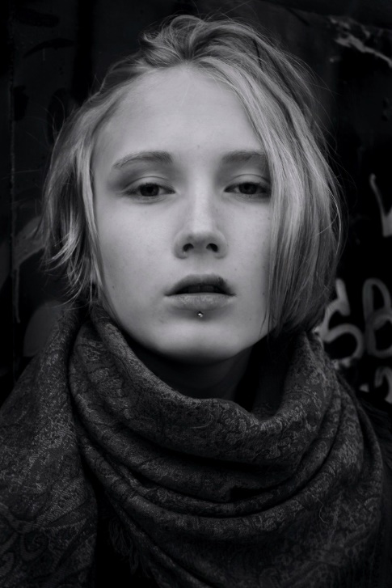 | 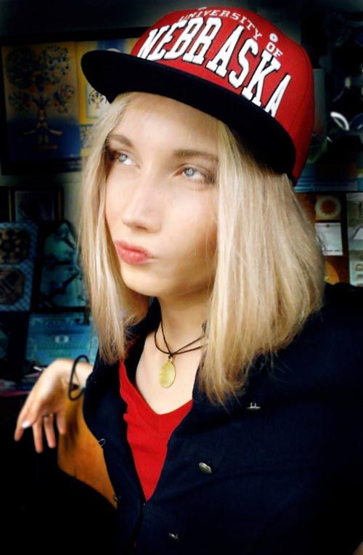

My muse for this story: Androgynous (but apparently unlike Blythe – still heterosexual) Russian male model Lyova Fargo | 