Forever Pregnant
A Christian Feminization Story
By Maryanne Peters

I never thought that I would love being pregnant, but I do! What am I talking about? I never thought about ever being pregnant! Why would I? I was a guy, for crying out loud! A manly gay man! Now look at me! Pregnant, pretty and glowing. Praise to God!

Being gay and Christian was hard for me. I would just go out and fuck, fuck, fuck, and then come home and drop to my knees in front of God, all of my sin seen by his eyes, begging His forgiveness. I knew that it was wrong. I knew that I had to do something.

I knew a couple of other gay Christians who were a couple, and when I met one of them in church and asked where “his friend” was, he told me all about the Christian Feminization Academy. His said that they had decided that this was the way. One of them would become a woman.

“She has made the sacrifice,” he said. “It is a beautiful thing, to surrender flesh for the love of me, and for the love of God.”

“But I have no partner,” I said, a little sadly – but not so much, because in those days what I really liked was fucking around.

“The church will find you a partner,” he said. “They say that they always make the right choices. They say that they are guided by God. Their relationships always seem to work. You just have to submit to the will of God, and the will of the man they choose.”

I am happy to take a guy, just so long as he has plenty to give. I guess I was worried about losing my dick. Who wouldn’t be? I mean I used that thing any chance I could. But when I went back to church later on and met his newly converted partner, I started to consider my options.

“Are you kidding?” she said (she was a she now). “I don’t miss that thing at all. I have more feeling with what I have. That means multiple orgasms. We are talking two or three just from foreplay, and that just gets you sensitive for the big one. Men are one shot wonders. Women are pump action repeaters!”

Doesn’t that sound good. Pump action repeating, and with God looking down and boy “at a boy” … or rather “go for it girl”.

Sign me up. Make me Dora. So they did.

When I was all done, The church introduced me to Mark. I had only one thing to say to him in a private moment. I said: “I am just warning you, I like sex. Do you think that you can keep me satisfied?”

He said: “Sweetheart, I love sex too, but I want kids. Are you Okay with that?”

So, we got married. Mark tore the wedding gown to pieces to get inside me. We had sex – so much sex. He was everything he promised he would be. He said that I wore him out, but that he loved it. And then I got pregnant almost immediately.

Of course it cannot really happen. The church lines up a surrogate – a cis-woman who could be inseminated with Mark’s seed and carry our child, and I get to wear the Preg-Sim Device and get flooded with extra hormones to get that extra “glow”. Great for my hair too, although it does get you thinking about things other than sex.

Mark says that he loves me pregnant. Maybe we don’t have as much sex as we used to, especially when I am in the third trimester – I am just so huge! But he loves it when we do have sex, and he just loves having a pregnant wife on his arm.

So we have three kids now, and I have had seven full term pregnancies in a row. And look at my belly! Tight and flat. We CFA girls are just so lucky. All those pregnancies and no after effects. I have to go home now. Mark will be back from work and I will be hungry for sex. He wants me to get pregnant again. Of course I want that too. It slows down sex a bit, but I just love being pregnant.

The End

© Maryanne Peters 2021

Home of the Vikings
A Christian Feminization Story
By Maryanne Peters

People did not know much about the traditions of Northern and eastern Sweden. We do not talk much about it ourselves. And then somebody comes along and makes a movie like “Midsommar” and people wonder if this is true. All that I can say is that this is not the tradition of my village, or the tradition of my family.

Many would consider it a curse upon my family, but we consider it an honor. We have a special lineage, you see. We are the descendants of the Viking Warrior Queen (Wikipedia ref: Birka Female Viking Warrior)

As such my family were always seen as being demi-gods from a long line of Valkyries who fought alongside mortal men as shield maidens, but that was in the days before Christianity came to Sweden.

My family are good Christians, but still the tradition persists, partly because many still believe that the extreme strength, fitness and good health of our people is because of the association with my family, but also because my family refuses to give up its special position in our local society. But that position of honor comes at a price. There can be no men in my family.

It has always been said that a boy becomes a man at 18 which means that boys in my family have until their 18th birthday to father a child. For on that day their manhood is to be taken away and they are to become women – modern Valkyries.

What about me? Well I did not father a child or even try. The simple reason was that I could not wait to lose my manhood. Finding a wife is not for me. I wanted a husband. I am happy to be a shield woman, but not a maiden. That is not for me.

Sure like the other men of my family I proved myself. The image is of me on the Swedish soccer team at the Junior Olympics, while I still had my testicles. I was already growing my hair in anticipation of becoming a woman.

When I heard that there was a Christian Feminization Academy in America for people just like me, I had to sign up. They wanted sponsorship from a local like-minded organization, The Christian Feminising Academi did not exist then, but my family decided that the country needed it, so we set it up ourselves.

Who better to instruct students in the ways of womanhood than people raised from birth to live both lives and then surrender their manhood to God as ordained by tradition.

I hope to return some day to Sweden, but for now it is not just my hands that are full!

The End

In Search of a Husband
A Christian Feminization Story
By Maryanne Peters

This is me. I am looking for a husband. I would like a husband who appreciates that I am the very best kind of wife. I am a graduate of the Christian Feminization Academy. I guess you know what that means.

I am looking for a manly man. I would like a strong man who can tell me what to do and when to do it. I want a man of traditional faith, not some lame modified view of it.

Christian doctrine is very clear. Woman was created out of man for man. Her purpose is to seek the support and protection of a man and to be there for his use and pleasure. Womankind has been blessed with beauty and with softness and weakness to be admired and adored but also handled by him with ease.

Modern women have no concept of this. Why do they seek to tease and torment men? A little temptation to that effect maybe fine, but only with the purpose of bringing pleasure to that man. To demean and embarrass the males of the species who have been favored by God to be of the dominant sex, must be sinful.

You will find in me the very opposite of this. You will find that I am attractive and dress in modern clothes, or as you direct. In my profile picture I am wearing leather, so you know I like a little adventure, but underneath I am wearing the most skimpy feminine underwear – all lace and bows – and it is scarlet red. That will be my only nod to sin – it is reversed for the man who undresses me.

At other times I will wear the clothes you ask me to. But I believe that an attractive wife is not there win the favors of other men, but to make them jealous of her husband … you. In public I will always behave in a manner that is loyal and dutiful to you.

At home I will continue to fulfil my duty in making your home a true oasis protected from the stresses of modern life. As you will protect me, I will give you that haven of peace.

But in the bedroom, you will only have peace if you demand it. In all respects I will be committed to ensure your excitement and your pleasure. The lips on my face can only hint to you just how glossy and inviting my other lips are, designed and constructed purely for your indulgence, and neither stretched nor soiled by any ugly childbirth or anybody other than you.

If you are out there, please contact me through the Christian Feminization Academy.

My name is Stephie and am seeking a manly man who wants a traditional female who longs to fulfil the classic feminine role.

The End

© Maryanne Peters 2021
The Gainsayer
A Christian Feminization Story
By Maryanne Peters

Not all Christians believe in what we are doing. We had a gainsayer visit the Christian Feminization Academy not so long ago, carrying a placard “Your body is a temple of the Holy Spirit. If anyone destroys God's temple, God will destroy him. For God's temple is holy, and you are that temple.” This is from Paul’s letter to the Corinthians, in particular 1 Corinthians 3:16 and 3:17

We welcomed him into our chapel to pray with us, and he agreed.

Who can deny scripture? But we need only look back – the book of Isaiah 56:4-5 reads: “For this is what the Lord says: To the eunuchs who keep my Sabbaths, who choose what pleases me and hold fast to my covenant - to them I will give within my temple and its walls a memorial and a name better than sons and daughters; I will give them an everlasting name that will endure forever”.

Castration for the glory of God had been the way from the beginning of faith. This is the holy word of God and cannot be denied.

So too, or Lord Jesus said as recorded in Matthew 19:12 “For there are eunuchs who were born that way, and there are eunuchs who have been made eunuchs by others--and there are those who choose to live like eunuchs for the sake of the kingdom of heaven. The one who can accept this should accept it."

Those men who surrender their genitals will be taken into heaven. This is the word of our Savior Jesus Christ as recorded in the gospels.

We stood about him, the Christian Feminization Prayer Group, all women who were once men. All true believers who had surrender up their male appendages to be closer to God.

“What have you surrendered, Friend?”

“But that is the surrender of sexuality,” he said. “What you are doing is to feed sexual desire, not extinguish it.” He cited Colossians 3:5: “Put to death therefore what is earthly in you: sexual immorality, impurity, passion, evil desire, and covetousness, which is idolatry.”

“Sexual immorality, impurity and evil desire is what we had, but no more. Now the instruments of evil are ripped from our bodies and replaced with a human chancel or narthex to receive one good Christian man into his place of worship.”

I said to him: “You could be that man. My nave is empty. My apse awaits. Cleansed with holy water and waiting to receive the man who surrenders his will to God, and allows his word to take him into the bosom that awaits.”

I may have been guilty of letting my decolletage become more prominent by my posture, but I prefer to think of it as being an act of God that made this doubter reach out to touch me in that place.
All the other women sighed in approval. I took the man into my arms in an embrace that truly spoke of our shared faith.

“Are you truly my sister in Christ?” the dear man asked me.

“Put your nose between these sisters,” I instructed him. “But I’ll want something else to enter the my chapel and those legs of yours to walk me down the aisle.

Clearly God is in his heaven and thanks to the Christian Feminization Academy all will be well in the world below him.

The End

Ladies Together  A Christian Feminization Story  By Maryanne Peters  We met at “Straight Camp” – a Christian conversion therapy exercise. Perhaps you have heard of it? Some people call it “pray the gay away”. If only it were that easy.  Even our “ex-gay” instructors were propositioning us! They called it “one on one transformational tutoring” – but it sure felt like anal sex.  These same guys would be leading us in prayer and promoting “introspective self-analysis” to discover the unconscious childhood conflicts that might be responsible for our homosexuality.  Next came "reparative therapy" which was really aversion conditioning. Perhaps you have heard of that? They said that we have moved on from the electric shocks or nausea-inducing drugs used during presentation of same-sex erotic images – the “old BYU technique”. Now it was “the covert sensitization method” where you just imagine the pain associated with the sin, even when everybody in the room knew that it was the greatest of pleasures. We all craved it, instructors included – we just lied to ourselves.  People who oppose conversion therapy call it torture, and say that it does not make us heterosexuals, only ashamed of being gay, and fearful. The problem is that as Christians we already were.  We walked out of there and we got a room and we fucked like there was no tomorrow. And that is how gay Christians fuck. We fuck without thought of the afterlife, because we know that we must burn in hell for what we do.  There seemed no way out for us.  And then we learned about the Christian Feminization Academy. Neither of us had ever been particularly effeminate, let alone cross-dressers, so sex change seemed ridiculous, but we decided that we would go along to a meeting with some “virtuous modest ladies – graduates of the Academy”. | 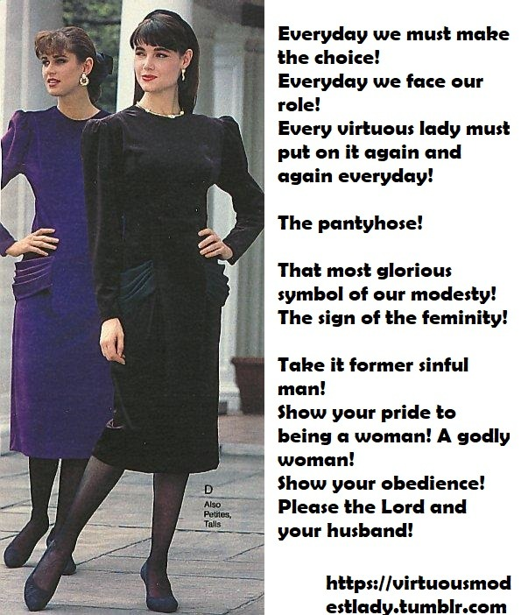

There is no sense in describing how desperate we were, except maybe to people who have a faith in Christ as deep as we have. All we need say is that to know that you are filthy and damned in the eyes of God and that you face the life everlasting in hell, will drive you to take the knife to your own body. And the scriptures bless it. In Matthew 19:12, Jesus speaks of “eunuchs who were born as such, eunuchs who were made so by others, and eunuchs who choose to live as such for the kingdom of heaven”.

But according to the Christian Feminization Academy, we need not be just castrated, we can have sex and we can have love, but as women. We can have a relationship as a man, but it must be as the passive partner always. A gay man might call that just half a sex-life, but at least it is a sex-life.

It helped that we went through it together. Along the way, before we took that first irreversible step, we prayed to God and then committed our last sinful act – actually quite a few of them. Then we surrendered our manhoods to Christ, together.

The Christian Feminization Academy organized everything – the surgery, the training, the introductions to the men that became our husbands. We have never looked back.

We are still very close. As you can see, we style our hair and dress alike. We could be even closer - we would be lesbians – we have actually tried it – but we both love cock so much, and neither of us have one anymore.

The End

© Maryanne Peters 2021

