Irony  Inspired by a Captioned Image  By Maryanne Peters  When Bill told me that he cross-dressed occasionally, I laughed, but not as loud until I saw him dressed for the first time. He looked ridiculous.  I know that it was a horrible thing to do, he looked hurt, although he laughed with me once he was over the shock of it.  “Maybe you should try to look better than I do?” he said.  I cruelly responded: “Buddy, I am sorry, but I could look better than that without even trying. I could convince my own mother that I was female.”  “Your mother is dead,” he said.  “Your mother isn’t,” I said. “I could convince her.”  “You do that, and I’ll never cross-dress again,” he said. | 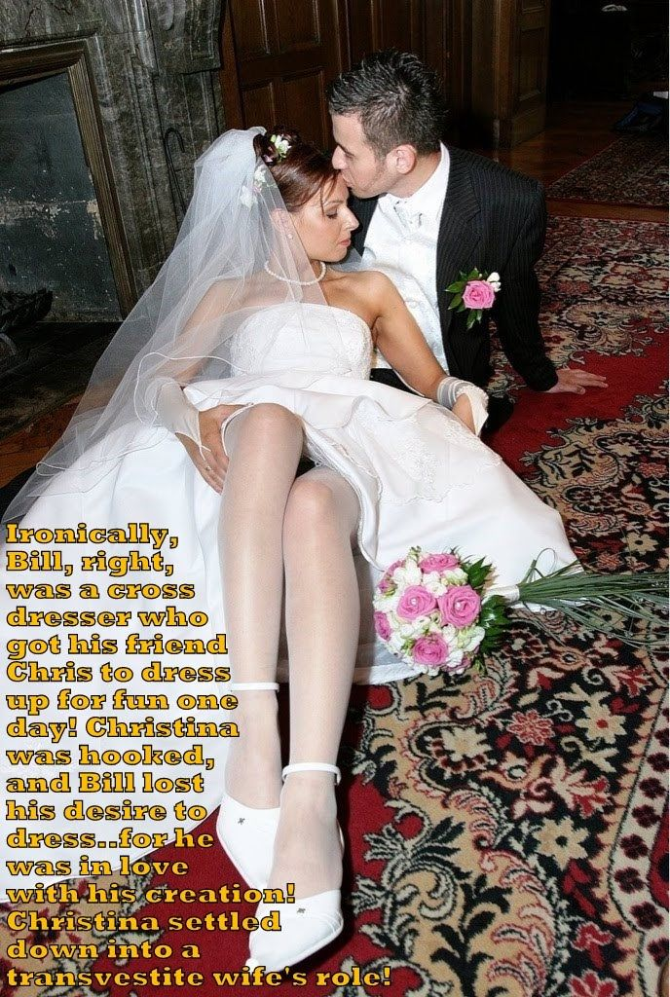

As I said to him, I owed the world a favor in ensuring that he never did, he looked that bad as a woman. I, on the other hand, looked damn good.

I had to spend the whole day as Christina, Bill’s new girlfriend. After I had finished my makeover, we needed to drive three hours north to Lake George where she lived, have lunch and then drive three hours back home.

I needed those first three hours. The salon had done a great job with the hair extensions, maybe a little too aggressive with the eyebrows and the body wax, but fantastic with the makeup and the manicure. But I needed to master the voice with Bill’s help, and develop with him a plausible back story.

“Just don’t give her any stupid hints that I am Chris,” I squeaked in my girly voice. You have to give me a chance to convince her that I am a girl. Then I am going to hold you to you promise.”

“I have to say that my future in skirts is not looking good,” he said. I had no idea that you would turn out looking this good.

We stopped for coffee at a tiny village in the valley on our way up, and it gave me a chance to work on my feminine table manners. Bill was a complete gentleman. I was a complete lady.

When we got to his mother’s cottage on the lake, she heard us pull up and she came out to greet us.

“What a pretty girl you are Christina,” she said. “My Bill is a very lucky boy.”

I smiled at my new boyfriend. He looked resigned to his fate. Unless I let something drop badly, I was going to win this. The truth is that I didn’t know where it came from, but it came easily. I think that I know now, but I didn’t know then. It was always there. It must have been.

It was a wonderful day. Bill’s mother is a wonderful woman. What I didn’t know about women before I met her, I learnt from her that day, just by being with her and talking about the kinds of things women talk about. We had time. She had small manly chores for Bill to do. The kind of thing that he was good at, and neither his mother nor me had any clue on what to do.

When we drove back to the city it was late. After getting almost halfway Bill said that he was too tired to drive further. I was tired too. There was a motel, so we did what people ought to do, we decided to get some sleep and head back at first light. Room options were limited, but we could handle it - just two old friends sharing a double room.

“You’re still talking in that girly voice,” said Bill.

“Am I?”

“And you are moving like a woman. Something I could never do. You’re a natural.”

“Do you think so,” I purred, for some reason coming close to him, and fingering the collar of his shirt. Something no guy would ever do to another guy. But it was as if I was somebody else, and I had been ever since I stepped into his car that morning.

He took me by the shoulders and kissed me on the mouth. I tore myself free and stared at him angrily. I just stared at him, not saying a word. And then we just fell together, like two magnets, attracted by forces beyond the understanding of ordinary people.

I am not sure when Bill’s mother learned that I was not really a woman, but it was not that day – it came later. She said that she knew of Bill’s attraction to women’s clothes, and she was glad that he was now cured of it.

“He just needed somebody like you to show him that he could never be female. That’s what you are. And I am so pleased that you will be my daughter in law.”

The End

Exposed
Inspired by a Captioned Image by Tiffany
By Maryanne Peters

I am a jealous woman. I admit it. I took things too far, and I know it.

Initially I felt guilty. I took his life as a man away from him. I thought that his masculinity really mattered to him. But I was wrong.

He was always looking at women. It seemed to me to be leering rather than looking. I thought that he was lusting after them. But I was wrong.

If he liked the black dress so much, then he could have one just like it, and he could wear it, and wear it the way it was supposed to be worn. I thought that he would be ashamed to be dressed like that. I was wrong about that too.

He said that his legs stripped of hair made him feel naked and exposed. So why spent so much time on not only shaving his armpits but his arms as well.

He looked way too good in the blond wig. His makeup was done for him at the store, and the girl who did it was a miracle worker. There was no trace of a man in that face anymore. Here was one night that he would not be staring at women, he would be one.

And then to cap it off, I introduced Bob to a man I had lined up to escort him – a man I knew with a penchant for girls with something extra. I introduced my boyfriend to him as “Barbie”. I suggested that they go to a private table at the back, while I sat at the bar waiting. I thought that Bob would turn and run back to me, and beg me that we should go home, but I was wrong.

I thought: ‘Okay. You want to keep me dangling, two can play at that game’. I turned away. I accepted the offer of a drink from the man next to me. When you accept a drink you have to listen, but I was not interested in what this stranger had to say. I tried to look interested, but not for his sake. I could see “Barbie” in the mirror behind the bar, and wanted “her” to know that could have any man I wanted if this was the game we were playing. But she never looked towards me. She had accepted a drink from the man sitting with her, and she was listening.

I was burning up, even while I was nodding to the idiot talking to me. But I did not have to put up with him for long. I saw Barbie and her date walking out the door.

I threw down my drink to follow, but the stranger begged me to stay. I was not going to, but his delaying me forced me to reconsider my actions: Why should I follow? What will happen next? If Bob is going home to our apartment, I will see him there, but I should not be the first one home. If he was going to the apartment of his date, a man with a fancy for trannies, God knows what might happen to him. It would serve him right.

I accepted the offer of one more drink, and then dinner, but I insisted on paying my share. I had to explain that I was in the middle of a breakup, and I was not ready for complications. He was a gentleman about it, so I took his number, with no intention of ever calling him.

I got home and Bob was not there. I went to bed and kept my arm across his side so that I would wake when he came to bed, but I woke in the morning and he was not there.

That is when I started feeling guilty, and more than a little worried. But my phone rang while I was drinking my coffee.

It was Bob, but he was not speaking in a manner that I recognized. His voice sounded high – even squeaky. He said: “Perhaps I should have called you last night, but you did set me up with Brad.”

“Why are you talking that way?” I asked.

“Everything has changed,” he said. “Everything!”

It hurts me to even think about it, but the man I shared so much with had gone. I made him disappear when I tore off his body hair, painted his face and put him in that wig and dress. How why I to know? Somewhere inside him a woman had been lurking all along. I just exposed her.

Initially I felt guilty, now I just feel envy, which is very different from jealousy. You know the difference – right. Jealousy requires three people. Envy is just me and her. She has a man who loves her, and I don’t.

The End

Panty Raid  Inspired by a Captioned Image  By Maryanne Peters  Mischief. I always used to say Mischief was my middle name. Paul M Robello. Of course, it was not my middle name, but now my middle name is Maria.  The panty raid was my idea. It had been a fraternity tradition, but in the days of “Me Too” that stuff has become a sin greater than mass murder. You are not going to get people saying: “That was just a bit of harmless fun”, even it though it was. Nowadays when the victim says that they want the penalty short of expulsion, the Board of Deans are going to agree to impose it, no matter how perverted that punishment might be.  As for me, what was I going to say? Expulsion would be the end for me.  “Accept the makeover, and if you are happy to stay at this college as Paula until the end of the year, you can stay in this college.” | 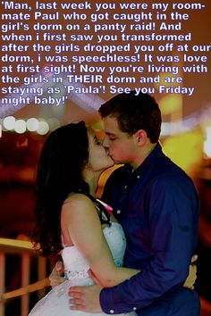

To pass the test, I was dropped off at my own dorm and I had to be Paula in front of the guys.

Obviously, they had guys in the fraternity checking on me. I had to be the girliest girl I could be, with every one of them. Nobody could be trusted, not even my room-mate Evan.

“I’m Paula now,” I said softly, looking down and playing with the hem of my dress.

There were some smirks, but nobody laughed out loud. I guess they thought: “There, but for the grace of God, go I”. Anybody on the raid could have been caught. I was taking one for the whole crew.

One of them said: “You can’t stay in the fraternity house looking like that.”

It was true that I did not fit in as Paula. I felt sad and helpless. It might have been the injection. I felt weak from the moment I felt that cool fluid entered my bloodstream.

“I can move out and you can have our room to yourself,” volunteered Evan. “That is only right. Come on guys. We have to support our frat brother. Or should we say our frat sister.”

“Thanks, Evan,” I said, my voice a soft feminine whisper. Was I pretending for the sorority spies? It hardly seemed that I was. It was the voice that came out of my mouth without thinking.

“She belongs in their dorm now,” said another onlooker. “They have created her. She should be their problem.”

It seemed as if none of the fraternity saw me as Paul anymore. I was the creation of the sorority girls. It seemed as if changes to the surface of my body had been absorbed to my very soul. I looked up at them through my extended eyelashes and I think that I whimpered – whatever that is. It was true. I did not belong among these men.

“Everybody understands what you did for the team,” said the fraternity head. “But we need to call the sorority and tell them ..”

And that was how I avoided expulsion. I moved across to the sorority and stayed in school as Paula. And now my old roommate is my boyfriend.

Until my surgery I need to wear special panties, but I keep them locked away. I would not want to lose those to a panty raid.

The End

Silly
Inspired by a Tiffany Captioned Image
By Maryanne Peters

Mommy is so silly, but I suppose girls are supposed to be a bit silly. Darryl tells me that anyway. He says that is what makes me adorable. I like being adorable.

Mom is silly because she thinks that the panty raid was just naughty boys causing trouble. It might have been for the other guys – they hung out the panties they took as trophies. The pair I took, I put on, and wore them in bed. That was when things changed for me, not when she decided to “feminize” the culprits rather than turn us in.

Mom is silly if she thinks some hair extensions, makeup and an estrogen patch is going to turn a boy into a girl. Life is not like that. Boys are boys and girls are girls, and I am a girl. Mom is too silly to know it.

She wanted a daughter. If only she had told me earlier. I have always wanted to be one. But I am not about to tell her now. I like the way she treats me – protective and generous. Once she has paid for the surgery Darryl says that he will take me away and make me his bride.

Just a big smoochy thank you to the boys who roped me in to that panty raid. It changed my life.

The End

Clearing Myself
Inspired by another brilliant Tiffany Captioned Image
By Maryanne Peters

I knew that I could do it. I am a good accountant. I could find the embezzler, if only I could get access to the books.

But I was the key suspect. Whoever had done it had hidden their tracks well. And what better way to hide your tracks than make another trail over them – one leading to me. It was a frame up.

I could have just run. I had money in an old business account. But that would mean being on the run forever. I had to get back into the office, and not surprisingly considering the disarray, they were hiring. But the disguise would need to be foolproof. My sister had the answer.

My sister was a hairdresser and she lived with a bunch of other girls in the beauty business in a large loft apartment downtown. It was so large that I was hiding out in her box room without the other girls knowing. She said that for this disguise we would need to bring in one of them – Rosa was a chubby and rather plain girl, but she was a whizz with makeup. My sister would do my hair. I was going to be applying for a job at my old company as a woman.

She said I looked ‘gorgeous’ and I asked whether it was necessary that I look quite so good.

“You need the hair and makeup to look female,” she said. “It is just that on you they look spectacular. Rosa and I are a little jealous.”

I needed to adjust my behavior to appear female, and the test would be when I applied to take the spare room and join the women as a roommate. When we felt that I was ready, that is what I did.

After that, getting the job was a cinch. I said that I had no formal qualifications but I had experience, and after a quick test (something that I had designed myself for recruitment of junior accounting staff) I was offered a lowly position from which I would need to build up to full access.

I had hoped that my ability would see that happen quickly, but I was now a woman, and I learned to face the realities of workplace discrimination. It seems that men doubt your figures when they are looking at your figure.

When settling in for the long term I had to make other changes that I had not anticipated. The hormones were designed to keep away facial and body hair, and to suppress any embarrassing activity in my panties, but for some reason I was particularly receptive to them. It seemed like no time at all before real flesh was pushing the gel inserts out of my bra cups.

And whether it was the hormones or just getting used to living 24/7 as a woman, I found that I was acquiring a softer appearance generally, and a grace of movement that was decidedly feminine and becoming increasingly comfortable.

My direct superior was a mid-level accountant of limited ability. I needed his access, so I needed to become indispensable to him and have him allow me to access and use the information directly. Unfortunately, this man, although married, had an old-fashioned view of workplace molestation. I have to admit that I let him do things that no woman would to get what I needed.

So, with the ability to view the transactions, focusing on the transfers that I knew had been used to set me up, I was able to trace things back and find where the money had been going before that. I will not name him, for the same reason that I have not named myself. I can only say that the villain was the son of the leading shareholder and a star at the board table. How far would I get by exposing him?

Accountants are rational people. We need to assess the pros and cons, and the risks associated with steps that we propose to take, even if justice demands that those steps be taken. Sometimes justice can be better achieved outside the system.

I have to say that when I first confronted the culprit he was unsurprisingly dismayed, but I was able to establish that there was no malice is setting me up – he simply did not know the man I was. He was more interested in knowing the woman I had become.

The End

© Maryanne Peters 2020

Author’s Note:
This is a great example of how good Tiffany’s caps are as inspirations. The image has the chunky makeover artist with the subject of the work showing a determined gaze, and just 75 words with the frame of a story that could be even longer than my teaser.

