Eternal Gutslut Scene Guide

Table of Contents

Internal Scenes

Minty

Vivian

Stressa

Pacifica

Quest Lines

Emmerich

Tabletop

Misc

~~~~~~~~~~~~~~~~~~~~~~~~~~~~~~~~~~~~~~~~~~~~~~~~~~~~~~~~~~~~~

Internal Survival Scenes

Minty (Demon Boy)
Location:Your roommate! Can be found at home, working on something.
General advice:Minty is a fairly safe predator. He won’t do anything you can’t handle. You can escape from him at any moment too! You can arouse him as well, which will give you more energy when you suckle from him. Though if he cums or sleeps, his arousal will go away.
He also has a belly ache tracker. Though it’s mostly used to unlock a scene.

Special Scenarios
Fatal end:Only one variation. Just run out of hp.
Eternal Stay:Spend 10 days inside of Minty at once, you’ll be given the option during the night at that point.
Shrunken cock Vore:Raise his arousal as much as you can, may take multiple days. Will occur during the evening. This also has an eternal stay variation if you refuse to leave multiple times.
Stormy Weather:Randomly occurs during some mornings. Minty gets scared and needs some attention. Has a variation at the end where he may squish you if your energy is above 50%
Belly Ache:If you keep struggling and upset his belly, he will end the day needing Alista to comfort his poor tummy. Should be doable in one day if you struggle every time you can.

Alternate Time Slots
Evening:Spend 3 days inside Minty, and that Evening Minty will run into a stranger who has eyes on Alista. Wren the Dullahan.
Notable Interactions:While this scene is linear, it does have a fatal end. As of writing, there is no way to repeat this scene. So it may be smart to save around when you expect to get the scene so you can set yourself up for this.

Evening:Wren and Minty want to go on a date, and Alista is sticking around to listen. It has a 40% base chance to happen, that increases each time it misses.
Notable Interactions:The Return of the tummyache! If you struggle leading up to this scene and then struggle inside of it, you can upset Minty’s belly and you’ll receive a short scene with Wren helping soothe it.
Looking back, this may be quite annoying to actually get to. This may receive some attention.

Also, if you arouse Minty in this time slot, you’ll get nice scene with a blow job from Wren~

Vivian (Cyclops Vtuber)
Location:Go have a nice chat with your neighbor :)
General advice:She shouldn’t be too much trouble She does decent damage to you, but always masturbates in the afternoon. There are many ways to keep your energy topped off. She is too big for struggling to do anything. But sneaking out is easy because of that!

Special Scenarios
Fatal end:Only one. Get to 0hp and don’t reform. Simple enough!
Eternal Stay:Survive 10 days inside her. Will be given during the night.
Most of her interesting scenes are quiet easy to access by just using an interaction with her. This guide is aimed to focus on some of the more obscure scenes. If you’d rather I go in deeper detail, please do tell me.

Alternate Time Slots
Afternoon:Vivian will go to the store! This one happens randomly. It has a 40% base chance to happen, that increases each time it misses. So if you’re inside long enough, it should be guaranteed!
Enjoy poking fun at Vivian in public~
Notable Interactions:If you struggle, or reform from chyme, you will trigger a large scene where a gutslut in the grocery store feeds themselves to her. What a travesty~

Evening:This is an alternate evening time where the stream changes up! Vivian has a belly cam so the viewers can see Alista live! It will trigger every other day.
Notable Interactions:No longer scenes, but many interactions have different results depending on your digestive state. Feel free to mess around! This scene should be common so you’ll have plenty of chances~

Stressa (Gluttonous Goblin Girl)
Location:In the cafeteria, aka the top right entrance to the West Wing.
General advice:Stressa is the most dangerous predator of the base 3. Her belly is the strongest. But she does give a good amount of ambient sin. None of these preds are hard. She was also the first scene created, so she has the smallest amount of extra mechanics to worry about.
If you need a refill, arouse her in the morning. She gives a lot of energy then.

Special Scenarios
Fatal ends:Three variations. One when you normally succumb in her belly, one when you fully digest during the Morning Punishment scene, and another when you masturbate to death in the morning.
Eternal Stay:The only pred to not have one :< She was written before I decided to do these. Will hopefully be fixed in future updates.
Morning Punishment:Try to sneak when you are melty (33-66% health). She will feel you, and deal a LOT of damage to you. Has a unique fatality.

Pacifica (Mermaid Princess)
Location:Head to the west wing of the school and leave via the north. It should have a bit of water right outside. You’ll encounter her in the scene and being eaten is inevitable!
General advice:Pacifica is rather uncaring, and only really gives energy during the evenings. If you wish to escape, the only convenient time is during the morning. It’s when she’s relaxed.
There is a main mechanic with befriending Pacifica. Certain actions will bring you closer. Each trigger can only happen once. You will get a special scene in the morning when you’ve gotten enough. She’ll even be nicer and let you out when you ask :D
You will need to get at least 5 friendship points. Each event gives one.
Here’s the full list
Morning
- Talk and ask “Why did you eat me?”
- Talk and ask “Why do you sleep with those men?”
- Talk and ask “Do you have any hobbies?”
Afternoon
- Talk and ask “It’s stinky…”
- Arouse her while in the melty state (33-66% health) and survive her onslaught. You do not need to be melty the whole time, just to trigger it. Scene fails if you end up goopy.
Evening
Jock
- Struggle while solid or melty. Will take some damage.
- Masturbate! That’s how you make friends.
Nerd
- Struggle while solid or melty. Will take damage until goopy.
- Arouse Pacifica. It’s just that simple :)

Special Scenarios
Fatal end:There are 3 unique endings. Two are found in the same way, by simply dying to Pacifica. One before you make friends with her and one after.
The other is found by talking to Pacifica during the afternoon when she is around other people, and bringing up her booty calls. This doesn’t go well for anybody.
Eternal Stay:Unlocked by befriending Pacifica. Should be available each time a week.

~~~~~~~~~~~~~~~~~~~~~~~~~~

Scene Quest Lines

Emmerich Scenes (F Preds/M prey)

Step 1:An Accidental Change of Mind
Chat to the pink haired boy in the University Side Entrance until he leaves. He should be right in front of the stage! Then return to your bed at home and you can Dream. There you can enjoy the side story. These will always take you from Alista’s perspective to see what another character is doing. Though watching this scene is not required for unlocking

Step 2:
Emmy has moved to the bar right next to Alista’s Apartment. You’ll see him on the dance floor spinning with his girlfriend(?). You do need to have done step one to see this scene. And it will be required for the next step. But that step is not out yet~

Tabletop Scenes
This is a category of scenes that will revolve around playing tabletop with other characters.
Future scenes will likely have requirements to unlock them. Still trying to decide exactly how.
But! You will have to go through the first scene to unlock them all. Just talk to Minty in the Library and ask to play the game! Simple as that, this does have alternatives for male and female preds.

Lab Scenes(M or F pred)
These are the category of scenes that will include Yllessa the kitsune, and Jiv the incubus. Often times experimenting on Alista!

- Step one is technically the tutorial. It is possible to skip it, but it is required to get to the rest of the content. It’s as simple as finding her in her lab in the West Wing of the school.
- Come back to her after you’ve collected 30 essence from being inside other people! This is something you’ll likely obtain while messing around in predators. Come back and she’ll ask to do a test where Jiv or Yllessa absorb Alista. Temporarily. Absorption involved, of course~

One-Off Scenes

Rhyma (F Pred)
Pink haired catgirl who will chase you in the West Wing! There is a random chance for her to spawn when you step on any of the circle’d dark squares.
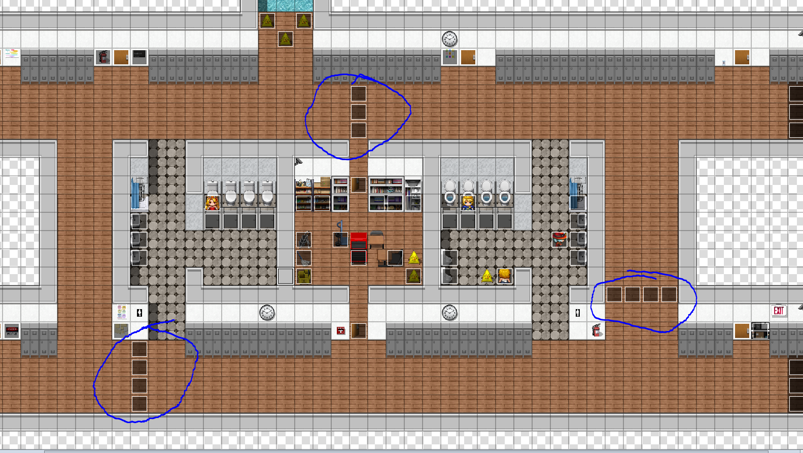
She does a bit of damage, but isn’t too terribly lethal.

Mysterious Catgirl(F Pred)
A strange catgirl is having a drink at the bar right next to Alista’s apartment building. Go have a chat with her, and don’t resists :)

Halloween with Rhyma (F Pred)
Head to your apartment and talk to Minty. Pick the “Lets…” option, then pick the “Celebrate Halloween” option. It’s just that simple c:

