-mini story-
One day has passed since Starlight arrived here with us. We wanted to invite her for Pinkie Pie's birthday, but I find it strange that I always see her with that pervert!
I mean, yeah, I asked him to show her the city, but ... do they always have to be so close together?!
Applejack: Sunset? Something happens?
Sunset: Look at that idiot... he seems to be very happy with Starlight! ò.ó .. And why does she take his hand to walk!
Applejack: Sunset please, we need to focus on Pinkie's birthday Dx
Fluttershy: Applejack is right. Also, it was you who asked him to take her for a walk to see new places ... he's just doing what you said o.o'
It's true, but I can't help but feel angry! Dx
*sigh*
For now I need to think about Pinkie's birthday, we have to do something great for her.
Rainbow Dash: I was thinking of using the party cannon, it's her favorite! :D
Sci-Twi: It's a great idea! A party without that cannon, it would not be a party! I'll take care of the muffins and the choco chip cookies, yummy! ^^
All the girls talk and comment their ideas, but my mind is elsewhere ... every time I turn around, I see them together. Starlight seems to enjoy his company, and well, he also enjoys Starlight's company.
Sunset: ...
Rarity: so, what do you think Sunset?
Sunset: ...
Rarity: ahm... Sunset?
Sunset: aaah! what? º-º
Applejack: Ugh, this is not going to work if Sunset doesn't cooperate with us... -_-'
Sunset: sorry girls, today has been a long day, do you mind if I take a few minutes?
Rainbow Dash: okay, let's take a little break, we deserve it anyway ^^
The girls decide to go to the cafeteria. But me, on the other hand...
Sunset: From here I can see them. Hehe, much better!
I decide hide behind the bushes... however...
Pinkie: Who are we peeking? :)
Sunset: WAAAAAAAAAAAAAAAAAAAAAAAAAAAAAA!!
Pinkie appears literally out of nowhere, right next to me! She hasn't heard anything about her party, has she? O________o!
Pinkie: hey hey!!! Ahm, why do you hide here and peek to the dummy-head? :O...
Oh no! I have to think of something quick to evade her questions!
Sunset: ah, ahmm...
Right at that moment, however, I see someone walking towards us...
Sunset: huh?
You: Sunset? What are you doing in that bush... oh hey Pinkie.
...
You: PINKIE??!!!
Pinkie: DUUUUUUUMMYYYYYYYYYYYYYYYYYYYYYYYYYYYY!! yaaaay!! *hugs you*
You: Ooooff!! no again!!
Is he here too? But a few seconds ago he was with Starlight!
Sunset: Where is Starlight! You can't leave her alone!
You: woah calm down! She needed to go to the bathroom, that's all. I was waiting for her, but I heard something over here, a scream!... It was you, Sunset? need help?
Sunset: no no, im fine.
You: okay... hmm, Pinkie, would you mind getting off my back?!
Pinkie: boooooring.
Uff .. it seems that Pinkie has already forgotten everything about Starlight. I have to do something with her, since in a few minutes I need to go back with the girls to continue planning her party.
Pinkie: So, tell me dummy, why are you together with Starlight? e.e
Ugh, she hasn't forgotten... Dx
You: oh, you know that, Pinkie. She came to visit us and I just show her the school hehehe. Right, Sunset?
He looks at me with a "help me please" face ... I just have to play along and we'll be fine.
Sunset: yeah. It's just a short visit, right?!
I look him in the eye, waiting for his answer to be "yes."
You: ooh, about that... heh... Ahem, Pinkie, we have to talk about that manual you made. -_-‘
Just then, I see Starlight approaching us.
Starlight: Im sorry "Iron Wall" hehe ^^ *she hold your hand*... come on, I want to see more places! *giggles*
You: heh, hey don't push me!
No! wait! I have to do something! They seem very close now! What is going on with them! Precisely at the moment when I was going to stop them...
Pinkie: woah woah!! Not so fast!.. hey Starlight, I can show you the school if you want. The dummy-head can't get into some places of this school, so "I" would must to show them to you :)
You: ahm, I don't remember being banned from anywhere in here, Pinkie.
Pinkie: silence dummy. Let's go Star!
Starlight: ah?! Pinkie, NO! I want to go with him! Dx
You: Pinkie!!
He quickly goes after Pinkie and Starlight, but I stop him.
Sunset: HEY wait, please!
You: huh?
He stops and looks at me. Why... just, why do I feel so strange when I'm alone with him :S. When I'm with the girls, I don't have a hard time talking to him, but now that we're alone, I can't say a single word!!
You: Sunset? Hey I need to go after Pinkie and Starlight, if you have nothing to say, I must go...
Sunset: …
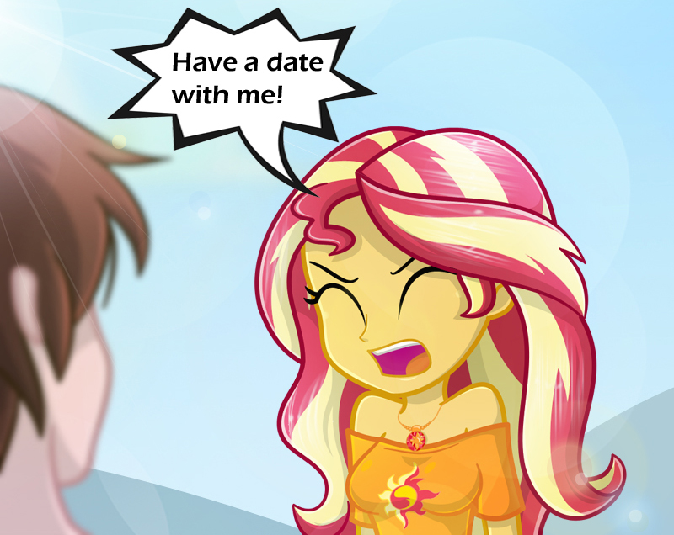
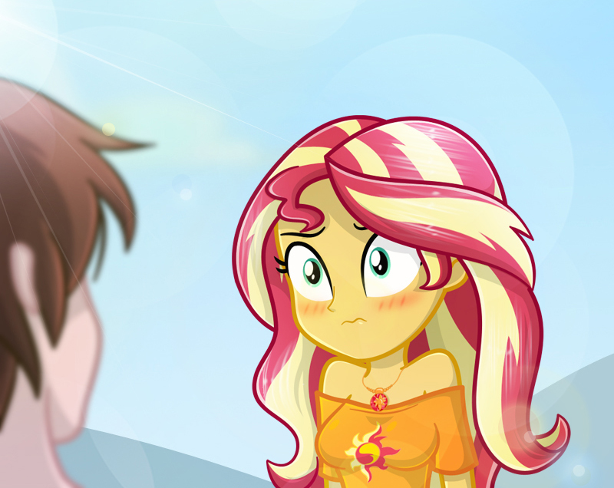
What did I just say?! O.O'
You: wh-what?
Sunset: aahm.. you know, a date... i mean, reunion...
You: for what?
Sunset: I have to explain everything to you?! I must tell you about our plans for Pinkie's party!... It's not like I want to go out with you or something! >-<
You: oh I see, that makes sense!... sure! why not.
Sunset: Great. Tomorrow at 4 pm, I'll wait for you here.
You: no problem, Starlight will be happy to know the plan too! hahaha!
Sunset: NOO!
You: no?
Sunset: nop, It will be just you and me, it will be our date... REUNION, it will be our reunion! There is no point in her coming with us as she will eventually know the plan. The girls will tell her everything she needs to know.
You: Alright then! See you tomorrow!
Sunset: Okay. Oh, were you going to tell me something before Starlight interrupted us? You changed the topic for Pinkie.
He freezes for a few seconds ... the expression on his face is "scared", hmm, it's like he's hiding something important!
You: I think now isn't the moment hehe, bye!!
He quickly runs to try to catch up Pinkie and Starlight.
I can't believe it yet, am I really going on a date with him?! O///o' .. Why did I have to tell him that! ...
*sigh* To be honest, I don't mind dating him. Actually, I'm ... happy?
-the same night-
Sunset: AAAAH! I cant sleep yet! Our date... REUNION! it has to be perfect.
I have been for 1 hour trying to decide what clothes to wear. I don't want to wear the same clothes as always, I want to look special, different. I want to look... pretty for him. AAAH! why am I saying those things!
Anyway, I'll go to sleep now, I need to be rested for our reunion... DATE! .. oh no wait! AAAAAAAAGGGHHH!! Dx
-the next day-
It's 3:45 pm ... I arrived early to avoid the traffic :D! .. ... ... WHAT A LIE! I arrived early because I'm impatient!!, but there's no way I'm telling him that!
15 minutes later, I see him walking in my direction. I must admit this: he is very punctual.
You: Sunset! Woah, you look beautiful! :O!
Sunset: you think that? hehe, thanks ^_^... .. ... OH! i mean, whatever... <-<
You: So, the other girls won't come with us?
Sunset: Ahem, nop.
You: Okay, let's do this quick. I guess you're very busy, so I don't want to take up too much time from you. Tell me, how are you going with the preparations for the party?

Sunset: You don't need to rush so much with the details, I have free time today hehe. Hey, it's a nice day, don't you think? ... do you want to… walk with me? I mean, I need to distract myself, a little fun would do me good.
You: Just with me won't be any fun at all -_-'
Sunset: w-well... oh, ahm... just come with me!
I take him by the arm and we start walking. Without realizing it, I start to get closer to him ... i must say that for some reason, I feel very calm now...
You: Sunset, are you sure that just walking is fun for you?
Sunset: ...it's not all bad.
You: huh? really? what's the good part? xD
Spending time alone with you, but i can't say that...
You: OH! i get it!
Sunset: ?!...
You: the party, right? I mean, walking clears the mind for good ideas! and we're talking about Pinkie's birthday! Is that the fun part?
Sunset: hahaha... indeed.
A brick... I dont know if i should be relieved or disappointed... but, that smile of him truly is precious.
Sunset: All right. Let's go to the videogame center, I heard that the Among Us Pony version is now available! I want to stream that video game!
You: Haha! That's what i'm talking about!

We go to the video game center and buy the physical version of Among Us Pony. It wasn't too expensive, so it was definitely worth it! He was very gentlemanly for help me pay the video game, I should invite him to one day play with me, it's the least I can do.
After that, we both decided to go for ice cream. It's great the fact that we share our tastes for video games, so the talk was very spontaneous and fun ^_^
Sunset: I have already won over 450 crowns in Fall Ponys, that game is very easy ^^
You: 450?! OMG, I only have 1, and it was because of a bug! :P
Sunset: 1?! HAHAHAH!! You need more practice! I will show you the best shortcuts if you want ^^
You: Okey great! Ahm, the ice cream made me very thirsty, do you want mineral water?
Sunset: sure, thank you :)
You: okay, i will be back soon!
Then, he walks away to buy the mineral water for both of us.
Sunset: ... *sigh*
All this time I have treated him very badly, but he is a very good person. Maybe, did this have to happen to realize how wrong I was?... I mean, have a date with him?
He has behaved correctly, in addition he has not even realized that it was all a lie. I wanted to go out with him because I was so jealous of Starlight.
This means that all of the previous misunderstandings were not really his fault ... I was just jumping to conclusions, never giving him a chance to explain himself properly.
I have been a very bad person... I thought I had changed, but I have been the same bad person that I once was.
Sunset: ...
You: aaaand here's your mineral water, Sunset. ^^
Sunset: ...
What a fool I have been... Is that the reason why I'm the last? It's normal that he not feel me worthy after all...
You: Sunset?
I admit I lack any semblance of femininity, there are many girls withing of his social circle who are far more feminine that I: Sci-Twi, Rarity, Fluttershy, Wallflower, Starlight... Am I even considered an option?! No likely.
In which case, what is wrong with having him to myself for just one day?
You: hello? Sunset?
He is a kind man. He would show the same kindness to anyone, not just myself... Even knowing that I have been a terrible friend.
Just thinking about it pains me. After all, I think I developed feeling for him... I wasn't sure, but today I can confirm it.
You: Sunset, are you okay?
Sunset: Forgive me!
I say this while standing up and closing my eyes. I am not able to look at his face right now.
You: ah, what? Forgive you? What are you talking about O.O'

Sunset: For being a bad friend, for hurting you, for not believing you, for not trusting you! ... I have been the same bully all this time, I thought I had changed, but it was not like that! please forgive me!!
You: woah! dont worry about that. There is nothing to forgive, you wanted to protect your friends and that's great! Everything is already forgotten hehe, besides the wounds heal with time, see? Im like new guy!! hahaha :)
And there it is, that tender, sweet smile of him. Even after everything that's happened because of me, he has always kept on smiling.
Sunset: thank you ^.^
You: why?
Sunset: For accepting this date with me ^.^
You: da-date? Wasn't this a reunion?? o///o
Sunset: hahaha! you jerk xD!
I throw him water with the bottle and run away hahaha! I must say that I can't remember the last time I had fun! xD
You: OH! Is that what you want? Take this!
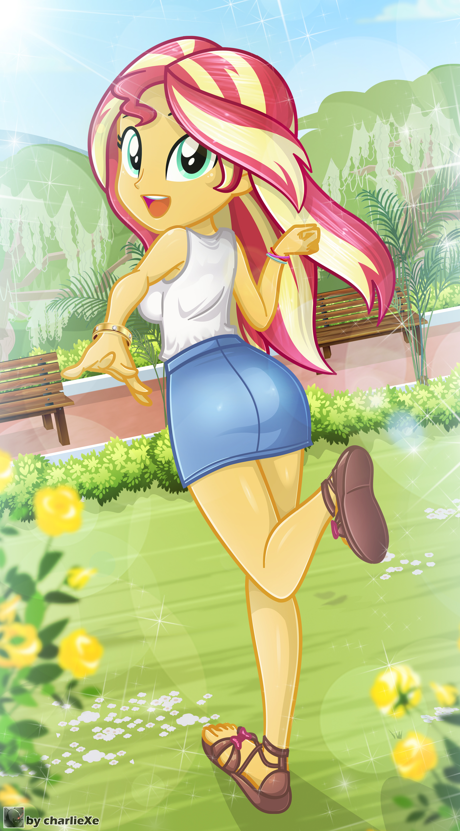
He starts chasing me around the park, foolishly trying to throw water on me x'D
Sunset: hahaha!! NOOOO!! hahaha x'D
You: aaargh!! xD
Hehehe, I'm so happy ^///^... I wish the day would never end <3. At the end, my date with him was perfect! yay!
-END-
…
…
??? #1: There is the traitor, and look, he seems to be having fun with the bacon hair hahaha!
??? #2: hmmm…
Two strangers see you from the distance, apparently they have a certain "interest" in you, and for some reason one of them keeps calling you a traitor :O!
??? #1: It has become a soft idiot, where was that ruffian boy who liked fights, looked down on the weak and made even Tartarus fearful?!
??? #2: Don't worry, he will come back ^^
??? #1: Definitely being turned to stone made your judgment clouded. LOOK AT HIM! He will NOT come back. I should go and crush him with my bare hands right now. I have the null orb, Shimmer won't hurt me.
??? #2: NO! UGH! It would have been better to come with a gorilla! Now let's go. We have work to do.
One of the two strangers is a little girl, who as she walks away, she fixes her gaze on you ...
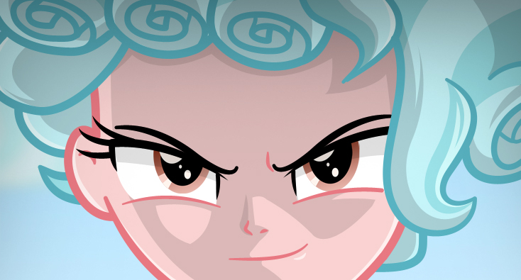
-END- :x

