Photoshoot  A Vignette  By Maryanne Peters  I was accompanying my girlfriend on a photoshoot. To be honest, as a guy I was pleased to tell my pals that I was dating a model, but the truth is that she was not getting much work. She mentioned that her father had a hand is teeing up the session to promote a line of clothing that was just her style, so I have to say I wondered if Daddy might have sweetened the deal a little, given that he has bundles of cash.  The shoot included a hair and makeup lady, and my girlfriend had her hair styled and makeup applied there on site. I thought that she looked pretty good. She was happy, grinning away through the whole thing.  Anyway, I was there to support her. I was not there for any other reason.  I could see the photographer eying me up and down. I guess I thought that he might be gay. It seemed to me that a lot of guys in the fashion industry are gay. Not me. I wasn’t in the industry. And I wasn’t gay either. At least not then.  Sure, my hair was long, but I would not have called it effeminate. And I had been out of the sun while spending so much time indoors gaming so I looked a little pale. And I was bored so I may have looked a little disinterested. | 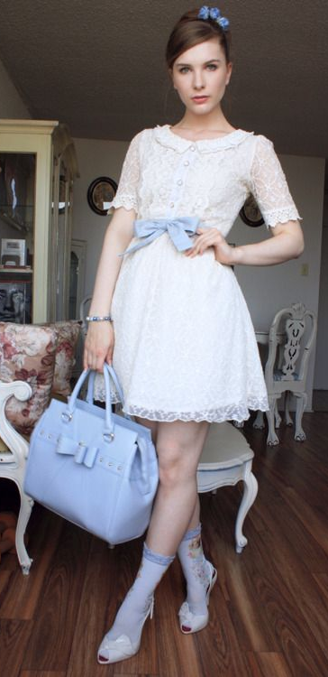

Anyway, the photographer was not happy with my girlfriend, and I could see it. He was getting frustrated. He could not get her to stop smiling. I guess he wanted that pout like models do. What is that all about? Surely it is better if they look happy in the clothes?

“That is the look I want from you!” he said. He was pointing at me. “Come to think of it, that is exactly the look that I want. What size are you, pal?”

I could not believe that he could be thinking of putting me in a dress and taking photos of me. Of course, I protested. My girlfriend started by getting really pissed off, but the photographer said that he had a bunch of photos of her and was just looking for another look.

“Your boyfriend is a fit but a different shape”, he said. “It is just an idea. Androgynous models are the thing these days, and these clothes are ultra-feminine, so the idea of having a boy wear them is an interesting concept to explore for a moment. Of course, he will get his own modelling fee.”

I have to say that there was an idea that appealed to me. Unlike her I did not have rich parents.

“We will need to have you in hair and makeup first,” he said. “You’ll have to lose the hair on your arms and legs. Get on with it. Time is limited.”

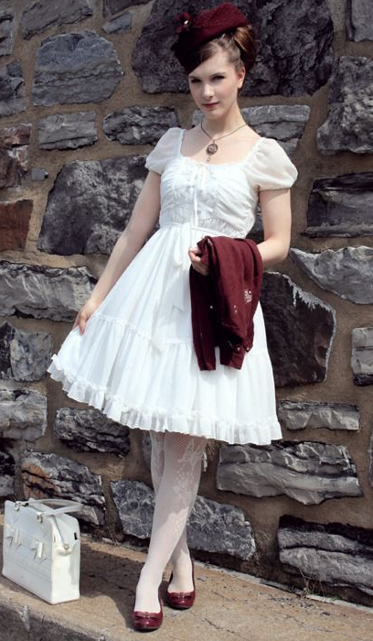 | Suddenly my girlfriend was intrigued by the idea and I ended up being rushed through the whole thing. My hair was washed and styled and after “tidying up” my eyebrows I had my face made up.  The photographer said that my skin was perfect for the look he wanted, and my hair color was just right too. But what he wanted was that pout. It was certainly evident in the first series of shots of me with the blue.  “Your eyes are the perfect color,” he said. “We have the hair-bow, the sash belt and the bag, and the shoes are not quite right … get some socks!” He seemed to know what he wanted.  He had me take up all kinds of positions and took a whole series of photos – man more than he took of my girlfriend. And that was just the first series. Then I wore more white dresses with feature and accessories in various colors. It was not until the burgundy outfit with the little hat, shoes and bolero jacket that I realized that my girlfriend was not watching.  He suggested that I needed something around my neck and he asked the hair and makeup girl of he could borrow her pendant. He came up to me and he put it around my neck – so close to me that I could feel his breath.

“You have such a beautiful neck,” he said. I blushed – I mean I could feel it hot all over my face and my neck. Why does that happen? As pale as I was I felt that I must be glowing bright red. He was just smiling at me.

“Where is my girlfriend?” I said. “I have just noticed that she is not here.”

“Oh, she left. She drove away when you were modelling the green,” he said in an off-hand manner. “Not as green as she was – green with envy.”

“We came in her car. How am I going to get home?”

“No problem,” he said. “I will drive you home. But before I do, I wonder if I could invite you to have dinner with me. You look so wonderful in this outfit that you really do need to present yourself to the world.”

And that is how my career in modelling started, and my new future too.

The End

© Maryanne Peters 2022

