Dealing with Debtors
Based on a cap by TGFusionist on Deviant Art
By Maryanne Peters

Ollie has to one of the dumbest guys on the planet, but I guess I love him now.

He made some money as a MMA fighter and somebody suggested that he go into lending. He had money and a look that said “pay me or else”. That meant that he could lend at bottom end. No security necessary. As he said to me when I had to resort to a loan shark: “Pay me back or I take your balls … and you still have to pay me back.

The other thing that you have to say about Ollie is that he keeps his word. If you need the money within the hour, he will see you get it. If he says that he will take your balls if you don’t pay, he will take your balls.

I should know. And I still had to pay.

With no balls and no money, I could only offer my brains. I said that I would help him to keep track of the loans, and work my debt off that way.

“You can be my secretary,” he said. “Or maybe my accounts lady. Because you have no balls you ain’t a guy no more. And anyways, your face is way too pretty to be a guy. You get yourself some girl’s clothes to wear. I’m gonna call you Sasha. I like that name.”

That is how it started. That was how I became Sasha, Ollie’s wife.

It was all surprisingly easy given that I was gay to start with. And I had a thing for bad boys which is how I ended up in trouble in the first place. It was just that Ollie was not gay so I had to become a woman.

I don’t mind the hair and makeup, and the clothes are just fine, but he did insist on these tits, and they are a burden. But he loves them big.

It is just that I never liked the way he collected. Violence is not my thing. I don’t want to see anybody else castrated. It is not just because I am squeamish, I am worried for Ollie. I have come to enjoy having him around and I would be heart-broken if he went to prison. So, I offered to collect for him.

“But that’s what I do, Babe,” he said. “You just need to look pretty and tickle that adding machine with your painted nails. I will do the tough stuff.”

But when he went out of town for a week fishing with the boys, I looked after things. I had been in touch with the debtors and getting instalment payments with interest into a receiving account. Ollie just wanted to see the big sums come back. He never really understood the concept of the cost of funds, bless him. I was able to show him repayments of lump sums that I had transferred across and use the collected money to offer instalment repayment terms to debtors.

Ollie really has no idea how much he has loaned out, but I do. I am collecting interest and penalties that he doesn’t see, and now I am collecting I simply tell the debtor’s: “Do it my way or you will get a visit from Ollie.” I have a buffer. I can absorb the non-payment of principal by paying out lump sums.

Somebody must have told him that I was absorbing the debtors, not the debts. It is weird, but he seems to have the idea that I am consuming these people somehow and it is making my tits grow. You have to love a man who that simple and who can’t keep his hands off you.

I doubt if he even knows what “absorb” means. He would certainly never understand what hormones are.

But Wow! Is he good in bed! Before all of this I was just a regular gay guy who never did drag, but now I am a wanton tranny hopelessly in love with the man who created me. A girl with a tassel.

Maybe a girl can’t expect everything from her guy, but when we are alone together, my Ollie gives me everything I want.

The End

How it Started  Inspired by a Captioned Image by Lenkeler on Deviant Art  By Maryanne Peters  I have that photo on my dressing table. It is Ellie and I at the prom, way back in high school. Tell me that does not look like love in her eyes. It certainly felt like it back then  I pulled out all the stops for her. I wanted her to see how much I was prepared to do to win her love. I had been growing my hair for months and wearing it in a greasy cue so that I did not have to wear a wig. Then some time before the promo I had a full body wax and took up a skin softening regime including tablets and lotions. And on the day I went to the salon and went through the works.  It was all for her. It was one night but I was ready to "explore my feminine side" and to find a way to live as her partner in life if she would have me.  Back then she was all I thought about. I knew that there could never be any other woman in my life but her, and it turns out that I was right. | 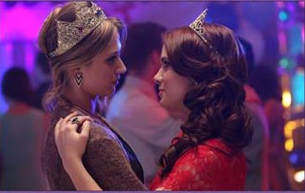  Ellie and Ryan had been best friends since they were little. Ryan always had a crush on Ellie but she didn't seem to feel the same way. They were both fairly popular when they got to high school, but Elbe eventfully came out as a lesbian their senior year and started to avoid a lot of social situations. As prom season drew near Ryan suggested they go as friends. Ellie thanked him, but said she really wanted to go with a girl. Ryan understood and told her he would try bis best to find a gorgeous girl for her to go with.  It was the day before prom and neither of them had any luck finding a girl for Ellie to go with. Seeing Ellie was really upset about it Ryan told her not to worry and to be ready at 7 the next evening; he would have a great girl ready to pick her up.  Ellie was blown away when Ryan showed up at her door with long blonde hair, makeup, and a flowing gown. When he told her that he would do anything for her she started crying. They ended up winning prom king and queen and Ryan had a feeling that they would be exploring more of his feminine side in the future.

But the sad truth was that Ellie was a lesbian and I was not. It was a night to remember, and where is should have been a night that culminated in love making, when it came down to the reality of my body the dream was over for her.

She left me standing there that night, in my ball gown deformed by the erection that had thrown her into a panic. Crying seemed like the only thing to do. Perhaps if I was wearing a tux I might not have, but I was dressed as a girl and I had been acting as a girl all night - for her. I dabbed my eyes with a tissue so as not to ruin my eye makeup.

"Abandoned?" I turned to see who had spoken, and it was Kade Newman, captain of the football team.

"You too?" I found myself speaking in the same quiet feminine tones that I had used with Ellie so as to reassure her that my male persona had been left at home for the night. It appeared that remained true.

"Hannah was not ready," he said. "I respect that." It struck me that he was genuine. He was a good person. I wondered who Hannah was and what kind of fool she must be.

"Women." We were in the same boat, both let down by them. But it must have seemed odd to him.

"You don't include yourself then?" he said. "I know who you are. Behind the gorgeous woman I am looking at is a guy named Ryan, but surely you can't let me call you that?"

He called me a gorgeous woman. At least somebody respected the effort I had put in. I could not help but smile, and I realized that any sadness from seeing Ellie walk away had evaporated. I said: "What name would you like to call me by?"

"I think Diana," he said. "Wasn't she the goddess of love?"

That was how it started. That night. My first night as a woman. The night after my last day as a man.

I keep that photo on my dressing table to remind me. Beside it is a photo of us - Kade and Diana, on our wedding day, over a year later.

Ellie was a lesbian and I was not, but that night showed me that I was a woman.

The End

Smile in the Photo  A Short Story for John (from a Cap by Becca?)  By Maryanne Peters  Can you fall in love with somebody you see in a photograph? Stranger yet, can you fall in love with a child in a photograph, imagining her to have grown into a creature with all the beauty and warmth in that image, but now with the body of a woman? It seems very odd, but it happened to me.  Hannah Jenkins rented one of my two bedroom apartments, and I knew that her children were grown, making it wiser to move from a large leased home only recently. In her living room were plenty of photographs of her two daughter and her young son, and then there was the photograph of the young girl in pink. She was not either of the daughters, who were not particularly attractive, particularly standing beside their good looking younger brother. But there was the photograph alongside the others. | 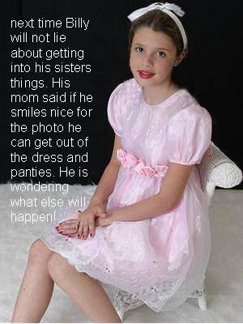

“Well there is a story behind that one,” said Hannah, when I had drawn my interest in the photo to her attention. In fact, it was much more than interest. I was smitten. The child looked so perfect with a ribbon in her hair, in her pink dress with flowers, with painted nails in her lap, and her legs not posed.

“Do tell,” I said, without taking my eyes away.

“That is actually my son Billy,” said Hannah. “I caught him dressing up in his sister’s old clothes. We had him dress fully so that we could take a photo which we could threaten him with. But the truth is that the smile was genuine. I think that day was one the happiest in his life.”

I was shaken by what I had heard. This girl never grew up. She existed only for a day, like a golden mayfly flitting across a pond dappled with sunlight, to be dead as darkness fell. That was sad, but for me it was much worse. If she had been a woman, I would have sought her out. I would have wooed her. There was something in those deep brown eyes that called out to me, even from the paper than the image was printed on.

“You have a photo of your son dressed as a girl?” It was not an allegation. It was a question.

“I don’t have it on display when he visits,” she said. “It embarrasses him. But he just looks so happy. And so pretty. Don’t you think?”

“He is not happy now?”

“He is a bit of a failure, I’m afraid,” she said. “I think that he might be gay, but he is fighting it. He has plenty of girls, but he cannot seem to form any kind of relationship. He is lost.”

“Maybe I could help him?” I said it because I was curious to meet him. I wanted to see what the person in this image looked like now. “My properties keep me busy. I am always looking for people. How old is he?”

“He has just turned twenty, my youngest,” she added, as if trying to reassure me that she was not that old. “In fact, he is coming over tonight. He brings his washing and has me cook him a decent meal. He is a bit helpless, I suppose.”

“May I drop by after dinner?” I suggested.

She agreed, and that evening I reappeared as arranged.

Billy did not get up off the couch where he sat watching something on TV. He looked untidy, with dark hair pulled back in a “man-bun” and just wisps where a young man like him should have a beard.

“This is the building owner I was telling you about, Billy,” his mother said, clearly annoyed by him.

“Oh yea,” said the youth, at last looking up in my direction. I could see those eyes. There they were. There she was. Because any image of a man before me disappeared in that instance. There was the girl in pink, but all grown up, and incongruously dressed as a young man.

And there seemed to me that the meeting of our gazes affected Billy too. It was almost as if it were a fairy tale, with only the violins missing. There was an instant bond if you like. We were just not sure what it was. At least not then.

“Billie?” I said. Of course, it was Billie. It was stupid to even ask. It was just that … “I saw that photo of you today. The one in the pink dress.” I just blurted it out, as if compelled to remind him of who he was, or should be.

Billie should have turned red with embarrassment. But that is not what happened. The words spoken were: “That was a long time ago. I don’t do that anymore.”

“If I bought something pink, would you wear it? Would you let me take you to dinner in it?”

“Just a minute,” said Hannah, clearly aware that she was interrupting something tense and almost other-worldly. “Are you talking about putting Billy back into dresses?”

“Yes,” said Billie, ignoring mother and answering me. “Yes, I would.”

“What size are you?” I asked.

“I don’t know,” said Billie. “What size am I Mom?”

“An 8, I guess,” said Hannah, still appearing confused, but understanding that she was largely irrelevant.

“Ok,” I said. “I will send it here by midday and pick you up from here at say 6:30 tomorrow evening?”

“Ok,” said Billie.

On the way out I said to Hannah: “There is a month’s rent holiday if you help her to get ready.”

She nodded, but her mouth was open. It had been a brief exchange between her child and her landlord, and it had left her confused. That seemed understandable to me. I was a little confused myself.

If it was unnatural to view an image, apparently of a very young girl, and have lustful thoughts, what about having those same thoughts when confronted by a young man? I comforted myself in the knowledge that what attracted me in the child was the woman she could be, and now it seemed as if that same attraction had carried through to the person I saw on the couch. What kind of woman could Billie be?.

I spent the following morning looking is shops close to my office. I confess that I know what I like on a woman but I could not decide between the three outfits I liked, so I bought all three, and three sets of underwear to match, and two pairs of shoes, and I send them all to Hannah’s apartment.

It added to the suspense. I had no idea what she would wear. My only hope was that the woman would emerge so that I did not have to face the embarrassment of escorting a drag to a meal at the restaurant that I had booked. Still, I had dined with others there before, women I was interested in and men I did business with. Something in between could be borne with head held high.

Hannah greeted me at the door. She was smiling.

“Thank you,” she said. “Thank you for bringing back the light in those eyes.”

I shook my head in confusion. Then I saw the light that she was talking about.  She was wearing the tight black dress, high at the neck with long sleeves, buy mid-thigh in length revealing shapely shaved legs. He hair was down over her shoulders in soft waves, and her make-up was crafted perfectly. Bright read lipstick was matched by a manicure with nail extensions.  And there was that smile too. Not quite the one in the photograph, but still with a trace of innocence, enhance by her shaped body being covered, where her legs needed no such assistance.  I became aware that my eyes were devouring that body like a hungry wolf, right there in front of her mother. | 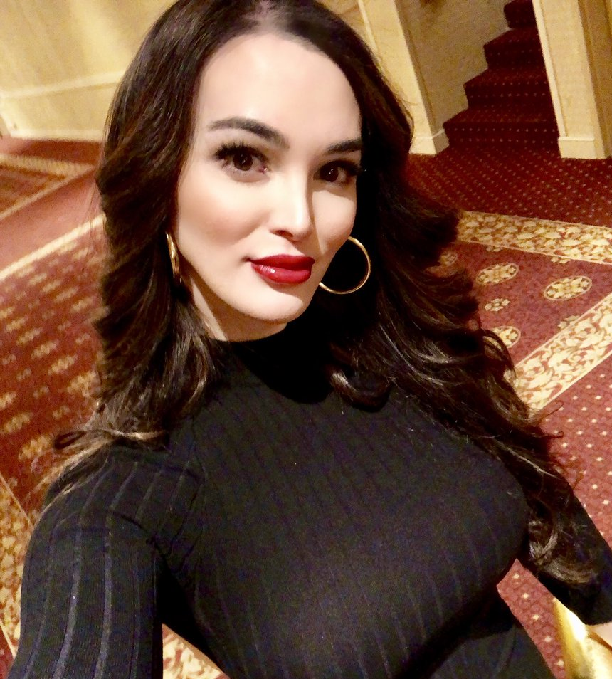

“I can’t say when we’ll be home,” I said.

“That’s alright,” she said. “Billie is old enough to look after him … herself.”

The correction made me look at her. She was happy, but I was happier. I said: “Make that two months rent holiday. She’s gorgeous.”

“Do you really think so?” said Billy, in the perfect high and husky voice.

I offered her my arm and we left.

We only ate the appetizer. It was long enough for both me and Billy to understand what had to follow, and why it could not be delayed beyond that single course.

“I have spent all this time searching for something when it was there inside me all the time,” she said. “I denied it, but you saw it in me. I know that my mother hides the photo, but when she is not looking I sometimes get it out, just to remind me of happy times.”

“Give me the smile in that photo,” I instructed her. She did. My heart leapt.

I took her home. I needed to be inside her, and she needed that too. It was to seal the deal – to confirm that there was no boy; no man. There had always been a girl, and now she was a woman. It was just the way I imagined it would be, as she looked up at me after the initial sweet agony: The smile in the photo. My girl Billie.

The End

A New Star
Inspired by a Captioned image
By TV Nicole
By Maryanne Peters

Ok, so it was only Junior High Football, but I was good at it. It was just that after Daddy left - Mom did not want me to play. She said that it was an awful sport. She said that it was everything she hated about men – violence and toxic masculinity – whatever that is. She said that instead of football I should be working alongside her in the fashion industry.

“Look at me,” she said. I am making the world a more beautiful and stylish place. And you just want to chase a ball around and hurt people.

Dad wanted me to play football, but he is not around anymore, so Mom gets her way.

“You are just so pretty,” she said. “Long hair really suits you.”

She took me out of pre-season training to push her “project” for having an androgynous preteen model for next years spring collection. The problem is that I don’t look androgynous – do I? I look all gyn and no andro!

But the LBD does look good on me – don’t you think? And if I do become a teen model after the end of the football season, I will be making money – that sounds good.

But with this magazine spread she has planned my face will be out there. Will the guys on my team see that it is me? Why would they even look at the fashion pages. I may be Okay. I can then take out the extensions and concentrate on my sport. But I have to say, I do like the way the hair feels down my back and across my cheek.

The team needs me. I am the guy who runs in the touchdowns. But I am not the only running back. That guy Jason is pretty quick. And he is good looking too. What am I saying?

I really don’t know what to do. Football or Fashion? What kind of star do I want to be?

The End

Just Friends  Inspired by a Captioned Image by Czolgolz  On Deviant Art  By Maryanne Peters  I was always big. Big but soft. Chubby, I guess. Late puberty had something to do with it, I was told. Big and soft and not like the other guys.  But I was still interested in girls. It was just that they were not so interested in me. All of them except Julie, that is.  She was not the prettiest girl in school, but I thought she looked good. She knew about makeup and everything, but she had a heavy brow and a big jaw and her eyes were small and dark.  She said that it was a crime that I had big blue eyes and good cheekbones and fair hair. She had none of those. It was Julie who suggested I wear my hair longer.  Everybody at school knew we were a couple. They joked about it. “Chunky and the Goth” they called us. There was a size difference between us  But Julie said that we were just friends.  I wanted a girlfriend, and she wanted a boyfriend, so I could not understand why we were to be “just friends”. It never occurred to me that she found me unattractive, because she was always pointing out my good features. But as it turned out she was not drawn to me sexually.  Actually, I was not sure exactly what drew her to me initially, but it was almost as if she wanted to use me like a giant human doll that she could dress and beautify in a way she could not do to herself. | 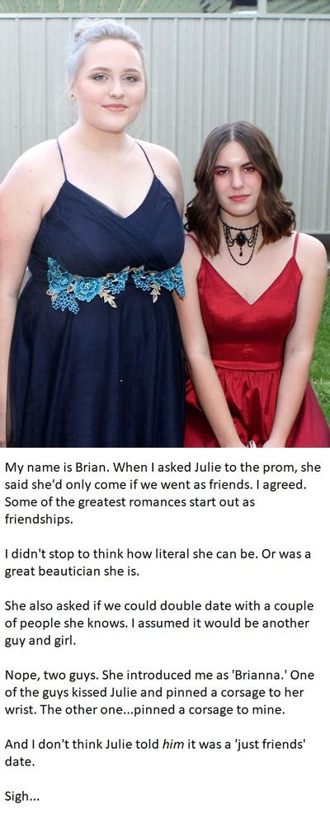

I did not know anything about the blockers and the hormones. My doctor said that obesity can delay the onset of male puberty and he suggested that I lose weight. But I seemed to just be putting it on in one place – my chest was swelling like crazy. Julie had pink cream to prevent them for getting sore, but that just seemed to make my nipples get bigger.

Then she started suggesting dressing like a girl, just around at her place. She had an aunt who was big and she got some of her cast off clothes and fitted them for me. Like I said – a human doll now with a range of outfits to parade around in for her amusement. I was happy to do it, because she was my girlfriend, and I thought that I was her boyfriend.

Then she went to work with the cosmetics. Her own look was heavy, and her hairstyle I came to know, was not right for the shape of her face. I had a big round open face, and I was happy to wear my hair pulled away from it. At school I kept it hanging down to hide myself, and I wore my baggy clothese to hide my unmanly shape. But somehow the bet way not to be recognized as Brian seemed to be to show this version of me that Julie had created. People would think that I was a girl. Nobody would thing that I was the guy known as “Chunky”.

Her mother took a photograph of us. She said that I was far too pretty to be a guy. What does my look say to you? Maybe she was right?

So then on the way Julie sprung this escort thing on me. She said that she did not want people to think that she was a lesbian, so she was going with Danny, the creepy from art class, and he was bringing his cousin as a date for me. I was Okay with that until we got there and his cousin was a guy! And I mean a real guy – a big football player – bigger than me. His name was Jerome.

To him I was Brianna. I suppose I could have just run off but he seemed really nice and he had a corsage for me to wear on my wrist and an arm to hold onto as we paraded in. Everybody was asking who the big couple were. He whispered in my ear that it was great to have a big girl on his arm as it made everybody seem so much smaller. I just looked at him and smiled. He was just so nice to be with.

We danced and everybody made room. Who wouldn’t? You would not want to be stepped on Jerome and Brianna. We laughed about it out the back, and he silenced my giggles with a huge kiss. Before I knew it my arms were flung around his neck and we were tongue wrestling.

So Julie is right, we went to the prom as “just friends”. Who needs a girlfriend when you have a boyfriend like Jerome?

The End

© Maryanne Peters 2021

