A Thing of Beauty
By Request: A Sequel to Beauty Boy
By Maryanne Peters

I sometimes think I am just a thing to him. A thing of Beauty.

I know what beauty is. It is my trade after all. I was a boy then, looking for a trade that did not require me to sweat or get dirty, and preferably involved in surrounding myself with beautiful things. Why should that be restricted to women? They do not have a monopoly on beauty.

Then I discovered that I was talented. I had flair and a steady hand, a temperament for precision and an eye for perfection. I could make women look beautiful. I could make anyone look beautiful – even myself. I modelled looks on my own face. I grew my hair and styled that. But I always thought of myself as a male makeup artist – just a beautiful one.

And then Thomas Denham came along and found me. He found me and he dressed me. He even took me out to dinner without realizing what I was. He never even bothered to ask.

When I told him he seemed momentarily in shock and then he just laughed.

“If this is a line to avoid me taking you into my bed, then it is a classic,” he said. But he knew it was true.

It was an awkward moment. The silence of horror. I think that we both felt it. We both knew the truth but we did not want it to be true.

The fire alarm had left us both on the sidewalk. I was in my mother’s robe, my makeup and hair styled for a woman on an important date - an evening out with somebody special. Except I was not that woman. I was just the makeup artist. But Thomas Denham is a man of wealth and power and is used to getting his own way. It is hard to resist that kind of influence. Before I knew it, I was in the Birdcage Bar at the Palace Hotel, dressed to his standard and looking gorgeous.

“Do you dance?” he said. We were standing at the bar waiting for our drinks before finding a quiet booth. I looked at my reflection in the mirror for guidance. What would she do?

“Yes,” she said … I mean I said, even though short of jumping around in a mosh pit I had no idea what dancing was.

Yet nothing seemed strange in his holding me close and moving to the slow music. There was only one other couple.

I was not wearing any scent, but I had washed my hair to style it, and he said that it smelled of the sweetest flowers. It was just what we used in the salon. I let him bury his nose in it.

It was as if I was in a trance, or watching a romantic movie. I was looking on through the eyes of the girl in it, except that I was not a girl.

It was when we sat down together and the bite of the hard liquor in the cocktail brought me to my senses. I had to take a mouthful to summon up the courage to tell him.

“I am sorry,” I said. “I don’t want you to get the wrong idea. You seemed so insistent. And we were both … well, not otherwise engaged. But, you see, I cannot … I am not … what you think I am.”

“I can see what you are,” he said.

“No you can’t,” I said. “You can see a beautiful woman. But I am not that. I am not even a woman.”

It occurred to me that the whole discussion had been with me speaking in a voice that was not my own. When we met I had barely spoken, but the lady in the boutique who dressed me had me speaking in a higher tone and from the moment that I was in that dress and those heels, only her voice came out of me.

And now I was bracing for his reaction. I was ready. Disgust – perhaps violence, but the tone of the Birdcage Bar offered me protection.

“Amazing,” he said. Just that. And he was looking at me with something very different from disgust. “You did this yourself? This look is all yours?”

“It’s what I do,” I said. Perhaps my relief was evident. There would not be scene in public. “I am a beautician. I like to think that I am a good one.”

“It would appear so,” he said.

“And of course the dress and the shoes and bag … that is all your doing. That belongs to you.”

“Not any more it doesn’t,” he said. “I want you to have it. I bought it for you. All of it.”

At that moment his phone rang. It was the doorman to inform him that after residents had been on the paving for over an hour and the fire department had checked all systems, the building was clear and we could return home – he to his penthouse and me to squalid lower level apartment.

“We’ll finish our drinks and then I would like you to come up to my place for a few minutes,” he said. “I would like to show you something.”

I remember that I was reluctant. The fear was no longer there. He knew what I was and he seemed accepting, even curious. But where was this going? He offered me his arm, and for whatever reason I took it. I may have told myself that I needed support in tripping my way back to the block in my heels, but in the walk over to the bar I had proved myself surprisingly adept. No, I liked being on his arm. I was less obvious and yet even more alluring, with a man.

We walked and he remarked on the possible cause of the fire alarm. He said: “We have several floors of fine apartments on the upper levels with our own elevators, but the same fire system. I suppose it had to be that way.”

A separate lobby too – all strange to me. But up we went, and I stepped into his luxurious apartment.

Is it vain or elitist to feel in that moment that I belonged? It was just a feeling. There was another mirror. Whoever I might be, she belonged in a place like this. She was dressed by Atelier and made up by an expert. She looked classy, which is the look that I was going for.

He said: “Look around yourself. I am in the art business. And I surround myself with art. I can never get enough beauty to satisfy me.”

There were paintings on the walls. Single pieces in some places and cluster in others, so that there was plenty to see but without looking cluttered. There were shelves too, table and sideboards with sculptures of ceramics. I am no expert, but it all looked like quality. I may have said as much.

“I think that you are something of an artist yourself, so perhaps you can appreciate why I treasure these things,” he said

“I am a makeup artist, that is true,” I said. “Some of us are just makeup technicians but yes, I consider what I do is art.”

“I can see that.” I turned and he was looking at me approvingly. I smiled – because I was happy. Those words made me so. Very happy.

He stepped over to an intricately painted vase. He said: “What is clay but a type of mud. The colors of the glazes here are oxides of metals from the earth. The same with the paint in these paintings on the walls. The oils are from black crude, and the colors are from metallic stone. Rock, pitch and mud. We take the very opposite of splendor and turn it into works of art. That is true beauty. To make it from nothing. That is art.”

He was still looking at me. He was talking about what surrounded him, but he was looking at me.

“That is what you are,” he said. “A beautiful woman made from not even a woman at all.”

I could not help myself – I struck a pose. I had seen it so many times. Once I had done my work my client might do it for a friend, or a boyfriend, or even just the girl in next chair. It said: ‘yes, I am beautiful aren’t I?’. It does not need words. I struck a pose, and he responded.

I could say that his arms and his kiss were unexpected and perhaps unwelcome. I should say that, but it would not be true. The boutique, the bar, the cocktail, the bewitching walk back, this apartment – everything was confused and out of place. Maybe unexpected, but not undesired.

“I am collector,” he explained. “I collect things of beauty”.

For you, Thomas Denham, I will happily be that.

The End

© Maryanne Peters 2020

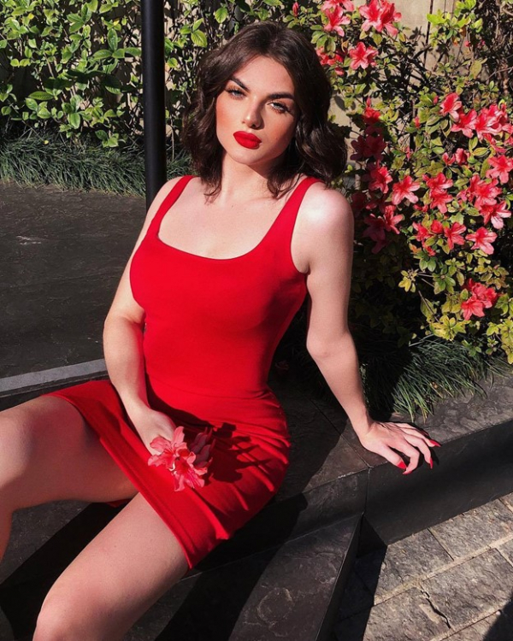 | 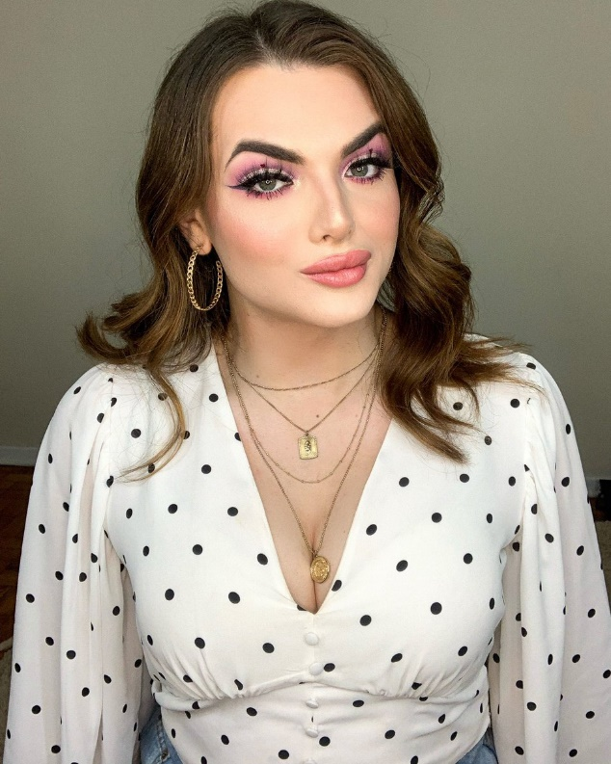

Author’s Note:  This is a sequel, of sorts. In her review of my story “Beauty Boy” Sammy C said: “Love the story. But this really cries out for a sequel. The relationship between the two has the potential for so much drama, conflict, and romance. I know you’ve got zillions of things on your docket but please consider revisiting this soon…”. My response was: “I would be interested in hearing where you think this might go. If I do a sequel I usually like it to stand alone…”. | 