Putting up my Hair  A Vignette  By Maryanne Peters  When I was a young boy, I wore my hair long. My mother did not discourage me because she said that my hair looked lovely, which is what I thought too. But my father hated it. He was always telling me to get it cut and I always resisted. I suppose that says something about my relationship with my father – I felt that he was proud of my older brother, but not me. As far as I was concerned, that made his opinion questionable, so I always questioned him.  “You are just like your mother, always turning everything into an argument,” he would say. That made my mother secretly smile. We were alike one another in other ways, I guess.  “You know what would really annoy your father,” she said. “It would be if you went to your uncle’s wedding as a flower girl.” | 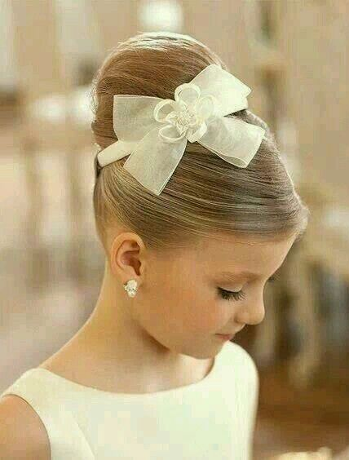

My mother’s brother, Uncle Mike, was going to get married and my brother was going to be an usher along with a guy called Seth, a boy from his bride’s wider family. The bride had a flower girl from her side (Seth’s sister Blanche) but my family had no girls, just my brother and me.

“I can just imagine your father’s face if he saw you walking down the aisle behind the bride in a cream dress with your beautiful hair up in a bun. I would be so proud of you, and he would be furious.”

There was something about the look on her face that made me agree to this crazy plan. I mean, I liked the idea of grinding my father’s gears, but the thought of her look of pride was what had me saying yes.

The bride thought that it was great idea. She said that I could join the bridal party to get ready, and they would give me a professional makeover – but only a slight one because I was so young.

I had never met Blanche before, but she got very excited about the whole thing. She was only a month older than me and she decided that I was going to be her project for the day.

“We are going to turn you into a girl from head to toe,” she said.

“It’s only just to see my father’s face in the church,” I said. I was also looking forward to my mother’s reaction. “After that I can go back to being me.”

“Oh please be a girl right through the reception too,” she pleaded. “This is all as new to me as it is to you. It is just that I suppose I always expected this, and you didn’t. You just need to learn how not to swing your arms around and stride about like a boy. I can show you.”

I liked her and so I went along with it. I had my hair washed and brushed and wound up on my head. The makeup lady just brushed my eyebrows and added a little mascara and lipstick, but then she suggested earrings. Maybe I should have said no but I was so transfixed by the vision of me in the mirror I just nodded and bang, bang, ears were pierced.

I was given a one-piece underwear thing to wear, something that crushed my little boy bits right up inside me, but also gave just a hint of a bust. The dress was simple but beautiful. I wore a ribbon in my hair and shoes that matched what Blanche was wearing – sandals with slight heels.

They say that good clothes make you feel like you are somebody else – or at least women say that – men are never concerned. I felt like somebody else. I felt like a girl.

I remember that my parents looked around at the bride and saw me. The look on my mother’s face I remember almost made my heart leap out of my chest. Proud is not a big enough word for it. It was then that I realized that what she really missed was a daughter who could be like the bride walking down the aisle, but she was not looking at the bride, but at me.

But I felt like a bride as I took each deliberate step. I smiled at my mother as if to say – “Thank you Mom for raising me as your beautiful daughter and as I walk her to marry my handsome man …”. I had to shake myself a little.

My father just looked confused. He was a bit angry later, but it did not last long. It was somebody else’s wedding, after all.

I suppose I realized how important wedding days are … for women. For men they are just an afternoon followed by free food and drink, but for the female sex they are a celebration of womanhood and a change of life. That was how it felt for me.

After the ceremony, and after Blanche and I had carried to train back down the aisle and detached and furled it for the reception, she introduced me to her brother.

“I heard that you were not really a girl, but I don’t believe it,” he said.

“Blanche is playing tricks on you,” I said. “I am a girl. I mean, look at me. Look at my hair. Do I look like a boy to you.” Blanche was smiling. She went along with it.

“Do you dance?” said Seth, after we had chatted a little about nothing at all really. “Blanche at I do tap and jazz, and I am looking for a partner. It is weird dancing with your sister. Would you dance with your brother? It would be creepy, right?”

It my case, it certainly would have been. Anyway, when the music started Seth grabbed my hand and led me onto the dance floor straight after the bride and groom had done their thing.

“You really move well,” he said. “Why don’t you come along to our dance studio and give it a go. I think that you would really enjoy it.

That was how I got started. Believe it or not, for two years I attended dance classes as a girl while I went to middle school as a boy. At home I could be either a boy or a girl, but I guess I just got more comfortable being feminine around the house. There was something about wearing my hair up that seemed right. I liked a bun or a high ponytail with it drawn up at the nape but bounce behind me as I walked or danced. I ended up with a whole bunch of clips and hair slides, and with a father who no longer seemed to care that I was even less male than I had been before that wedding.

It was like a double life, but as I got closer to puberty, I needed to make a decision, and I suppose that nobody will be surprised that it was that I was going to register at high school as a girl.

But that was all years ago. I look at these photos of what I used to look like with a smile on my face. They all seemed to have me with my hair up.

Seth and I are still together. It took him a while to come to terms with who I was when we started high school together out of different middle schools, but I suppose that we sort of fell for one another even before the hormones started flowing, on that dancefloor at the wedding where I was the flower girl, and I wore my hair up for the first time.

The End

© Maryanne Peters 2024
1290

