Story © 2023 Ziel
Art © @cbl_art on twitter

The Shocking Adventures of Lumen
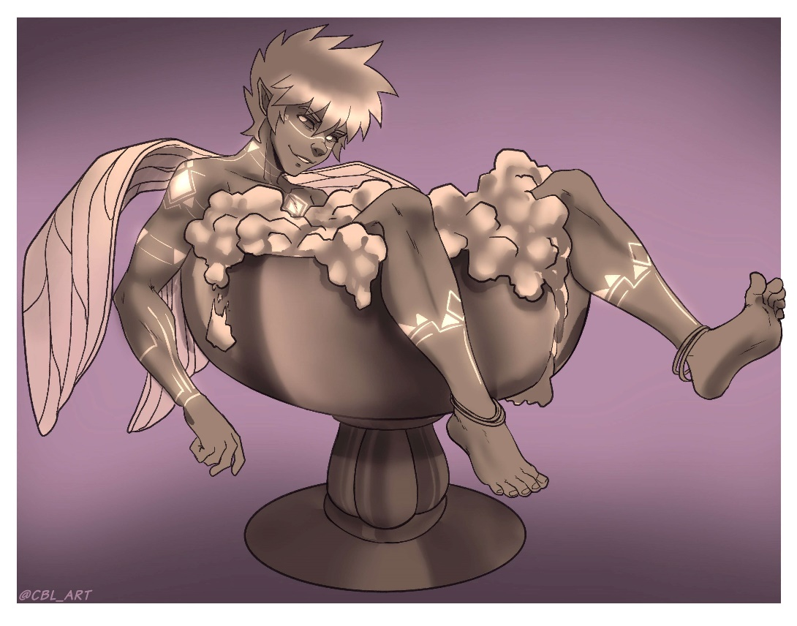

Part 3
Lumen’s whole body felt warm and tingly to the touch. He was so giddy and ticklish that even the most innocuous poke would have him giggling like a doughboy. He just wanted to lie there and bask in the afterglow, but as his mind slowly stirred back to consciousness, his eyes began to wander.
Lumen took stock of where he was. He was relaxing on a large, plush pillow which rested at the head of the most luxurious bed Lumen had ever seen in his life. All around him, the room was covered in brightly colored curtains and tapestries. Slowly, he came to realize that he was in the dao’s bed chamber, but the room was surprisingly cum-free and restored to its former pristine glory. Even the centuries of sand and cobwebs had been cleared off.
The sound of a door opening drew Lumen’s attention to the far end of the room. The dao stepped forth liking as jovial as ever. The short, chubby figure was still clad in his loose, open-front robes which let his massive cock and balls splay out in front of him.
“Ah, good. You’re awake,” he said pleasantly.
There was a brief pause. It wasn’t clear if the dao was waiting for some response from Lumen or was just being polite, but before the silence got awkward, the djinn approached the bed and said, “I took the liberty of cleaning up while you were asleep. You made quit the mess, but it wasn’t anything a little magic couldn’t take care of.” He gave a dramatic swish of his wrist to mimic the act of casting a spell.
Lumen slowly pushed himself up onto his elbows and then onto his ass. He was soon perched comfortably atop the pillow. Lumen yawned and stretched and gave a nod of approval to the dao.
“Here. Have some water. You will need to rehydrate after all that,” The dao said with a chuckle. The dao reached forth a hand. As he did so a small, thimble-sized glass appeared between his fingers. He then offered the small glass to the tiny fairy. Lumen had to grasp the thimble-sized glass with both hands, but he accepted it and began to sip.
As Lumen sipped at his drink, the dao continued to speak. “I’d like to thank you again for rescuing me. We both had a lot of fun earlier, but I think you understand how I feel when I say that I am eager to get back on the open road and explore the world. So much time has passed since I’ve been locked away. I’m sure the world has changed much in my absence.”
Lumen finished his drink but continued to listen quietly as the dao continued.
“I’ve gathered a few more thank you gifts which should help you on your way.” The dao said and reached into the loose sleeves of his robe and fished out a small slip of paper and handed it to the small fairy.
Lumen reached up and accepted the small slip of paper. In the dao’s hands it was little more than a post-it note or a napkin, but for Lumen it was like holding a road map. Lumen’s eyes scanned the writing on the page. It was filled with odd glyphs and sigils. It was not a language that he should know, but somehow, he understood the contents perfectly. As he read the sheet of paper, the runes suddenly flashed bright blue. The light was blinding, but Lumen could not look away. As he stared at the glowing runes, a strange sensation worked its way into his eyes. It was similar to when he looked at the sun which caused a negative image of the light to remain burned to the back of his retinas. He blinked a few times to clear the image, and when his eyes readjusted, he noticed that he was holding a blank sheet of paper.
“I noticed the vials at your waist,” the dao commented as if predicting Lumen’s question. “You look like you have some skill mixing potions. I made you as large as I could without impacting your ability to fly, but if you ever want to play around with larger sizes, those recipes should now be imprinted onto your memory. The changes will only last an hour or so depending on the dosage you mix so feel free to experiment.”
Lumen closed his eyes while he waited for the slight searing to fade from his cornea. His mind was swimming. He suddenly remembered all kinds of herbs and properties and formulae for mixing them. It was like all the stuff he had crammed before an exam had come rushing back to him right after he had already failed the test. It was dizzying, but even amidst the haze of his newfound knowledge, Lumen’s ears perked up at some of the dao’s words.
Lumen glanced down at the bed which spread out before him. The covers were pulled up to Lumen’s waist. Now that Lumen was sitting upright, the cover clumped up on his lap. Yet despite the fact that he was only covered from the waist down, there was a giant mound in the blankets that made it look like there was much more than just a pair of tiny fairy legs tucked underneath.
Lumen wasn’t strong enough to toss the covers off of him, but he had other ways of knocking them aside. He summoned a gust of wind which blew the covers back and revealed what it was that made the enormous mound in the bed.
Lumen stared in awe at the cock and balls that lay spread out before him. The sheer size and scale were even more dizzying than being psychically force-fed the book on alchemy. His sack alone was so massive that he couldn’t even see his legs. The only reason his legs weren’t being crushed under the weight of his own stones was because they nestled safely in the cleft between the two massive boulders. Lumen had originally thought that the weight pushing down on his legs had been from the covers of the dao’s luxurious bed. It felt much like he had a warm, weighted blanket stretched across his lap and shins, but it truth, it was the warm, thick flesh of his own enlarged sack that pressed down against his legs. Either enormous nut rose well above Lumen’s head. He doubted that he would be able to see over them even had he been standing upright.
Lumen shimmied his way out from under his own nuts. His lower body was red and sweaty as if he had been soaking in a sauna for the past several hours – which wasn’t too far from the truth. His legs trembled as he unsteadily got to his feet. The weight of his immense sack on his lap had done his circulation no favors, but it wasn’t just the fact that his legs were still asleep that made him so unsteady. The sheer weight – literally and figuratively – of what he had wished for was starting to set in.
Lumen looked up at his own immense cock. It was like staring up the initial ramp of a roller coaster. The colossal, flaccid shaft draped lazily over his nuts before extending out far in front of him. Lumen couldn’t even fathom how huge his dick must be. The sheer girth of it was so fat he couldn’t even hope to wrap his arms around it. He may as well be hugging the side of a barn.
Lumen fluttered his wings and awkwardly lifted off from the plus launchpad that was the dao’s pillow. Lumen was able to lift several inches into the air, which at his size was akin to if a normal sized person started levitating twenty feet off the ground, but he soon hit a point where he just could go no higher. His cock and balls wouldn’t budge even a millimeter. His nuts still rested solidly on the mattress before, and his cock still draped lazily over his nuts and stretched out in front of him for what felt miles – although that was more the sense of vertigo playing tricks on him than the actual size of his schlong. Lumen’s softy was only around two feet long, which was large enough to give even a cave troll a cock complex. However, at Lumen’s small size, his bait and tackle was many times longer than he was tall and weighed exponentially more.
Lumen’s heart started to race, and it wasn’t from the exertion of trying to lift his mountainous meat. His mind began to get hazy. He wanted to take off and fly away as fast as he could, but he was tethered. Images of his lantern that served as his prison flooded into his mind. His vision faded away and the sight before him was replaced with the semi-opaque glass that had surrounded him on all sides for so long. Everything was muffled. He could only make out vague traces of conversations happening around him, and all that he could see through the glass was faint outlines and amorphous shadows of the crews that all but ignored him.
The buzzing of Lumen’s own wings and the crackling of the lightning surging around him drowned out anything that the dao may have said to him, but before Lumen could fully panic, he felt the dao’s thumb gently stroking his hair.
Lumen slowly started to come down – literally and emotionally. As the tension left his body, he just wanted to collapse once more onto the plush mound of the dao’s pillow, but he found a firmer landing spot before that. Lumen’s bare booty landed with a plop in the dao’s palm.
Normally, Lumen hated being handled. People too often liked to wrap their fingers around the little fairy which usually resulted in them getting bitten. The dao, however, made no motion to grasp the small figure and instead just cradled Lumen’s body while the tiny fairy caught his breath.
Lumen’s heart was still pounding in his ears, but even through the pounding, he could hear the dao’s soft, soothing voice reassuring him. “There is so much power inside of you. You don’t need your wings to fly,” he said.
Lumen nodded and then took a moment to steady his breathing. Lumen had forgotten the dao’s words from earlier. The old djinn knew how much power was inside the little fairy, and he had made Lumen’s equipment no larger than the storm sprite could handle. Lumen just had to learn how to tap into that power.
Lumen focused his mind and tried to center himself. He tried to tap into that font of magic that sprung from within. He could feel the wind blowing within him, and as he focused, he could feel that gust turn into a gale. It was as if a storm was billowing up within him.
He could feel it. Even in a place like this that had been closed off for so long, Lumen could feel the currents of wind. They were so clear that he could almost see them. It was as if he could reach out and grab them. He may not be able to grab them with his hands, but his mind was a different story. He willed the currents to him. He rewrote and redirected the lanes and paths of the wind to circle him and his immense cock.
Even before Lumen could see the change, he could feel it. The currents and eddies clustered around his cock and balls and began to hoist his immense package into the air. Lumen watched in awe as his monolithic cock and balls lifted off from the mattress and floated in front of him.
Lumen’s wings were still exhausted from his attempt at flying earlier. They did not want to perform even the lightest flutter. Still, Lumen managed to awkwardly slide towards the edge of the dao’s palm and hop the short gap onto his gargantuan, floating schlong.
Lumen was seated awkwardly in the space between his two floating balls. His massive cock jutted out in front of him like an oversized boogie-board. His package bobbed and shifted with the circling currents. Maybe soon, Lumen would learn enough control to give himself a steady ride, but for now, it was like riding on a giant inflatable raft in a choppy pool. The ride was awkward and taxing, but Lumen could fly. He could actually fly!
Lumen started slowly at first, but as he got more comfortable steering his sky ship of a schlong, he began to dart faster and faster around the dao’s room. The dao merely smiled and watched his tiny friend dodge, duck, dip, dive, and dodge his way around the room.
Lumen was having the time of his life. He was huge, and he could still fly! This was the best day ever! But as much as he enjoyed doing laps, he soon started to feel a bit silly flitting around like that, and in someone else’s bedroom no less.
Lumen coasted to a halt and sheepishly glanced back towards the dao. The dao laughed in reply.
“You don’t need to stop on my account. This is a gift, and I want you to enjoy it!” he said cheerfully.
Lumen’s sheepish glance quickly shifted back to a massive grin of manic glee. He was tempted to start doing even more laps, but a strange grinding sound caught his attention.
“Oh. It seems we’ve arrived at the town. The palace is beginning to surface,” the dao commented.
“Oh… does that mean I have to go?” Lumen said. His lips didn’t move, but this was hardly the first time he had spoken telepathically to the dao. At Lumen’s size, his words just wouldn’t reach that far if spoken aloud.
“You’re welcome to stay as long as you like. Don’t let anyone say I’m not a gracious host, but I know you have your own adventure to get back to, and so do I.” The dao said.
Lumen nodded in agreement. He was excited to get back into the world. His mind was racing with ideas of all the fun he could have with his new enhancements… still… he wasn’t sure he wanted to say goodbye to his new friend just yet.
The dao chuckled again. “I see that look,” he said. “This doesn’t have to be goodbye. Think of it more ‘farewell for now’.”
Lumen perked up again and nodded emphatically.
“However… before you go I have one last little gift for you,” the dao said as he fished out a small satchel from the sleeves of his robe. The pouch was incredibly small in the doa’s hand. It was roughly the size of a peppermint candy. The dao held the pouch easily between his thumb and pointer finger as he handed it over to Lumen. To the small fairy however, the pouch was so large that Lumen had to hold it with both arms.
“I had considered making a backpack for you, but I don’t think that would work as well for you as it would other races,” the dao commented and gestured towards Lumen’s back. Lumen glanced over his shoulder at his wings and gave them a flutter before turning back to the dao and giving the large djinn a nod of agreement.
“Consider it a starter pack,” the dao explained.
Lumen opened the pouch and sifted through the contents. It was filled with numerous vials and bottles which were all filled with colorful liquids. They weren’t labeled, but the newly imprinted knowledge bubbled to the surface of Lumen’s mind, and he recognized all of these potions instantly.
“Strength. Stamina. Size. Some basic potions to tide you over until you have a chance to mix some of your own,” The dao explained.
Lumen was grinning like a kid at Christmas. The possibilities were endless. Spewing cum from a three-foot hard on had been so amazing, he couldn’t wait to test it out at double that size! With a proper potion, he could be swinging a sausage that would not only dwarf an orc’s cock but dwarf the orc’s entire body!
Lumen’s already semi-boned shaft began to harden as his mind raced with ideas for things he could do with his new goodie bag, but as his mind raced, another thought steadily surfaced.
It was less a thought and more of an idea. A single word. A name. A true name.
Lumen’s jaw dropped. The dao had imprinted knowledge in Lumen’s mind. Knowledge that the dao wanted to share but didn’t dare write down. Among that knowledge was an entire encyclopedia of alchemical reagents and formulae, but more importantly, there was also the name of the author of that knowledge – the dao himself.
The dao tapped the side of his head. “Magic is a muscle. The more you use it, the stronger it becomes. Someday soon, you may find that you can carry that weight with ease, and you may even find that you want to carry even more,” the dao said. The pause at the end was palpable. A shudder ran down Lumen’s spine and a lurch ran up his cock as the implication hit home.
“… and even if you decide that you don’t want to upgrade just yet… well… it would be nice to hear from you from time to time,” the dao concluded.

